

2026 Worship Service
Contact us
Faith Lutheran Church & School 2111 Lower Roswell Rd, Marietta, GA 30068 | 770-973-8877

CHURCH: www.faithmarietta.com SCHOOL: www.faithmarietta.org
Rev. Shaun Daugherty, Pastor Mr. Chris Bradshaw, Headmaster
pastor.shaun@faithmarietta.org chris.bradshaw@faithmarietta.org
470-289-9469 470-641-6239
See the full leadership directory: www.faithmarietta.com/leadership
Serving at Faith
 | 10/4/2026 | 10/11/2026 | 10/18/2026 | 10/25/2026
Musicians | Vaunda Noerenberg | Vaunda Noerenberg | Ben Nye | Vaunda Noerenberg
Elders | Woody Wood  Glenn Jones | Ward Irvin  Russ Couch | Steve Buchtrup  Vinny Caracci | Jonathan Cain  Tim Lambert
Reader | Jill Musgrove | David Barnett | Greg Schaag | Amy Meyer
Ushers | Rosina Sawh  Louise Cox  Jamie Bass  Pam Cole | Steve Buchtrup  Mark Patterson  Gary Schleicher  Reagan Gronsbell  Paris Brown | David Barnett  Greg Sinatra  Ryan Cain  Brennan Lambert | Chris Bradshaw  Herman Dean  Bryan Powell  Christian Campbell
Acolytes | Adam Cain  Amadeo Brown  Lily Cain  Addie Bradshaw | Josiah Brown  Alex Bradshaw  Daniel Bass  Zach Daugherty | Amadeo Brown  Christian Brown  Lily Cain  Addie Bradshaw | Amadeo Brown  Adam Cain  Melanie Rojas  Lily Cain



For your convenience, we now accept gifts
Pay Pal
via Venmo or PayPal.

Our Discipleship
Date | 9/20 | 9/27 | 10/04 |  | Budget Summary (Aug-Sept)
Worship | 116/106 | 124/117 | - |  | Avg. Worship | 145
Sunday School | 30 | 34 | - |  | Avg. SS | 31
Gen. Giving | $8,164 | $4,100 | - |  | Gen. Giving | $108,345
MTD Giving | $40,447 | $44,547 | - |  | Budgeted Giving | $87,000
Monthly Budget | $44,600 | $44,600 | $63,700 |  | Over (Under) | $21,345

FAITH GROWS is our debt reduction account, geared towards eliminating our mortgage.
Please prayerfully consider donating to this fund - over and beyond your normal tithe.

September Debt Reduction | $775 | Remaining Mortgage Debt | $2,677,536

ALTAR FLOWERS are given today in celebration of LWML Sunday
+ Confession and Absolution +
We enter the presence of God by humbly confessing our sins and gladly receiving His forgiveness.

Stand

PROCESSIONAL HYMN

697 AWAKE, O SLEEPER, RISE FROM DEATH

1 Awake, O sleeper, rise from death,
And Christ shall give you light;
So learn His love, its length and breadth,
Its fullness, depth, and height.

2 To us on earth He came to bring
From sin and fear release,
To give the Spirit’s unity,
The very bond of peace.

3 Then walk in love as Christ has loved,
Who died that He might save;
With kind and gentle hearts forgive
As God in Christ forgave.

4 For us Christ lived, for us He died,
And conquered in the strife;
Awake, arise, go forth in faith,
And Christ shall give you life.

The sign of the cross may be made by all in remembrance of their Baptism.

INVOCATION
P In the name of the Father and of the T Son and of the Holy Spirit.
C Amen.

Opening Sentences:
P Dearest Lord Jesus, you have told us that you came into this world not to be served but to serve.
C In your service dear Lord we were granted forgiveness, peace and hope.
P You dear Lord are the One whom we now serve.
C We serve you in thought, word and deed.
P Dear Lord, bless us in our service to you.
C Lead and guide us dear Lord in all our acts of service.
P Dear Lord, you tell us whatever we have done unto the least of these your brothers and sisters.
C we have done unto you.
P Bless us dear Lord in our doing.
C that it would be done unto you and your kingdom.

P If we say we have no sin, we deceive ourselves, and the truth is not in us.
C But if we confess our sins, God, who is faithful and just, will forgive our sins and cleanse us from all unrighteousness.

Silence for reflection on God’s Word and for self-examination.

CONFESSION AND ABSOLUTION LSB 151
P Let us then confess our sins to God our Father.
C Most merciful God, we confess that we are by nature sinful and unclean. We have sinned against You in thought, word, and deed, by what we have done and by what we have left undone. We have not loved You with our whole heart; we have not loved our neighbors as ourselves. We justly deserve Your present and eternal punishment. For the sake of Your Son, Jesus Christ, have mercy on us. Forgive us, renew us, and lead us, so that we may delight in Your will and walk in Your ways to the glory of Your holy name. Amen.

P Almighty God in His mercy has given His Son to die for you and for His sake forgives you all your sins. As a called and ordained servant of Christ, and by His authority, I therefore forgive you all your sins in the name of the Father and of the T Son and of the Holy Spirit.
C Amen.

Stand

+ Service of the Word +
Having received God's forgiveness, we come before Him with songs of praise, eager to hear His Word.

INTROIT

Oh give thanks to the Lord, for | he is good;*
for his steadfast love endures for- | ever!
The stone that the builders re- | jected*
has become the | cornerstone.
This is the Lord’s | doing;*
it is marvelous | in our eyes.
This is the day that the | Lord has made;*
let us rejoice and be | glad in it.
Glory be to the Father and | to the Son*
and to the Holy | Spirit;
as it was in the be- | ginning,*
is now, and will be forever. | Amen.
Oh give thanks to the Lord, for | he is good;*
for his steadfast love endures for- | ever!

KYRIE LSB 152



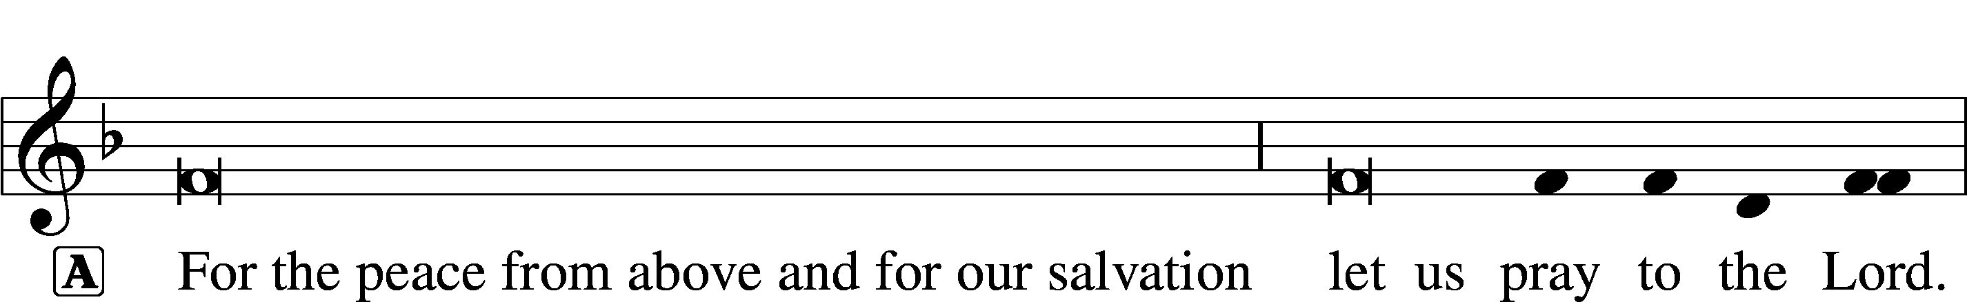


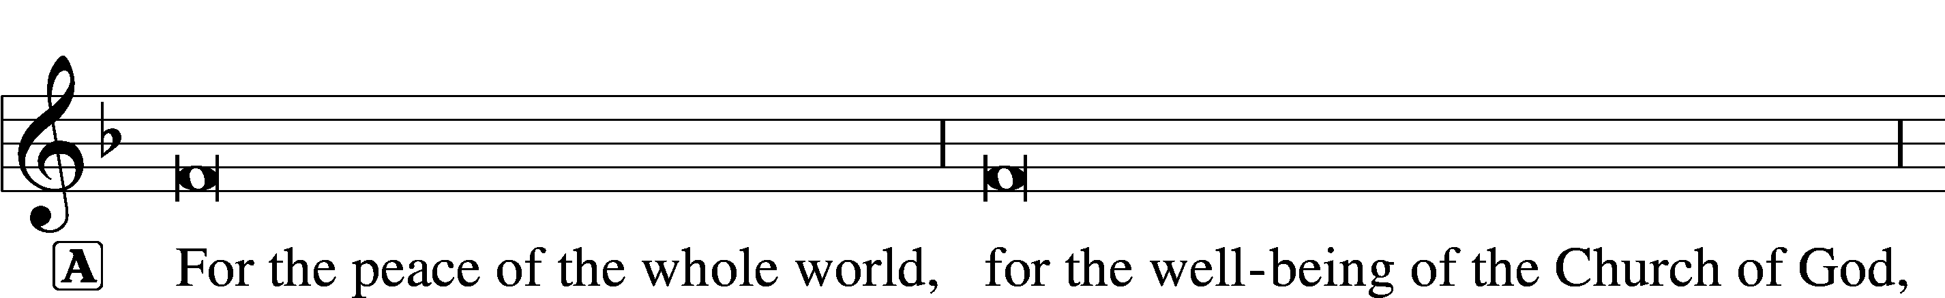



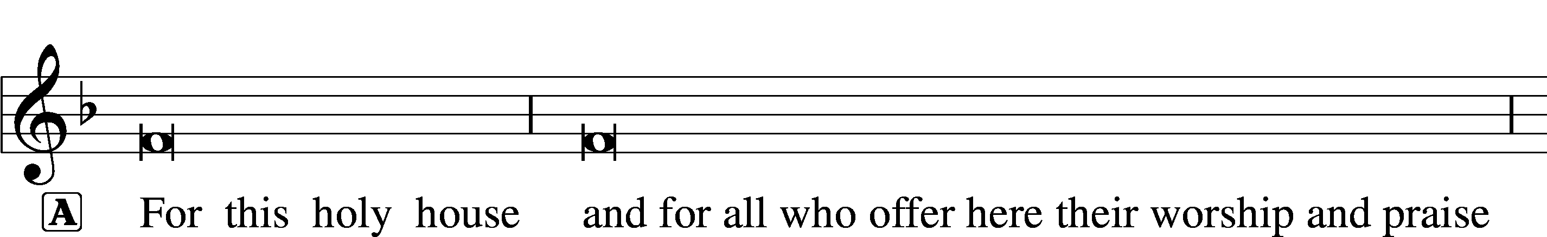






THIS IS THE FEAST LSB 155
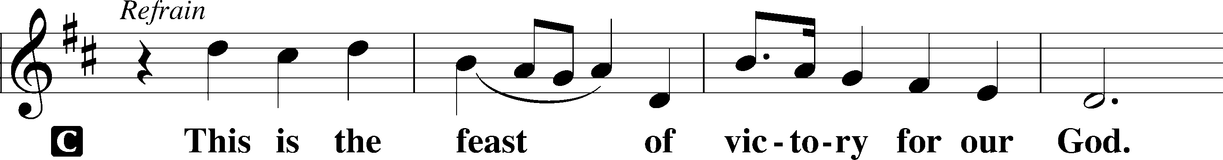
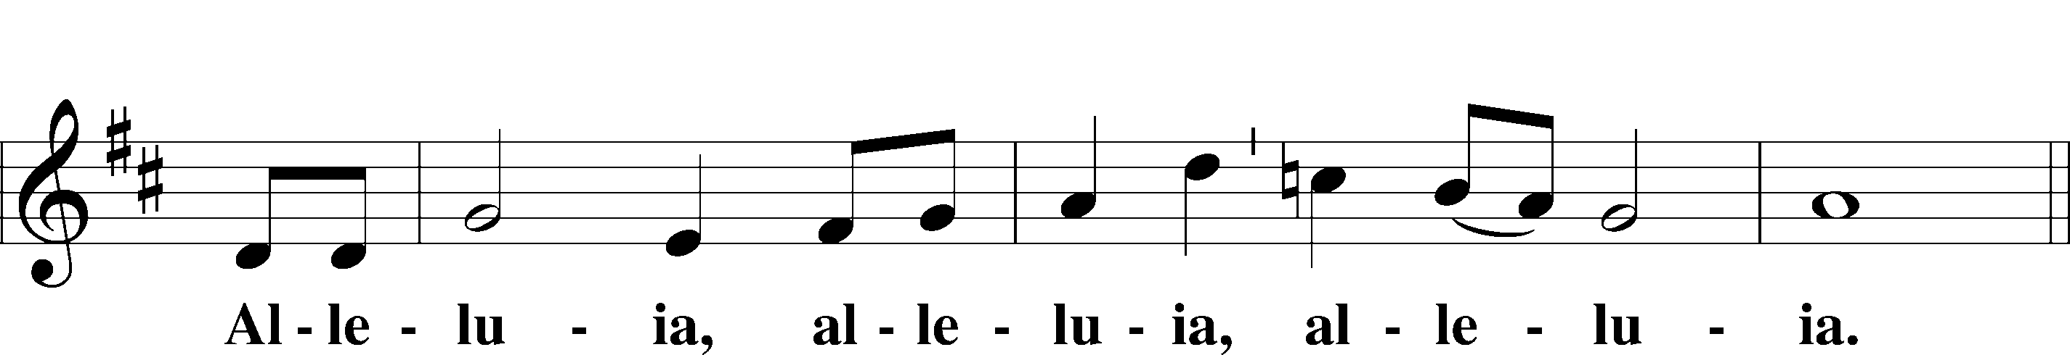
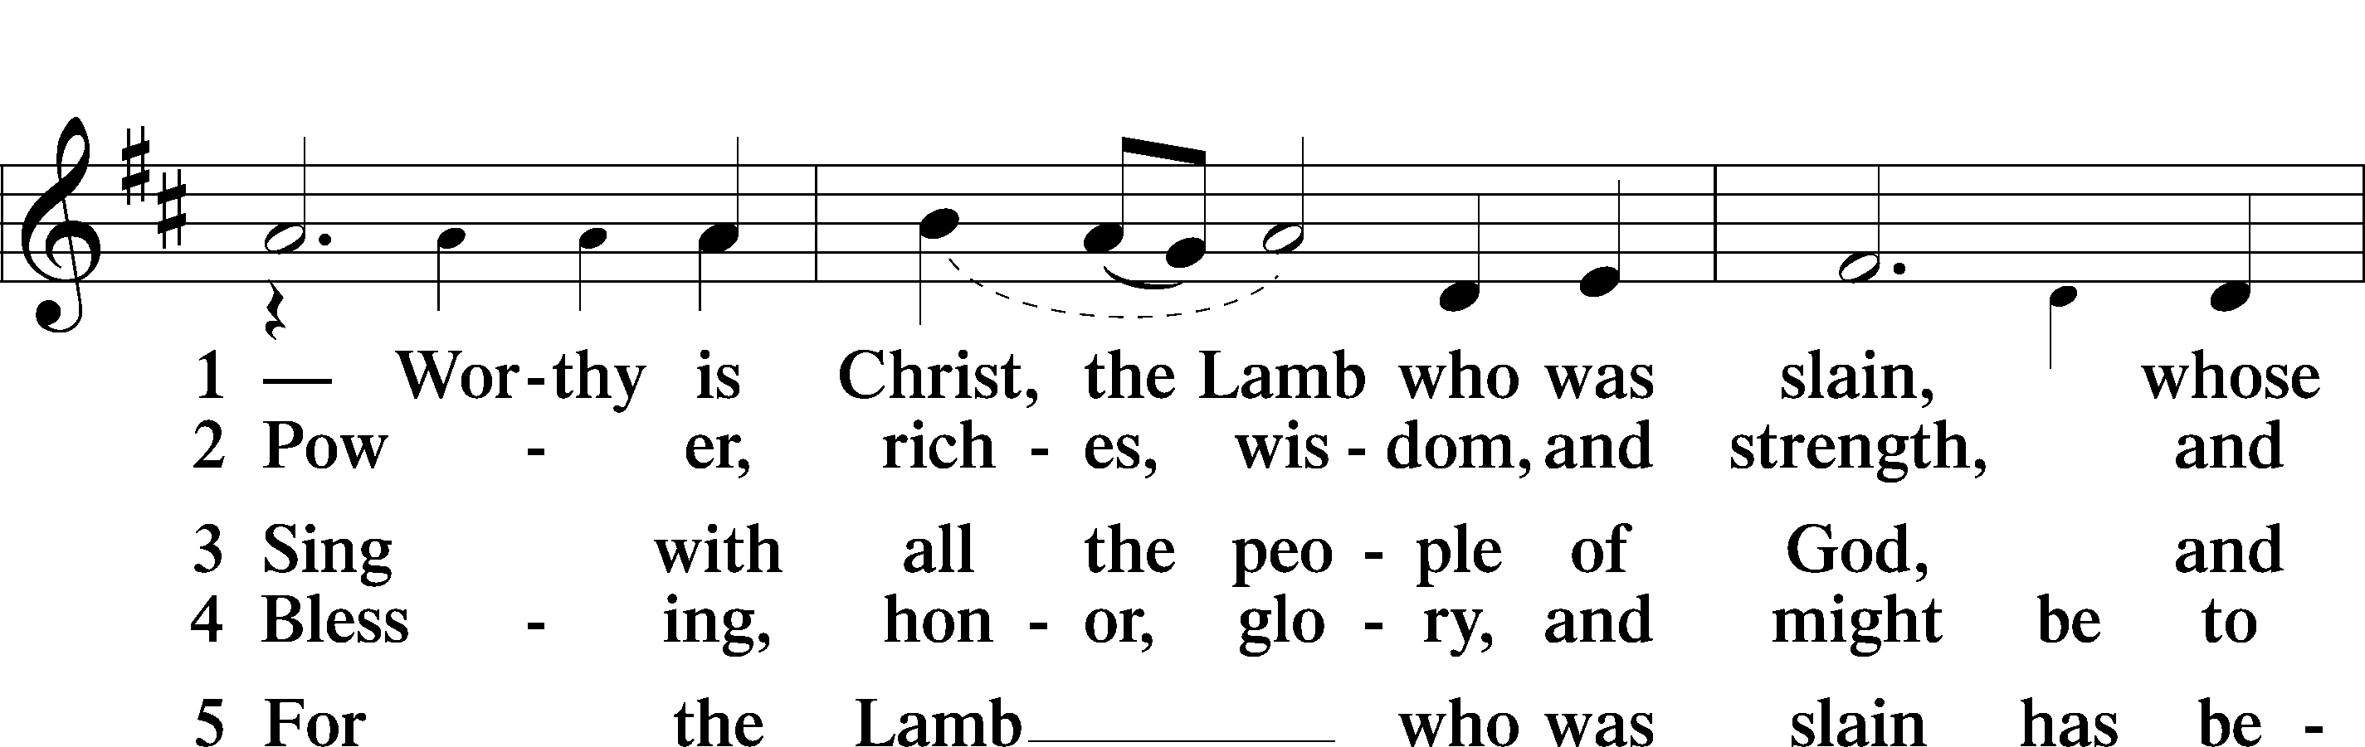
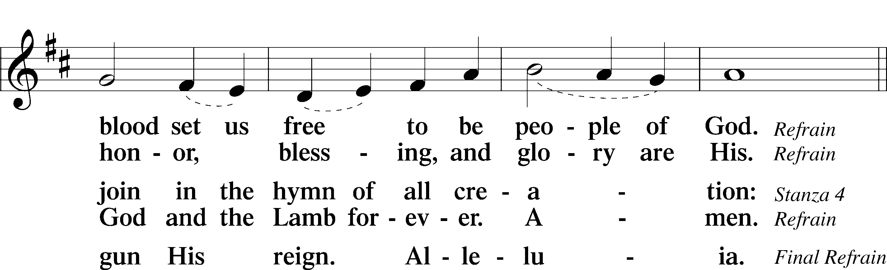
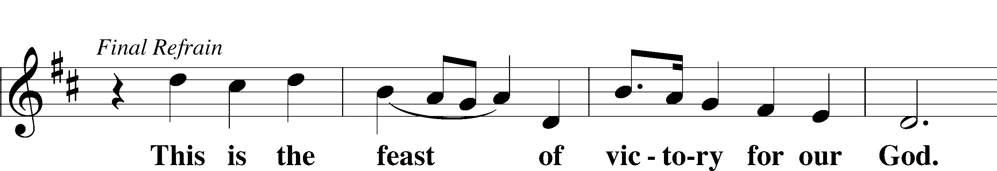
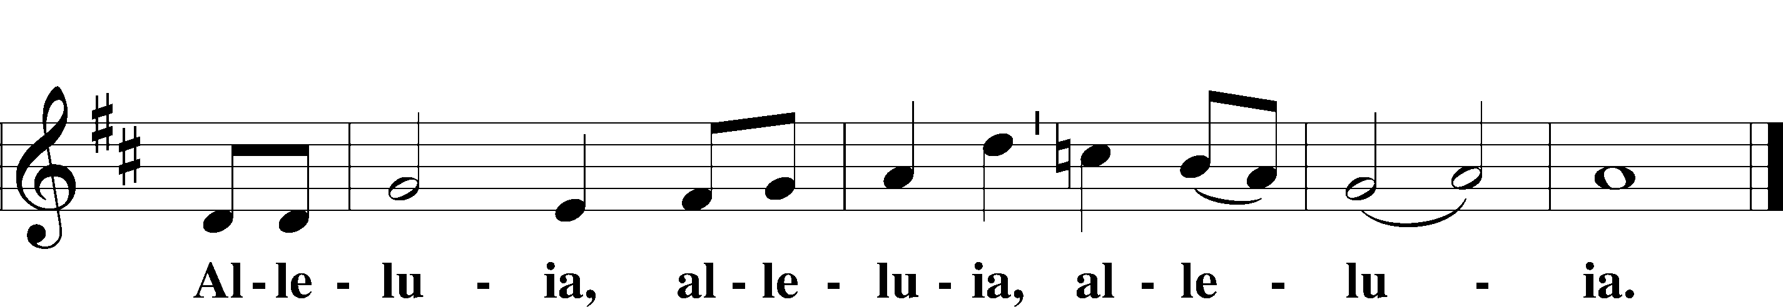

SALUTATION AND COLLECT OF THE DAY
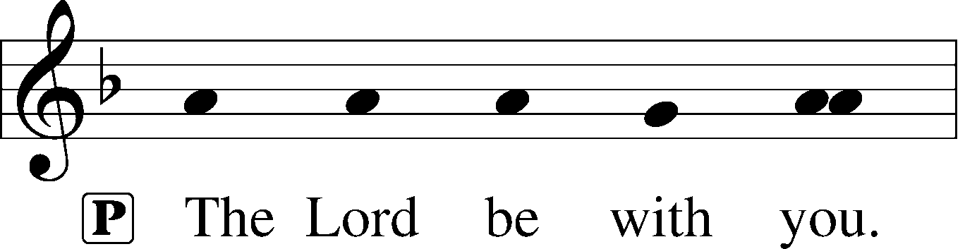
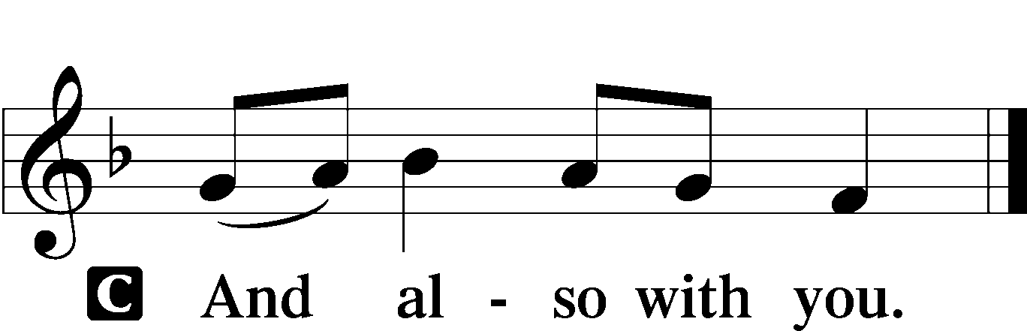

P Let us pray.
Almighty and gracious God, You want all to be saved and to come to the knowledge of the truth. Magnify the power of the Gospel in the hearts of Your faithful people that Your Church may spread the good news of salvation. Protect, encourage, and bless all missionaries who proclaim the saving cross that Christ, being lifted up, may draw all people to Himself, who lives and reigns with You and the Holy Spirit, one God, now and forever.

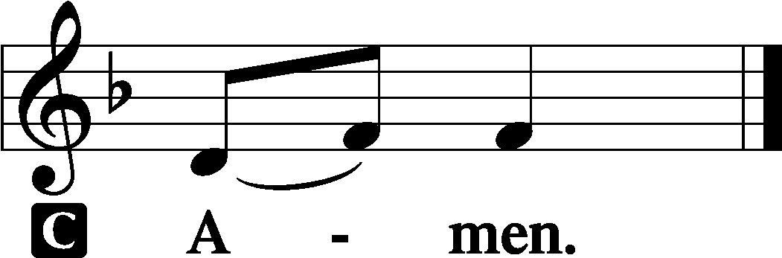

Sit

OLD TESTAMENT READING Isaiah 5:1–7
1Let me sing for my beloved
my love song concerning his vineyard:
My beloved had a vineyard
on a very fertile hill.
2He dug it and cleared it of stones,
and planted it with choice vines;
he built a watchtower in the midst of it,
and hewed out a wine vat in it;
and he looked for it to yield grapes,
but it yielded wild grapes.
3And now, O inhabitants of Jerusalem
and men of Judah,
judge between me and my vineyard.
4What more was there to do for my vineyard,
that I have not done in it?
When I looked for it to yield grapes,
why did it yield wild grapes?
5And now I will tell you
what I will do to my vineyard.
I will remove its hedge,
and it shall be devoured;
I will break down its wall,
and it shall be trampled down.
6I will make it a waste;
it shall not be pruned or hoed,
and briers and thorns shall grow up;
I will also command the clouds
that they rain no rain upon it.
7For the vineyard of the Lord of hosts
is the house of Israel,
and the men of Judah
are his pleasant planting;
and he looked for justice,
but behold, bloodshed;
for righteousness,
but behold, an outcry!

A This is the Word of the Lord.
C Thanks be to God.

GRADUAL
He will command his angels con- | cerning you*
to guard you in | all your ways.
Bless the Lord, | O my soul,*
and all that is within me, bless his | holy name!

EPISTLE Philippians 3:4b–14
If anyone else thinks he has reason for confidence in the flesh, I have more: 5circumcised on the eighth day, of the people of Israel, of the tribe of Benjamin, a Hebrew of Hebrews; as to the law, a Pharisee; 6as to zeal, a persecutor of the church; as to righteousness, under the law blameless. 7But whatever gain I had, I counted as loss for the sake of Christ. 8Indeed, I count everything as loss because of the surpassing worth of knowing Christ Jesus my Lord. For his sake I have suffered the loss of all things and count them as rubbish, in order that I may gain Christ 9and be found in him, not having a righteousness of my own that comes from the law, but that which comes through faith in Christ, the righteousness from God that depends on faith— 10that I may know him and the power of his resurrection, and may share his sufferings, becoming like him in his death, 11that by any means possible I may attain the resurrection from the dead.
12Not that I have already obtained this or am already perfect, but I press on to make it my own, because Christ Jesus has made me his own. 13Brothers, I do not consider that I have made it my own. But one thing I do: forgetting what lies behind and straining forward to what lies ahead, 14I press on toward the goal for the prize of the upward call of God in Christ Jesus.

A This is the Word of the Lord.
C Thanks be to God.

Stand

ALLELUIA AND VERSE LSB 156
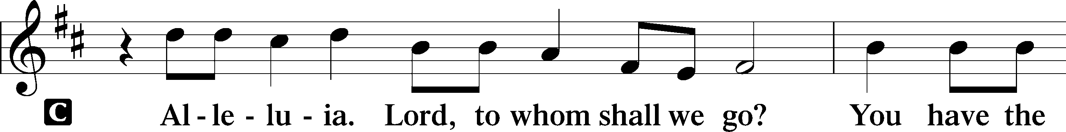
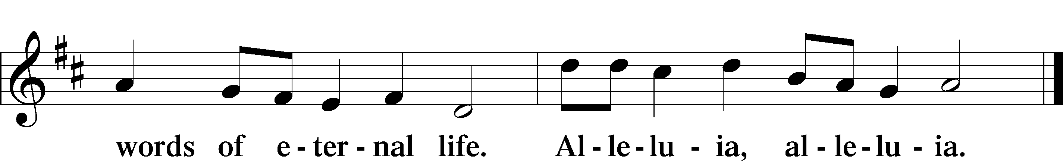

HOLY GOSPEL Matthew 21:33–46
P The Holy Gospel according to St. Matthew, the twenty-first chapter.

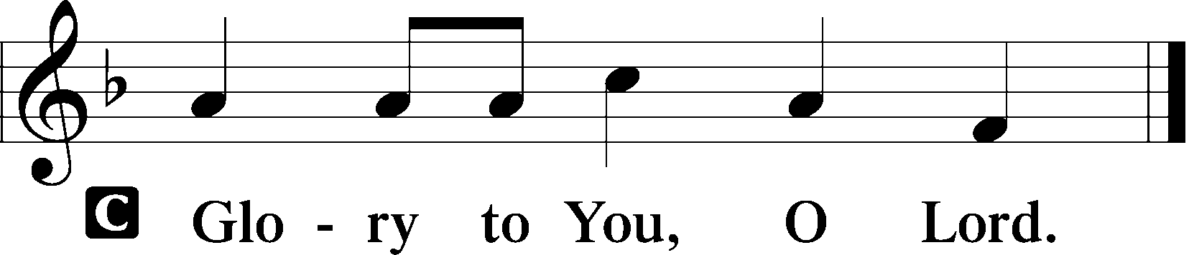

33[Jesus said:] “Hear another parable. There was a master of a house who planted a vineyard and put a fence around it and dug a winepress in it and built a tower and leased it to tenants, and went into another country. 34When the season for fruit drew near, he sent his servants to the tenants to get his fruit. 35And the tenants took his servants and beat one, killed another, and stoned another. 36Again he sent other servants, more than the first. And they did the same to them. 37Finally he sent his son to them, saying, ‘They will respect my son.’ 38But when the tenants saw the son, they said to themselves, ‘This is the heir. Come, let us kill him and have his inheritance.’ 39And they took him and threw him out of the vineyard and killed him. 40When therefore the owner of the vineyard comes, what will he do to those tenants?” 41They said to him, “He will put those wretches to a miserable death and let out the vineyard to other tenants who will give him the fruits in their seasons.”
42Jesus said to them, “Have you never read in the Scriptures:
“‘The stone that the builders rejected
has become the cornerstone;
this was the Lord’s doing,
and it is marvelous in our eyes’?
43Therefore I tell you, the kingdom of God will be taken away from you and given to a people producing its fruits. 44And the one who falls on this stone will be broken to pieces; and when it falls on anyone, it will crush him.”
45When the chief priests and the Pharisees heard his parables, they perceived that he was speaking about them. 46And although they were seeking to arrest him, they feared the crowds, because they held him to be a prophet.

P This is the Gospel of the Lord.

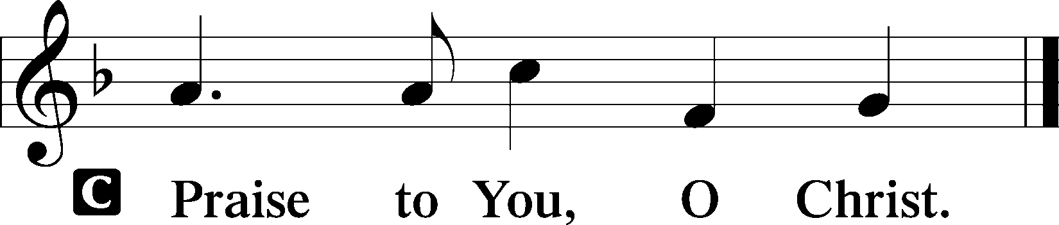

Sit

CHILDREN'S MESSAGE

HYMN OF THE DAY

446 JESUS, GREATEST AT THE TABLE

1 Jesus, greatest at the table,
The almighty Son of Man,
Laid aside His outer clothing,
Poured some water in a pan;
As the Twelve lay, hushed in silence,
He the servant’s task began.

2 Marvel how their Lord and teacher
Gently taught them not to vie
As He humbly knelt before them,
Dusty feet to wash and dry,
By His tender touch expressing
True compassion from on high.

3 Jesus took the role of servant
When upon that gruesome span,
For all human sin He suffered
As a vile and loathsome man;
On the cross poured out like water
To fulfill the Father’s plan.

4 Can we fathom such deep mercy?
Do we see what God has done?
Who can grasp this great reversal:
Love that gives His only Son?
Christ, the sinless for the sinners,
For the many dies the One.

5 Jesus gave to His disciples
A commandment that was new:
“Show My love to one another,
Do as I have done for you;
All the world will know you love Me
As you love each other too.”

SERMON Rev. Shaun Daugherty

Stand

NICENE CREED
C I believe in one God,
the Father Almighty,
maker of heaven and earth
and of all things visible and invisible.

And in one Lord Jesus Christ,
the only-begotten Son of God,
begotten of His Father before all worlds,
God of God, Light of Light,
very God of very God,
begotten, not made,
being of one substance with the Father,
by whom all things were made;
who for us men and for our salvation came down from heaven
and was incarnate by the Holy Spirit of the virgin Mary
and was made man;
and was crucified also for us under Pontius Pilate.
He suffered and was buried.
And the third day He rose again according to the Scriptures
and ascended into heaven
and sits at the right hand of the Father.
And He will come again with glory to judge both the living and the dead,
whose kingdom will have no end.

And I believe in the Holy Spirit,
the Lord and giver of life,
who proceeds from the Father and the Son,
who with the Father and the Son together is worshiped and glorified,
who spoke by the prophets.
And I believe in one holy Christian and apostolic Church,
I acknowledge one Baptism for the remission of sins,
and I look for the resurrection of the dead
and the life T of the world to come. Amen.

PRAYER OF THE CHURCH
After each petition:
P Lord, in Your mercy,
C hear our prayer.

Sit

COLLECTION OF TITHES AND OFFERING

CHOIR SING “The Lord Is my Shepherd” Howard Goodall

Stand

OFFERTORY LSB 159

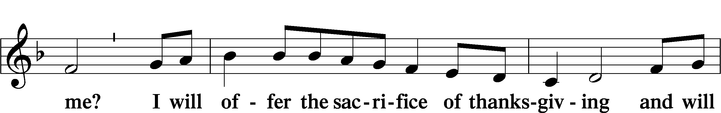
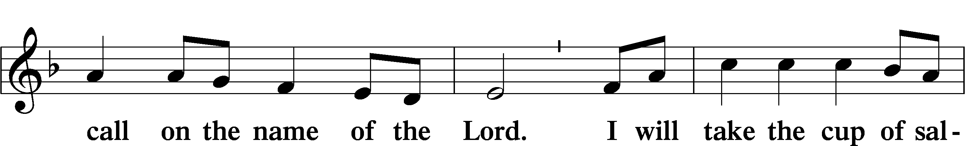
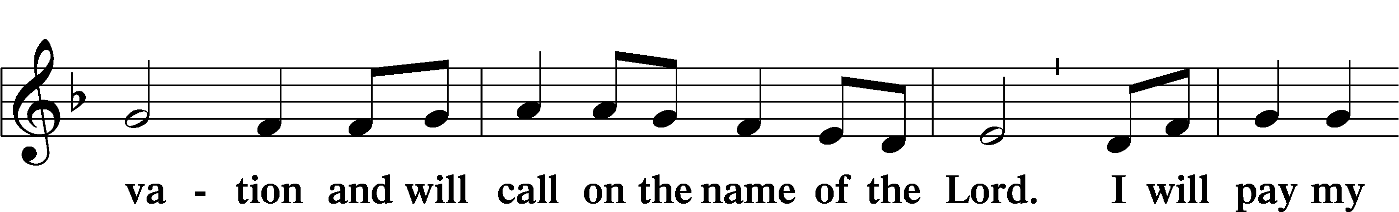
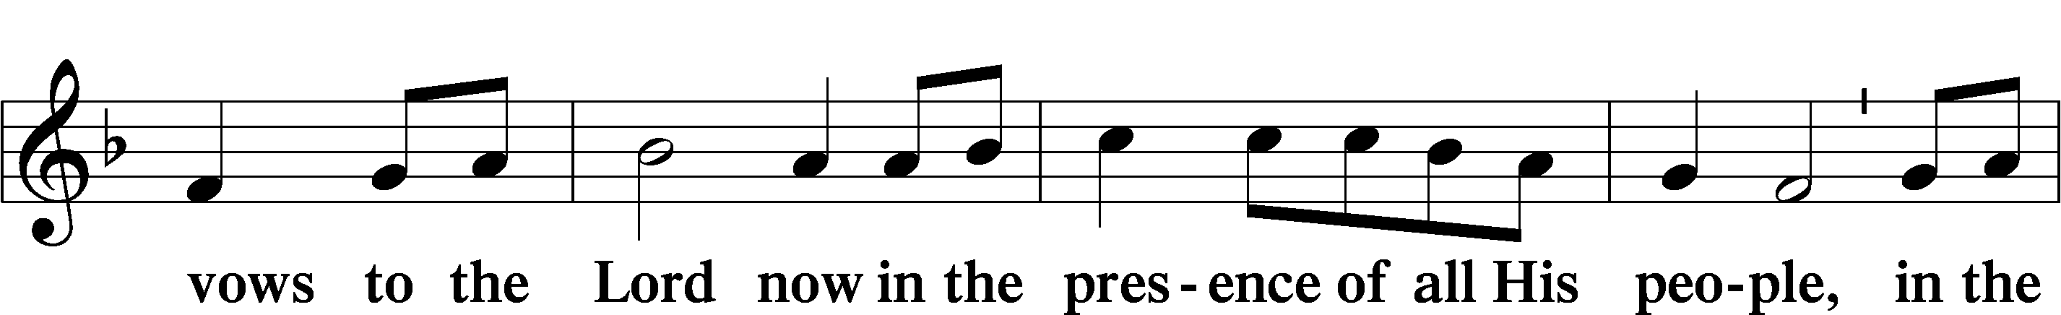
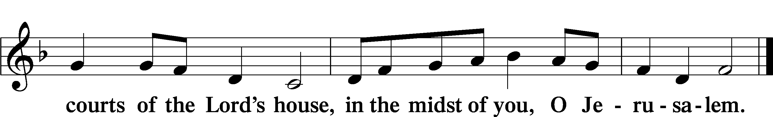

+ Service of the Sacrament +
As God's baptized and forgiven people, we gather at His invitation to receive The Lord's Supper.

The Lord’s Supper is celebrated at this congregation in the confession and glad confidence that, as he says, our Lord gives into our mouths not only bread and wine but His very body and blood to eat and to drink for the forgiveness of sins and to strengthen our union with him and with one another. Our Lord invites to his table those Baptized Christians who trust his words, repent of all sin, and set aside any refusal to forgive and love as he forgives and loves us, that they may show forth his death until he comes.

Because those who eat and drink our Lord’s body and blood unworthily do so to their great harm and because Holy Communion is a confession of the faith which is confessed at this altar, any who are not yet instructed, in doubt, or who hold a confession differing from that of this congregation and The Lutheran Church— Missouri Synod, and yet desire to receive the sacrament, are asked first to speak with the pastor or an elder.

For further study, see Matthew 5:23f.; 10:32f.; 18:15-35; 26:26-29; 1 Cor. 11:17- 34.

PREFACE LSB 160





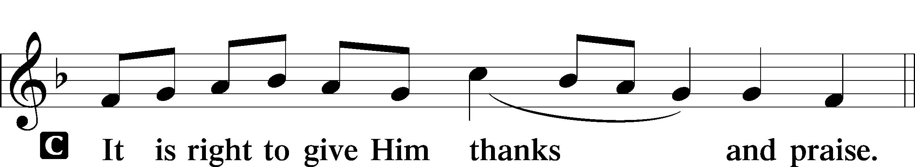

PROPER PREFACE 161
P It is truly good, right, and salutary that we should at all times and in all places give thanks to You, holy Lord, almighty Father, everlasting God, through Jesus Christ, our Lord, who bestows on His people the righteousness of Christ and teaches them to live as salt and light in the world, serving with the strength that God supplies and joyfully supporting the spread of the Gospel. Therefore with angels and archangels and with all the company of heaven we laud and magnify Your glorious name, evermore praising You and saying:

SANCTUS LSB 161
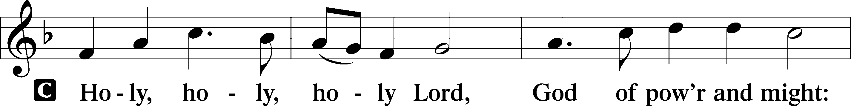
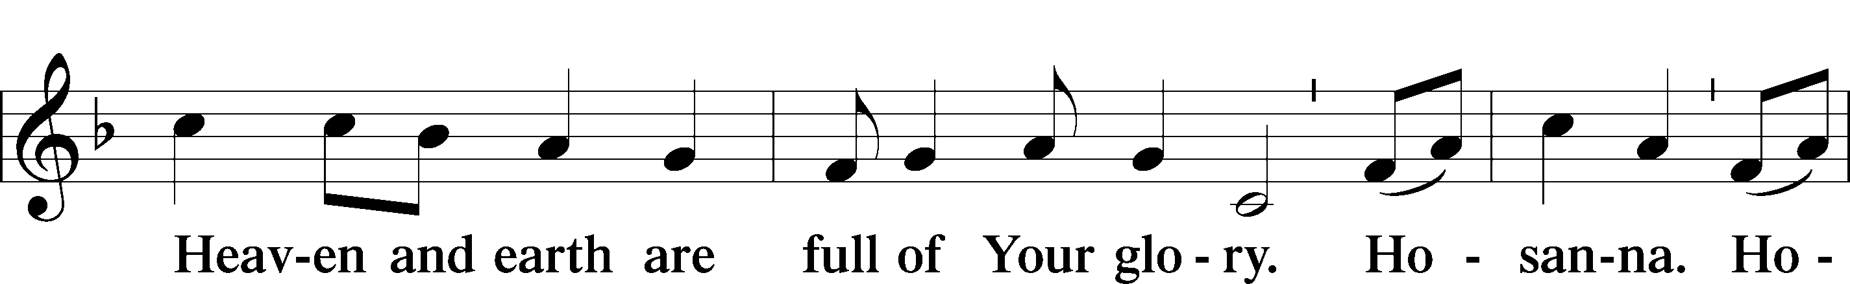
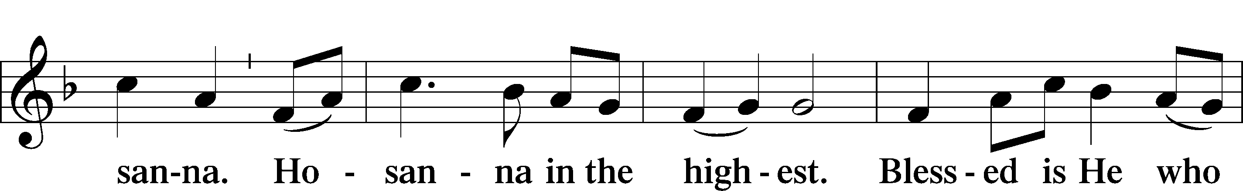
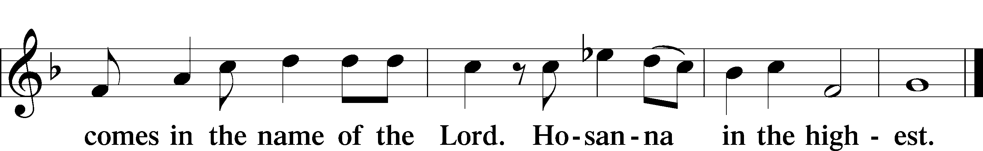

PRAYER OF THANKSGIVING 161
P Blessed are You, Lord of heaven and earth, for You have had mercy on those whom You created and sent Your only-begotten Son into our flesh to bear our sin and be our Savior. With repentant joy we receive the salvation accomplished for us by the all-availing sacrifice of His body and His blood on the cross.

Gathered in the name and the remembrance of Jesus, we beg You, O Lord, to forgive, renew, and strengthen us with Your Word and Spirit. Grant us faithfully to eat His body and drink His blood as He bids us do in His own testament. Gather us together, we pray, from the ends of the earth to celebrate with all the faithful the marriage feast of the Lamb in His kingdom, which has no end. Graciously receive our prayers; deliver and preserve us. To You alone, O Father, be all glory, honor, and worship, with the Son and the Holy Spirit, one God, now and forever.
C Amen.

THE WORDS OF OUR LORD

PROCLAMATION OF CHRIST
P As often as we eat this bread and drink this cup, we proclaim the Lord’s death until He comes.
C Amen. Come, Lord Jesus.

P O Lord Jesus Christ, only Son of the Father, in giving us Your body and blood to eat and to drink, You lead us to remember and confess Your holy cross and passion, Your blessed death, Your rest in the tomb, Your resurrection from the dead, Your ascension into heaven, and Your coming for the final judgment. So remember us in Your kingdom and teach us to pray:

LORD’S PRAYER
C Our Father who art in heaven, hallowed be Thy name, Thy kingdom come, Thy will be done on earth as it is in heaven; give us this day our daily bread; and forgive us our trespasses as we forgive those who trespass against us; and lead us not into temptation, but deliver us from evil. For Thine is the kingdom and the power and the glory forever and ever. Amen.

PAX DOMINI LSB 163
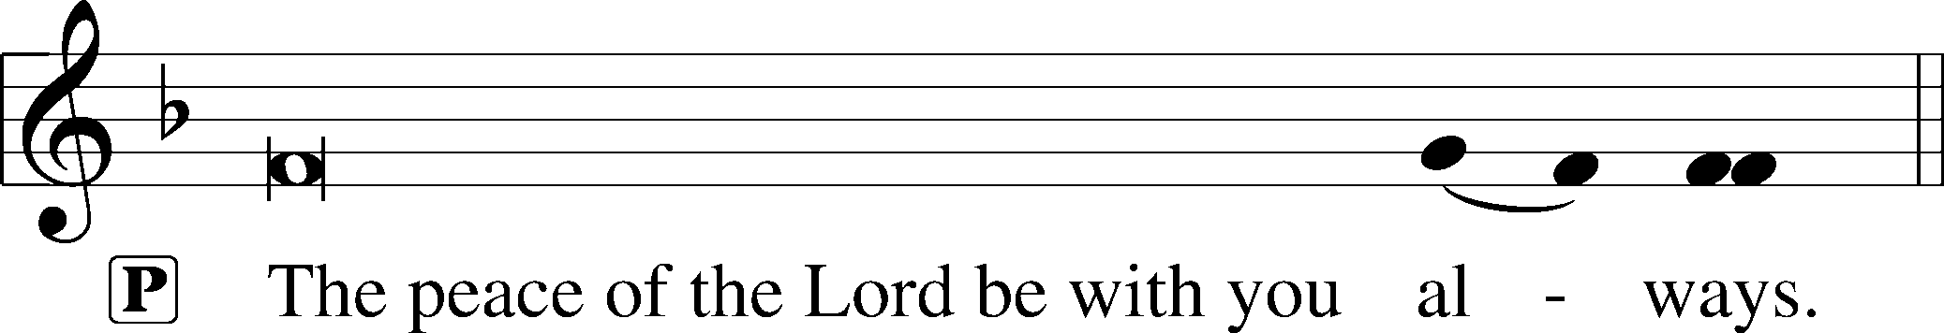


AGNUS DEI LSB 163
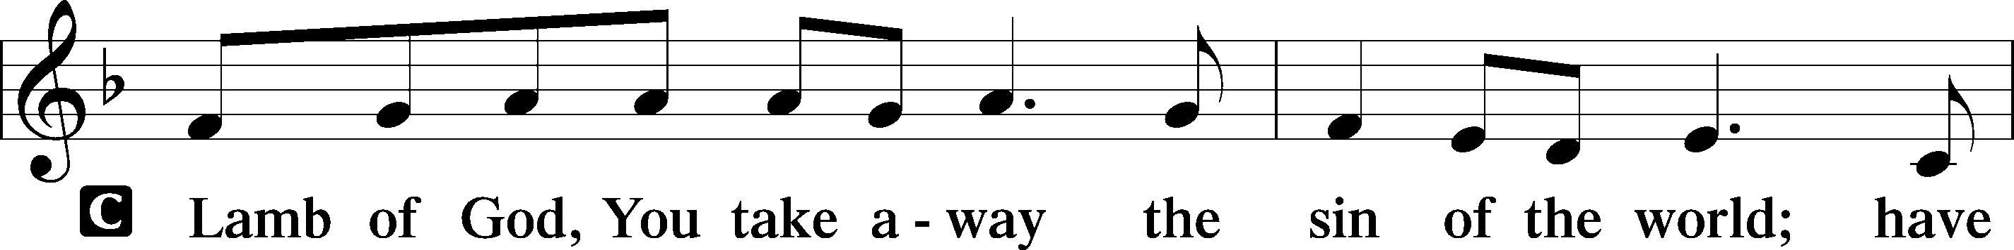
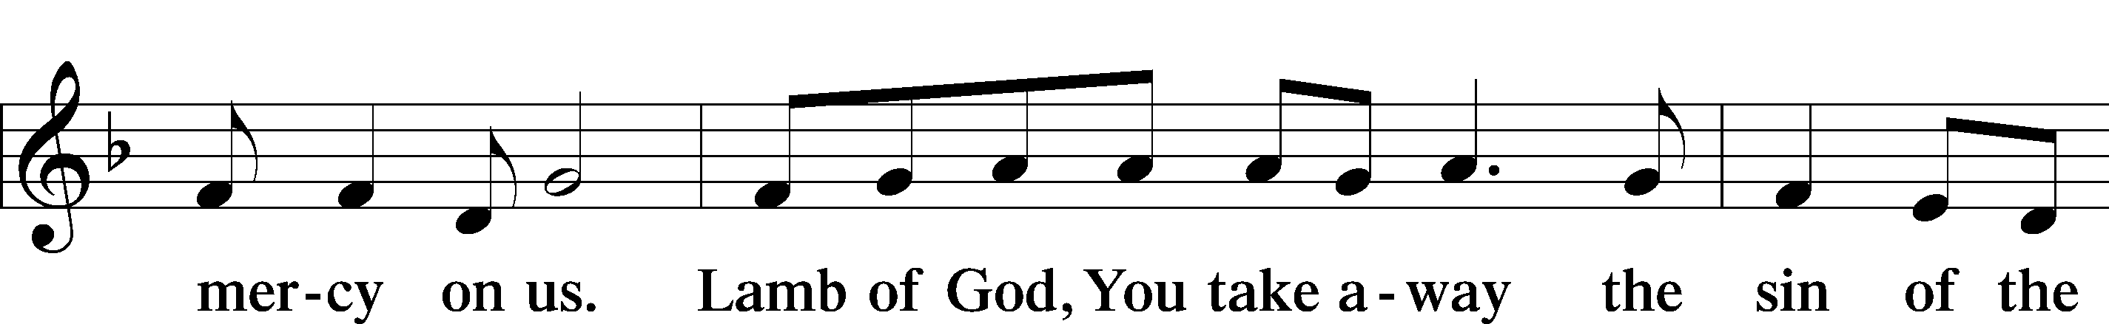

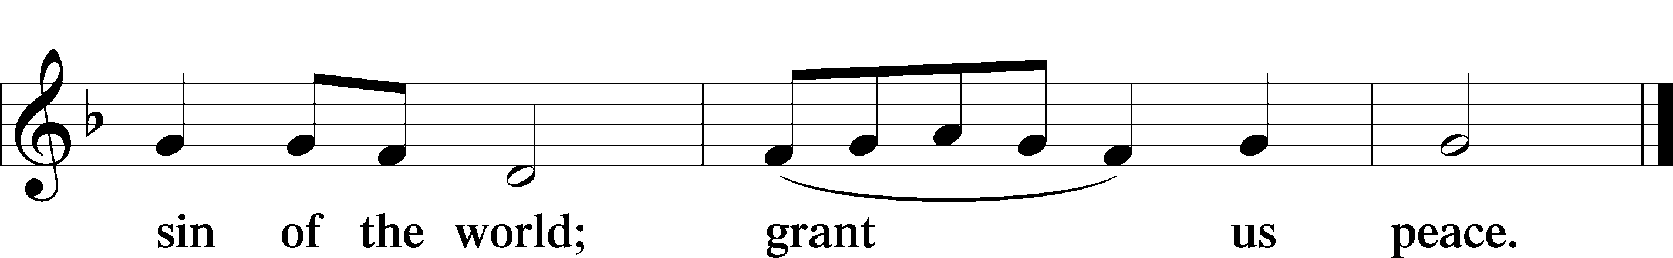

Following the Agnus Dei, please greet one another in the name of the Lord, saying, “Peace be with you,” as a sign of reconciliation and of the unity of the Spirit in the bond of peace (Matt. 5:22–24; Eph. 4:1–3).

Sit

DISTRIBUTION HYMNS

526 YOU ARE THE WAY; THROUGH YOU ALONE

1 You are the way; through You alone
Can we the Father find;
In You, O Christ, has God revealed
His heart and will and mind.

2 You are the truth; Your Word alone
True wisdom can impart;
You only can inform the mind
And purify the heart.
3 You are the life; the empty tomb
Proclaims Your conqu’ring arm,
And those who put their trust in You
Not death nor hell shall harm.

4 You are the way, the truth, the life;
Grant us that way to know,
That truth to keep, that life to win
Whose joys eternal flow
.
706 LOVE IN CHRIST IS STRONG AND LIVING

1 Love in Christ is strong and living,
Binding faithful hearts in one;
Love in Christ is true and giving.
May His will in us be done.

2 Love is patient and forbearing,
Clothed in Christ’s humility,
Gentle, selfless, kind, and caring,
Reaching out in charity.

3 Love in Christ abides forever,
Fainting not when ills attend;
Love, forgiving and forgiven,
Shall endure until life’s end.

696 O GOD, MY FAITHFUL GOD

1 O God, my faithful God,
True fountain ever flowing,
Without whom nothing is,
All perfect gifts bestowing:
Give me a healthy frame,
And may I have within
A conscience free from blame,
A soul unstained by sin.

2 Grant me the strength to do
With ready heart and willing
Whatever You command,
My calling here fulfilling;
That I do what I should
While trusting You to bless
The outcome for my good,
For You must give success.

3 Keep me from saying words
That later need recalling;
Guard me lest idle speech
May from my lips be falling;
But when within my place
I must and ought to speak,
Then to my words give grace
Lest I offend the weak.

4 Lord, let me win my foes
With kindly words and actions,
And let me find good friends
For counsel and correction.
Help me, as You have taught,
To love both great and small
And by Your Spirit’s might
To live in peace with all.

5 Let me depart this life
Confiding in my Savior;
By grace receive my soul
That it may live forever;
And let my body have
A quiet resting place
Within a Christian grave;
And let it sleep in peace.

6 And on that final day
When all the dead are waking,
Stretch out Your mighty hand,
My deathly slumber breaking.
Then let me hear Your voice,
Redeem this earthly frame,
And bid me to rejoice
With those who love Your name

Stand

DISMISSAL

THANK THE LORD LSB 164
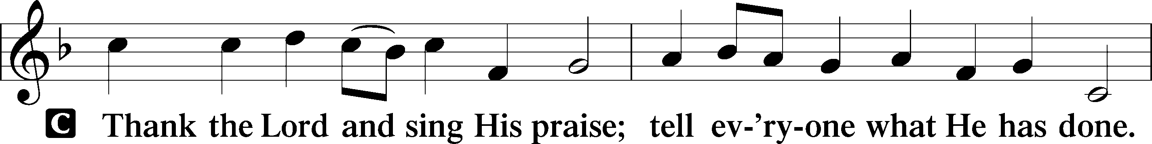
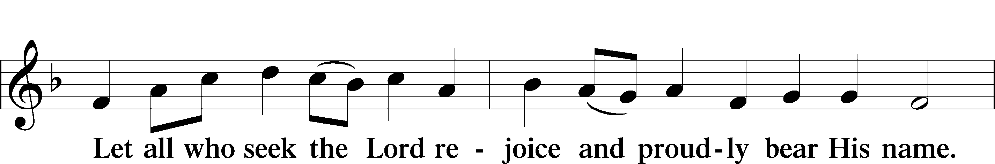
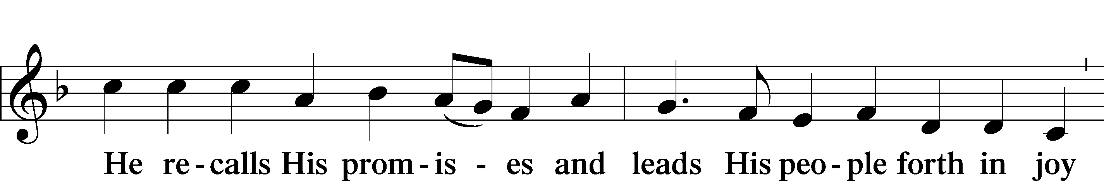
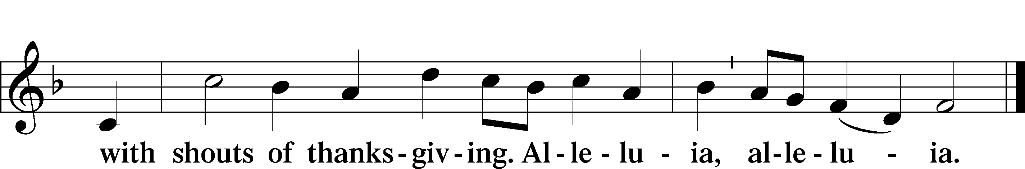

POST-COMMUNION COLLECT

BENEDICTION LSB 166
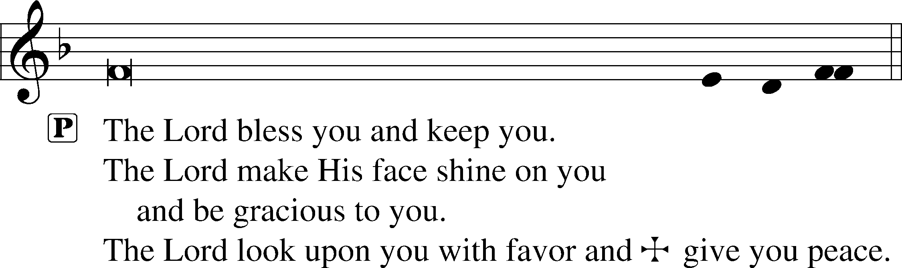


RECESSIONAL HYMN

832 JESUS SHALL REIGN

1 Jesus shall reign where’er the sun
Does its successive journeys run;
His kingdom stretch from shore to shore
Till moons shall wax and wane no more.

2 To Him shall endless prayer be made,
And endless praises crown His head;
His name like sweet perfume shall rise
With ev’ry morning sacrifice.

3 People and realms of ev’ry tongue
Dwell on His love with sweetest song;
And infant voices shall proclaim
Their early blessings on His name.

4 Blessings abound where’er He reigns:
The pris’ners leap, unloose their chains,
The weary find eternal rest,
And all who suffer want are blest.

5 Let ev’ry creature rise and bring
Honors peculiar to our King;
Angels descend with songs again,
And earth repeat the loud amen.

ANNOUNCEMENTS
See the announcements and prayer guide at the end of the bulletin.

SENDING
P Let us pray.
Lord God, You have called Your servants to ventures of which we cannot see the ending, by paths as yet untrodden, through perils unknown. Give us faith to go out with good courage, not knowing where we go but only that Your hand is leading us and Your love supporting us; through Jesus Christ, our Lord.
C Amen

P Go in peace to serve the Lord.
C Thanks be to God.

THIS WEEK AT FAITH

Sunday Oct 4 Bible Study 8:30am
Fellowship 9:30am
Worship 10:00am
CREDO 11:30am
Mon-Fri Oct 5-9 Chapel 8:30am
Tuesday Oct 6 Create in Me Crafting 10:00am
Wednesday Oct 7 Dinner 5:30pm
Adult Bible Studies 6:30pm
Confirmation & Youth Group
Sunday Oct 11 Bible Studies 8:30am
Fellowship 9:30am
Worship 10:00am
CREDO 11:30am

CHURCH ANNOUNCEMENTS

STAYING CONNECTED: OUR COMMUNICATION UPDATES
We are streamlining our communication processes to help everyone stay connected and updated with church news, events, and ministries! Please see our weekly newsletter for immediate news about that week, and our monthly newsletter for a broader look at that month and future months. You can also continue to use this printed bulletin for core information or visit our website anytime for a full library of resources. We are here to serve you, so please let us know how we can assist you!

WEDNESDAY NIGHTS ARE BACK - Family dinner at 5:30pm, programming at 6:30-8
Wednesday Nights start with a family dinner at 5:30, followed by programming for all ages (confirmation, youth group, Bible studies, choir, and handbells).

OPERATION CHRISTMAS CHILD - October 4th-November 15th
Starting today, you can help share joy with children worldwide by bringing a filled shoebox or gift donations to the church by November 15. Please check the accepted-items list in the Narthex before shopping. If you would prefer to cover $10 shipping cost for a box, please include "Operation Christmas Child" in the memo.

CREDO - NEW MEMBER CLASS (or member refresher) – Starts today after Worship, 11:30am
While this six-week study of the Bible and Small Catechism prepares new members to join Faith Lutheran Church, current members are also warmly invited. Join us after worship for the next six weeks for an excellent "refresher" course. Contact Pastor Shaun to be added to the class.

FAITH LUTHERAN SCHOOL PRAYERS - October 13, 9:00am
The School Prayer group meets the 2nd Tuesday of the month at 9:00am in the craft room. Dates are Oct 13th, Nov 10th, Dec 8th. Call or text Norma Palmer at (256-653-8349) for more information.

FIREWOOD MINISTRY - Saturday, October 17, 9am
This session will get us familiar with the equipment and processes. We will start at 9:00, please RSVP if you plan to attend, and feel free to invite anyone else who is interested. Coffee and donuts will be provided, so an accurate headcount ensures there is enough for everyone! Contact Christian Henshaw with questions or to RSVP

CHURCH DIRECTORY PHOTOS - Sunday, October 18, after worship
We would love for ALL members to take new/updated photos for our directory! Our school's photographer will take free church directory portraits for all members. View samples of her work at ginacellino.shootproof.com. Optional personal prints (from $13) and digital packages (from $35) will be available for purchase.

YOUTH BOWLING - October 18, 12:15pm
Youth and their families are invited to an afternoon of bowling on October 18th. After church photos join us in the cafeteria at 12:15 for lunch and devotion. Afterward, we will head over to Stars and Strikes Woodstock from 2-4pm for bowling. We encourage you to invite a friend! The cost is $8 per participant (includes 2 hrs of bowling +shoe rental). RSVP is required by 10/13 to Liz Cain (678.270.7636)


REFORMATION FESTIVAL - October 30, 5:00-7:00pm
Mark your calendars! Our next community event is Reformation Festival and will feature a Trunk-or-Treat! There will be face painting, food, drinks, games and more! Scan the QR code to be directed to the website where you can read about the festival and sign up to “reform” your trunk!


MEN'S AXE THROWING - November 13, 7-8pm
Men, please join us for an evening of fellowship and axe throwing. Located at American Axes (821 Livingston Ct Marietta, GA 30067). Scan the QR code to see more and fill out the waiver. Please RSVP by 11/6 to Jon Cain (678.472.5226 or jcain1280@gmail.com)
VOTER’S MEETING – Sunday November 15, 11:30am


ONE FAITH:
Family Devotions for the Week of October 4, 2026
THEME: Rooted in Christ through Stewardship
by Ward Irvin
Scan to View
Devotions ONLINE

We give Thee but Thine own, Whate'er the gift may be; All that we have is Thine alone, A trust, O Lord, from Thee.” LSB 781 "We Give Thee But Thine Own," stanza 1 — William Walsham How, 1858

DEVOTION:
In Zen and the Art of Motorcycle Maintenance (1974, a "Boomer" classic), Robert Pirsig describes the well-known and at least partly true "South Indian Monkey Trap." A hollowed-out coconut is chained to a stake, with a hole just big enough for a monkey's open hand. Rice is placed inside. The monkey reaches in and grabs a fistful, but the closed fist won't fit back through the hole. When the hunter steps out of hiding, the monkey panics and tries to flee, but its hand is stuck fast. All it has to do is let go of the rice. It can't. In that moment, the rice seems worth more than its freedom.
"Ha, ha, dumb monkey," we think, as we drive our luxury car into our very expensive neighborhood, pull into the garage, and walk into our professionally decorated house. "Hey honey, is my man cave ready with my beer and chips? I'm going to binge-watch three seasons of Game of Thrones today!"
In Mark 10: 17 [ESV], a man runs up to Jesus, kneels, and asks, "Good Teacher, what must I do to inherit eternal life?" What a fantastic question! So much eagerness! Jesus points him to the commandments, and the man replies, "Teacher, all these I have kept from my youth." Then: "And Jesus, looking at him, loved him, and said to him, 'You lack one thing: go, sell all that you have and give to the poor, and you will have treasure in heaven; and come, follow me.'" (Mark 10:21)
What a great story! Of course, the man saw his trap, realized his hand was stuck grasping material wealth, gave it all away in total faith and obedience, and followed Jesus for eternity!
No, sorry. "Disheartened by the saying, he went away sorrowful, for he had great possessions" (Mark 10:22). The disciples' reaction? "And they were exceedingly astonished, and said to him, 'Then who can be saved?'" (Mark 10:26). And Jesus' response? "Jesus looked at them and said, 'With man it is impossible, but not with God. For all things are possible with God'" (Mark 10:27).
Are you caught in a monkey trap? There’s hope: the God who does the impossible can open even a clenched fist.
CATECHISM MEMORY:
The Eighth Commandment You shall not give false testimony against your neighbor.
What does this mean? We should fear and love God so that we do not tell lies about our neighbor, betray him, slander him, or hurt his reputation, but defend him, speak well of him, and explain everything in the kindest way.
READINGS for THIS WEEK:
Mon: Matt. 6:19-24 Tue: Luke 12:22-34 Wed: 2 Cor. 8:1-15 Thu: Prov. 11:24-31 Fri: 1 Chron. 29:10-18 Sat: Matt. 22:1-14

REFLECTION QUESTIONS & ACTIVITIES for the READINGS
- What do the readings teach you about stewardship and the “traps” of this world?
- Matt 6:19-21 seems backwards. Wouldn’t your money follow your heart? Why not? What is Jesus saying to you here?
- 1 Chronicles 29:14. God directs even our heartbeat. What can we give God that He hasn’t already given us?
- Decide on a ministry that you love. Choose a generous gift. Double it and give the money immediately!
- What questions do you have about the readings this week? (Write them down and share them with Pastor.)

Prayers for the Week

Let my prayer rise before You as incense…” - Psalm 141:2 Following the instruction of God's Word, we lift our hearts and hands in prayer. As a priesthood of believers called to bear one another’s burdens, we bring our petitions before our heavenly Father.

Please join us in interceding for: Baby Thorston & Thom family (bloodwork concerns referred to hematology/oncology) //Loretta Engelhardt (recovering from a fall)// Ruth Trinklein (successful surgery on fractured ankle)// MaryLou (recovery from injuries after car accident)// Elizabeth (recovery following surgery)// Debby Lenord (peace, protection, guidance)//Sandy Skrbanek’s sister// Judy Hamilton (recover from shoulder surgery) // Carol Seelman’s sister-in-law; Sandy (complications from chemotherapy) // friend of Schleichers // Paula Gronemeyer (recovery from stroke, restoration of vision); Makenna (guidance, faith and Christian fellowship) // LaJaun (mercy, faith, and wise decision making for her family members)// Heidi Fletcher’s mother (recovery following stroke and fall)// Nathan (relief and treatment for bulging disc in back) // Jill Musgrove’s son; Allie and her baby (high-risk pregnancy) // sister of Roby Hamilton; Viva Kirk (health and employment)// Thanksgiving for the birth of Finnegan to Brittain and Josh Rebuck; Thanksgiving for Shirley’s move to a rehabilitation center // Greg Schaag’s aunt; Janice Schaag (health and peace following diagnosis of a hereditary condition); Steve and his family as he nears the end of his life // father of Phil Manginelli (Phil is Ward’s & Susan’s son-in-law) // Brennan Lambert (a quick recovery from jaw surgery); Audrey and Thomas (provision for their needs of body and soul, following a house fire) // family of Henshaws; Alex (protection during deployment, safe return to family in October) and his wife, Amanda, and children William, Aurora, & Olivia// Thanksgiving for medical and spiritual care for Tracy Woolery following his recent surgery// Ruth Brown as she mourns the death of her husband // friend of Sandy Skrybanek// Darrell Weers (lost his battle with Parkinson’s disease) // brother of George Weers; Thanksgiving for our flourish Youth Group; Beth (suffering from an illness), and her husband Matthew as he cares for her and their children // Marylou’s son; Andrew Hirschler (hospitalization) // former member, friend of Pietros// Caroline O’Neal (cancer)// Ramona (recovery from surgery, peace) and her husband John, and children // sister of Rosina Sawh; Gary Griffin (cancer treatment and gallbladder infection) and his wife, Karen // former members, friends of Lamberts// Thanksgiving for progress in recovery for GanneElyse and for the joy of seeing her in worship!// Kyle Laurendine (diagnosed with brain tumor)// Thanksgiving for the birth of Charlotte Ross Webb to Ciji Parrish and Craig Webb, Thanksgiving for the birth of Luke Robert Ross to Allie Hamilton.

ONGOING
For faith and salvation for those who are not yet believers; and repentance for those who have strayed from the faith (especially Jonathan, Bethany, Ean, Bud, Roger, Connor Brett, Mike, Brad, Joel, Ben, Regan, Adam, Corinne, Ana, Samantha, Victoria, Jason, Mike, Josh, Dan, Lisa, Steve, Jessica, Daniel, Hannah, Destiny, Nate, Carol, a member’s brother and sisters, Ben, Bill, Mary, Jack and Jason; along with those others we hold in our heart.); For those who mourn (the families of Joyce Elston, Steven Erny, Jewley Del Duca, and Tom Olson); For members of the Armed Forces of the United States, who protect and defend us (Alex & Brett) ; For our Staff: Pastor Shaun, Headmaster Bradshaw, and all the staff and leaders of Faith Lutheran Church and School (for Godly vision and stewardship; and that the Gospel would be faithfully proclaimed in church and school.); For our Missionaries: Rev. Chris and Dr. Jenny Yang, missionaries to Taiwan; For the families and youth of Faith Lutheran Church & School (that God would grant them steadfast, vibrant faith); For our confirmation students (Daniel, Lily, Zach, Madeline, Isabelle, and Melanie); For more students at Faith Lutheran School, according to God’s will; For faithful leaders of our state and nation.


