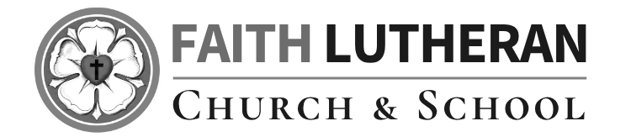

Eighteenth Sunday After Pentecost
September 27, 2026
OUR MISSION: Connecting People to Jesus

Contact us
Faith Lutheran Church & School 2111 Lower Roswell Rd, Marietta, GA 30068 | 770-973-8877

CHURCH: www.faithmarietta.com SCHOOL: www.faithmarietta.org
Rev. Shaun Daugherty, Pastor Mr. Chris Bradshaw, Headmaster
pastor.shaun@faithmarietta.org chris.bradshaw@faithmarietta.org
470-289-9469 470-641-6239
See the full leadership directory: www.faithmarietta.com/leadership
Serving This Month at Faith
 | 9/6/2026 | 9/13/2026 | 9/20/2026 | 9/27/2026
Musicians | Vaunda Noerenberg | Vaunda Noerenberg | Ben Nye | Vaunda Noerenberg
Elders | Ward Irvin  Vinny Caracci | Steve Buchtrup  Greg Sinatra | Vinny Caracci  Ward Irvin | Steve Buchtrup  Woody Wood
Reader | David Barnett | Amy Meyer | Jon Wareham | Stacy Sinatra
Ushers | Greg Czerwonka  Matthew Czerwonka  Jacob Czerwonka  Luke Czerwonka  Sam Czerwonka | Steve Buchtrup  Mark Patterson  Gary Schleicher  Reagan Gronsbell  Paris Brown | Kim Kaumeyer  David Barnett  Greg Sinatra | Chris Bradshaw  Herman Dean  Bryan Powell  Christian Campbell
Acolytes | Adam Cain  Amadeo Brown | Josiah Brown  Alex Bradshaw | Andrew Linsey  Christian Brown | Amadeo Brown  Adam Cain



For your convenience, we now accept gifts
Pay Pal
via Venmo or PayPal.

Our Discipleship
Date | 9/13 | 9/20 | 9/27 |  | Budget Summary (August)
Worship | 148/133 | 118/106 | - |  | Avg. Worship | 155
Sunday School | 48 | 30 | - |  | Avg. SS | 25
Gen. Giving | $21,963 | $8,164 | - |  | Gen. Giving | $61,945
MTD Giving | $32,283 | $40,447 | - |  | Budgeted Giving | $42,400
Monthly Budget | $44,600 | $44,600 | $44,600 |  | Over (Under) | $19,545

FAITH GROWS is our debt reduction account, geared towards eliminating our mortgage.
Please prayerfully consider donating to this fund - over and beyond your normal tithe.

August Debt Reduction | $2,333 | Remaining Mortgage Debt | $2,678,311

ALTAR FLOWERS are given today In Celebration of Ramona Bode’s 90th Birthday
WELCOME
Narrative Service
This morning’s service is going to be different. It’s called a “Narrative Service” or a “Teaching Service.” We will follow the normal liturgy, but before each portion of the service we will have a historical and biblical introduction. This narration will be the “sermon” for the day, so the service won’t be any longer than normal. The goal is to consider each portion of the liturgy: where it comes from in the Scriptures, when it was introduced into the church’s worship, and what part it plays in the overarching theme of the Divine Service.
-- Most of this “narrative service” was developed by Pastor Bryan Wolfmeuller.

NARRATION: The Theme of the Divine Service
+ The Service of Preparation +
We enter the presence of God by humbly confessing our sins and gladly receiving His forgiveness.

Stand
PROCESSIONAL HYMN
579 THE LAW OF GOD IS GOOD AND WISE

1 The Law of God is good and wise
And sets His will before our eyes,
Shows us the way of righteousness,
And dooms to death when we transgress.

2 Its light of holiness imparts
The knowledge of our sinful hearts
That we may see our lost estate
And turn from sin before too late.

3 To those who help in Christ have found
And would in works of love abound
It shows what deeds are His delight
And should be done as good and right.

4 But those who scornfully disdain
God’s Law shall then in sin remain;
Its terror in their ear resounds
And keeps their wickedness in bounds.

5 The Law is good; but since the fall
Its holiness condemns us all;
It dooms us for our sin to die
And has no pow’r to justify.

6 To Jesus we for refuge flee,
Who from the curse has set us free,
And humbly worship at His throne,
Saved by His grace through faith alone

Sit
NARRATION: The Invocation, Confession and Absolution

The sign of the cross may be made by all in remembrance of their Baptism.

Stand
INVOCATION
P In the name of the Father and of the T Son and of the Holy Spirit.
C Amen.

P If we say we have no sin, we deceive ourselves, and the truth is not in us.
C But if we confess our sins, God, who is faithful and just, will forgive our sins and cleanse us from all unrighteousness.

Silence for reflection on God’s Word and for self-examination.

CONFESSION AND FORGIVENESS LSB 151
P Let us then confess our sins to God our Father.
C Most merciful God, we confess that we are by nature sinful and unclean. We have sinned against You in thought, word, and deed, by what we have done and by what we have left undone. We have not loved You with our whole heart; we have not loved our neighbors as ourselves. We justly deserve Your present and eternal punishment. For the sake of Your Son, Jesus Christ, have mercy on us. Forgive us, renew us, and lead us, so that we may delight in Your will and walk in Your ways to the glory of Your holy name. Amen.

P Almighty God in His mercy has given His Son to die for you and for His sake forgives you all your sins. As a called and ordained servant of Christ, and by His authority, I therefore forgive you all your sins in the name of the Father and of the T Son and of the Holy Spirit.
C Amen.

+ Service of the Word +
Having received God's forgiveness, we come before Him with songs of praise, eager to hear His Word.

Sit
NARRATION: The Introit, The Kyrie, and the Hymn of Praise
Stand
INTROIT

The Lord lifts up the | humble;*
he casts the wicked | to the ground.
Praise the Lord! For it is good to sing praises | to our God;*
for it is pleasant, and a song of praise is | fitting.
The Lord builds up Je- | rusalem;*
he gathers the outcasts of | Israel.
He heals the broken- | hearted*
and binds | up their wounds.
He determines the number | of the stars;*
he gives to all of | them their names.
Great is our Lord, and abun- | dant in power;*
his understanding is beyond | measure.
Glory be to the Father and | to the Son*
and to the Holy | Spirit;
as it was in the be- | ginning,*
is now, and will be forever. | Amen.
The Lord lifts up the | humble;*
he casts the wicked | to the ground.
KYRIE LSB 152

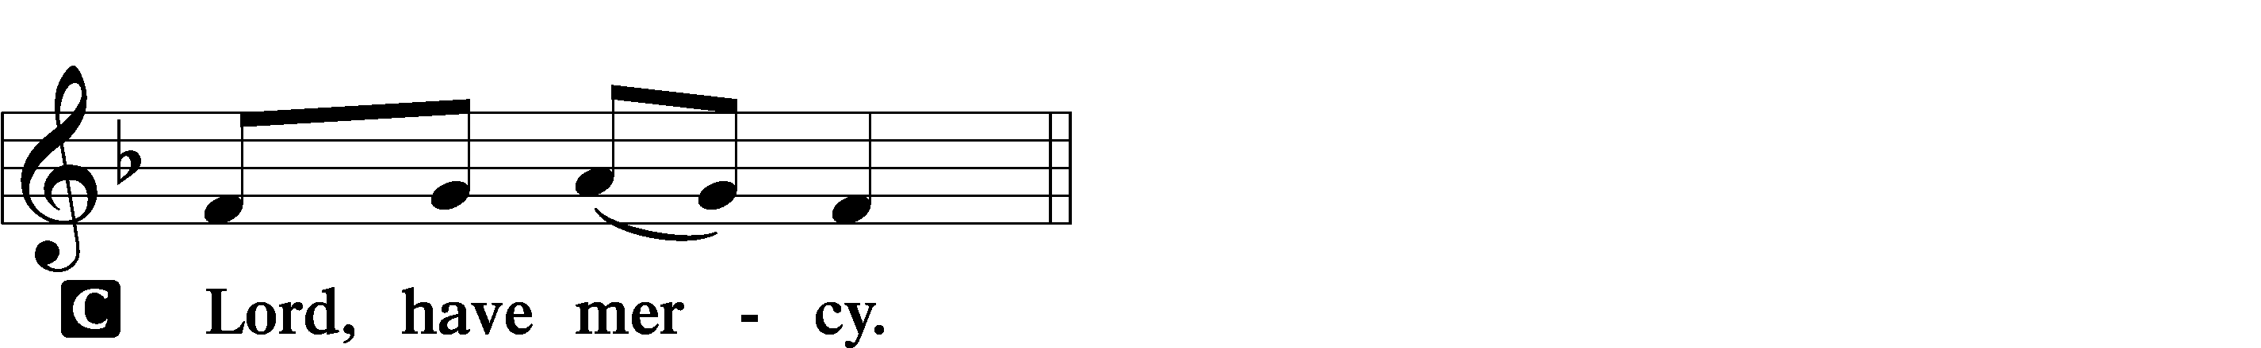

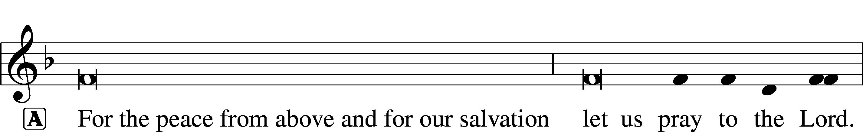


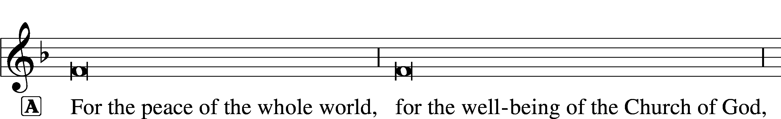



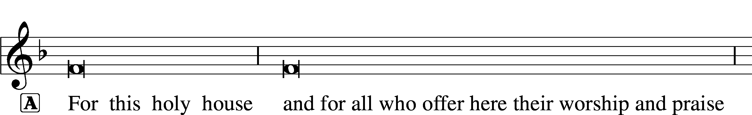

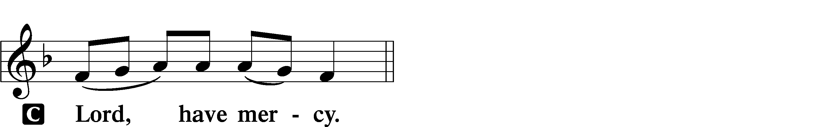




THIS IS THE FEAST LSB 155
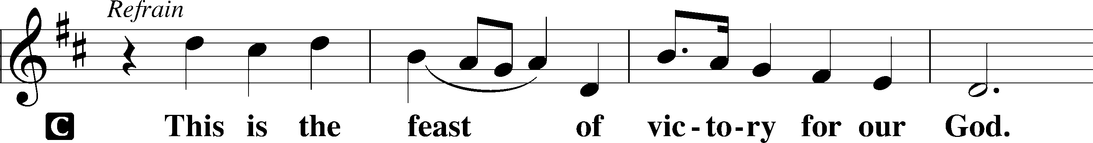
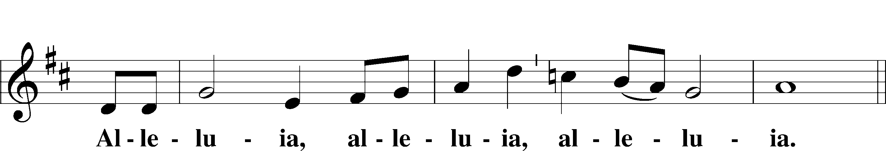
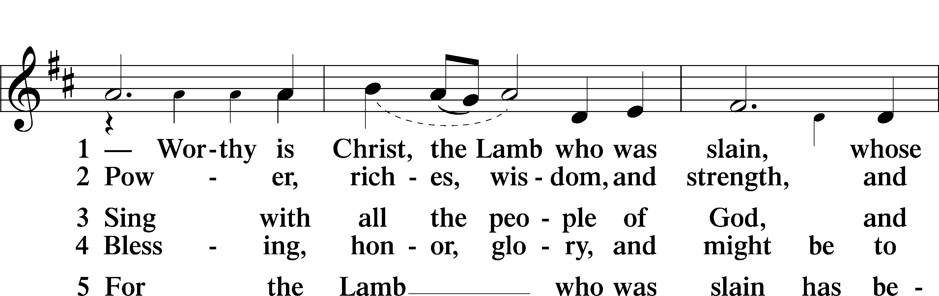
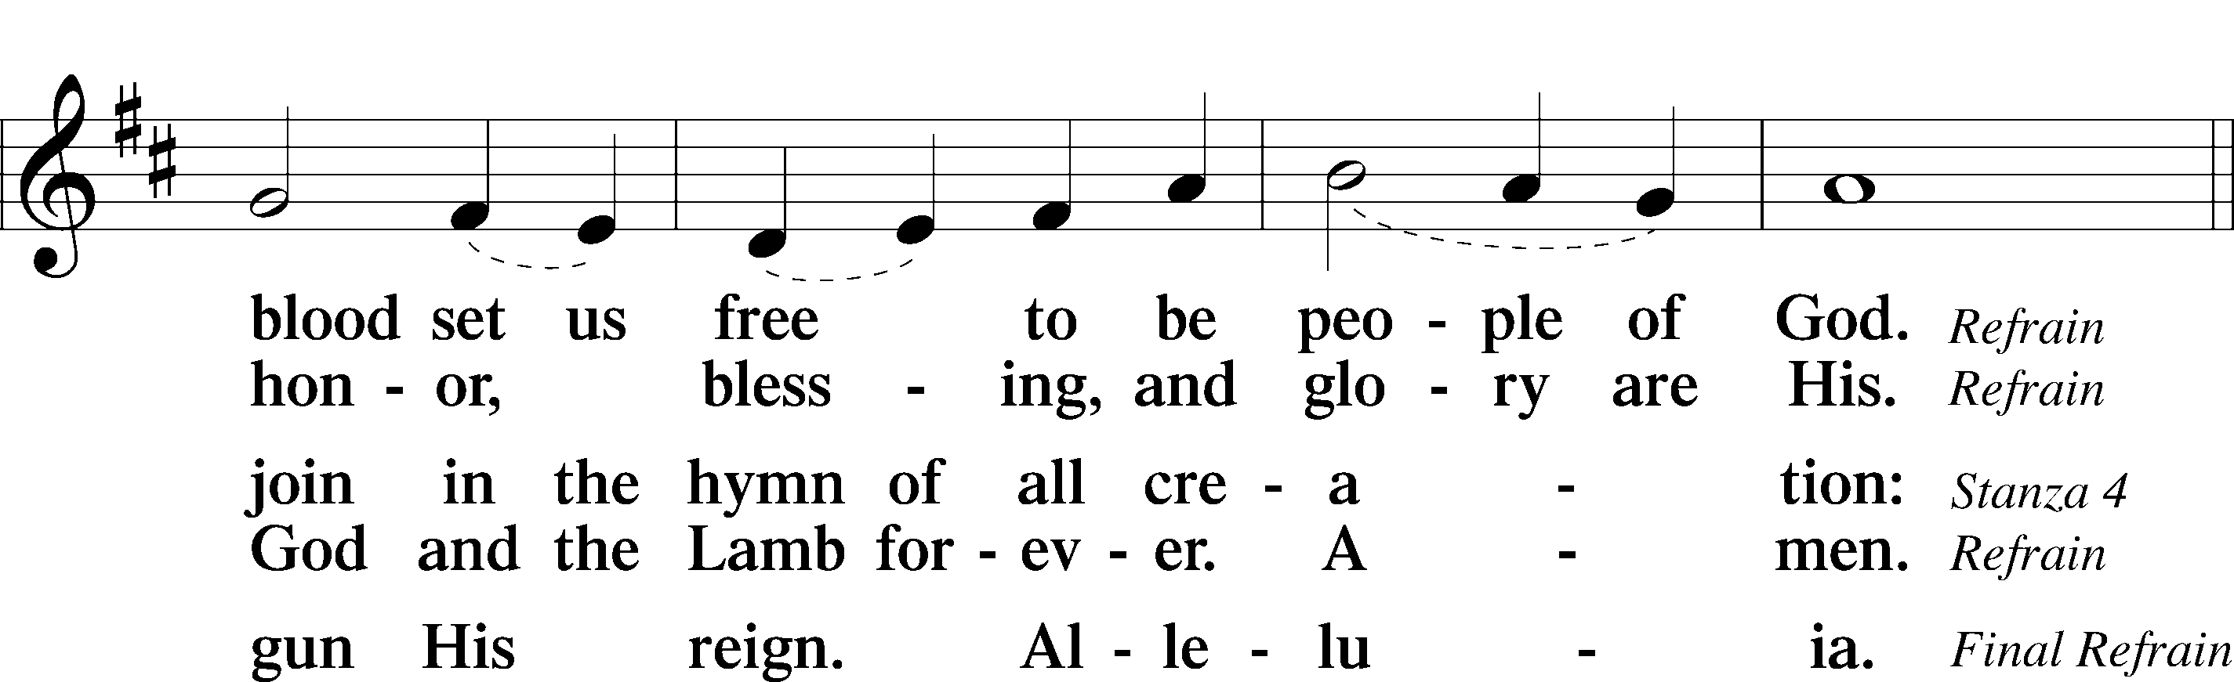
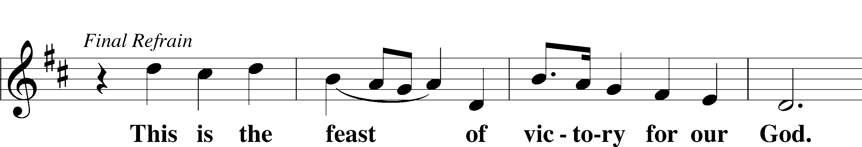
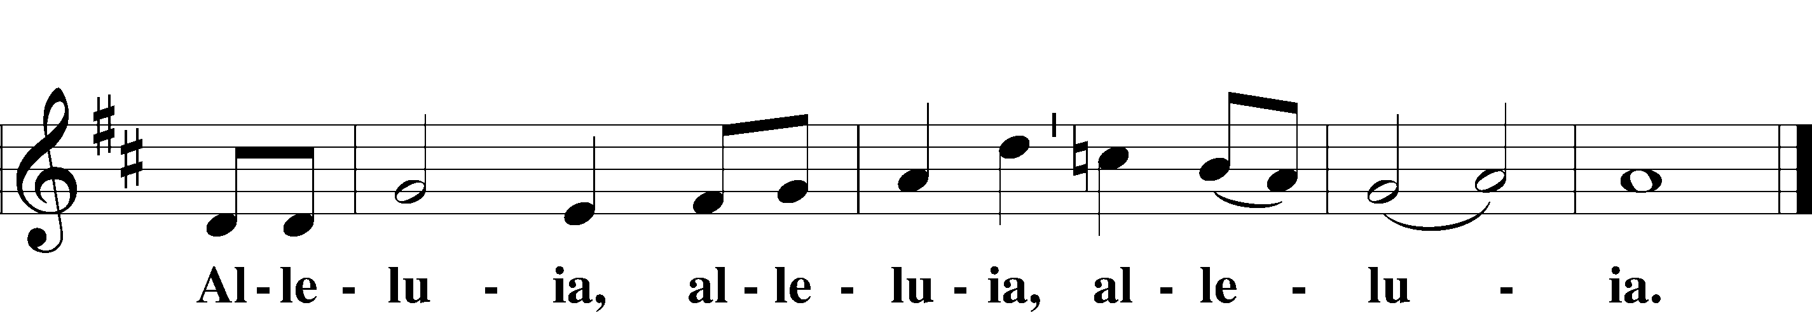
Sit
NARRATION: The Salutation and the Collect
Stand
SALUTATION AND COLLECT OF THE DAY
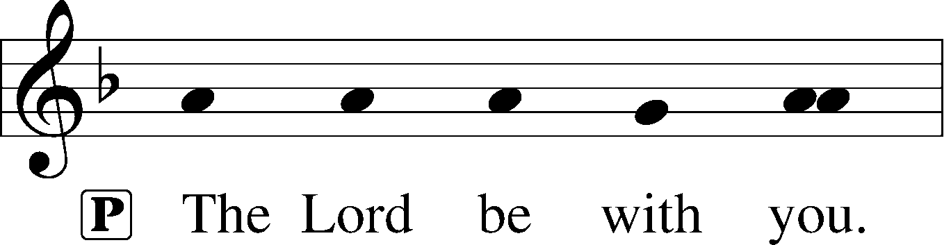
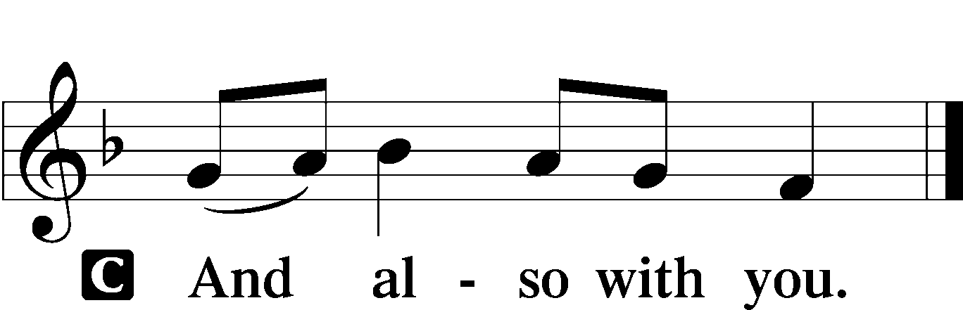

P Let us pray.
Almighty God, You exalted Your Son to the place of all honor and authority. Enlighten our minds by Your Holy Spirit that, confessing Jesus as Lord, we may be led into all truth; through the same Jesus Christ, our Lord, who lives and reigns with You and the Holy Spirit, one God, now and forever.

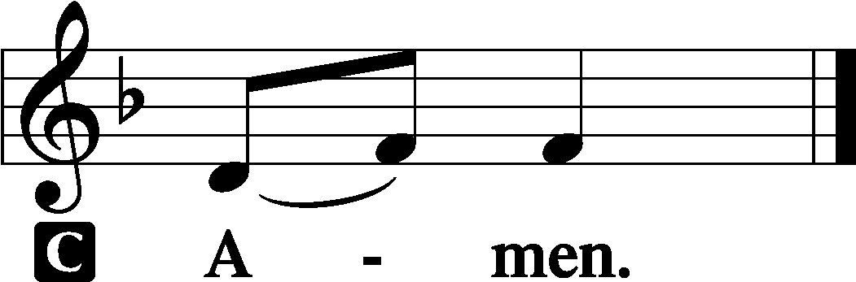

Sit
NARRATION: The Scripture Readings

OLD TESTAMENT READING Ezekiel 18:1–4, 25–32
1The word of the Lord came to me: 2“What do you mean by repeating this proverb concerning the land of Israel, ‘The fathers have eaten sour grapes, and the children’s teeth are set on edge’? 3As I live, declares the Lord God, this proverb shall no more be used by you in Israel. 4Behold, all souls are mine; the soul of the father as well as the soul of the son is mine: the soul who sins shall die. . . .
25“Yet you say, ‘The way of the Lord is not just.’ Hear now, O house of Israel: Is my way not just? Is it not your ways that are not just? 26When a righteous person turns away from his righteousness and does injustice, he shall die for it; for the injustice that he has done he shall die. 27Again, when a wicked person turns away from the wickedness he has committed and does what is just and right, he shall save his life. 28Because he considered and turned away from all the transgressions that he had committed, he shall surely live; he shall not die. 29Yet the house of Israel says, ‘The way of the Lord is not just.’ O house of Israel, are my ways not just? Is it not your ways that are not just?
30“Therefore I will judge you, O house of Israel, every one according to his ways, declares the Lord God. Repent and turn from all your transgressions, lest iniquity be your ruin. 31Cast away from you all the transgressions that you have committed, and make yourselves a new heart and a new spirit! Why will you die, O house of Israel? 32For I have no pleasure in the death of anyone, declares the Lord God; so turn, and live.”

A This is the Word of the Lord.
C Thanks be to God.

GRADUAL
He will command his angels con- | cerning you*
to guard you in | all your ways.
Bless the Lord, | O my soul,*
and all that is within me, bless his | holy name!

EPISTLE Philippians 2:1–4, 14–18
1If there is any encouragement in Christ, any comfort from love, any participation in the Spirit, any affection and sympathy, 2complete my joy by being of the same mind, having the same love, being in full accord and of one mind. 3Do nothing from rivalry or conceit, but in humility count others more significant than yourselves. 4Let each of you look not only to his own interests, but also to the interests of others. . . .
14Do all things without grumbling or questioning, 15that you may be blameless and innocent, children of God without blemish in the midst of a crooked and twisted generation, among whom you shine as lights in the world, 16holding fast to the word of life, so that in the day of Christ I may be proud that I did not run in vain or labor in vain. 17Even if I am to be poured out as a drink offering upon the sacrificial offering of your faith, I am glad and rejoice with you all. 18Likewise you also should be glad and rejoice with me.

A This is the Word of the Lord.
C Thanks be to God.

Stand
ALLELUIA AND VERSE LSB 156
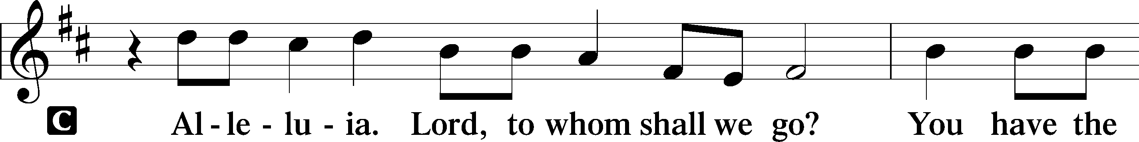
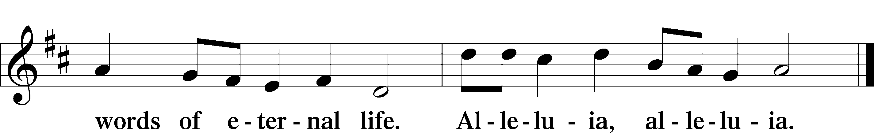

HOLY GOSPEL Matthew 21:23–27
P The Holy Gospel according to St. Matthew, the twenty-first chapter.

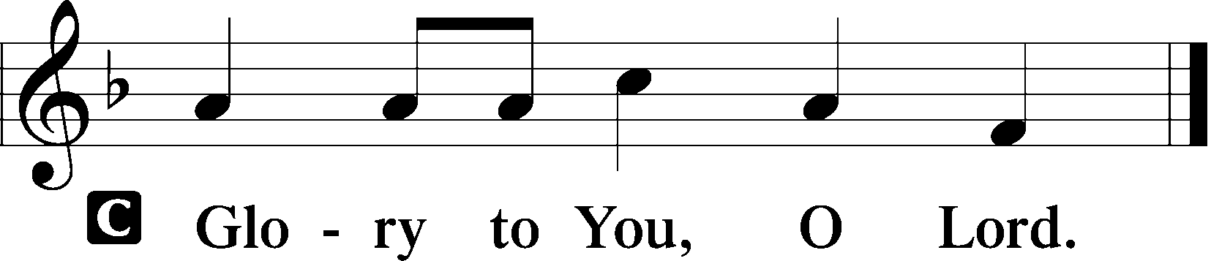

23When [Jesus] entered the temple, the chief priests and the elders of the people came up to him as he was teaching, and said, “By what authority are you doing these things, and who gave you this authority?” 24Jesus answered them, “I also will ask you one question, and if you tell me the answer, then I also will tell you by what authority I do these things. 25The baptism of John, from where did it come? From heaven or from man?” And they discussed it among themselves, saying, “If we say, ‘From heaven,’ he will say to us, ‘Why then did you not believe him?’ 26But if we say, ‘From man,’ we are afraid of the crowd, for they all hold that John was a prophet.” 27So they answered Jesus, “We do not know.” And he said to them, “Neither will I tell you by what authority I do these things.”

P This is the Gospel of the Lord.

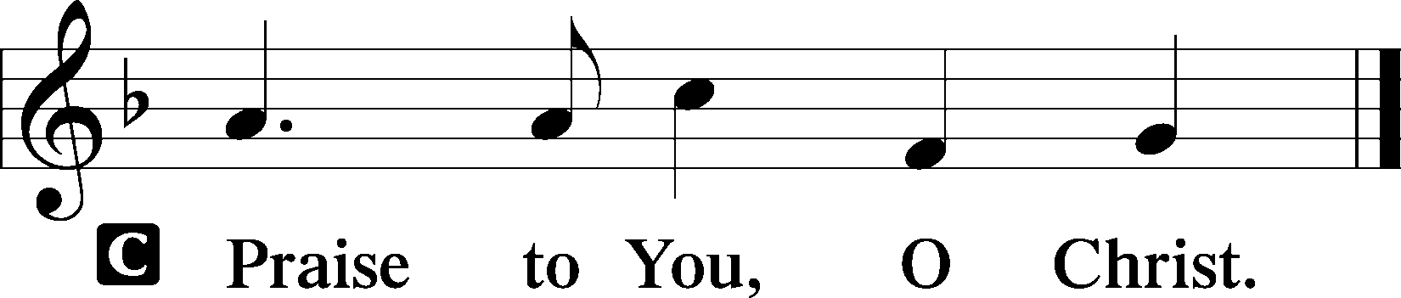

Sit
CHILDREN'S MESSAGE / NARRATION: The Hymns of the Day

HYMN OF THE DAY
655 LORD, KEEP US STEADFAST IN YOUR WORD

1 Lord, keep us steadfast in Your Word;
Curb those who by deceit or sword
Would wrest the kingdom from Your Son
And bring to naught all He has done.

2 Lord Jesus Christ, Your pow’r make known,
For You are Lord of lords alone;
Defend Your holy Church that we
May sing Your praise eternally.

3 O Comforter of priceless worth,
Send peace and unity on earth;
Support us in our final strife
And lead us out of death to life.

NARRATION: Preaching and The Creed

Stand
APOSTLES’ CREED
C I believe in God, the Father Almighty, maker of heaven and earth.

And in Jesus Christ, His only Son, our Lord, who was conceived by the Holy Spirit, born of the virgin Mary, suffered under Pontius Pilate, was crucified, died and was buried. He descended into hell. The third day He rose again from the dead. He ascended into heaven and sits at the right hand of God the Father Almighty. From thence He will come to judge the living and the dead.

I believe in the Holy Spirit, the holy Christian Church, the communion of saints, the forgiveness of sins, the resurrection of the body, and the life T everlasting. Amen.

NARRATION: The Prayers of the Church

PRAYER OF THE CHURCH
After each petition:
P Lord, in Your mercy,
C hear our prayer.

Sit
NARRATION: The Offering and the Offertory

COLLECTION OF TITHES AND OFFERING

Stand
OFFERTORY LSB 159
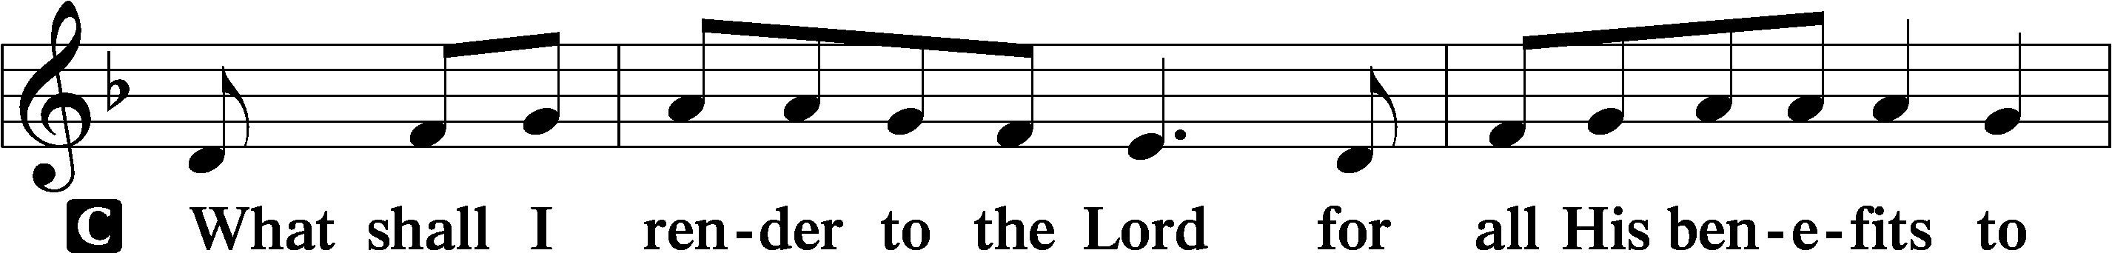
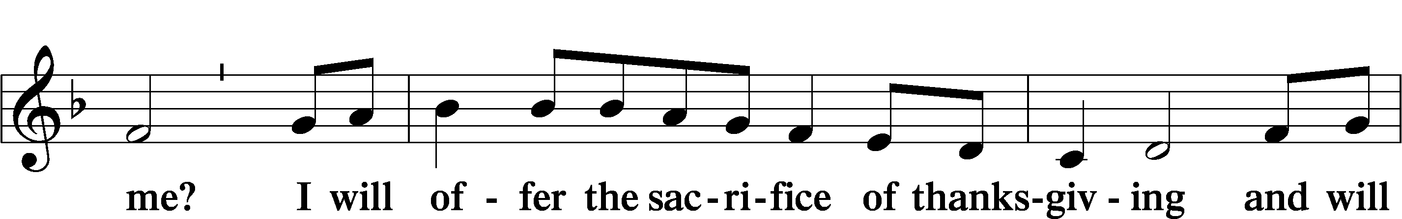
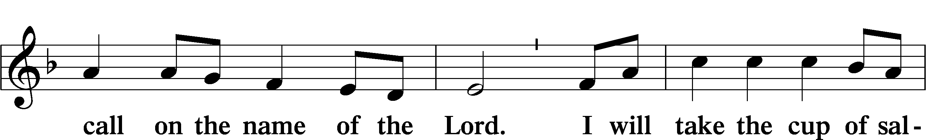
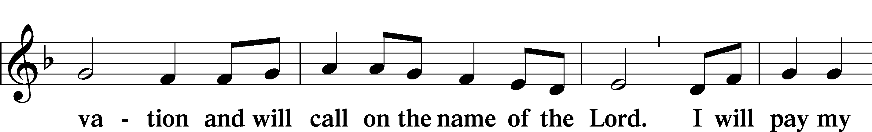
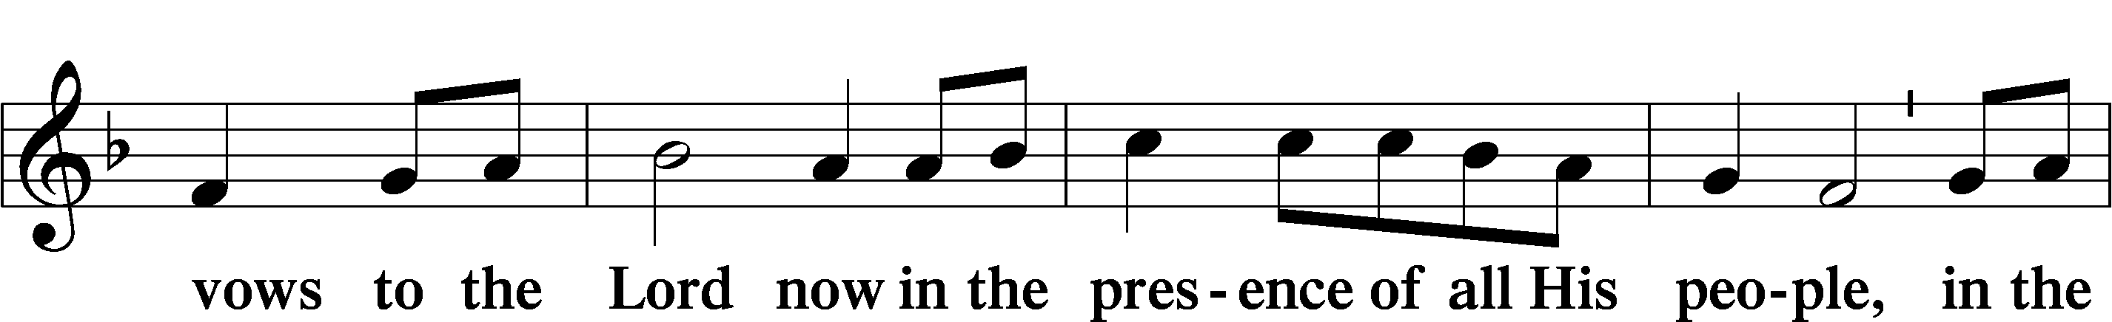
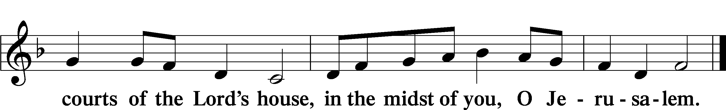

+ Service of the Sacrament +
As God's baptized and forgiven people, we gather at His invitation to receive The Lord's Supper.

The Lord’s Supper is celebrated at this congregation in the confession and glad confidence that, as he says, our Lord gives into our mouths not only bread and wine but His very body and blood to eat and to drink for the forgiveness of sins and to strengthen our union with him and with one another. Our Lord invites to his table those Baptized Christians who trust his words, repent of all sin, and set aside any refusal to forgive and love as he forgives and loves us, that they may show forth his death until he comes.

Because those who eat and drink our Lord’s body and blood unworthily do so to their great harm and because Holy Communion is a confession of the faith which is confessed at this altar, any who are not yet instructed, in doubt, or who hold a confession differing from that of this congregation and The Lutheran Church— Missouri Synod, and yet desire to receive the sacrament, are asked first to speak with the pastor or an elder.

For further study, see Matthew 5:23f.; 10:32f.; 18:15-35; 26:26-29; 1 Cor. 11:17- 34.

Sit
NARRATION: The Preface, Proper Preface, Sanctus, Lord’s Prayer, Words of Institution, Pax Domini, Agnus Dei, and Distribution
Stand
PREFACE LSB 160





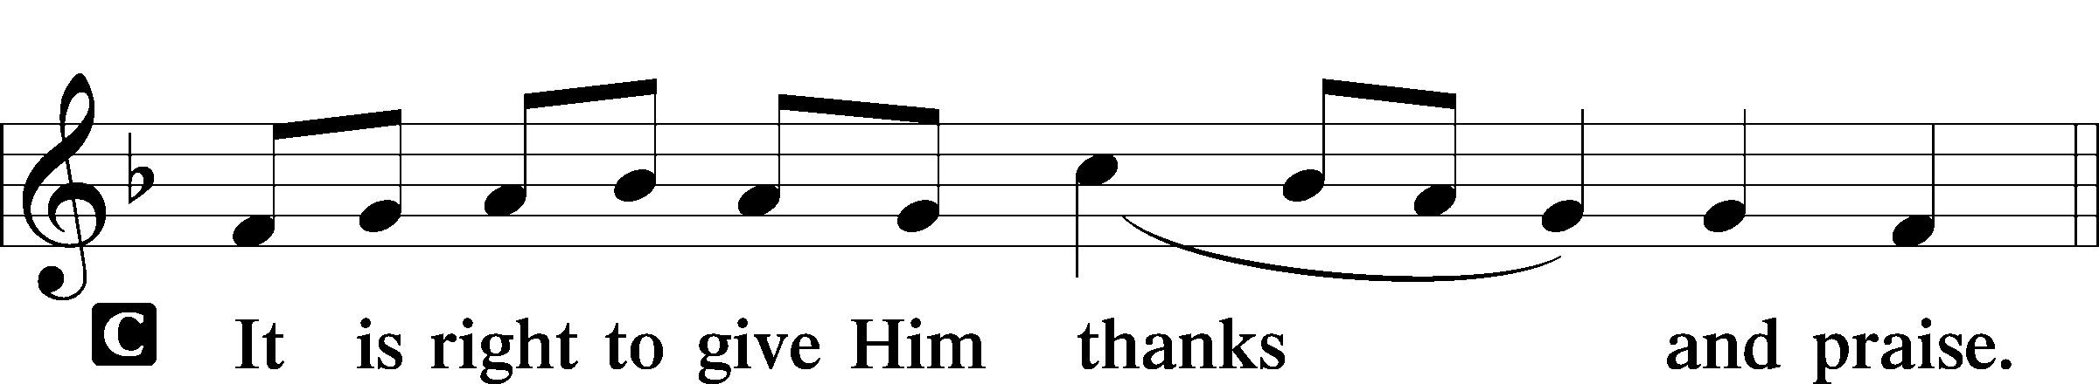

PROPER PREFACE LSB 161
P It is truly good, right, and salutary . . . evermore praising You and saying:

SANCTUS LSB 161
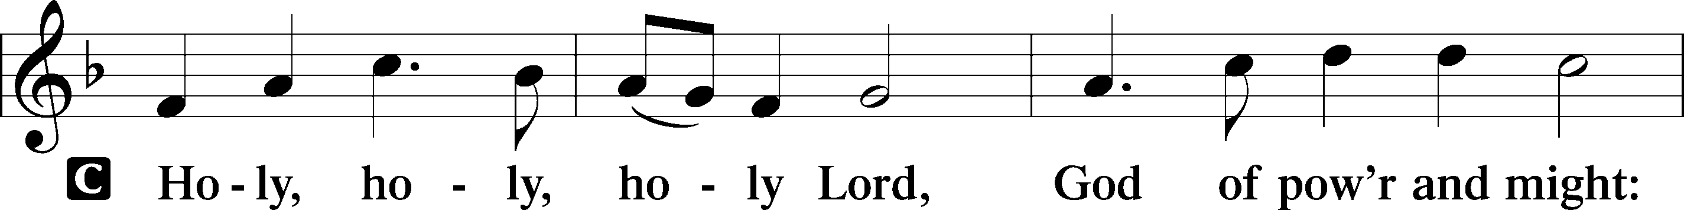
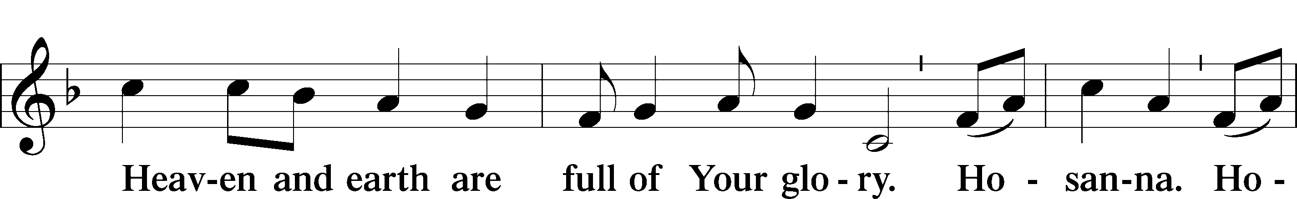
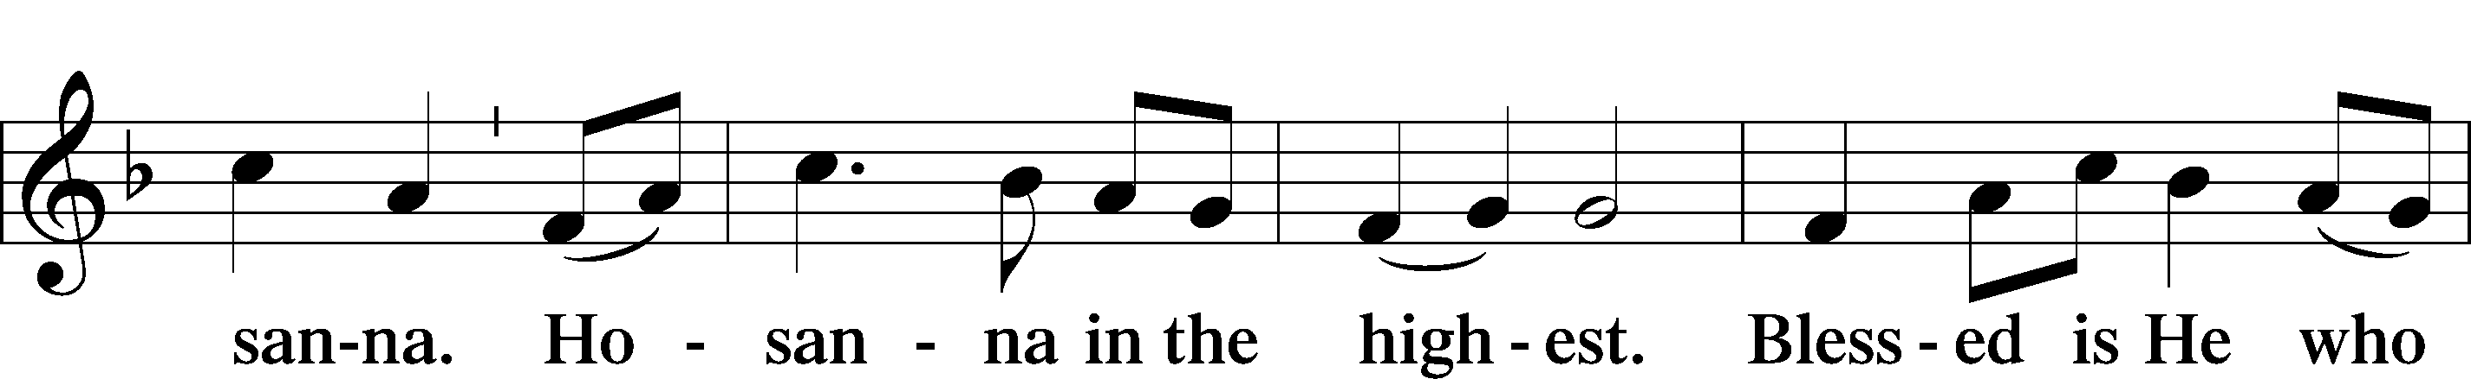
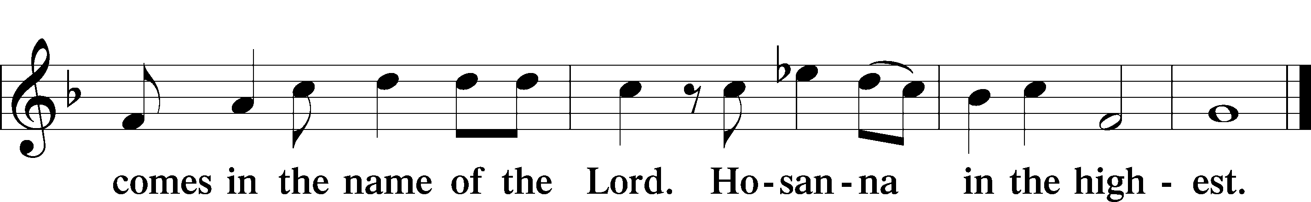

PRAYER OF THANKSGIVING LSB 161
P Blessed are You, Lord of heaven and earth, for You have had mercy on those whom You created and sent Your only-begotten Son into our flesh to bear our sin and be our Savior. With repentant joy we receive the salvation accomplished for us by the all-availing sacrifice of His body and His blood on the cross.

Gathered in the name and the remembrance of Jesus, we beg You, O Lord, to forgive, renew, and strengthen us with Your Word and Spirit. Grant us faithfully to eat His body and drink His blood as He bids us do in His own testament. Gather us together, we pray, from the ends of the earth to celebrate with all the faithful the marriage feast of the Lamb in His kingdom, which has no end. Graciously receive our prayers; deliver and preserve us. To You alone, O Father, be all glory, honor, and worship, with the Son and the Holy Spirit, one God, now and forever.
C Amen.

THE WORDS OF OUR LORD

PROCLAMATION OF CHRIST
P As often as we eat this bread and drink this cup, we proclaim the Lord’s death until He comes.
C Amen. Come, Lord Jesus.

P O Lord Jesus Christ, only Son of the Father, in giving us Your body and blood to eat and to drink, You lead us to remember and confess Your holy cross and passion, Your blessed death, Your rest in the tomb, Your resurrection from the dead, Your ascension into heaven, and Your coming for the final judgment. So remember us in Your kingdom and teach us to pray:

LORD’S PRAYER
C Our Father who art in heaven, hallowed be Thy name, Thy kingdom come, Thy will be done on earth as it is in heaven; give us this day our daily bread; and forgive us our trespasses as we forgive those who trespass against us; and lead us not into temptation, but deliver us from evil. For Thine is the kingdom and the power and the glory forever and ever. Amen.

PAX DOMINI LSB 163
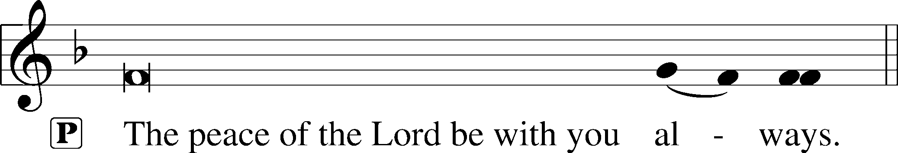


AGNUS DEI LSB 163
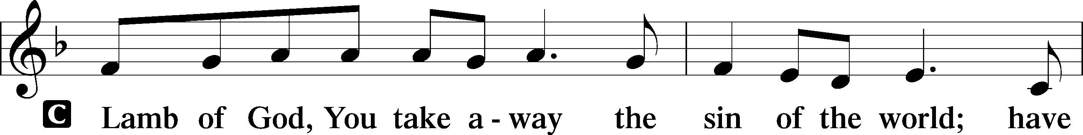
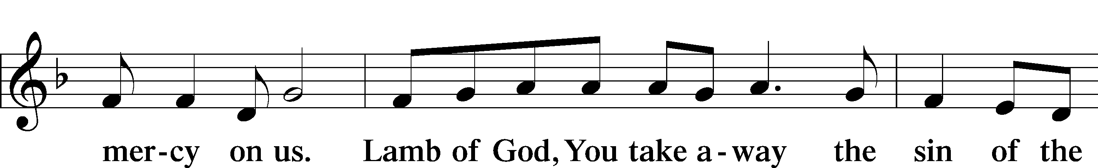
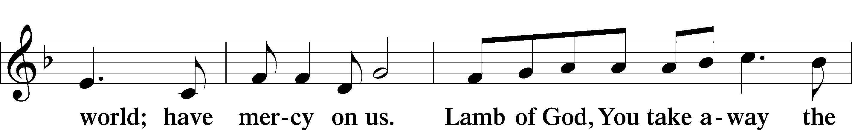
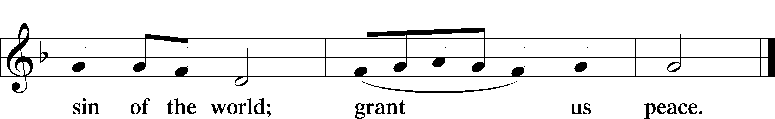

Following the Agnus Dei, please greet one another in the name of the Lord, saying, “Peace be with you,” as a sign of reconciliation and of the unity of the Spirit in the bond of peace (Matt. 5:22–24; Eph. 4:1–3).

Sit

DISTRIBUTION HYMNS
538 PRAISE BE TO CHRIST

1 Praise be to Christ in whom we see
The image of the Father shown,
The firstborn Son revealed and known,
The truth and grace of deity;
Through whom creation came to birth,
Whose fingers set the stars in place,
The unseen pow’rs, and this small earth,
The furthest bounds of time and space.

2 Praise be to Him whose sov’reign sway
And will upholds creation’s plan;
Who is, before all worlds began
And when our world has passed away:
Lord of the Church, its life and head,
Redemption’s price and source and theme,
Alive, the firstborn from the dead,
To reign as all-in-all supreme.

3 Praise be to Him who, Lord Most High,
The fullness of the Godhead shares;
And yet our human nature bears,
Who came as man to bleed and die.
And from His cross there flows our peace
Who chose for us the path He trod,
That so might sins and sorrows cease
And all be reconciled to God.

704 RENEW ME, O ETERNAL LIGHT

1 Renew me, O eternal Light,
And let my heart and soul be bright,
Illumined with the light of grace
That issues from Your holy face.

2 Remove the pow’r of sin from me
And cleanse all my impurity
That I may have the strength and will
Temptations of the flesh to still.

3 Create in me a new heart, Lord,
That gladly I obey Your Word.
Let what You will be my desire,
And with new life my soul inspire.

4 Grant that I only You may love
And seek those things which are above
Till I behold You face to face,
O Light eternal, through Your grace.

532 THE HEAD THAT ONCE WAS CROWNED WITH THORNS

1 The Head that once was crowned with thorns
Is crowned with glory now;
A royal diadem adorns
The mighty Victor’s brow.

2 The highest place that heav’n affords
Is His, is His by right,
The King of kings and Lord of lords,
And heav’n’s eternal Light;

3 The Joy of all who dwell above,
The Joy of all below
To whom He manifests His love
And grants His name to know.

4 To them the cross, with all its shame,
With all its grace, is giv’n;
Their name an everlasting name,
Their joy the joy of heav’n.

5 They suffer with their Lord below,
They reign with Him above,
Their profit and their joy to know
The myst’ry of His love.

6 The cross He bore is life and health,
Though shame and death to Him:
His people’s hope, His people’s wealth,
Their everlasting theme.

Stand
NARRATION: The Dismissal and Post-Communion Collect

DISMISSAL

THANK THE LORD LSB 164
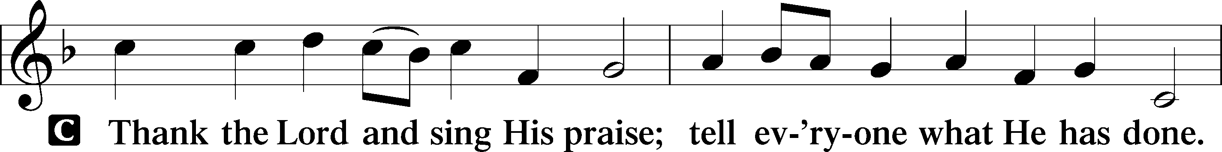
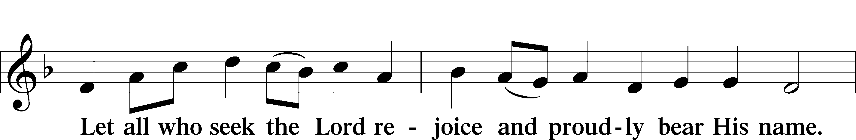
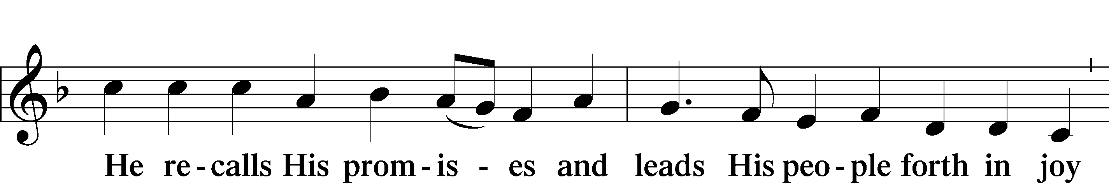
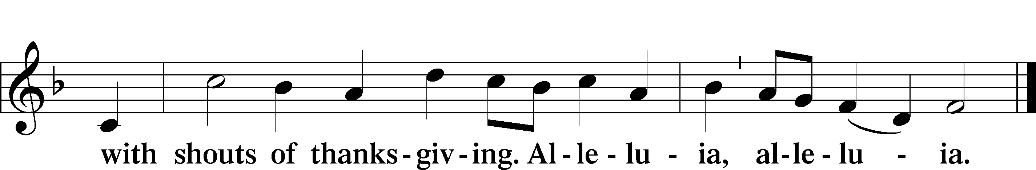

POST-COMMUNION COLLECT

NARRATION: The Benediction

BENEDICTION LSB 166
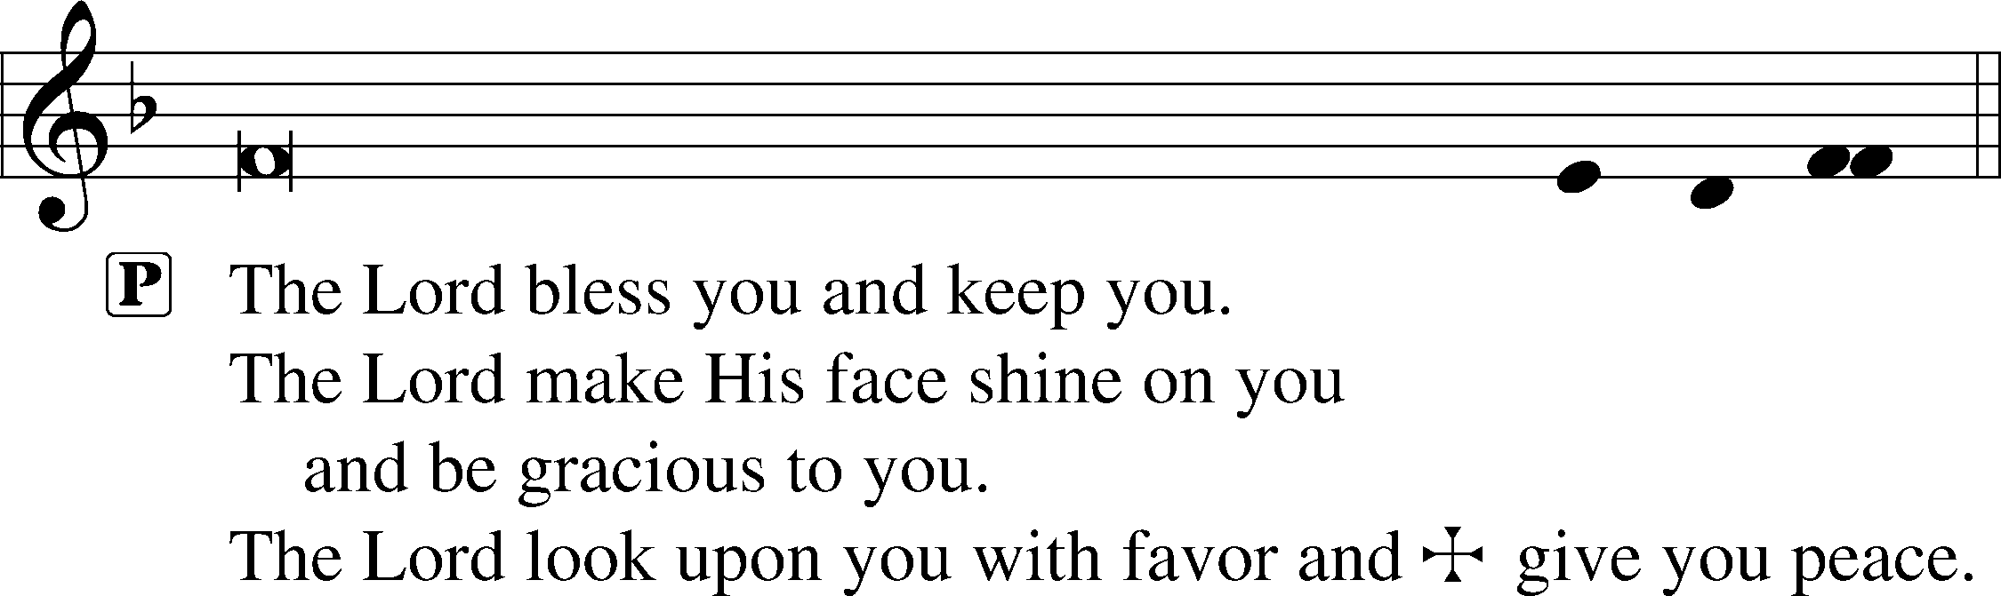


RECESSIONAL HYMN
900 JESUS! NAME OF WONDROUS LOVE

1 Jesus! Name of wondrous love,
Name all other names above,
Unto which must ev’ry knee
Bow in deep humility.

2 Jesus! Name decreed of old,
To the maiden mother told,
Kneeling in her lowly cell,
By the angel Gabriel.

3 Jesus! Name of priceless worth
To the fallen of the earth
For the promise that it gave,
“Jesus shall His people save.”

4 Jesus! Name of mercy mild,
Given to the holy Child
When the cup of human woe
First He tasted here below.

5 Jesus! Only name that’s giv’n
Under all the mighty heav’n
Whereby those to sin enslaved
Burst their fetters and are saved.

6 Jesus! Name of wondrous love,
Human name of God above;
Pleading only this, we flee
Helpless, O our God, to Thee.

ANNOUNCEMENTS
See announcements on the back of the bulletin.

SENDING
P Let us pray.
Lord God, You have called Your servants to ventures of which we cannot see the ending, by paths as yet untrodden, through perils unknown. Give us faith to go out with good courage, not knowing where we go but only that Your hand is leading us and Your love supporting us; through Jesus Christ, our Lord.
C Amen

P Go in peace to serve the Lord.
C Thanks be to God.

THIS WEEK AT FAITH

Sunday Sept. 27 Bible Study 8:30am
Fellowship 9:30am
Worship 10:00am
Mon-Fri Sept. 28- Oct 2 Chapel 8:30am
Tuesday Sept. 29 Create in Me Crafting 10:00am
Wednesday Sept. 30 Dinner 5:30pm
Adult Bible Studies 6:30pm
Confirmation & Youth Group
Saturday Oct 3 LWML Zone Rally 9:00-2pm
Men’s Breakfast 8:00am
East Cobber Festival 11:00-2pm
Sunday Oct 4 Bible Studies 8:30am
Fellowship 9:30am
Worship 10:00am

CHURCH ANNOUNCEMENTS

PRIVATE CONFESSION AND ABSOLUTION - available Monday-Thursday 4:30-5:30pm
In the Church, God daily and richly forgives our sins. This forgiveness (absolution) is a gift we receive in worship each week. It is also available to you personally to comfort you with Christ's victory in the battle against sin and the devil. Whether you are particularly troubled by sin, or simply desire to receive the absolution personally, you are welcomed. Appointments are preferred so Pastor can set aside dedicated time for you.

STAYING CONNECTED: OUR COMMUNICATION UPDATES
We are streamlining our communication processes to help everyone stay connected and updated with church news, events, and ministries! Please keep an eye on our weekly newsletter for immediate news about that week, and check our monthly newsletter for a broader look at that month and the months to come. You can also continue to use our weekly printed bulletin for core information, or visit our website anytime for a full library of resources. We are here to serve you, so please let us know how we can assist you!

LWML ZONE RALLY – Saturday, Oct 3, 9-2:00 pm
Donate small or medium teddy bears with sewn eyes to the LWML Gifts from the Heart drive, supporting children in crisis. Drop them off in the LWML room or bring them to the Zone Rally on October 3, 2026. RSVP to Louise Cox at 478-957-7332 and find details at faithmarietta.com/lwml

EAST COBBER FESTIVAL - Saturday October 3, 11:00am – 2:00pm
Faith Lutheran Church & School will have a booth at the upcoming East Cobber Festival! Stop by and visit us in the north parking lot of Johnson Ferry Baptist Church (955 Johnson Ferry Road). If you would like to volunteer to greet attendees at our booth, please reach out to Steven Bass.

MEN’S BREAKFAST – Saturday October 3, 8:00am-9:30am

Men, please join us for our monthly study and Breakfast. This month we meet at Morning Shift (745 Chastain Rd. NW, Kennesaw, GA 30144). You can scan the QR code to RSVP.
For questions or more details contact Jon Cain 678.472.5226

FAITH SCHOOL PRAYERS - October 13, 9:00am
The School Prayer group meets the 2nd Tuesday of the month at 9:00am in the craft room. Dates are Oct 13th, Nov 10th, Dec 8th. Call or text Norma Palmer at (256-653-8349) for more information.

WEDNESDAY NIGHTS ARE BACK - Family dinner at 5:30pm, programming at 6:30-8
Wednesday Nights start with a family dinner at 5:30, followed by programming for all ages (confirmation, youth group, Bible studies, choir, and handbells). The menu for September 30th: Pizza, salad, fruit and brownies.

NEW MEMBER CLASS (Adult Confirmation) – Begin in the Sanctuary Sunday, October 4, 11:30am
This 6-week class will focus on the Doctrine of the Christian Church as taught in Luther's Small Catechism. This is required for those who are not currently members of a congregation of the Lutheran Church – Missouri Synod (LCMS). Contact Pastor Shaun to be added to the class.

CHURCH DIRECTORY PHOTOS & MAKEUP DAY – Sunday, October 18, after worship
Faith school's photographer will take free church directory portraits for all members. View samples of her work at ginacellino.shootproof.com. Optional personal prints (from $13) and digital packages (from $35) will be available for purchase.

LUTHERAN COALITION FOR HABITAT - BUILD PROJECT
Volunteer in Austell, GA with the Lutheran Coalition for Habitat on Saturdays (7:45am – 4pm). Schedule: exterior paint (10/10), interior prep/trim (10/17), painting/trim (10/31), paint/punchout (11/7), and landscaping (11/14). Contact Laura Elston at laura.elston2@gmail.com to sign up.


REFORMATION FESTIVAL - October 30, 5:00-7:00pm
Mark your calendars! Reformation Festival will feature a Trunk-or-Treat and the signup is live! Scan the QR code be directed to the website where you can read about the festival and sign up to reform your trunk!

FAITH LUTHERAN NEW MEMBER ORIENTATION - Sunday November 15, 11:30am
Orientation is a 1-week introduction to Faith for those transferring AND for those who have just finished Adult Confirmation. Please Contact Pastor Shaun to be added to the class. November 22 new members will be formally received during Worship with a Welcoming Luncheon afterwards.

YOUTH MUSICIANS - Share your musical talents during worship by preparing a 3–5-minute classical or Christian piece for pre-service or offertory. Bring your own instrument, or use a provided keyboard. Young pianists interested in playing the organ will receive training and practice time. All music choices will be reviewed by Pastor Shaun - contact him today to sign up and make a joyful noise!

ONE FAITH:
Family Devotions for the Week of September 27, 2026
THEME: Rooted in Christ through Prayer
by Pastor Shaun
Scan to View
Devotions ONLINE

“Do not be anxious about anything, but in everything by prayer and supplication with thanksgiving let your requests be made known to God. And the peace of God, which surpasses all understanding, will guard your hearts and your minds in Christ Jesus. (Philippians 4:6-7 ESV)

DEVOTION:
The Holy Spirit is constantly a work in our lives, re-ordering our way of thinking through the Scriptures and the practices of the Christian life. Proper prayer, as taught by our Lord on the pages of the Bible, embodies this re-ordered life.

By nature we are constantly seeking to manage the circumstances of life. We do so by way of our own supposed wisdom, power and strength. But when challenging circumstances prevail against us, anxiety arises. Anxious worry is the expression of our desire to manage and control our circumstances, together with the fear (or realization) that we will eventually fail in this.

Here’s a simple example: I want my sons to learn to drive safely. I can contribute my own wisdom to this process, teaching them the skills and habits of a good driver. But then I realize that I cannot control other drivers. Nor can I be certain that my sons will always follow the wisdom that I have given them. I want to control this situation. But I can’t. So I worry. In worry, I add all sorts of potentially catastrophic outcomes to this situation. What if a distracted driver does something dangerous and foolish? What if my son is in a car accident? What if, what if, what if…?

You see where all this goes? We want to manage and control the circumstances of our lives. We want to maximize safety and well-being and success. But we can’t, and that makes us anxious. And anxiety is the enemy of peace.

But prayer, as taught by our Lord and his servants, re-orders our way of thinking about things that are beyond our control. In his explanation of the Introduction to the Lord’s Prayer, Luther writes that when He teaches us to pray, Our Father in Heaven, “God tenderly invites us to believe that He is our true Father and that we are His true children, so that with all boldness and confidence we may ask Him as dear children ask their dear father.”

To say that God Almighty is our Father who loves us, His Children, is a bold confession. He, who has all things in His hands, holds our life and our future. It is not by our own wisdom, power or strength that good comes to us. Instead, it is by God’s wisdom, power and strength.

Challenging circumstances, even tragedies, will still come against us in our lives. But when they do, we endure them in peace and hope rather than being consumed by anxiety. We are not in control, but God, who loves us IS in control. And He has promised us, life and salvation that lasts forever, through Christ. So then, we are to be anxious about NOTHING. As we face these challenging circumstances, we pray, and entrust our lives into the hands of our dear Father. And the result is peace, in all things.

Amen!
CATECHISM MEMORY:
The Seventh Commandment You shall not steal.
What does this mean? We should fear and love God so that we do not take our neighbor’s money or possessions, or get them in any dishonest way, but help him to improve and protect his possessions and income.
READINGS for THIS WEEK:
Mon: Matthew 6:5-13 Tue: Philippians 1 Wed: Philippians 2 Thu: Philippians 3 Fri: Philippians 4 Sat: Matthew 21:33-46

REFLECTION QUESTIONS & ACTIVITIES for the READINGS
- What do the readings teach you about God’s love and kindness in your life?
- How does prayer re-order your thinking about life?
- Where are you tempted to rely on your own wisdom, power, and strength, instead of God’s?
- What questions do you have about the readings this week?
(Write them down and share them with Pastor Shaun!)
Prayers for the Week
Let my prayer rise before You as incense…” - Psalm 141:2 Following the instruction of God's Word, we lift our hearts and hands in prayer. As a priesthood of believers called to bear one another’s burdens, we bring our petitions before our heavenly Father.

Please join us in interceding for: Ruth Trinklein (successful surgery on fractured ankle); MaryLou (recovery from injuries after car accident); Elizabeth (recovery following surgery); Debby Lenord (peace, protection, guidance) //Sandy Skrbanek’s sister; Judy Hamilton (recover from shoulder surgery) // Carol Seelman’s sister-in-law; Sandy (complications from chemotherapy) // friend of Schleichers; Paula Gronemeyer (recovery from stroke, restoration of vision); Makenna (guidance, faith and Christian fellowship); LaJaun (mercy, faith, and wise decision making for her family members); Heidi Fletcher’s mother (recovery following stroke and fall); Nathan (relief and treatment for bulging disc in back) // Jill Musgrove’s son; Allie and her baby (high-risk pregnancy) // sister of Roby Hamilton; Viva Kirk (health and employment); Thanksgiving for the birth of Finnegan to Brittain and Josh Rebuck; Thanksgiving for Shirley’s move to a rehabilitation center // Greg Schaag’s aunt; Janice Schaag (health and peace following diagnosis of a hereditary condition); Steve and his family as he nears the end of his life // father of Phil Manginelli (Phil is Ward’s & Susan’s son-in-law); Brennan Lambert (a quick recovery from jaw surgery); Audrey and Thomas (provision for their needs of body and soul, following a house fire); family of Henshaws; Alex (protection during deployment, safe return to family in October) and his wife, Amanda, and children William, Aurora, & Olivia; Thanksgiving for medical and spiritual care for Tracy Woolery following his recent surgery; Ruth Brown as she mourns the death of her husband // friend of Sandy Skrybanek; Darrell Weers (lost his battle with Parkinson’s disease) // brother of George Weers; Thanksgiving for our flourish Youth Group; Beth (suffering from an illness), and her husband Matthew as he cares for her and their children // Marylou’s son; Andrew Hirschler (hospitalization) // former member, friend of Pietros; Caroline O’Neal (cancer); Ramona (recovery from surgery, peace) and her husband John, and children // sister of Rosina Sawh; Gary Griffin (cancer treatment and gallbladder infection) and his wife, Karen // former members, friends of Lamberts; Thanksgiving for progress in recovery for GanneElyse and for the joy of seeing her in worship!; Kyle Laurendine (diagnosed with brain tumor); Thanksgiving for the birth of Charlotte Ross Webb to Ciji Parrish and Craig Webb

ONGOING
For faith and salvation for those who are not yet believers; and repentance for those who have strayed from the faith (especially Jonathan, Bethany, Ean, Bud, Roger, Connor Brett, Mike, Brad, Joel, Ben, Regan, Adam, Corinne, Ana, Samantha, Victoria, Jason, Mike, Josh, Dan, Lisa, Steve, Jessica, Daniel, Hannah, Destiny, Nate, Carol, a member’s brother and sisters, Ben, Bill, Mary, Jack and Jason; along with those others we hold in our heart.); For those who mourn (the families of Joyce Elston, Steven Erny, Jewley Del Duca, and Tom Olson); For members of the Armed Forces of the United States, who protect and defend us (Alex & Brett) ; For our Staff: Pastor Shaun, Headmaster Bradshaw, and all the staff and leaders of Faith Lutheran Church and School (for Godly vision and stewardship; and that the Gospel would be faithfully proclaimed in church and school.); For our Missionaries: Rev. Chris and Dr. Jenny Yang, missionaries to Taiwan; For the families and youth of Faith Lutheran Church & School (that God would grant them steadfast, vibrant faith); For our confirmation students (Daniel, Lily, Zach, Madeline, Isabelle, and Melanie); For more students at Faith Lutheran School, according to God’s will; For faithful leaders of our state and nation.



