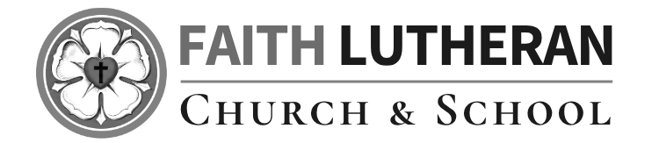

Seventeenth Sunday After Pentecost
September 20, 2026
OUR MISSION: Connecting People to Jesus

Contact us
Faith Lutheran Church & School 2111 Lower Roswell Rd, Marietta, GA 30068 | 770-973-8877

CHURCH: www.faithmarietta.com SCHOOL: www.faithmarietta.org
Rev. Shaun Daugherty, Pastor Mr. Chris Bradshaw, Headmaster
pastor.shaun@faithmarietta.org chris.bradshaw@faithmarietta.org
470-289-9469 470-641-6239
See the full leadership directory: www.faithmarietta.com/leadership
Serving This Month at Faith
 | 9/6/2026 | 9/13/2026 | 9/20/2026 | 9/27/2026
Musicians | Vaunda Noerenberg | Vaunda Noerenberg | Ben Nye | Vaunda Noerenberg
Elders | Ward Irvin  Vinny Caracci | Steve Buchtrup  Greg Sinatra | Vinny Caracci  Ward Irvin | Steve Buchtrup  Woody Wood
Reader | David Barnett | Amy Meyer | Jon Wareham | Stacy Sinatra
Ushers | Greg Czerwonka  Matthew Czerwonka  Jacob Czerwonka  Luke Czerwonka  Sam Czerwonka | Steve Buchtrup  Mark Patterson  Gary Schleicher  Reagan Gronsbell  Paris Brown | Kim Kaumeyer  David Barnett  Greg Sinatra | Chris Bradshaw  Herman Dean  Bryan Powell  Christian Campbell
Acolytes | Adam Cain  Amadeo Brown | Josiah Brown  Alex Bradshaw | Andrew Linsey  Christian Brown | Amadeo Brown  Adam Cain



For your convenience, we now accept gifts
Pay Pal
via Venmo or PayPal.

Our Discipleship
Date | 9/6 | 9/13 | 9/20 |  | Budget Summary (August)
Worship | 137/121 | 148/133 | - |  | Avg. Worship | 155
Sunday School | 36 | 48 | - |  | Avg. SS | 25
Gen. Giving | $10,320 | $21,963 | - |  | Gen. Giving | $61,945
MTD Giving | $10,320 | $32,283 | - |  | Budgeted Giving | $42,400
Monthly Budget | $44,600 | $44,600 | $44,600 |  | Over (Under) | $19,545

FAITH GROWS is our debt reduction account, geared towards eliminating our mortgage.
Please prayerfully consider donating to this fund - over and beyond your normal tithe.

August Debt Reduction | $2,333 | Remaining Mortgage Debt | $2,678,311
ALTAR FLOWERS Dedicated today in honor of Susan Kilpinen, my grandmother who passed in 2017. Wife of Jon Kilpinen, Mother of Jennifer Kilpinen, and Grandmother of Jared Oakley. Was an active member of the Lutheran Church Missouri Synagogue & LWML, Taught Sunday School & Bible Studies.

+ Confession and Absolution +
We enter the presence of God by humbly confessing our sins and gladly receiving His forgiveness.

Stand

PROCESSIONAL HYMN

720 WE WALK BY FAITH AND NOT BY SIGHT

1 We walk by faith and not by sight,
No gracious words we hear
From Him who spoke as none e’er spoke,
But we believe Him near.

2 We may not touch His hands and side,
Nor follow where He trod;
But in His promise we rejoice
And cry “My Lord and God!”

3 Help then, O Lord, our unbelief;
And may our faith abound
To call on You when You are near
And seek where You are found.

4 For You, O resurrected Lord,
Are found in means divine:
Beneath the water and the Word,
Beneath the bread and wine.

5 Lord, when our life of faith is done,
In realms of clearer light
We may behold You as You are,
With full and endless sight.

The sign of the cross may be made by all in remembrance of their Baptism.

INVOCATION
P In the name of the Father and of the T Son and of the Holy Spirit.
C Amen.

P If we say we have no sin, we deceive ourselves, and the truth is not in us.
C But if we confess our sins, God, who is faithful and just, will forgive our sins and cleanse us from all unrighteousness.

Silence for reflection on God’s Word and for self-examination.

CONFESSION AND ABSOLUTION LSB 151
P Let us then confess our sins to God our Father.
C Most merciful God, we confess that we are by nature sinful and unclean. We have sinned against You in thought, word, and deed, by what we have done and by what we have left undone. We have not loved You with our whole heart; we have not loved our neighbors as ourselves. We justly deserve Your present and eternal punishment. For the sake of Your Son, Jesus Christ, have mercy on us. Forgive us, renew us, and lead us, so that we may delight in Your will and walk in Your ways to the glory of Your holy name. Amen.

P Almighty God in His mercy has given His Son to die for you and for His sake forgives you all your sins. As a called and ordained servant of Christ, and by His authority, I therefore forgive you all your sins in the name of the Father and of the T Son and of the Holy Spirit.
C Amen.

Stand
+ Service of the Word +
Having received God's forgiveness, we come before Him with songs of praise, eager to hear His Word.
INTROIT

I will offer to you the sacrifice of thanks- | giving*
and call on the name | of the Lord.
What shall I render | to the Lord*
for all his bene- | fits to me?
I will lift up the cup of sal- | vation*
and call on the name | of the Lord.
Precious in the sight | of the Lord*
is the death | of his saints.
O Lord, I am your | servant;*
I am your servant, the son of your maidservant. You have | loosed my bonds.
Glory be to the Father and | to the Son*
and to the Holy | Spirit;
as it was in the be- | ginning,*
is now, and will be forever. | Amen.
I will offer to you the sacrifice of thanks- | giving*
and call on the name | of the Lord.

KYRIE LSB 152

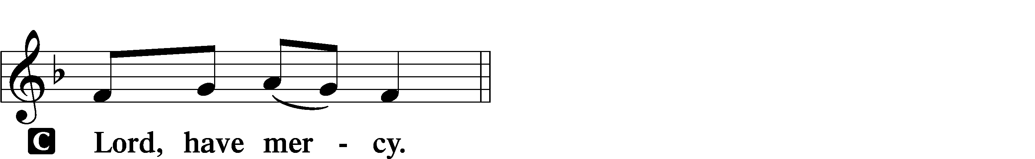
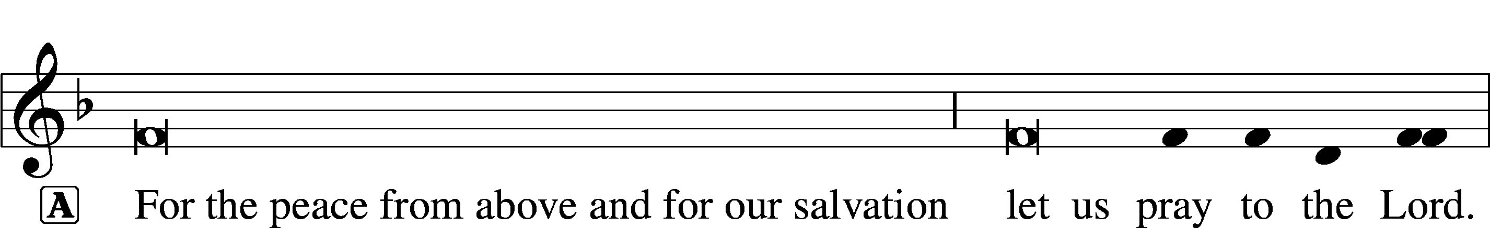
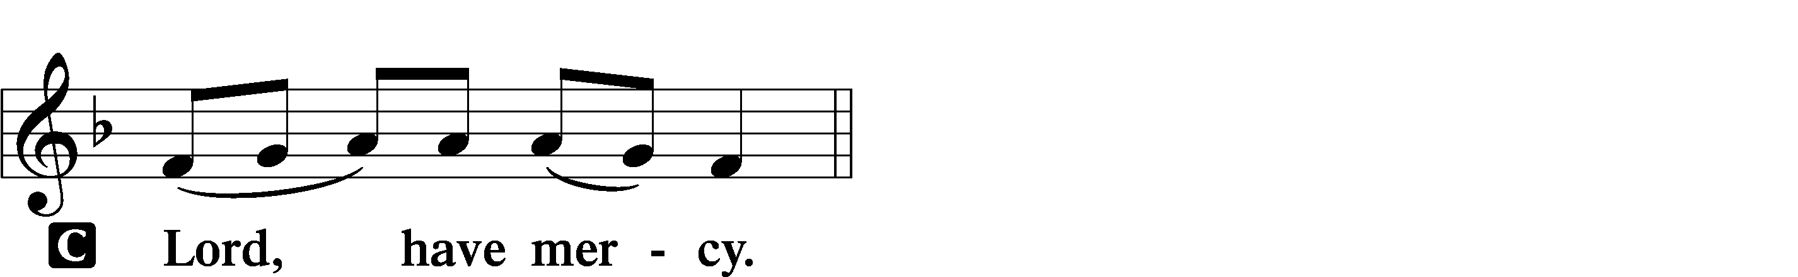
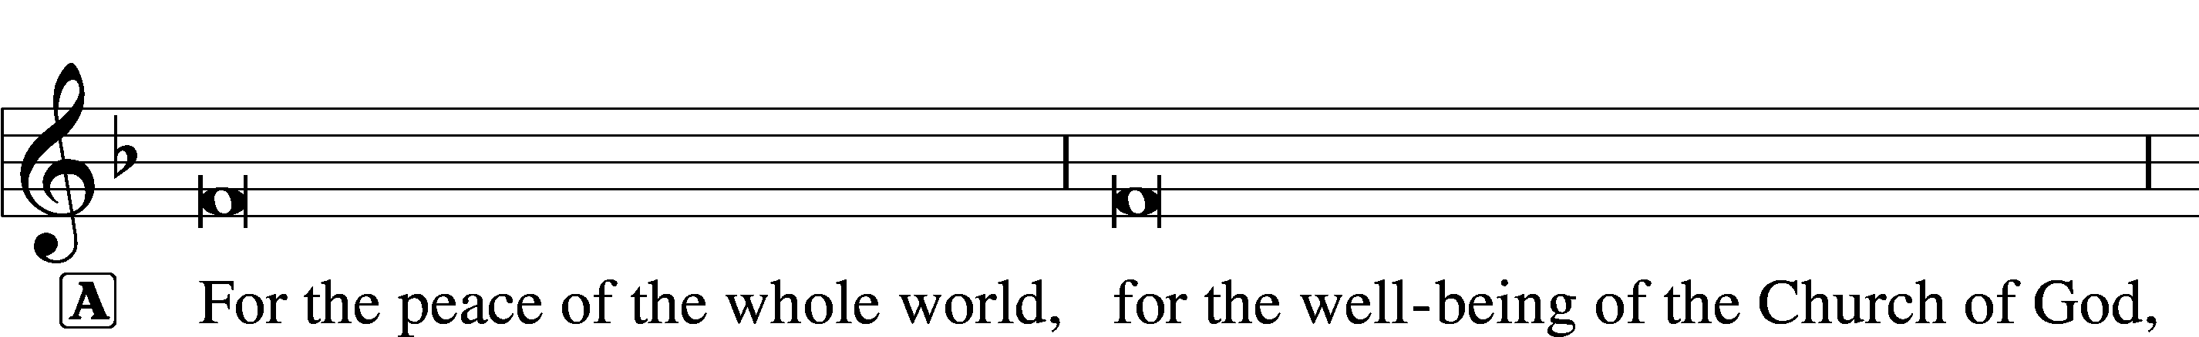

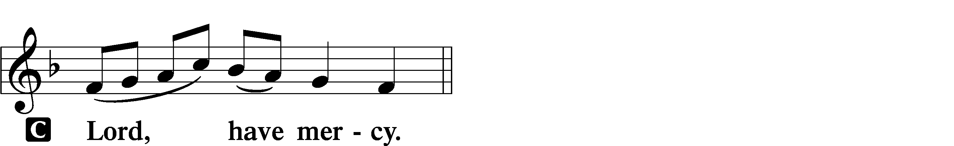

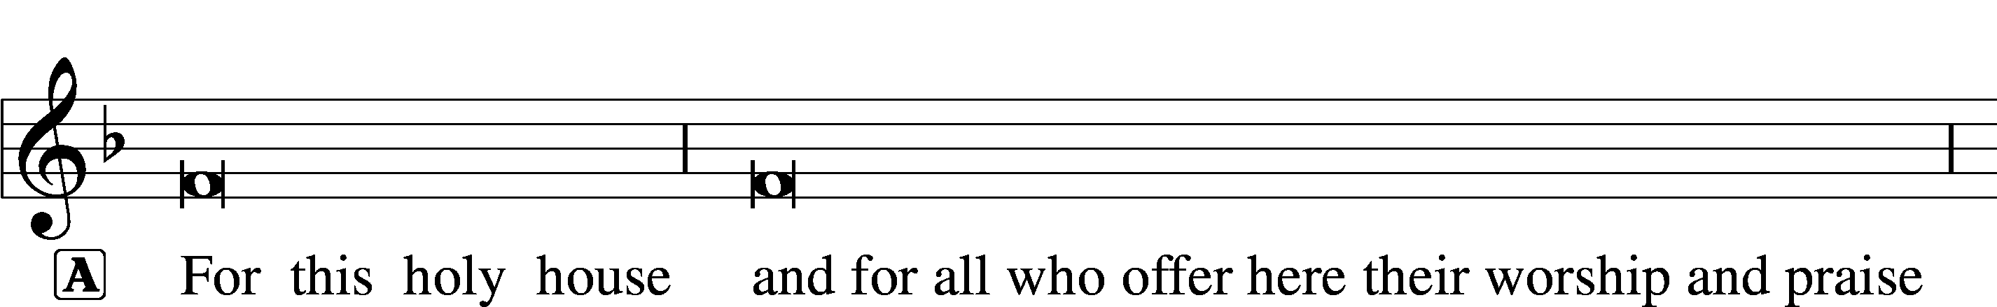

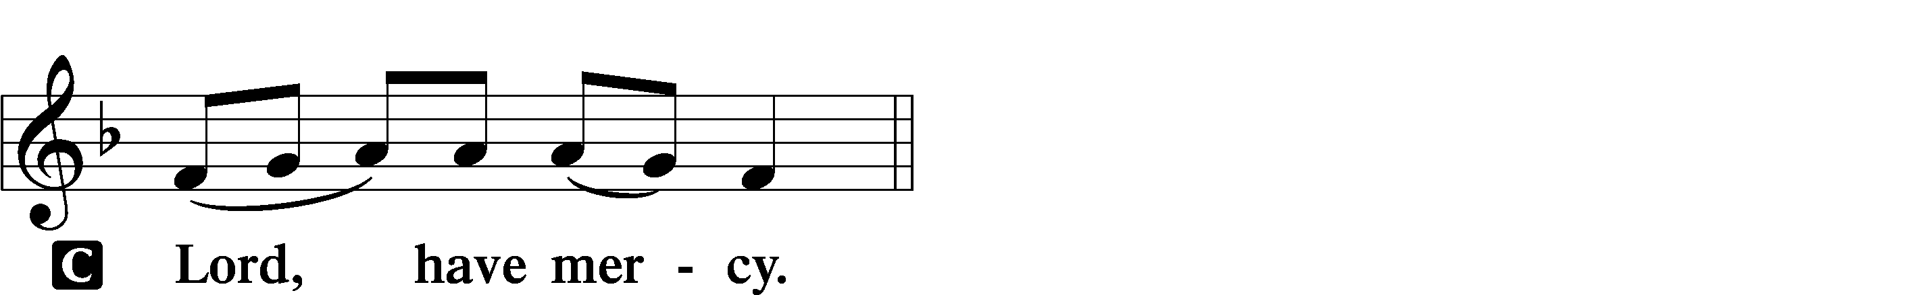




THIS IS THE FEAST LSB 155
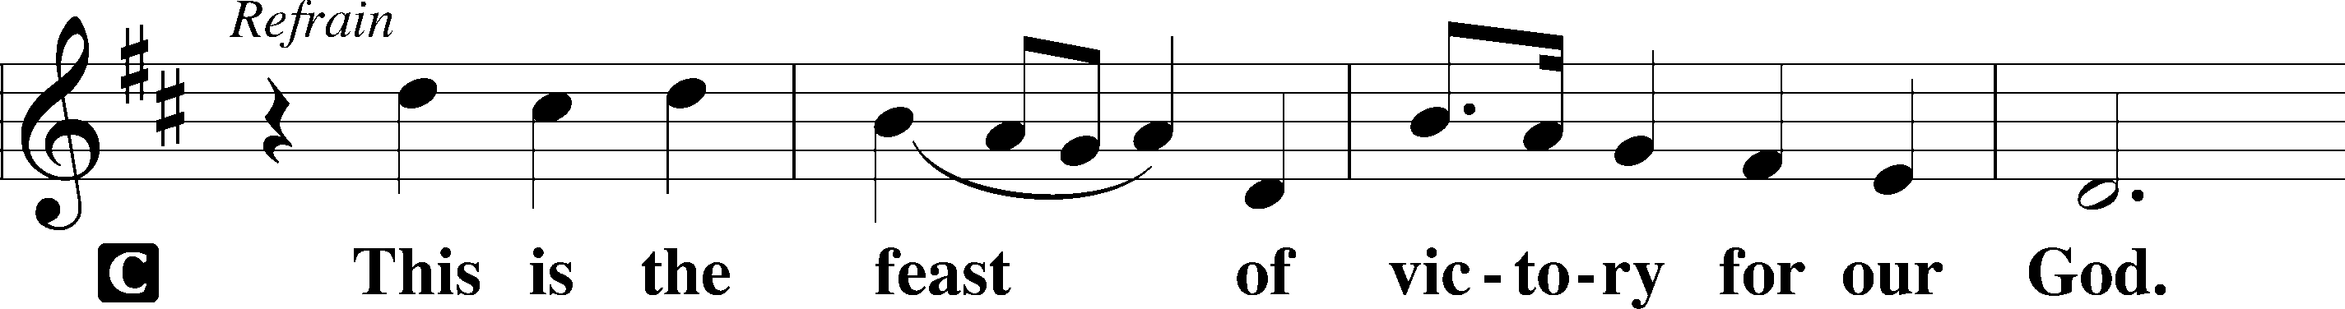
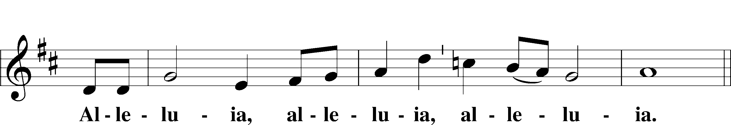
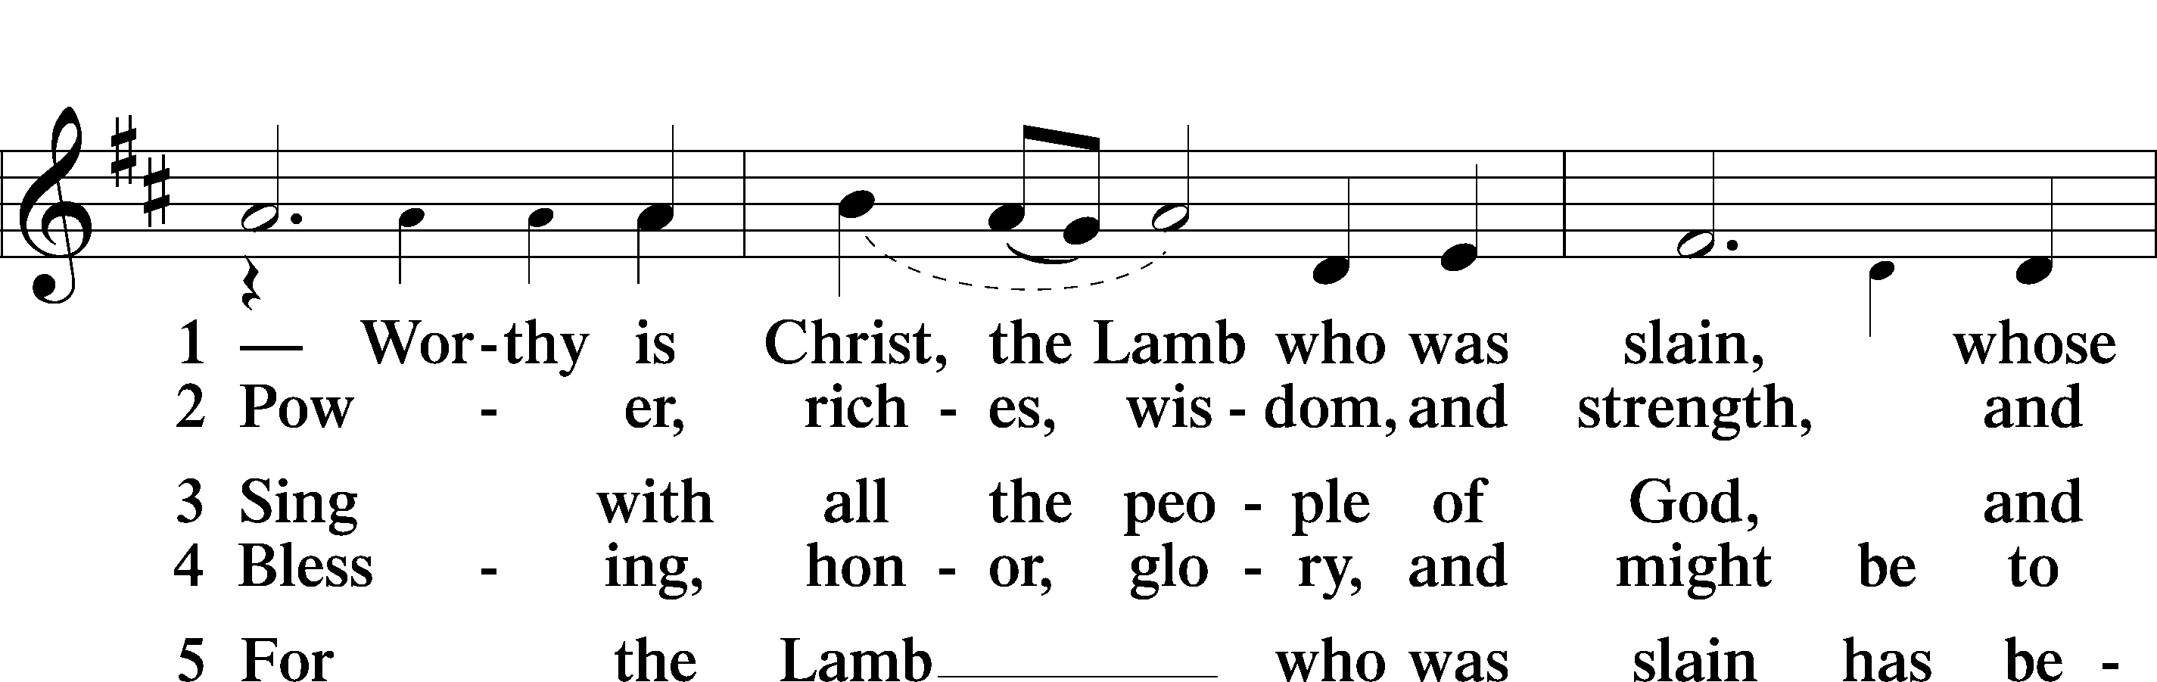
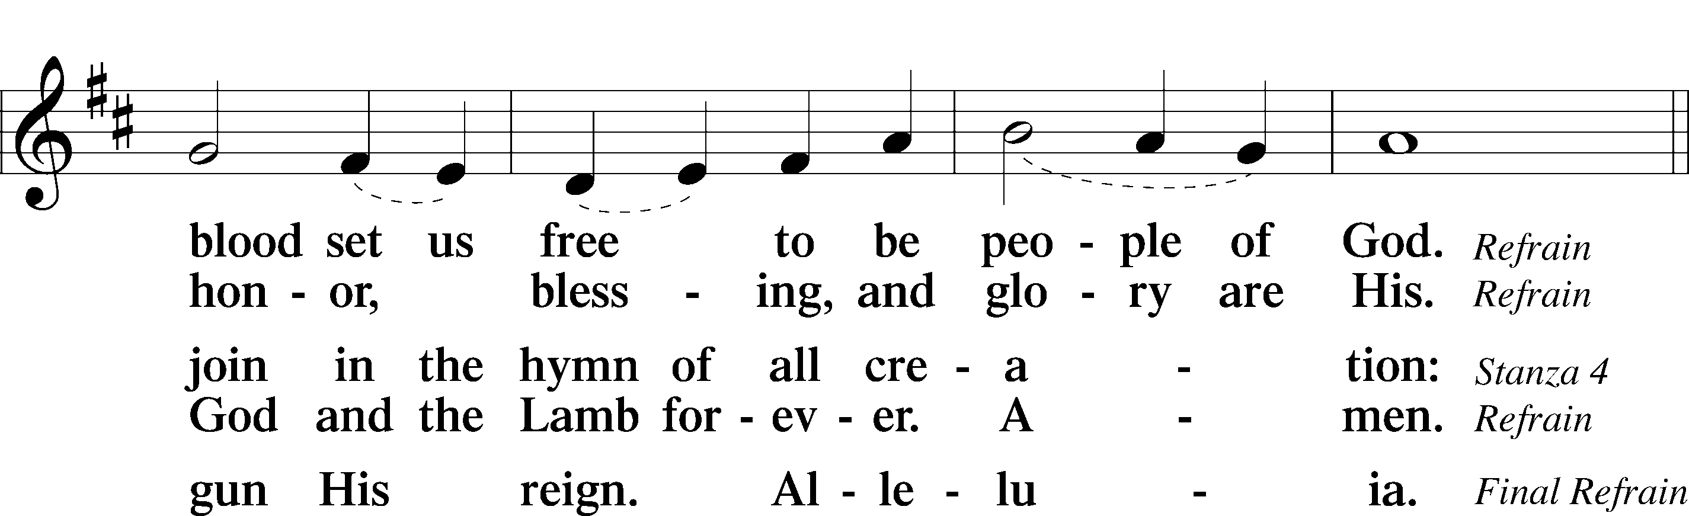
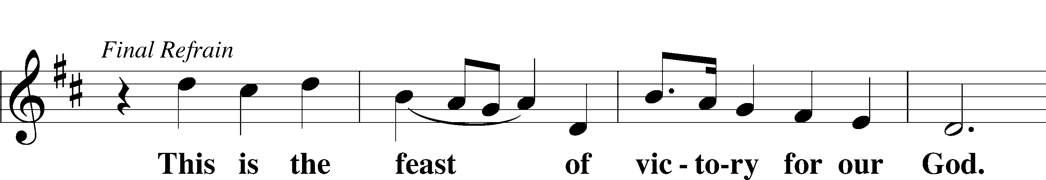
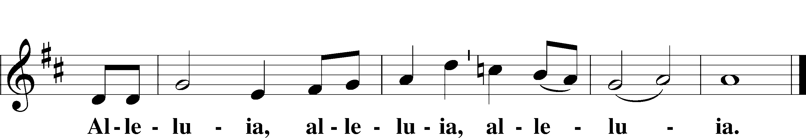

SALUTATION AND COLLECT OF THE DAY
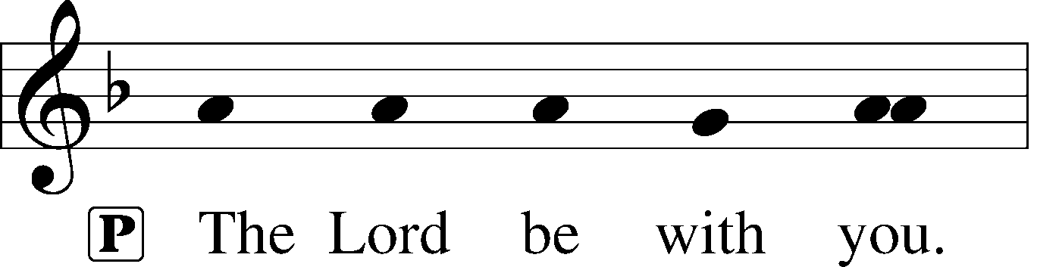
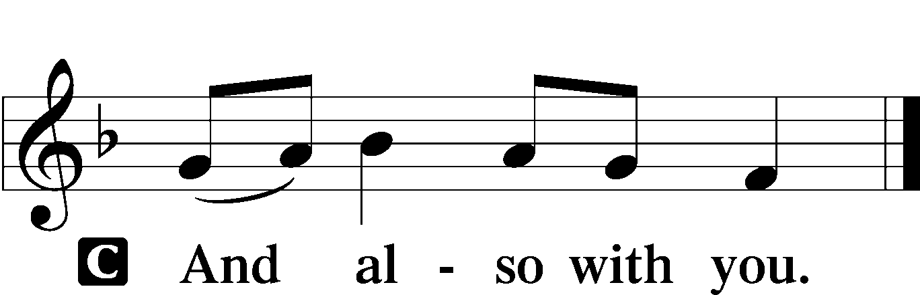

P Let us pray.
Lord God, heavenly Father, since we cannot stand before You relying on anything we have done, help us trust in Your abiding grace and live according to Your Word; through Jesus Christ, Your Son, our Lord, who lives and reigns with You and the Holy Spirit, one God, now and forever.

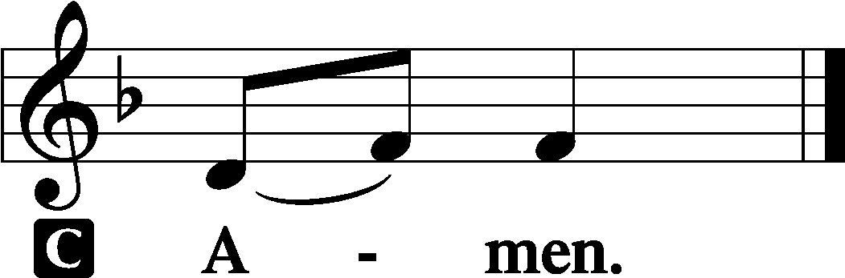
Sit

OLD TESTAMENT READING Isaiah 55:6–9
6“Seek the Lord while he may be found;
call upon him while he is near;
7let the wicked forsake his way,
and the unrighteous man his thoughts;
let him return to the Lord, that he may have compassion on him,
and to our God, for he will abundantly pardon.
8For my thoughts are not your thoughts,
neither are your ways my ways, declares the Lord.
9For as the heavens are higher than the earth,
so are my ways higher than your ways
and my thoughts than your thoughts.”
A This is the Word of the Lord.
C Thanks be to God.

GRADUAL
Fear the Lord, | you his saints,*
for those who fear him lack | nothing!
Many are the afflictions of the | righteous,*
but the Lord delivers him out | of them all.
EPISTLE Romans 16
1I commend to you our sister Phoebe, a servant of the church at Cenchreae, 2that you may welcome her in the Lord in a way worthy of the saints, and help her in whatever she may need from you, for she has been a patron of many and of myself as well.
3Greet Prisca and Aquila, my fellow workers in Christ Jesus, 4who risked their necks for my life, to whom not only I give thanks but all the churches of the Gentiles give thanks as well. 5Greet also the church in their house. Greet my beloved Epaenetus, who was the first convert to Christ in Asia. 6Greet Mary, who has worked hard for you. 7Greet Andronicus and Junia, my kinsmen and my fellow prisoners. They are well known to the apostles, and they were in Christ before me. 8Greet Ampliatus, my beloved in the Lord. 9Greet Urbanus, our fellow worker in Christ, and my beloved Stachys. 10Greet Apelles, who is approved in Christ. Greet those who belong to the family of Aristobulus. 11Greet my kinsman Herodion. Greet those in the Lord who belong to the family of Narcissus. 12Greet those workers in the Lord, Tryphaena and Tryphosa. Greet the beloved Persis, who has worked hard in the Lord. 13Greet Rufus, chosen in the Lord; also his mother, who has been a mother to me as well. 14Greet Asyncritus, Phlegon, Hermes, Patrobas, Hermas, and the brothers who are with them. 15Greet Philologus, Julia, Nereus and his sister, and Olympas, and all the saints who are with them. 16Greet one another with a holy kiss. All the churches of Christ greet you.
17I appeal to you, brothers, to watch out for those who cause divisions and create obstacles contrary to the doctrine that you have been taught; avoid them. 18For such persons do not serve our Lord Christ, but their own appetites, and by smooth talk and flattery they deceive the hearts of the naive. 19For your obedience is known to all, so that I rejoice over you, but I want you to be wise as to what is good and innocent as to what is evil. 20The God of peace will soon crush Satan under your feet. The grace of our Lord Jesus Christ be with you.
21Timothy, my fellow worker, greets you; so do Lucius and Jason and Sosipater, my kinsmen.
22I Tertius, who wrote this letter, greet you in the Lord.
23Gaius, who is host to me and to the whole church, greets you. Erastus, the city treasurer, and our brother Quartus, greet you.
25Now to him who is able to strengthen you according to my gospel and the preaching of Jesus Christ, according to the revelation of the mystery that was kept secret for long ages 26but has now been disclosed and through the prophetic writings has been made known to all nations, according to the command of the eternal God, to bring about the obedience of faith— 27to the only wise God be glory forevermore through Jesus Christ! Amen.

A This is the Word of the Lord.
C Thanks be to God.
Stand

ALLELUIA AND VERSE LSB 156
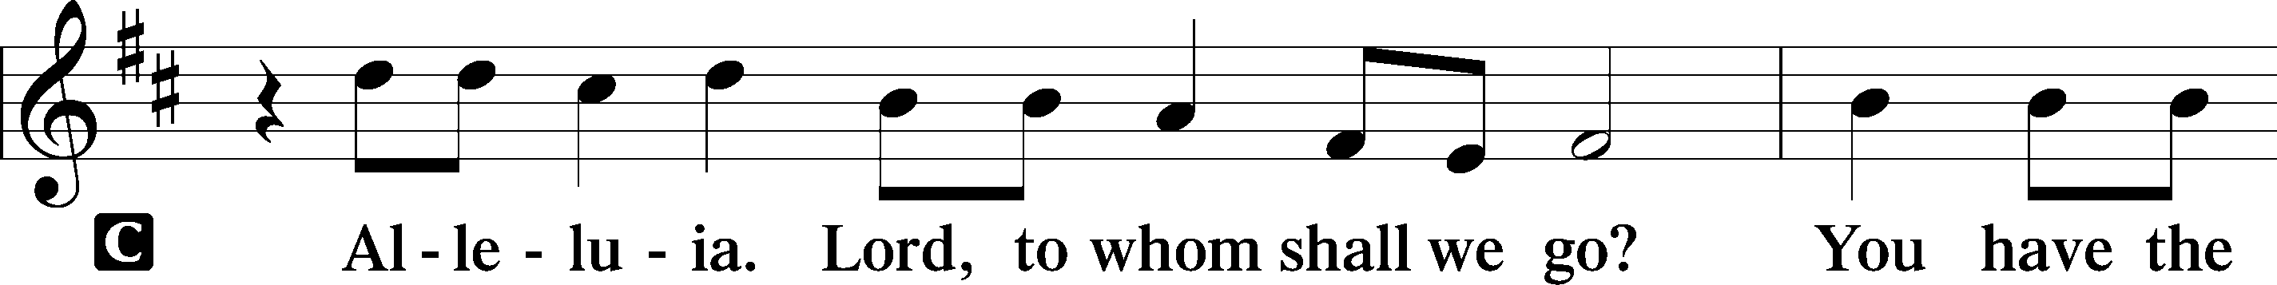
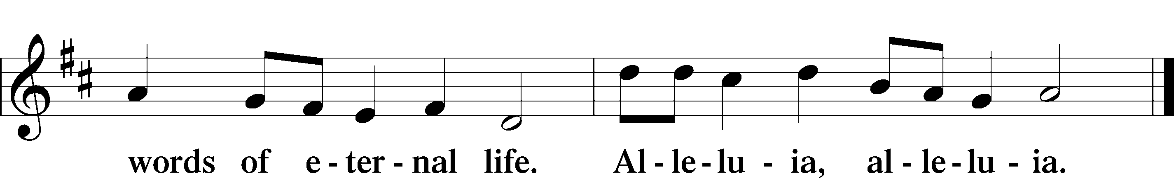

HOLY GOSPEL Matthew 20:1–16
P The Holy Gospel according to St. Matthew, the twentieth chapter.

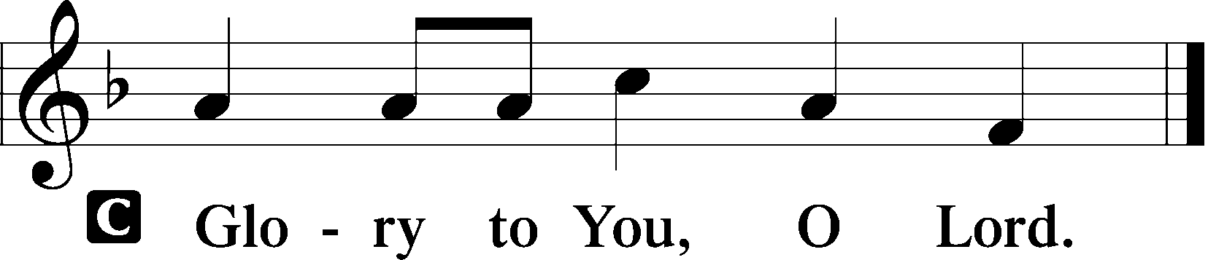

1[Jesus said:] “The kingdom of heaven is like a master of a house who went out early in the morning to hire laborers for his vineyard. 2After agreeing with the laborers for a denarius a day, he sent them into his vineyard. 3And going out about the third hour he saw others standing idle in the marketplace, 4and to them he said, ‘You go into the vineyard too, and whatever is right I will give you.’ 5So they went. Going out again about the sixth hour and the ninth hour, he did the same. 6And about the eleventh hour he went out and found others standing. And he said to them, ‘Why do you stand here idle all day?’ 7They said to him, ‘Because no one has hired us.’ He said to them, ‘You go into the vineyard too.’ 8And when evening came, the owner of the vineyard said to his foreman, ‘Call the laborers and pay them their wages, beginning with the last, up to the first.’ 9And when those hired about the eleventh hour came, each of them received a denarius. 10Now when those hired first came, they thought they would receive more, but each of them also received a denarius. 11And on receiving it they grumbled at the master of the house, 12saying, ‘These last worked only one hour, and you have made them equal to us who have borne the burden of the day and the scorching heat.’ 13But he replied to one of them, ‘Friend, I am doing you no wrong. Did you not agree with me for a denarius? 14Take what belongs to you and go. I choose to give to this last worker as I give to you. 15Am I not allowed to do what I choose with what belongs to me? Or do you begrudge my generosity?’ 16So the last will be first, and the first last.”

P This is the Gospel of the Lord.

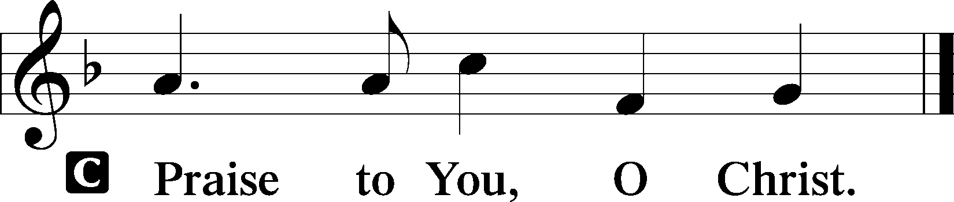

Sit

CHILDREN'S MESSAGE

HYMN OF THE DAY

557 SEEK WHERE YOU MAY TO FIND A WAY

1 Seek where you may
To find a way
That leads to your salvation.
My heart is stilled,
On Christ I build,
He is the one foundation.
His Word is sure,
His works endure;
He overthrows
All evil foes;
Through Him I more than conquer.

2 Seek whom you may
To be your stay,
None can redeem his brother.
All helpers failed;
This man prevailed,
The God-man and none other,
Our Servant-King
Of whom we sing.
We’re justified
Because He died,
The guilty being guiltless.
3 Seek Him alone
Who did atone,
Who did your souls deliver.
O seek Him first,
All you who thirst
For grace that fails you never.
In ev’ry need
Seek Him indeed;
To ev’ry heart
He will impart
His blessings without measure.

4 My heart’s delight,
My crown most bright,
O Christ, my joy forever.
Not wealth nor pride
Nor fortune’s tide
Our bonds of love shall sever.
You are my Lord;
Your precious Word
Shall guide my way
And help me stay
Forever in Your presence.

SERMON Rev. Shaun Daugherty

Stand

APOSTLES’ CREED
C I believe in God, the Father Almighty, maker of heaven and earth.

And in Jesus Christ, His only Son, our Lord, who was conceived by the Holy Spirit, born of the virgin Mary, suffered under Pontius Pilate, was crucified, died and was buried. He descended into hell. The third day He rose again from the dead. He ascended into heaven and sits at the right hand of God the Father Almighty. From thence He will come to judge the living and the dead.

I believe in the Holy Spirit, the holy Christian Church, the communion of saints, the forgiveness of sins, the resurrection of the body, and the life T everlasting. Amen.
PRAYER OF THE CHURCH
After each petition:
P Lord, in Your mercy,
C hear our prayer.

Sit

COLLECTION OF TITHES AND OFFERING

CHOIR “Agnus Dei” Michael W. Smith

Stand

OFFERTORY LSB 159
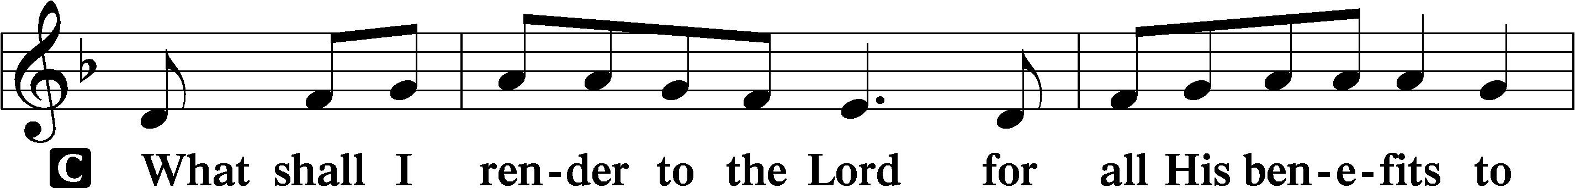
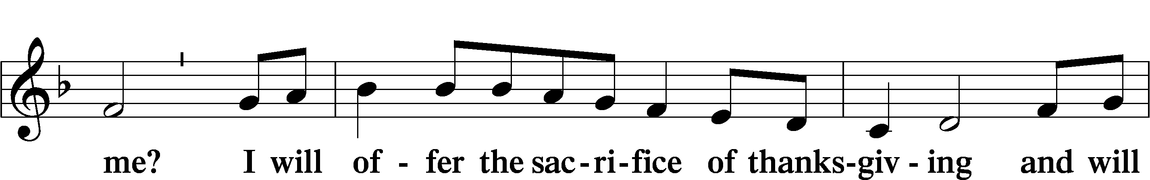
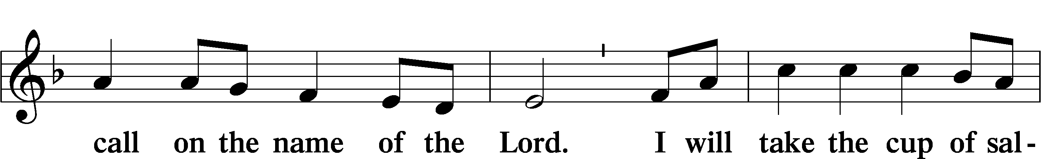
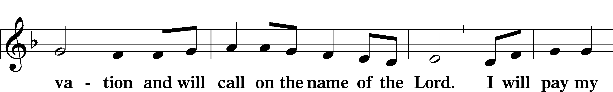
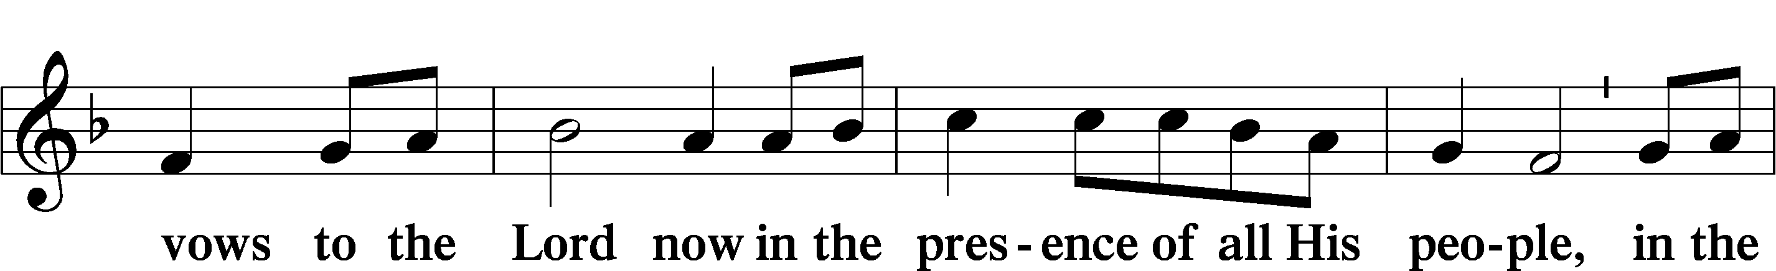
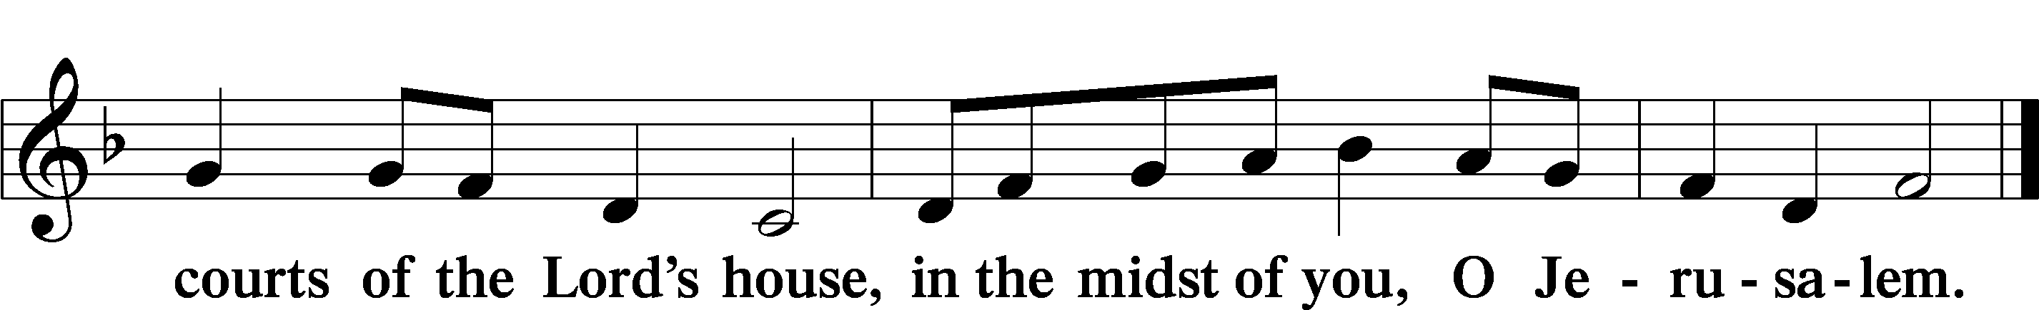

+ Service of the Sacrament +
As God's baptized and forgiven people, we gather at His invitation to receive The Lord's Supper.

The Lord’s Supper is celebrated at this congregation in the confession and glad confidence that, as he says, our Lord gives into our mouths not only bread and wine but His very body and blood to eat and to drink for the forgiveness of sins and to strengthen our union with him and with one another. Our Lord invites to his table those Baptized Christians who trust his words, repent of all sin, and set aside any refusal to forgive and love as he forgives and loves us, that they may show forth his death until he comes.

Because those who eat and drink our Lord’s body and blood unworthily do so to their great harm and because Holy Communion is a confession of the faith which is confessed at this altar, any who are not yet instructed, in doubt, or who hold a confession differing from that of this congregation and The Lutheran Church— Missouri Synod, and yet desire to receive the sacrament, are asked first to speak with the pastor or an elder.

For further study, see Matthew 5:23f.; 10:32f.; 18:15-35; 26:26-29; 1 Cor. 11:17- 34.

PREFACE LSB 160


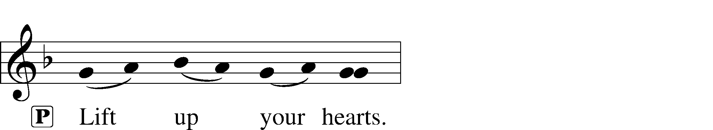


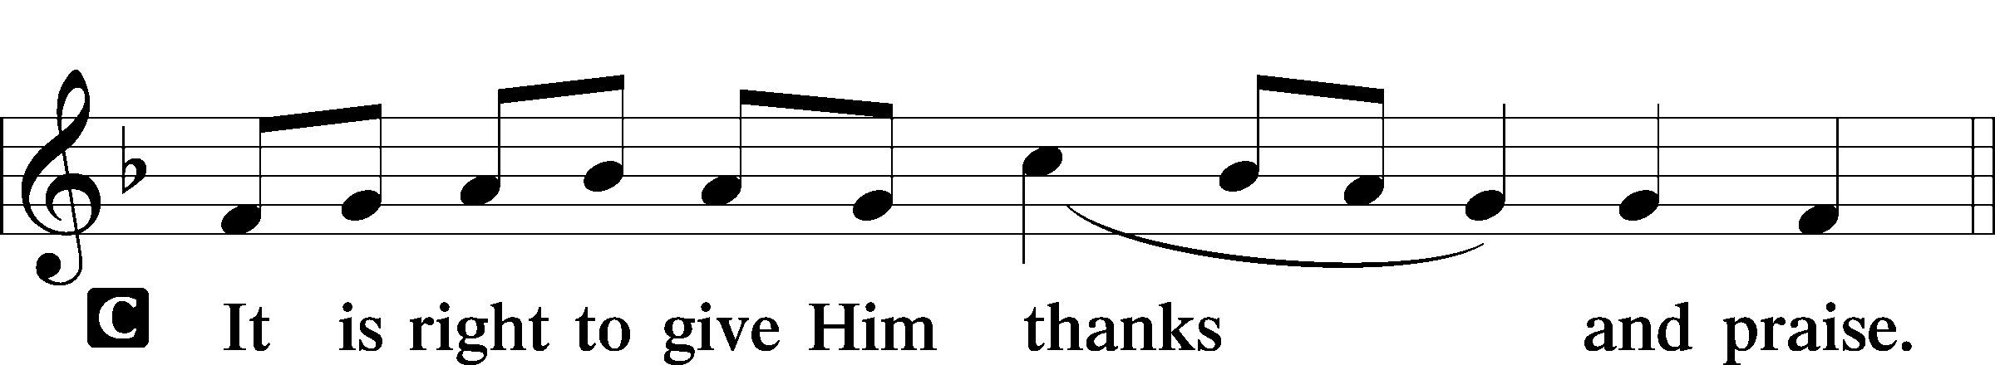

PROPER PREFACE LSB 161
P It is truly good, right, and salutary . . . evermore praising You and saying:

SANCTUS LSB 161
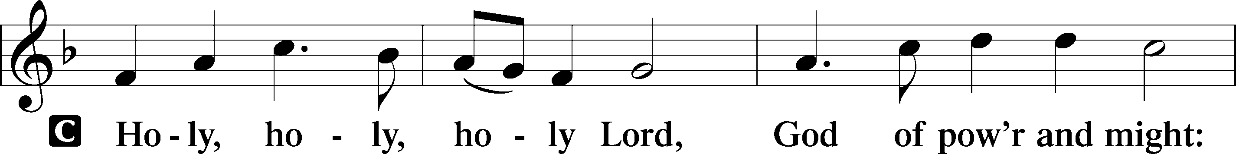
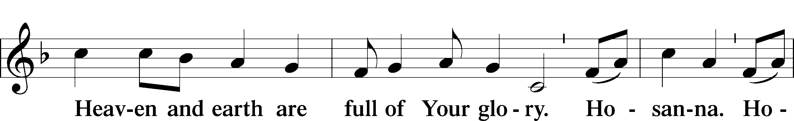
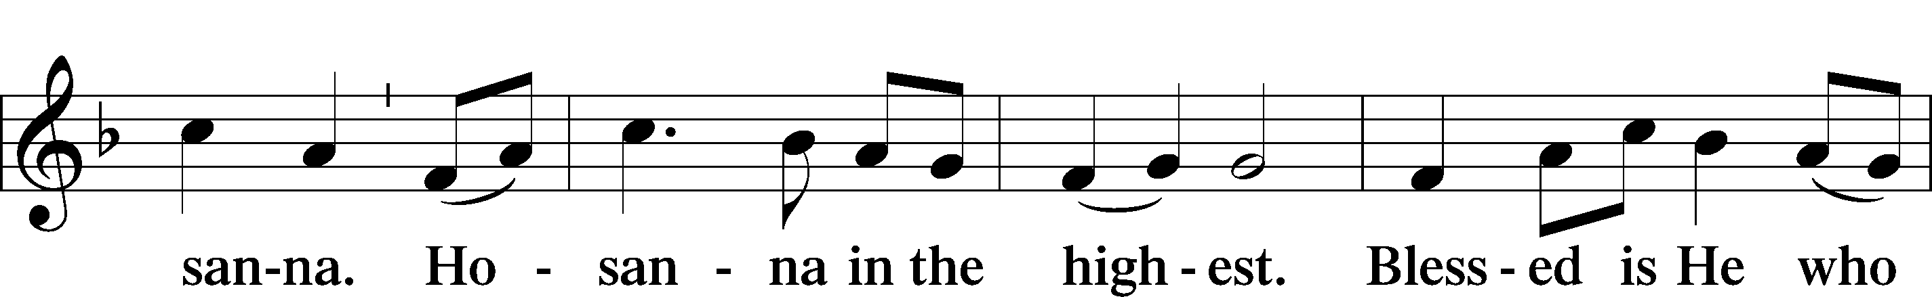
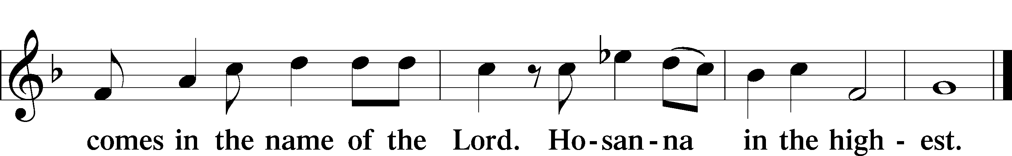

PRAYER OF THANKSGIVING LSB 161
P Blessed are You, Lord of heaven and earth, for You have had mercy on those whom You created and sent Your only-begotten Son into our flesh to bear our sin and be our Savior. With repentant joy we receive the salvation accomplished for us by the all-availing sacrifice of His body and His blood on the cross.

Gathered in the name and the remembrance of Jesus, we beg You, O Lord, to forgive, renew, and strengthen us with Your Word and Spirit. Grant us faithfully to eat His body and drink His blood as He bids us do in His own testament. Gather us together, we pray, from the ends of the earth to celebrate with all the faithful the marriage feast of the Lamb in His kingdom, which has no end. Graciously receive our prayers; deliver and preserve us. To You alone, O Father, be all glory, honor, and worship, with the Son and the Holy Spirit, one God, now and forever.
C Amen.

THE WORDS OF OUR LORD

PROCLAMATION OF CHRIST
P As often as we eat this bread and drink this cup, we proclaim the Lord’s death until He comes.
C Amen. Come, Lord Jesus.

P O Lord Jesus Christ, only Son of the Father, in giving us Your body and blood to eat and to drink, You lead us to remember and confess Your holy cross and passion, Your blessed death, Your rest in the tomb, Your resurrection from the dead, Your ascension into heaven, and Your coming for the final judgment. So remember us in Your kingdom and teach us to pray:

LORD’S PRAYER
C Our Father who art in heaven, hallowed be Thy name, Thy kingdom come, Thy will be done on earth as it is in heaven; give us this day our daily bread; and forgive us our trespasses as we forgive those who trespass against us; and lead us not into temptation, but deliver us from evil. For Thine is the kingdom and the power and the glory forever and ever. Amen.

PAX DOMINI LSB 163
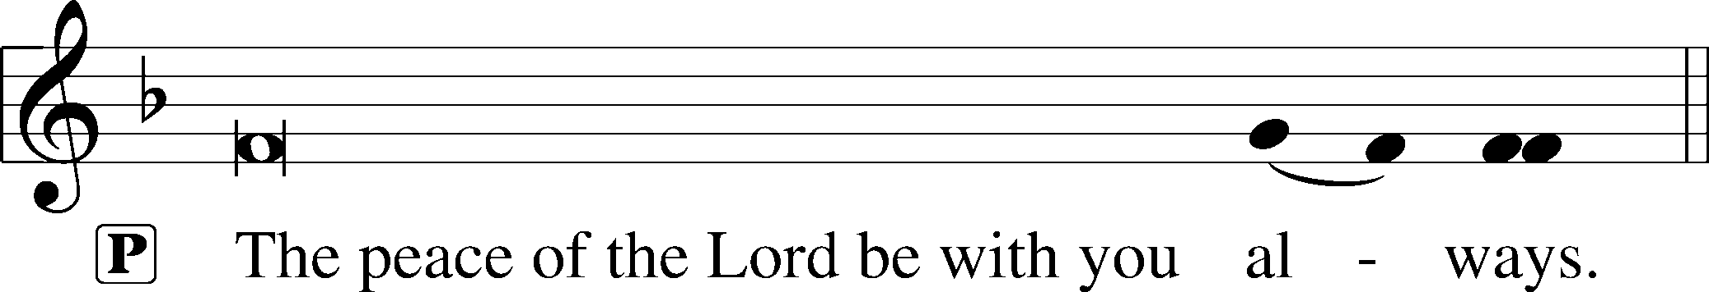


AGNUS DEI LSB 163
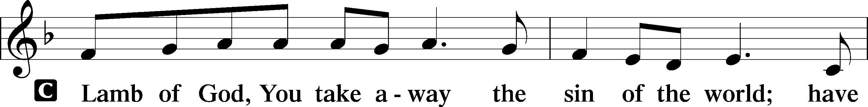
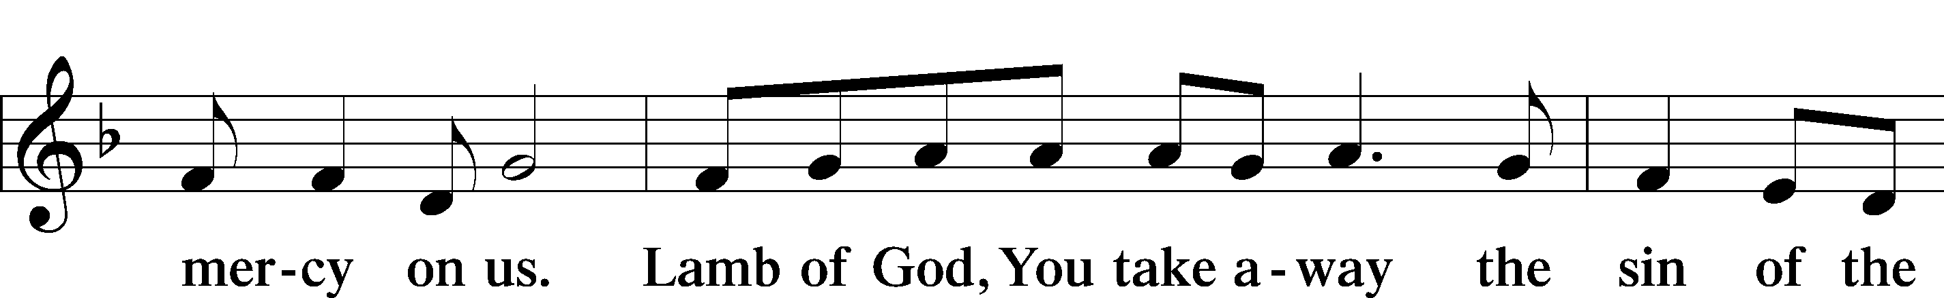
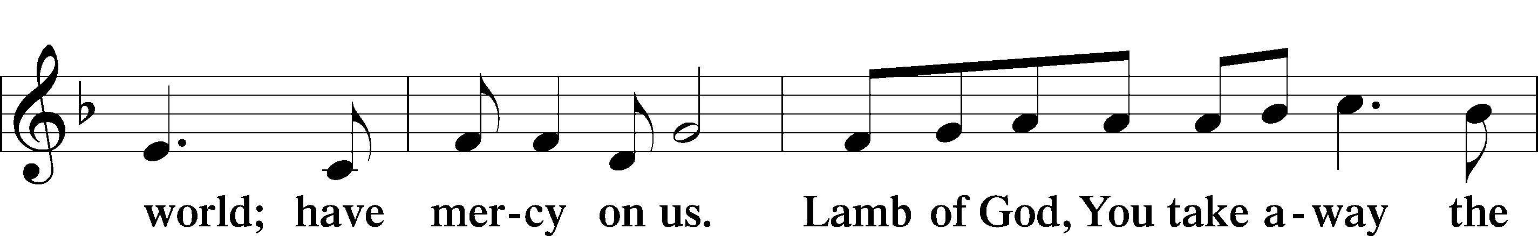
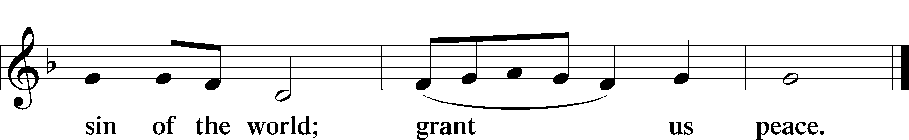

Following the Agnus Dei, please greet one another in the name of the Lord, saying, “Peace be with you,” as a sign of reconciliation and of the unity of the Spirit in the bond of peace (Matt. 5:22–24; Eph. 4:1–3).

Sit

DISTRIBUTION HYMNS

565 THY WORKS, NOT MINE, O CHRIST

1 Thy works, not mine, O Christ,
Speak gladness to this heart;
They tell me all is done,
They bid my fear depart. Refrain

ref To whom save Thee,
Who canst alone
For sin atone,
Lord, shall I flee?

2 Thy wounds, not mine, O Christ,
Can heal my bruisèd soul;
Thy stripes, not mine, contain
The balm that makes me whole. Refrain

3 Thy cross, not mine, O Christ,
Has borne the crushing load
Of sins that none could bear
But the incarnate God. Refrain

4 Thy death, not mine, O Christ,
Has paid the ransom due;
Ten thousand deaths like mine
Would have been all too few. Refrain

5 Thy righteousness, O Christ,
Alone can cover me;
No righteousness avails
Save that which is of Thee. Refrain

705 THE MAN IS EVER BLESSED

1 The man is ever blessed
Who shuns the sinners’ ways,
Among their counsels never stands,
Nor takes the scorners’ place,

2 But makes the Law of God
His study and delight
Amid the labors of the day
And watches of the night.

3 He like a tree shall thrive,
With waters near the root;
Fresh as the leaf his name shall live,
His works are heav’nly fruit.

4 Not so the wicked race,
They no such blessings find;
Their hopes shall flee like empty chaff
Before the driving wind.

5 How will they bear to stand
Before the judgment seat
Where all the saints at Christ’s right hand
In full assembly meet?
6 He knows and He approves
The way the righteous go;
But sinners and their works shall meet
A dreadful overthrow.

555 SALVATION UNTO US HAS COME

1 Salvation unto us has come
By God’s free grace and favor;
Good works cannot avert our doom,
They help and save us never.
Faith looks to Jesus Christ alone,
Who did for all the world atone;
He is our one Redeemer.

2 What God did in His Law demand
And none to Him could render
Caused wrath and woe on ev’ry hand
For man, the vile offender.
Our flesh has not those pure desires
The spirit of the Law requires,
And lost is our condition.

3 It was a false, misleading dream
That God His Law had given
That sinners could themselves redeem
And by their works gain heaven.
The Law is but a mirror bright
To bring the inbred sin to light
That lurks within our nature.

4 From sin our flesh could not abstain,
Sin held its sway unceasing;
The task was useless and in vain,
Our guilt was e’er increasing.
None can remove sin’s poisoned dart
Or purify our guileful heart—
So deep is our corruption.

5 Yet as the Law must be fulfilled
Or we must die despairing,
Christ came and has God’s anger stilled,
Our human nature sharing.
He has for us the Law obeyed
And thus the Father’s vengeance stayed
Which over us impended.

6 Since Christ has full atonement made
And brought to us salvation,
Each Christian therefore may be glad
And build on this foundation.
Your grace alone, dear Lord, I plead,
Your death is now my life indeed,
For You have paid my ransom.

7 Let me not doubt, but truly see
Your Word cannot be broken;
Your call rings out, “Come unto Me!”
No falsehood have You spoken.
Baptized into Your precious name,
My faith cannot be put to shame,
And I shall never perish.

8 The Law reveals the guilt of sin
And makes us conscience-stricken;
But then the Gospel enters in
The sinful soul to quicken.
Come to the cross, trust Christ, and live;
The Law no peace can ever give,
No comfort and no blessing.

9 Faith clings to Jesus’ cross alone
And rests in Him unceasing;
And by its fruits true faith is known,
With love and hope increasing.
For faith alone can justify;
Works serve our neighbor and supply
The proof that faith is living.

D 10 All blessing, honor, thanks, and praise
To Father, Son, and Spirit,
The God who saved us by His grace;
All glory to His merit.
O triune God in heav’n above,
You have revealed Your saving love;
Your blessèd name we hallow.

Stand

DISMISSAL

THANK THE LORD LSB 164
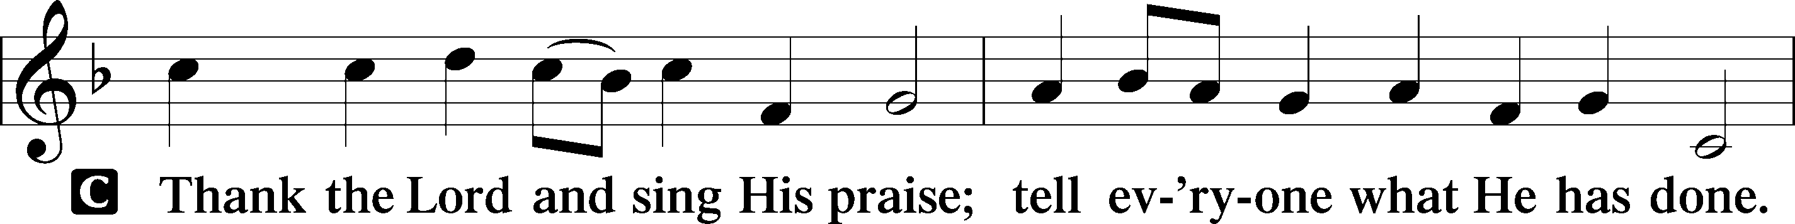
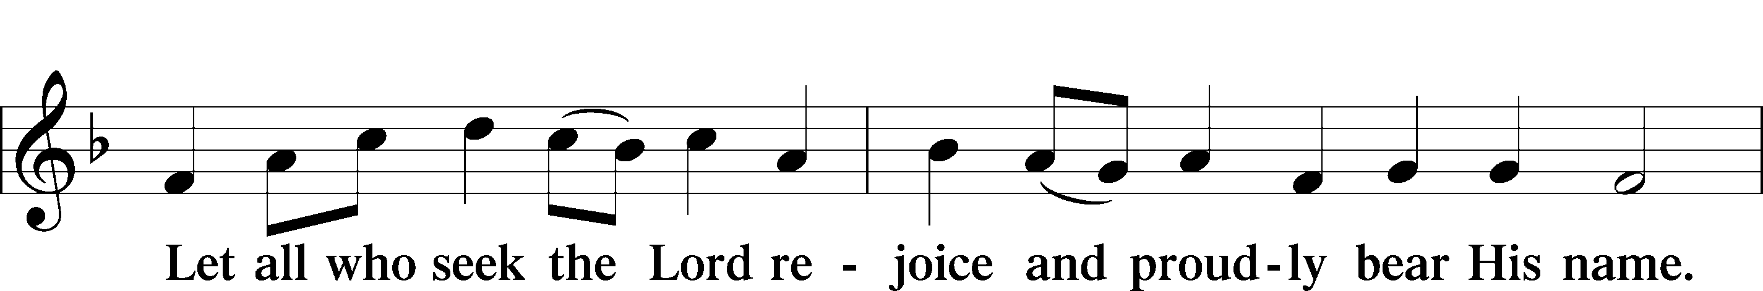
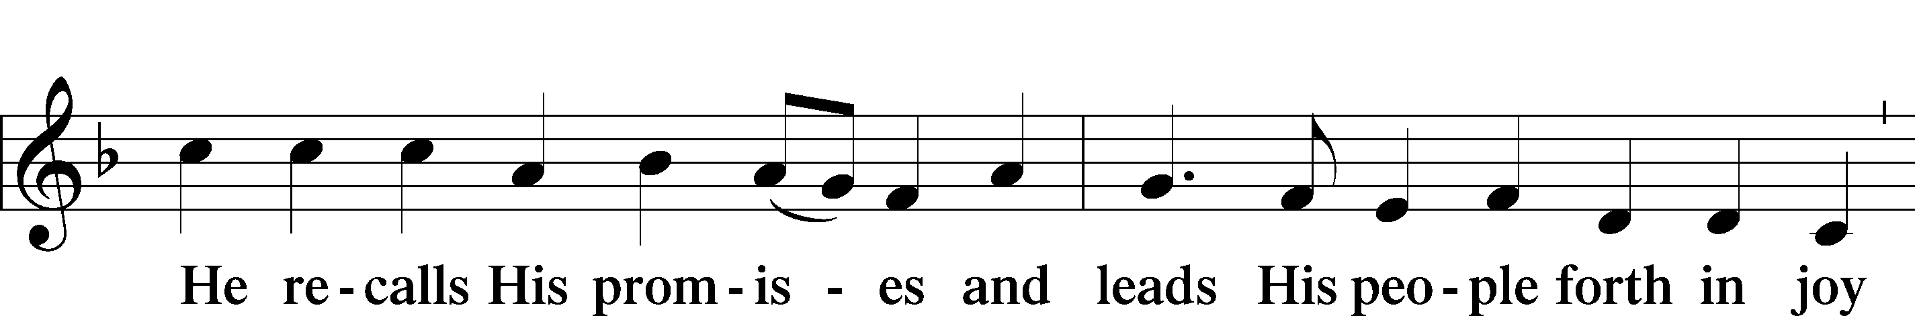
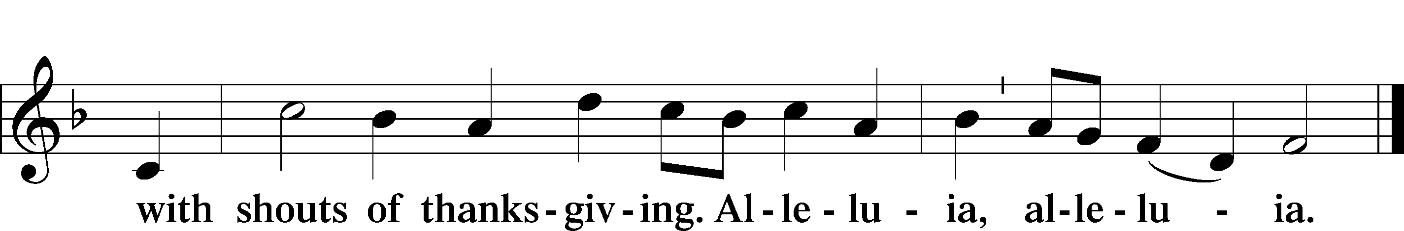

POST-COMMUNION COLLECT

BENEDICTION LSB 166
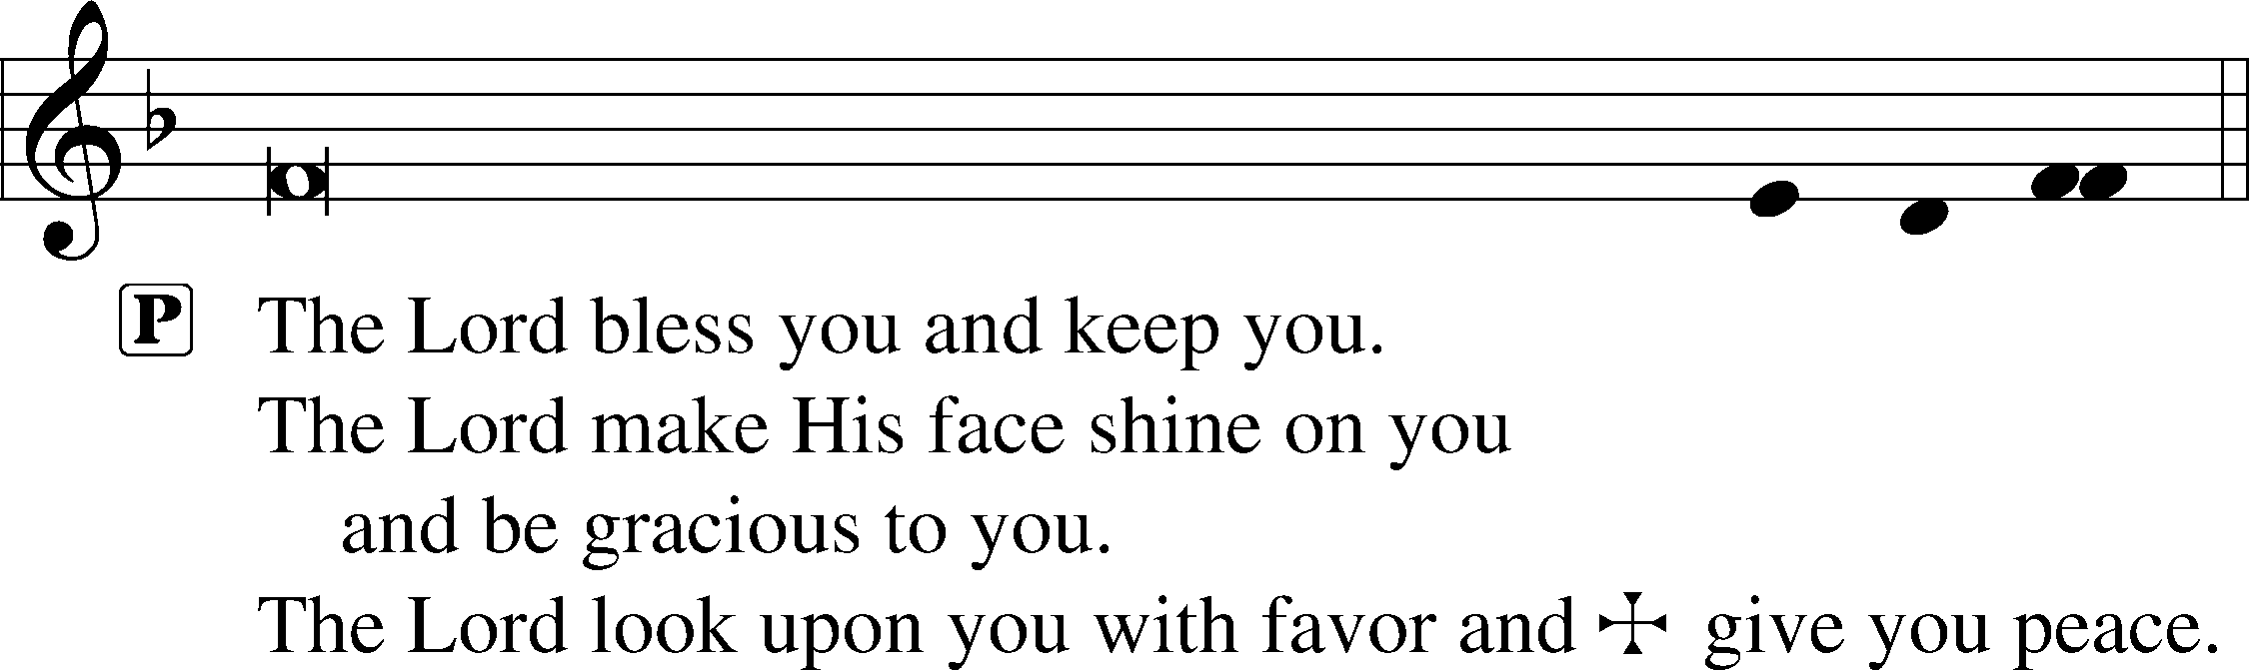


RECESSIONAL HYMN
854 FORTH IN THY NAME, O LORD, I GO

1 Forth in Thy name, O Lord, I go,
My daily labor to pursue,
Thee, only Thee, resolved to know
In all I think or speak or do.

2 The task Thy wisdom has assigned,
O let me cheerfully fulfill;
In all my works Thy presence find,
And prove Thy good and perfect will.

3 Thee may I set at my right hand,
Whose eyes my inmost substance see,
And labor on at Thy command,
And offer all my works to Thee.

4 Give me to bear Thine easy yoke,
And ev’ry moment watch and pray,
And still to things eternal look,
And hasten to Thy glorious day.

5 For Thee delightfully employ
Whate’er Thy bounteous grace has giv’n,
And run my course with even joy,
And closely walk with Thee to heav’n.

ANNOUNCEMENTS
See the announcements and prayer guide at the end of the bulletin.

SENDING
P Let us pray.
Lord God, You have called Your servants to ventures of which we cannot see the ending, by paths as yet untrodden, through perils unknown. Give us faith to go out with good courage, not knowing where we go but only that Your hand is leading us and Your love supporting us; through Jesus Christ, our Lord.
C Amen
P Go in peace to serve the Lord.
C Thanks be to God.

THIS WEEK AT FAITH

Sunday Sept. 20 Bible Study 8:30am
Fellowship 9:30am
Worship 10:00am
Mon-Fri Sept. 21-25 Fall Break 8:30am
Tuesday Sept. 22 Create in Me Crafting 10:00am
Wednesday Sept. 23 No Wed. Night Programming 6:30pm
Thurs-Sat Sept. 24-26 Men’s Camping Retreat
Sunday Sept. 27 Bible Studies 8:30am
Fellowship 9:30am
Worship 10:00am

CHURCH ANNOUNCEMENTS

PRIVATE CONFESSION AND ABSOLUTION - available Monday-Thursday 4:30-5:30pm
In the Church, God daily and richly forgives our sins. This forgiveness (absolution) is a gift we receive in worship each week. It is also available to you personally in order to comfort you with Christ's victory in the battle against sin and the devil. Whether you are particularly troubled by sin, or simply desire to receive the absolution personally, you are welcomed. Appointments are preferred so that Pastor can set aside dedicated time for you.

THANK YOU
Our family, Joan Olson and Sherri Booker, want to share our appreciation for all the prayers, words of comfort, loving hugs, and cards we received during our days of grief during the illness and passing of our son and brother Tom Olson. We celebrated his life this past weekend and could feel the comfort of prayers during that time. Thank you so much for the kindness shown to both of us. Joan Olson and Sherri Booker.

CHURCH DIRECTORY PHOTOS & MAKEUP DAY – Sunday, October 18, after worship
Faith school’s photographer will be taking portraits of our church members for our directory. This is also the final makeup opportunity for lay leaders, elder board and SMB. You can see a sample of Gina’s work at https://ginacellino.shootproof.com. The photos will be free of charge for the directory, personal prints (starting at $13) and digital packages (starting at $35) are also available to purchase in time for the holidays.

WEDNESDAY NIGHTS RESUME 9/30 -
There will be no Wednesday Night programming on September 23, 2026. We will resume our regular schedule the following week on September 30.

MENS CAMPING RETREAT THIS WEEK - September 24-26th
Men of Faith, join us for a weekend dedicated to brotherhood and authentic fellowship. Location of the Irvin’s property is in Upson County roughly 95 miles from church. If you have questions, please contact Ward Irvin. You can see more and sign up at faithmarietta.com/mensretreat

LWML ZONE RALLY - Oct 3, 9-2:00 pm
Registration is $15 (includes lunch, pay at the rally) please make checks payable to LWML FL-GA Atlanta Zone Rally. Gifts from the Heart (handmade or purchased) LWML is collecting small or medium-size teddy bears (sewn eyes) for local Police and Fire Departments, these gifts are given to children who have experienced traumatic events and will be given at the Zone Rally. Please leave teddy bears in the LWML room or bring them with you to the Zone Rally. Contact Louise Cox 478-957-7332 to RSVP, you can find more information at faithmarietta.com/lwml

NEW MEMBER CLASS (Adult Confirmation) - Start Sunday, October 4, 11:30am
Classes begin Sunday, October 4, 2026 at 11:30am in the Sanctuary. This 6-week class will focus on the Doctrine of the Christian Church as taught in Luther's Small Catechism. This is required for those who are not currently members of a congregation of the Lutheran Church – Missouri Synod (LCMS). Contact Pastor Shaun to be added to the class.

FAITH SCHOOL PRAYERS - October 13, 9:00am
The School Prayer group meets the 2nd Tuesday of the month, at 9:00am in the craft room. Dates are Oct 13th, Nov 10th, Dec 8th. Call or text Norma Palmer at (256-653-8349) for more information.

LUTHERAN COALITION FOR HABITAT - BUILD PROJECT
Lutheran Coalition for Habitat is sponsoring a build this fall in Austell, GA, and has volunteer
opportunities available. Workdays will be Saturdays from 7:45am – 4pm. Opportunities include;
10/10: Exterior paint, 10/17: Interior prep and trim, 10/31: Painting and trim work, 11/7: Paint and punchout day, 11/14: Landscaping
Contact Laura Elston at laura.elston2@gmail.com for more information or to sign up to work
on the house.

REFORMATION FESTIVAL - October 30, 5:00-7:00pm
Mark your calendars! Reformation Festival will feature a Trunk-or-Treat, be sure to tune in at faithmarietta.com/reformation for more details being released this week!

FAITH LUTHERAN NEW MEMBER ORIENTATION - Sunday November 15, 11:30am
Orientation is a 1-week introduction to Faith for those transferring AND for those who have just finished Adult Confirmation. Please Contact Pastor Shaun to be added to the class.

NEW MEMBER SUNDAY - November 22, 10:00am
Join us this day as new members will be formally received during Worship. Please welcome them into our Faith Family by visiting afterwards at the Welcoming Luncheon.

YOUTH MUSICIANS - Since God has blessed you with musical talent, we want you to use those gifts in worship. Prepare a 3–5-minute musical piece for pre-service or offertory. The music should not be "pop" music, but classical and/or Christian. All music choices will be reviewed by Pastor Shaun for appropriateness. Bring your own instrument or we can provide a keyboard. Note: If young pianists are willing to play a piece on the organ, we will provide time to learn about the organ and the basics of how to play it, along with opportunities to practice your piece on the organ. We look forward to making a joyful noise to the Lord with you! Contact Pastor Shaun to sign up.

ONE FAITH:
Family Devotions for the Week of September 20, 2026
THEME: Rooted in Christ through Worship
by Pastor Shaun
(Scan for online devotions)

“Oh come, let us sing to the Lord; let us make a joyful noise to the rock of our salvation! (Psalm 95:1 ESV)

DEVOTION:
Worship is not an indifferent matter. When we hear, believe, and confess the truth about God, and receive His gifts in Word and Sacrament, we are formed in faith and ROOTED in CHRIST. Prosper of Aquitaine, a 5th Century lay-theologian, acknowledged this when he first composed the famous Latin maxim: Lex orandi, lex credendi. The phrase is literally translated, “the law of prayer (is) the law of belief.” In other words, as people pray (and worship), so they also believe. If we pray and worship using words that are true, then our faith will be formed in truth. But if we tolerate falsehood in our lives, and especially in our worship, we will be formed by that, too.
This is the main reason we should be cautious about singing hymns and songs that aren’t in our hymnal. It’s not that new things are forbidden, but rather that everything should be carefully tested by the Scripture. We should NOT casually sing, “I have decided to follow Jesus,” because it’s a catchy song that makes us feel good. Instead, We should ask ourselves, “Is that true?”

Is my faith defined by my decision to follow Jesus, or is it defined by the faithfulness of Christ, who chose me before the foundation of the world? Do poor sinners choose to follow Jesus or are they in bondage to sin and unable to free themselves? Are we saved because we chose Jesus or because Jesus chose to rescue us out of the prison house of sin by His death on the cross? In every case it’s the latter. But as the church prays and worships, so the church believes. If we tolerate bad theology, we are likely to believe false and dangerous, deadly things about ourselves and about God.
This is also why our Lutheran Worship Services are ALMOST ENTIRELY comprised of quotations from Scripture. Take for instance the reading from Psalm 95:1, which says “Oh come, let us sing to the Lord; let us make a joyful noise to the rock of our salvation!” Does that sound familiar? We sing it every day in chapel. We know it as the “Venite,” from the Order of Matins. It is an ancient call to worship. We sing it because it’s true. We know this because it is the Word of God, who always speaks the truth. And singing His Word forms us.

So dear Christians, worship often, and let your Worship be founded on the great truth of God’s Word. Read the Bible. Sing and pray the Psalms. Sing the old Christian (Lutheran!) hymns that confess the truth. And as you pray and worship, so believe and be deeply ROOTED in CHRIST, who loves you and forgives all of your sins. Amen!

CATECHISM MEMORY:
The Seventh Commandment You shall not steal.
What does this mean? We should fear and love God so that we do not take our neighbor’s money or possessions, or get them in any dishonest way, but help him to improve and protect his possessions and income.
READINGS FOR THIS WEEK:
Mon: Psalm 46 Tue: Acts 16 Wed: Psalm 47 Thu: Exodus 15:1-21 Fri: Psalm 95:1-7 Sat: Matthew 21:23-32

REFLECTION QUESTIONS & ACTIVITIES for the READINGS
- What do the readings teach you about worship?
- Why is worship important for the Christian life?
- How does worship affect the lives of non-Christians?
- What does Lex orandi, lex credendi mean?
- Why is it good to worship using prayers and songs based on God’s Word (like Psalm 95), rather than words invented by man?
- What questions do you have about the readings this week?
(Write them down and share them with Pastor Shaun!)
Prayers for the Week
Let my prayer rise before You as incense…” - Psalm 141:2 Following the instruction of God's Word, we lift our hearts and hands in prayer. As a priesthood of believers called to bear one another’s burdens, we bring our petitions before our heavenly Father.

Please join us in interceding for: Ruth Trinklein (successful surgery on fractured ankle); MaryLou (recovery from injuries after car accident); Elizabeth (recovery following surgery); Debby Lenord (peace, protection, guidance) //Sandy Skrbanek’s sister; Judy Hamilton (recover from shoulder surgery) // Carol Seelman’s sister-in-law; Sandy (complications from chemotherapy) // friend of Schleichers; Paula Gronemeyer (recovery from stroke, restoration of vision); Makenna (guidance, faith and Christian fellowship); LaJaun (mercy, faith, and wise decision making for her family members); Heidi Fletcher’s mother (recovery following stroke and fall); Nathan (relief and treatment for bulging disc in back) // Jill Musgrove’s son; Allie and her baby (high-risk pregnancy) // sister of Roby Hamilton; Viva Kirk (health and employment); Thanksgiving for the birth of Finnegan to Brittain and Josh Rebuck; Thanksgiving for Shirley’s move to a rehabilitation center // Greg Schaag’s aunt; Janice Schaag (health and peace following diagnosis of a hereditary condition); Steve and his family as he nears the end of his life // father of Phil Manginelli (Phil is Ward’s & Susan’s son-in-law); Brennan Lambert (a quick recovery from jaw surgery); Audrey and Thomas (provision for their needs of body and soul, following a house fire); family of Henshaws; Alex (protection during deployment, safe return to family in October) and his wife, Amanda, and children William, Aurora, & Olivia; Thanksgiving for medical and spiritual care for Tracy Woolery following his recent surgery; Ruth Brown as she mourns the death of her husband // friend of Sandy Skrybanek; Darrell Weers (lost his battle with Parkinson’s disease) // brother of George Weers; Thanksgiving for our flourish Youth Group; Beth (suffering from an illness), and her husband Matthew as he cares for her and their children // Marylou’s son; Andrew Hirschler (hospitalization) // former member, friend of Pietros; Caroline O’Neal (cancer); Ramona (recovery from surgery, peace) and her husband John, and children // sister of Rosina Sawh; Gary Griffin (cancer treatment and gallbladder infection) and his wife, Karen // former members, friends of Lamberts; Thanksgiving for progress in recovery for GanneElyse and for the joy of seeing her in worship!; Kyle Laurendine (diagnosed with brain tumor); Thanksgiving for the birth of Charlotte Ross Webb to Ciji Parrish and Craig Webb

ONGOING
For faith and salvation for those who are not yet believers; and repentance for those who have strayed from the faith (especially Jonathan, Bethany, Ean, Bud, Roger, Connor Brett, Mike, Brad, Joel, Ben, Regan, Adam, Corinne, Ana, Samantha, Victoria, Jason, Mike, Josh, Dan, Lisa, Steve, Jessica, Daniel, Hannah, Destiny, Nate, Carol, a member’s brother and sisters, Ben, Bill, Mary, Jack and Jason; along with those others we hold in our heart.); For those who mourn (the families of Joyce Elston, Steven Erny, Jewley Del Duca, and Tom Olson); For members of the Armed Forces of the United States, who protect and defend us (Alex & Brett) ; For our Staff: Pastor Shaun, Headmaster Bradshaw, and all the staff and leaders of Faith Lutheran Church and School (for Godly vision and stewardship; and that the Gospel would be faithfully proclaimed in church and school.); For our Missionaries: Rev. Chris and Dr. Jenny Yang, missionaries to Taiwan; For the families and youth of Faith Lutheran Church & School (that God would grant them steadfast, vibrant faith); For our confirmation students (Daniel, Lily, Zach, Madeline, Isabelle, and Melanie); For more students at Faith Lutheran School, according to God’s will; For faithful leaders of our state and nation.

