

Sixteenth Sunday After Pentecost
September 13, 2026
OUR MISSION: Connecting People to Jesus

Contact us
Faith Lutheran Church & School 2111 Lower Roswell Rd, Marietta, GA 30068 | 770-973-8877

CHURCH: www.faithmarietta.com SCHOOL: www.faithmarietta.org
Rev. Shaun Daugherty, Pastor Mr. Chris Bradshaw, Headmaster
pastor.shaun@faithmarietta.org chris.bradshaw@faithmarietta.org
470-289-9469 470-641-6239
See the full leadership directory: www.faithmarietta.com/leadership
Serving This Month at Faith
 | 9/6/2026 | 9/13/2026 | 9/20/2026 | 9/27/2026
Musicians | Vaunda Noerenberg | Vaunda Noerenberg | Ben Nye | Vaunda Noerenberg
Elders | Ward Irvin  Vinny Caracci | Steve Buchtrup  Greg Sinatra | Vinny Caracci  Ward Irvin | Steve Buchtrup  Woody Wood
Reader | David Barnett | Amy Meyer | Jon Wareham | Stacy Sinatra
Ushers | Greg Czerwonka  Matthew Czerwonka  Jacob Czerwonka  Luke Czerwonka  Sam Czerwonka | Steve Buchtrup  Mark Patterson  Gary Schleicher  Reagan Gronsbell  Paris Brown | Kim Kaumeyer  David Barnett  Greg Sinatra | Chris Bradshaw  Herman Dean  Bryan Powell  Christian Campbell
Acolytes | Adam Cain  Amadeo Brown | Josiah Brown  Alex Bradshaw | Andrew Linsey  Christian Brown | Amadeo Brown  Adam Cain



For your convenience, we now accept gifts
Pay Pal
via Venmo or PayPal.

Our Discipleship
Date | 8/30 | 9/6 | 9/13 |  | Budget Summary (August)
Worship | 169/161 | 137/121 | - |  | Avg. Worship | 155
Sunday School | N/A | 36 | - |  | Avg. SS | 25
Gen. Giving | $17,883 | $10,320 | - |  | Gen. Giving | $61,945
MTD Giving | $61,945 | $10,320 | - |  | Budgeted Giving | $42,400
Monthly Budget | $42,400 | $44,600 | $44,600 |  | Over (Under) | $19,545

FAITH GROWS is our debt reduction account, geared towards eliminating our mortgage.
Please prayerfully consider donating to this fund - over and beyond your normal tithe.

August Debt Reduction | $2,333 | Remaining Mortgage Debt | $2,678,311
ALTAR FLOWERS are given today to the Glory of God
+ Confession and Absolution +
We enter the presence of God by humbly confessing our sins and gladly receiving His forgiveness.

Stand

PROCESSIONAL HYMN

845 WHERE CHARITY AND LOVE PREVAIL

1 Where charity and love prevail
There God is ever found;
Brought here together by Christ’s love
By love are we thus bound.

2 With grateful joy and holy fear
His charity we learn;
Let us with heart and mind and soul
Now love Him in return.

3 Forgive we now each other’s faults
As we our faults confess,
And let us love each other well
In Christian holiness.

4 Let strife among us be unknown;
Let all contention cease;
Be God’s the glory that we seek;
Be ours His holy peace.

5 Let us recall that in our midst
Dwells Christ, His only Son;
As members of His body joined
We are in Him made one.

6 For love excludes no race or clan
That names the Savior’s name;
His family embraces all
Whose Father is the same.

The sign of the cross may be made by all in remembrance of their Baptism.

INVOCATION
P In the name of the Father and of the T Son and of the Holy Spirit.
C Amen.

P If we say we have no sin, we deceive ourselves, and the truth is not in us.
C But if we confess our sins, God, who is faithful and just, will forgive our sins and cleanse us from all unrighteousness.

Silence for reflection on God’s Word and for self-examination.

CONFESSION AND ABSOLUTION 151
P Let us then confess our sins to God our Father.
C Most merciful God, we confess that we are by nature sinful and unclean. We have sinned against You in thought, word, and deed, by what we have done and by what we have left undone. We have not loved You with our whole heart; we have not loved our neighbors as ourselves. We justly deserve Your present and eternal punishment. For the sake of Your Son, Jesus Christ, have mercy on us. Forgive us, renew us, and lead us, so that we may delight in Your will and walk in Your ways to the glory of Your holy name. Amen.

P Almighty God in His mercy has given His Son to die for you and for His sake forgives you all your sins. As a called and ordained servant of Christ, and by His authority, I therefore forgive you all your sins in the name of the Father and of the T Son and of the Holy Spirit.
C Amen.

Stand

+ Service of the Word +
Having received God's forgiveness, we come before Him with songs of praise, eager to hear His Word.

INTROIT

Deliver me from my enemies, | O Lord!*
I have fled to you for | refuge!
Hear my prayer, O Lord; give ear to my pleas for | mercy!*
In your faithfulness answer me, in your | righteousness!
Enter not into judgment with your | servant,*
for no one living is righteous be- | fore you.
Glory be to the Father and | to the Son*
and to the Holy | Spirit;
as it was in the be- | ginning,*
is now, and will be forever. | Amen.
Deliver me from my enemies, | O Lord!*
I have fled to you for | refuge!

KYRIE LSB 152

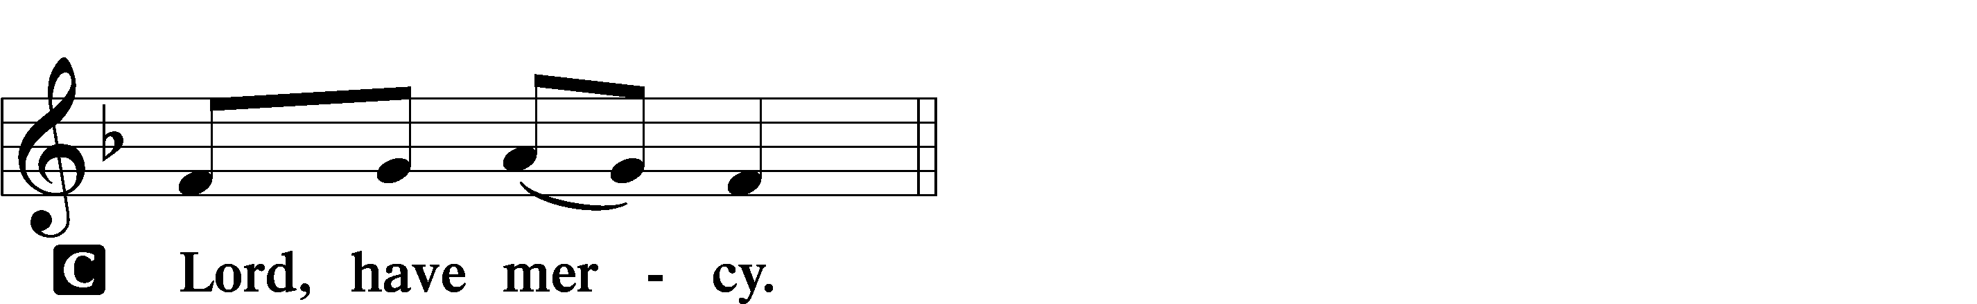
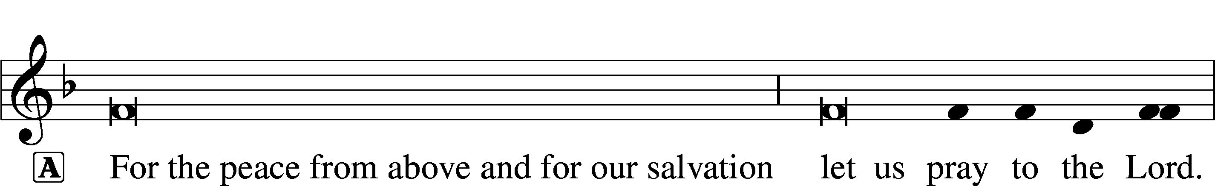
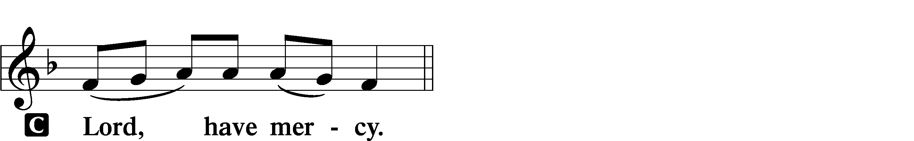
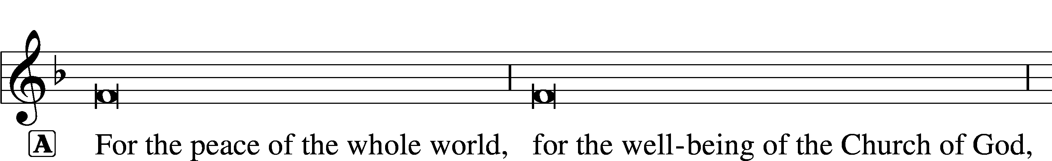

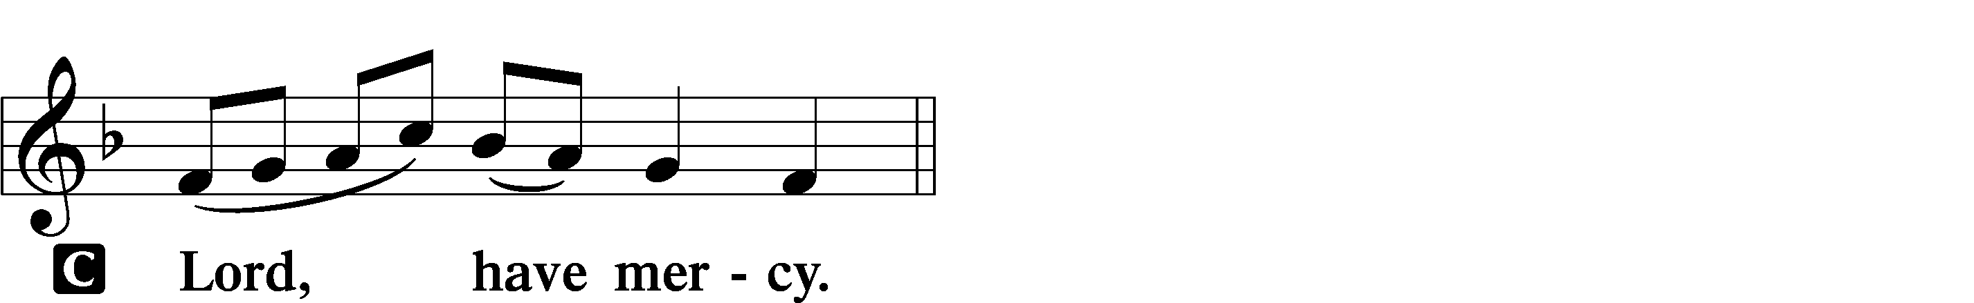
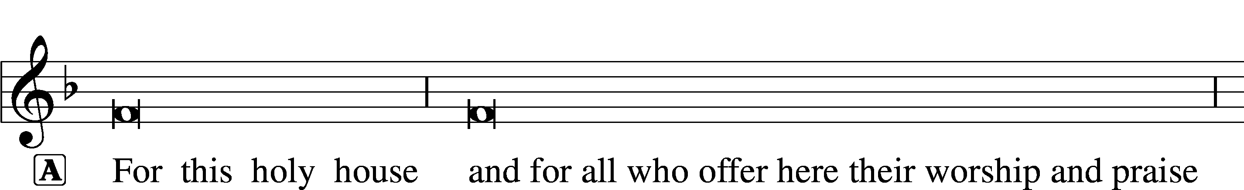

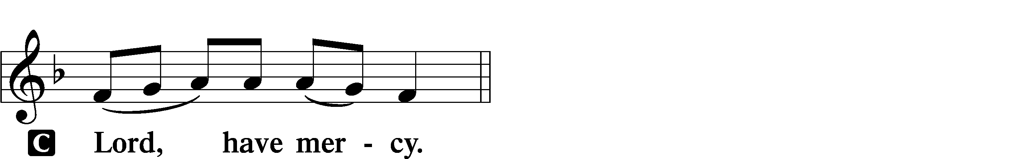



THIS IS THE FEAST LSB 155
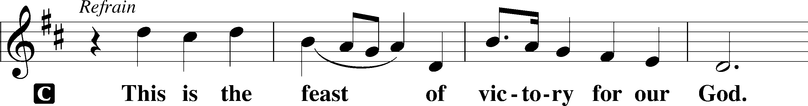
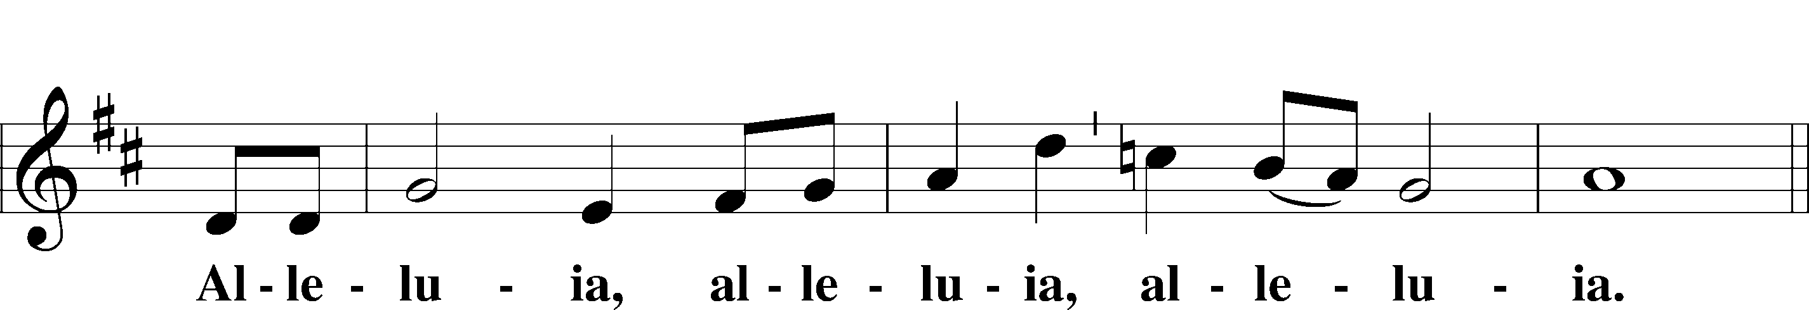
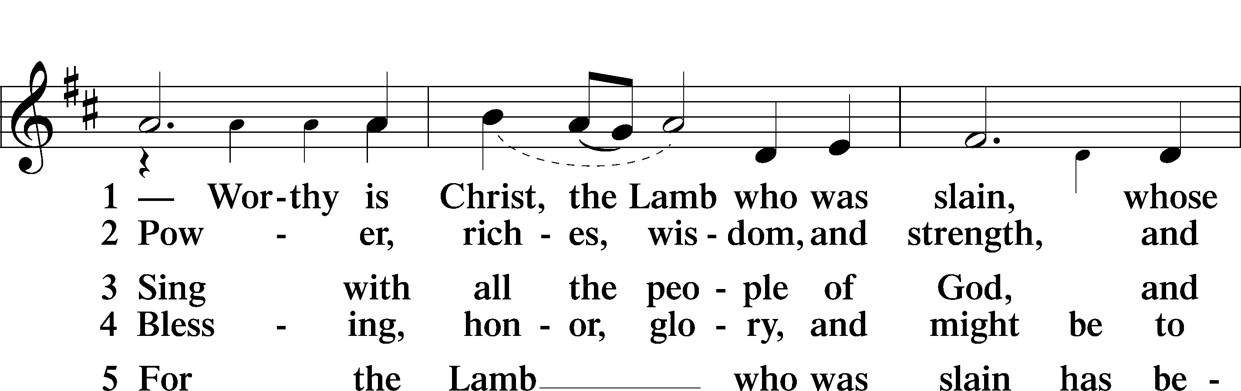
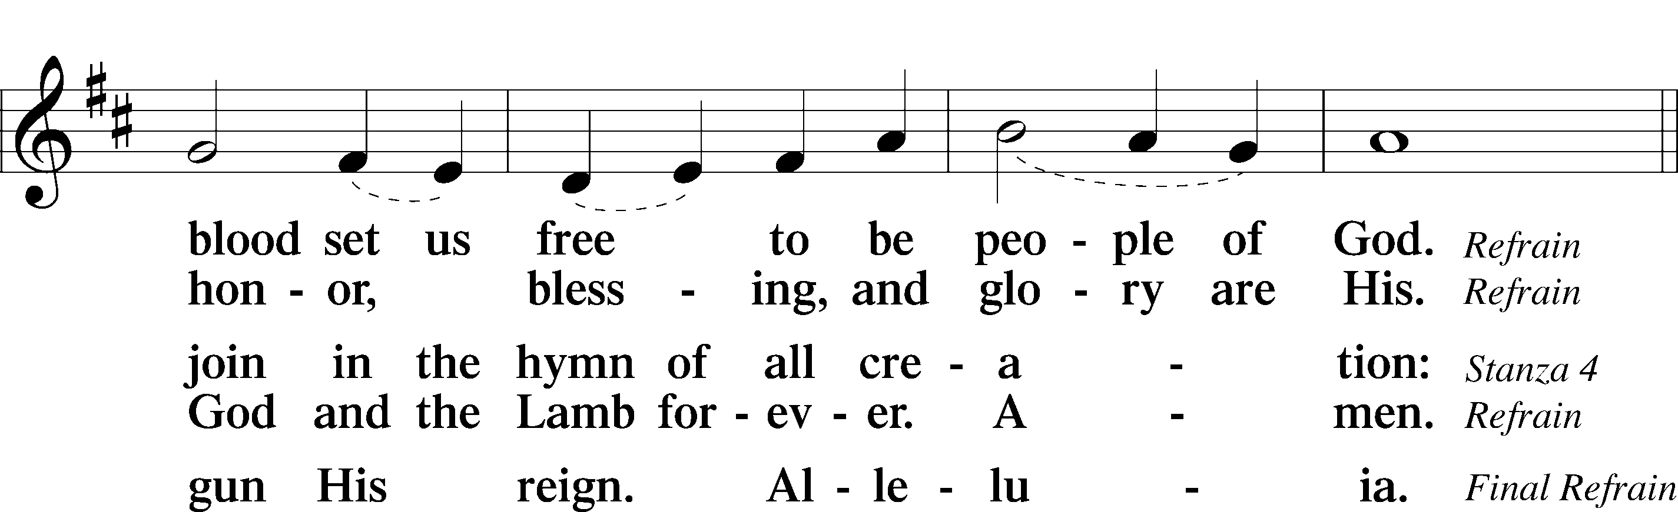
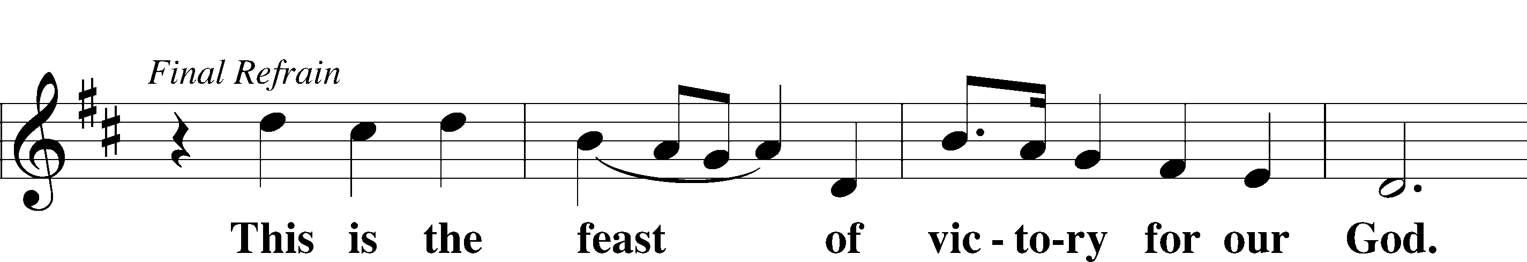
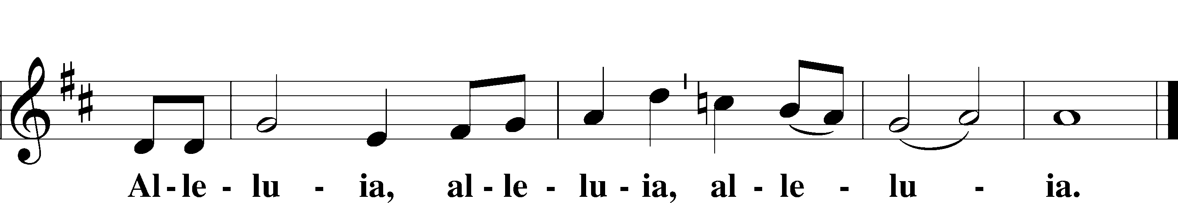

SALUTATION AND COLLECT OF THE DAY
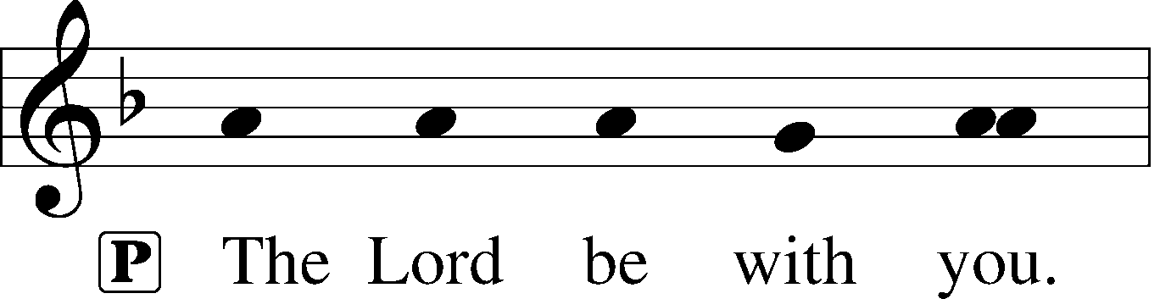
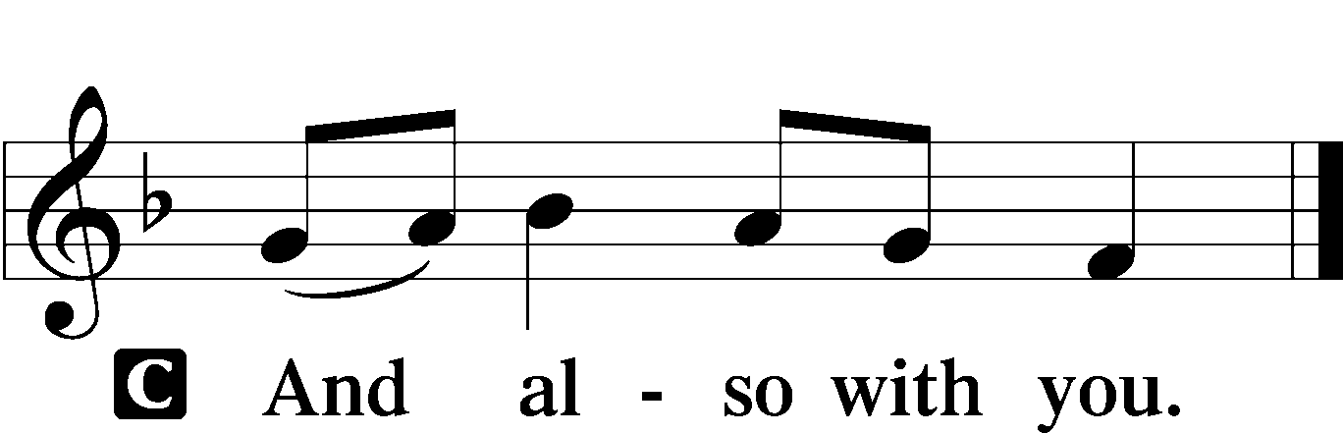

P Let us pray.
O God, our refuge and strength, the author of all godliness, hear the devout prayers of Your Church, especially in times of persecution, and grant that what we ask in faith we may obtain; through Jesus Christ, our Lord, who lives and reigns with You and the Holy Spirit, one God, now and forever.

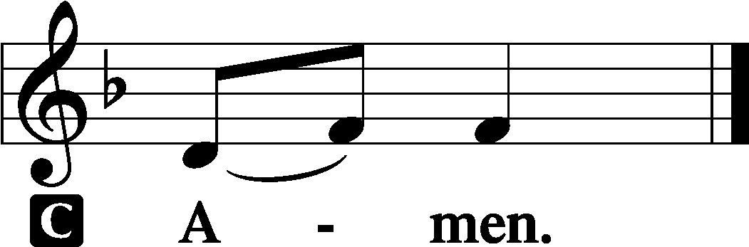

Sit

OLD TESTAMENT READING Genesis 50:15–21
15When Joseph’s brothers saw that their father was dead, they said, “It may be that Joseph will hate us and pay us back for all the evil that we did to him.” 16So they sent a message to Joseph, saying, “Your father gave this command before he died, 17‘Say to Joseph, Please forgive the transgression of your brothers and their sin, because they did evil to you.’ And now, please forgive the transgression of the servants of the God of your father.” Joseph wept when they spoke to him. 18His brothers also came and fell down before him and said, “Behold, we are your servants.” 19But Joseph said to them, “Do not fear, for am I in the place of God? 20As for you, you meant evil against me, but God meant it for good, to bring it about that many people should be kept alive, as they are today. 21So do not fear; I will provide for you and your little ones.” Thus he comforted them and spoke kindly to them.

A This is the Word of the Lord.
C Thanks be to God.

GRADUAL
Fear the Lord, | you his saints,*
for those who fear him lack | nothing!
Many are the afflictions of the | righteous,*
but the Lord delivers him out | of them all.

EPISTLE Romans 15
1We who are strong have an obligation to bear with the failings of the weak, and not to please ourselves. 2Let each of us please his neighbor for his good, to build him up. 3For Christ did not please himself, but as it is written, “The reproaches of those who reproached you fell on me.” 4For whatever was written in former days was written for our instruction, that through endurance and through the encouragement of the Scriptures we might have hope. 5May the God of endurance and encouragement grant you to live in such harmony with one another, in accord with Christ Jesus, 6that together you may with one voice glorify the God and Father of our Lord Jesus Christ. 7Therefore welcome one another as Christ has welcomed you, for the glory of God.
8For I tell you that Christ became a servant to the circumcised to show God’s truthfulness, in order to confirm the promises given to the patriarchs, 9and in order that the Gentiles might glorify God for his mercy. As it is written,
“Therefore I will praise you among the Gentiles,
and sing to your name.”
10And again it is said,
“Rejoice, O Gentiles, with his people.”
11And again,
“Praise the Lord, all you Gentiles,
and let all the peoples extol him.”
12And again Isaiah says,
“The root of Jesse will come,
even he who arises to rule the Gentiles;
in him will the Gentiles hope.”
13May the God of hope fill you with all joy and peace in believing, so that by the power of the Holy Spirit you may abound in hope.
14I myself am satisfied about you, my brothers, that you yourselves are full of goodness, filled with all knowledge and able to instruct one another. 15But on some points I have written to you very boldly by way of reminder, because of the grace given me by God 16to be a minister of Christ Jesus to the Gentiles in the priestly service of the gospel of God, so that the offering of the Gentiles may be acceptable, sanctified by the Holy Spirit. 17In Christ Jesus, then, I have reason to be proud of my work for God. 18For I will not venture to speak of anything except what Christ has accomplished through me to bring the Gentiles to obedience—by word and deed, 19by the power of signs and wonders, by the power of the Spirit of God—so that from Jerusalem and all the way around to Illyricum I have fulfilled the ministry of the gospel of Christ; 20and thus I make it my ambition to preach the gospel, not where Christ has already been named, lest I build on someone else’s foundation, 21but as it is written,
“Those who have never been told of him will see,
and those who have never heard will understand.”
22This is the reason why I have so often been hindered from coming to you. 23But now, since I no longer have any room for work in these regions, and since I have longed for many years to come to you, 24I hope to see you in passing as I go to Spain, and to be helped on my journey there by you, once I have enjoyed your company for a while. 25At present, however, I am going to Jerusalem bringing aid to the saints. 26For Macedonia and Achaia have been pleased to make some contribution for the poor among the saints at Jerusalem. 27They were pleased to do it, and indeed they owe it to them. For if the Gentiles have come to share in their spiritual blessings, they ought also to be of service to them in material blessings. 28When therefore I have completed this and have delivered to them what has been collected, I will leave for Spain by way of you. 29I know that when I come to you I will come in the fullness of the blessing of Christ.
30I appeal to you, brothers, by our Lord Jesus Christ and by the love of the Spirit, to strive together with me in your prayers to God on my behalf, 31that I may be delivered from the unbelievers in Judea, and that my service for Jerusalem may be acceptable to the saints, 32so that by God’s will I may come to you with joy and be refreshed in your company. 33May the God of peace be with you all. Amen.

A This is the Word of the Lord.
C Thanks be to God.

Stand

ALLELUIA AND VERSE LSB 156
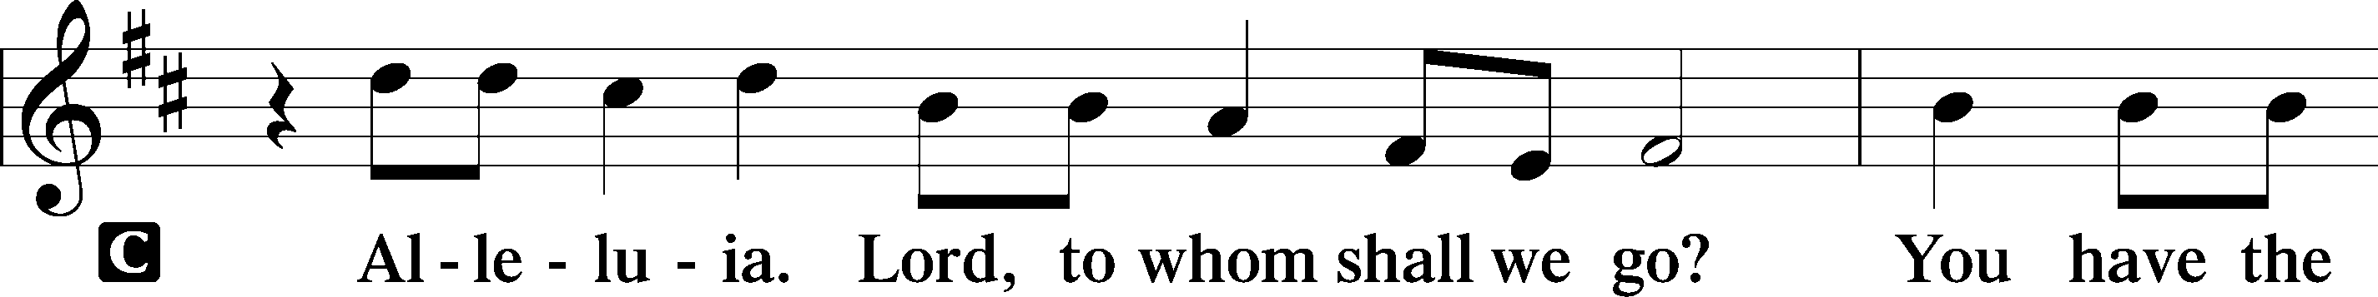
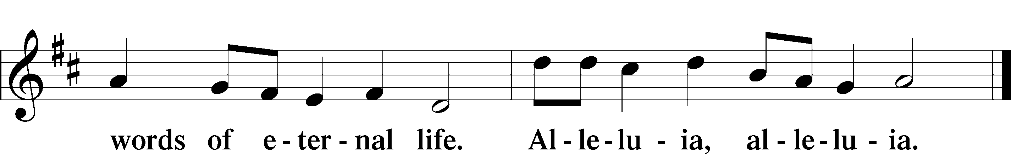

HOLY GOSPEL Matthew 18:21–35
P The Holy Gospel according to St. Matthew, the eighteenth chapter.

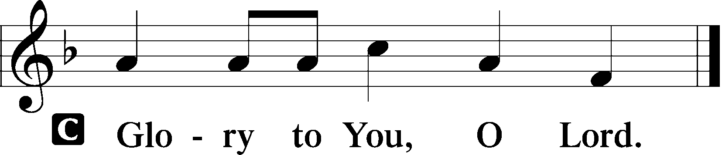

21Peter came up and said to [Jesus], “Lord, how often will my brother sin against me, and I forgive him? As many as seven times?” 22Jesus said to him, “I do not say to you seven times, but seventy times seven.
23“Therefore the kingdom of heaven may be compared to a king who wished to settle accounts with his servants. 24When he began to settle, one was brought to him who owed him ten thousand talents. 25And since he could not pay, his master ordered him to be sold, with his wife and children and all that he had, and payment to be made. 26So the servant fell on his knees, imploring him, ‘Have patience with me, and I will pay you everything.’ 27And out of pity for him, the master of that servant released him and forgave him the debt. 28But when that same servant went out, he found one of his fellow servants who owed him a hundred denarii, and seizing him, he began to choke him, saying, ‘Pay what you owe.’ 29So his fellow servant fell down and pleaded with him, ‘Have patience with me, and I will pay you.’ 30He refused and went and put him in prison until he should pay the debt. 31When his fellow servants saw what had taken place, they were greatly distressed, and they went and reported to their master all that had taken place. 32Then his master summoned him and said to him, ‘You wicked servant! I forgave you all that debt because you pleaded with me. 33And should not you have had mercy on your fellow servant, as I had mercy on you?’ 34And in anger his master delivered him to the jailers, until he should pay all his debt. 35So also my heavenly Father will do to every one of you, if you do not forgive your brother from your heart.”

P This is the Gospel of the Lord.

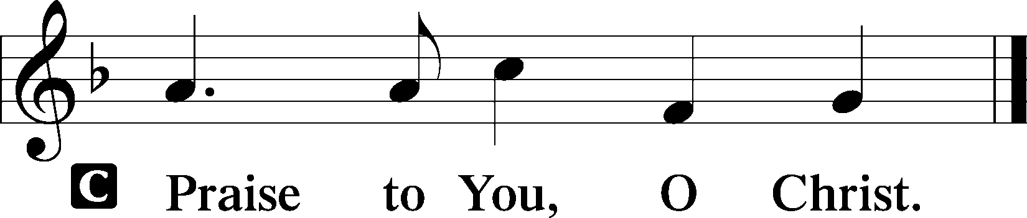

Sit

CHILDREN'S MESSAGE

HYMN OF THE DAY

496 HOLY SPIRIT, LIGHT DIVINE

1 Holy Spirit, light divine,
Shine upon this heart of mine;
Chase the shades of night away,
Turn the darkness into day.

2 Let me see my Savior’s face,
Let me all His beauties trace;
Show those glorious truths to me
Which are only known to Thee.

3 Holy Spirit, pow’r divine,
Cleanse this guilty heart of mine;
In Thy mercy pity me,
From sin’s bondage set me free.

4 Holy Spirit, joy divine,
Cheer this saddened heart of mine;
Yield a sacred, settled peace,
Let it grow and still increase.

5 Holy Spirit, all divine,
Dwell within this heart of mine;
Cast down ev’ry idol throne,
Reign supreme, and reign alone.

SERMON Rev. Shaun Daugherty

Stand

APOSTLES’ CREED
C I believe in God, the Father Almighty, maker of heaven and earth.

And in Jesus Christ, His only Son, our Lord, who was conceived by the Holy Spirit, born of the virgin Mary, suffered under Pontius Pilate, was crucified, died and was buried. He descended into hell. The third day He rose again from the dead. He ascended into heaven and sits at the right hand of God the Father Almighty. From thence He will come to judge the living and the dead.

I believe in the Holy Spirit, the holy Christian Church, the communion of saints, the forgiveness of sins, the resurrection of the body, and the life T everlasting. Amen.

PRAYER OF THE CHURCH
After each petition:
P Lord, in Your mercy,
C hear our prayer.

Sit

COLLECTION OF TITHES AND OFFERING

Stand

OFFERTORY LSB 159
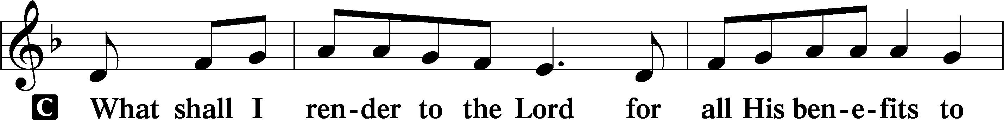
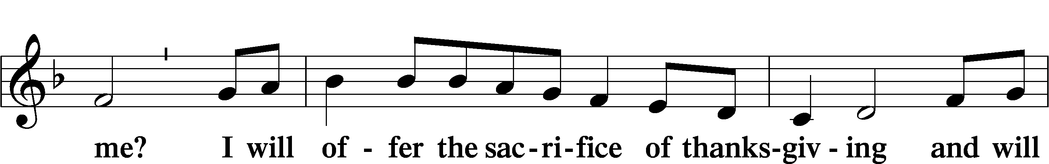
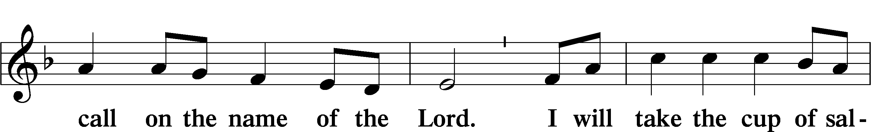
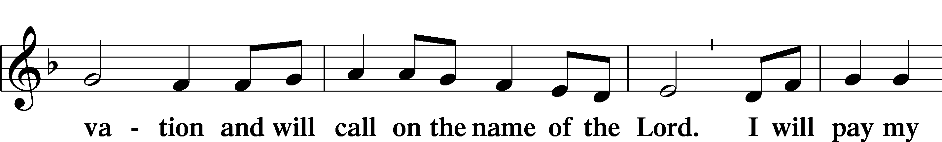
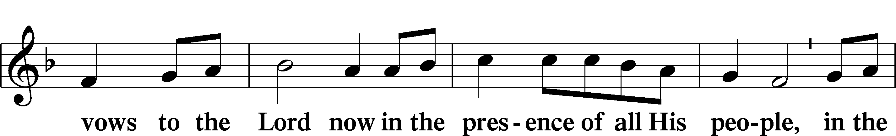
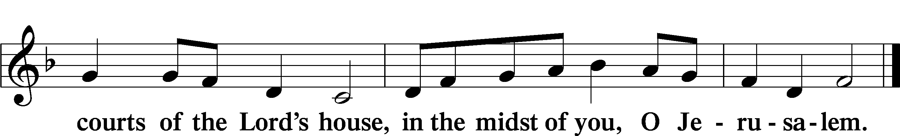
+ Service of the Sacrament +
As God's baptized and forgiven people, we gather at His invitation to receive The Lord's Supper.

The Lord’s Supper is celebrated at this congregation in the confession and glad confidence that, as he says, our Lord gives into our mouths not only bread and wine but His very body and blood to eat and to drink for the forgiveness of sins and to strengthen our union with him and with one another. Our Lord invites to his table those Baptized Christians who trust his words, repent of all sin, and set aside any refusal to forgive and love as he forgives and loves us, that they may show forth his death until he comes.

Because those who eat and drink our Lord’s body and blood unworthily do so to their great harm and because Holy Communion is a confession of the faith which is confessed at this altar, any who are not yet instructed, in doubt, or who hold a confession differing from that of this congregation and The Lutheran Church— Missouri Synod, and yet desire to receive the sacrament, are asked first to speak with the pastor or an elder.
For further study, see Matthew 5:23f.; 10:32f.; 18:15-35; 26:26-29; 1 Cor. 11:17- 34.

PREFACE LSB 160





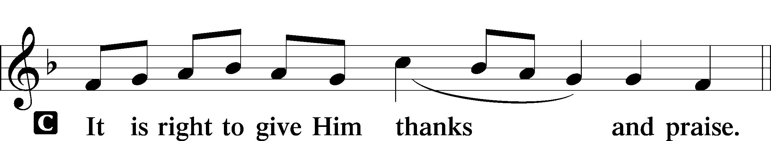

PROPER PREFACE LSB 161
P It is truly good, right, and salutary . . . evermore praising You and saying:

SANCTUS LSB 161
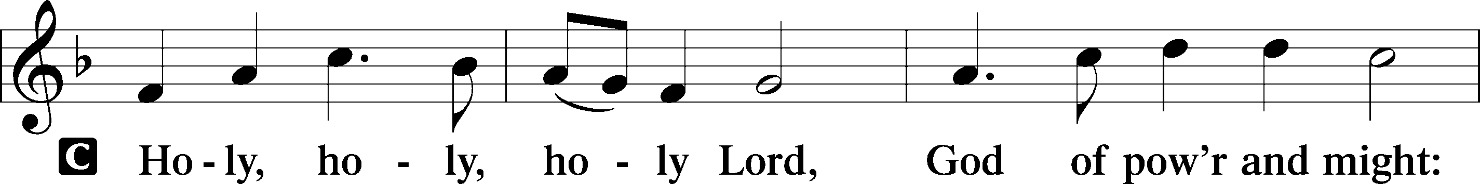
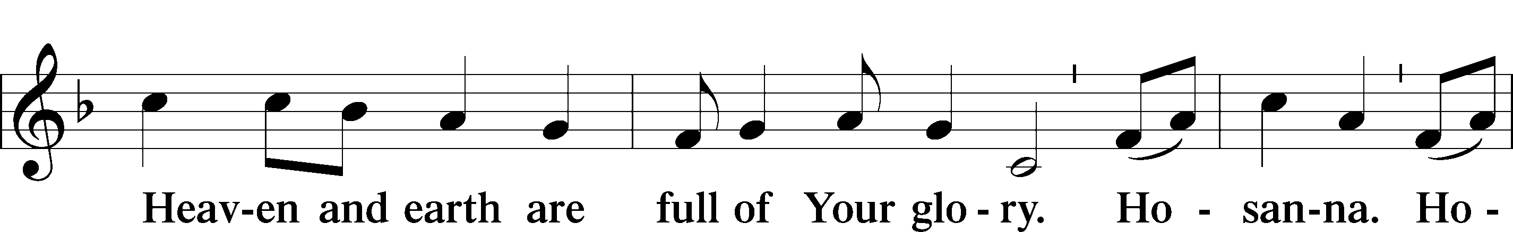
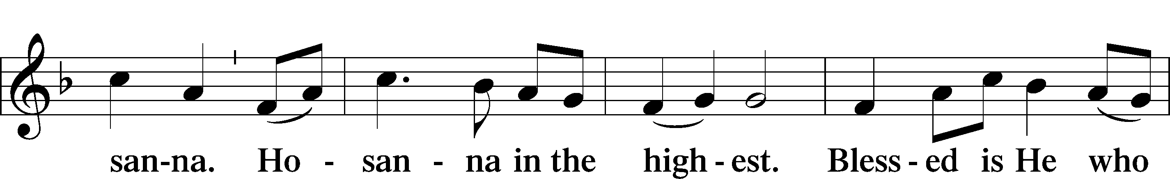
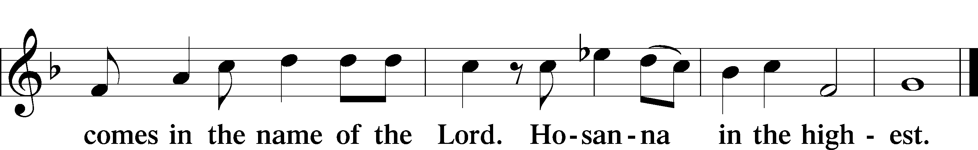

PRAYER OF THANKSGIVING 161
P Blessed are You, Lord of heaven and earth, for You have had mercy on those whom You created and sent Your only-begotten Son into our flesh to bear our sin and be our Savior. With repentant joy we receive the salvation accomplished for us by the all-availing sacrifice of His body and His blood on the cross.

Gathered in the name and the remembrance of Jesus, we beg You, O Lord, to forgive, renew, and strengthen us with Your Word and Spirit. Grant us faithfully to eat His body and drink His blood as He bids us do in His own testament. Gather us together, we pray, from the ends of the earth to celebrate with all the faithful the marriage feast of the Lamb in His kingdom, which has no end. Graciously receive our prayers; deliver and preserve us. To You alone, O Father, be all glory, honor, and worship, with the Son and the Holy Spirit, one God, now and forever.
C Amen.

THE WORDS OF OUR LORD

PROCLAMATION OF CHRIST
P As often as we eat this bread and drink this cup, we proclaim the Lord’s death until He comes.
C Amen. Come, Lord Jesus.

P O Lord Jesus Christ, only Son of the Father, in giving us Your body and blood to eat and to drink, You lead us to remember and confess Your holy cross and passion, Your blessed death, Your rest in the tomb, Your resurrection from the dead, Your ascension into heaven, and Your coming for the final judgment. So remember us in Your kingdom and teach us to pray:

LORD’S PRAYER
C Our Father who art in heaven, hallowed be Thy name, Thy kingdom come, Thy will be done on earth as it is in heaven; give us this day our daily bread; and forgive us our trespasses as we forgive those who trespass against us; and lead us not into temptation, but deliver us from evil. For Thine is the kingdom and the power and the glory forever and ever. Amen.

PAX DOMINI LSB 163
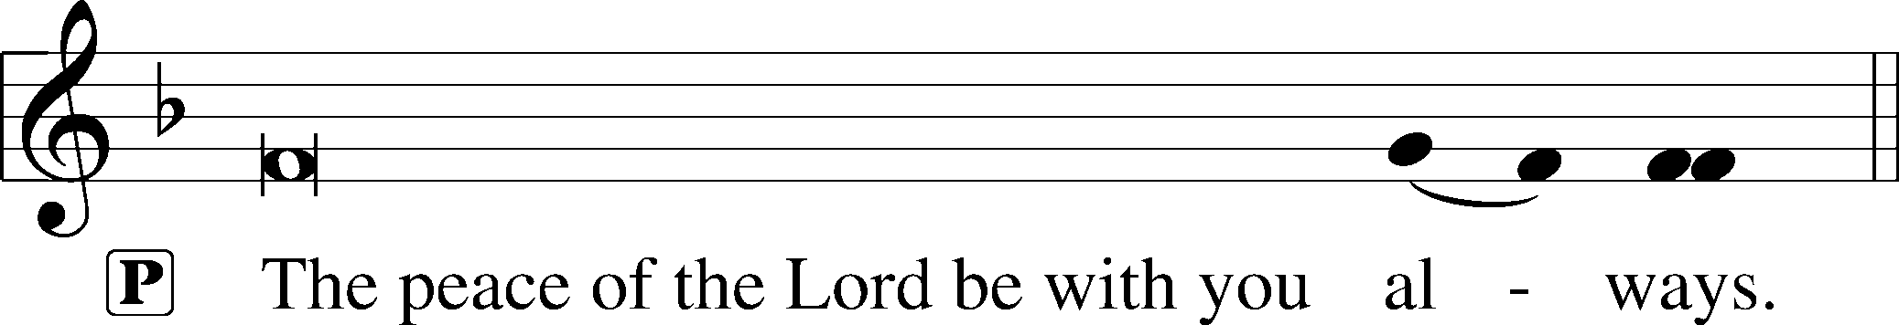


AGNUS DEI LSB 163
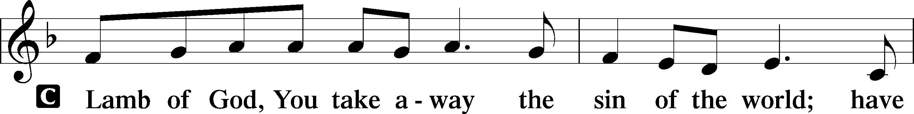
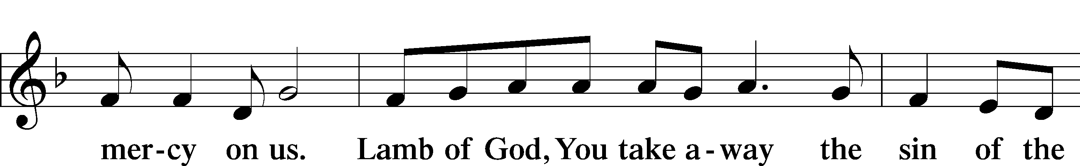

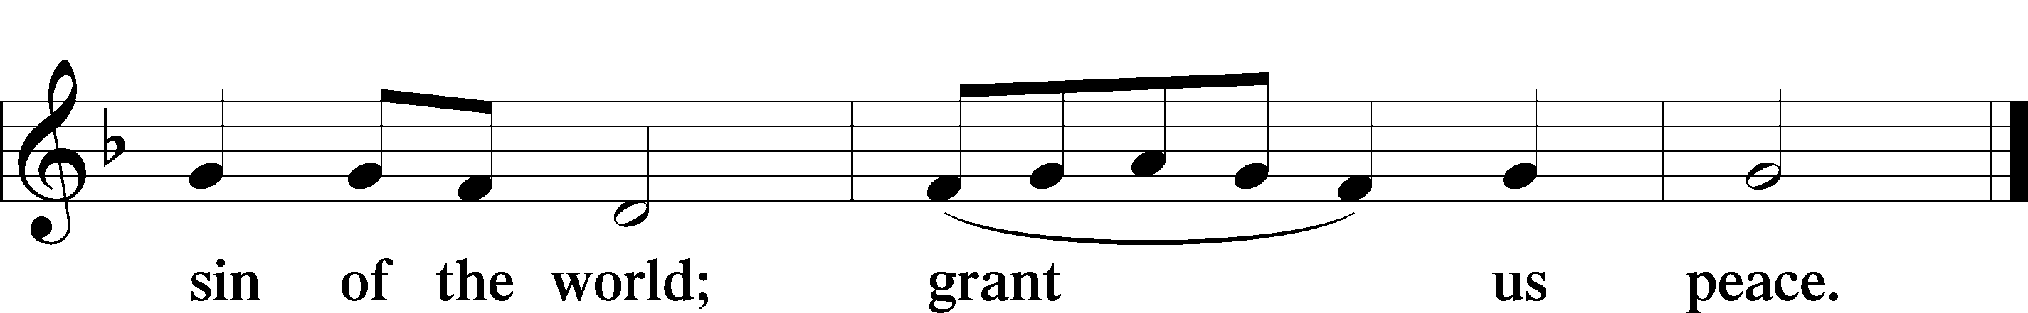

Following the Agnus Dei, please greet one another in the name of the Lord, saying, “Peace be with you,” as a sign of reconciliation and of the unity of the Spirit in the bond of peace (Matt. 5:22–24; Eph. 4:1–3).

Sit
DISTRIBUTION HYMNS
760 WHAT GOD ORDAINS IS ALWAYS GOOD

1 What God ordains is always good:
His will is just and holy.
As He directs my life for me,
I follow meek and lowly.
My God indeed
In ev’ry need
Knows well how He will shield me;
To Him, then, I will yield me.

2 What God ordains is always good:
He never will deceive me;
He leads me in His righteous way,
And never will He leave me.
I take content
What He has sent;
His hand that sends me sadness
Will turn my tears to gladness.

3 What God ordains is always good:
His loving thought attends me;
No poison can be in the cup
That my physician sends me.
My God is true;
Each morning new
I trust His grace unending,
My life to Him commending.

4 What God ordains is always good:
He is my friend and Father;
He suffers naught to do me harm
Though many storms may gather.
Now I may know
Both joy and woe;
Someday I shall see clearly
That He has loved me dearly.

5 What God ordains is always good:
Though I the cup am drinking
Which savors now of bitterness,
I take it without shrinking.
For after grief
God gives relief,
My heart with comfort filling
And all my sorrow stilling.
6 What God ordains is always good:
This truth remains unshaken.
Though sorrow, need, or death be mine,
I shall not be forsaken.
I fear no harm,
For with His arm
He shall embrace and shield me;
So to my God I yield me.

611 CHIEF OF SINNERS THOUGH I BE

1 Chief of sinners though I be,
Jesus shed His blood for me,
Died that I might live on high,
Lives that I might never die.
As the branch is to the vine,
I am His, and He is mine.

2 Oh, the height of Jesus’ love,
Higher than the heav’ns above,
Deeper than the depths of sea,
Lasting as eternity!
Love that found me—wondrous thought!
Found me when I sought Him not.

3 Only Jesus can impart
Balm to heal the wounded heart,
Peace that flows from sin forgiv’n,
Joy that lifts the soul to heav’n,
Faith and hope to walk with God
In the way that Enoch trod.

4 Chief of sinners though I be,
Christ is all in all to me;
All my wants to Him are known,
All my sorrows are His own.
He sustains the hidden life
Safe with Him from earthly strife.

5 O my Savior, help afford
By Your Spirit and Your Word!
When my wayward heart would stray,
Keep me in the narrow way;
Grace in time of need supply
While I live and when I die.

351 CREATOR OF THE STARS OF NIGHT

1 Creator of the stars of night,
Thy people’s everlasting Light:
O Christ, Redeemer, save us all
And hear Thy servants when they call.

2 Thou, grieving that the ancient curse
Should doom to death a universe,
Hast found the healing, full of grace,
To cure and save our ruined race.

3 Thou cam’st the Bridegroom of the bride,
As drew the world to eventide,
The spotless Victim all divine
Proceeding from a virgin shrine.

4 At whose dread name, majestic now,
All knees must bend, all hearts must bow;
All things celestial Thee shall own,
And things terrestrial, Lord alone.

5 O Thou, whose coming is with dread
To judge the living and the dead,
Preserve us from the ancient foe
While still we dwell on earth below.

D 6 To God the Father and the Son
And Holy Spirit, Three in One,
Praise, honor, might, and glory be
From age to age eternally. Amen.

Stand

DISMISSAL

THANK THE LORD LSB 164
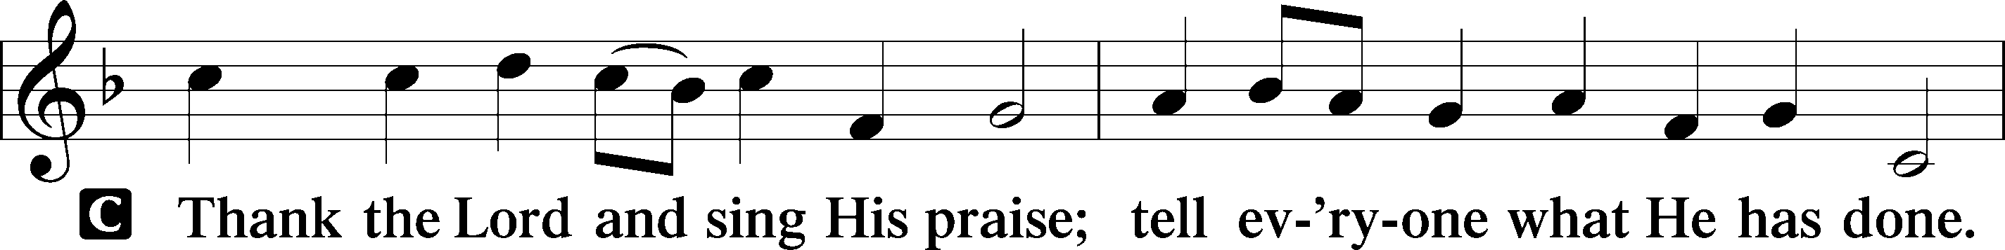
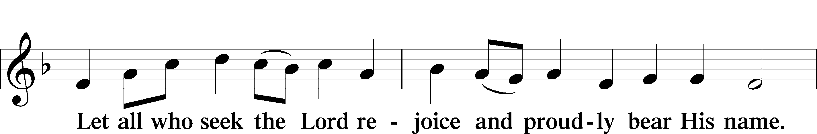
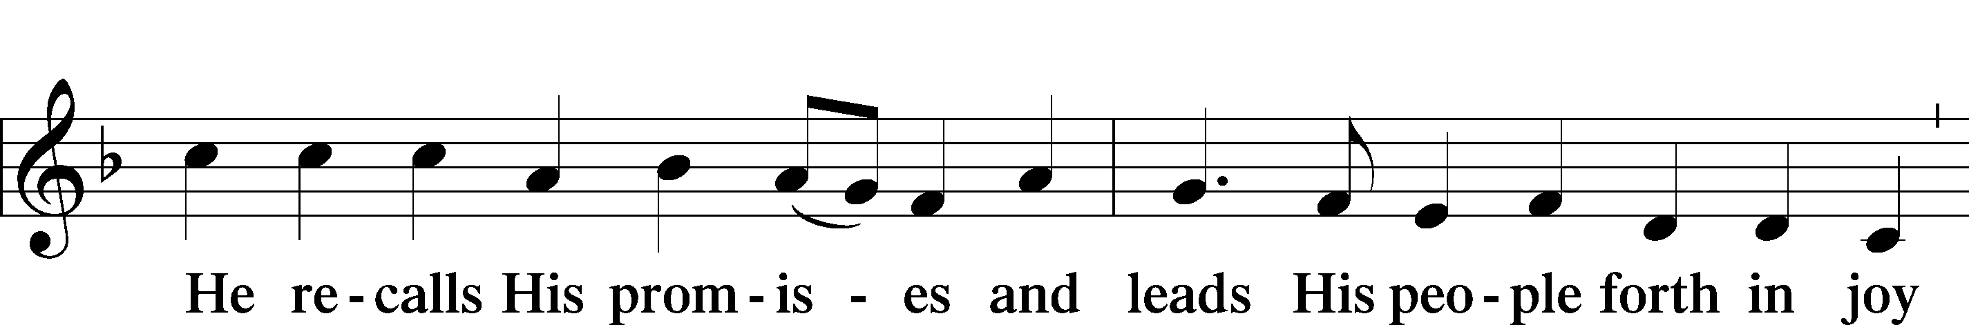
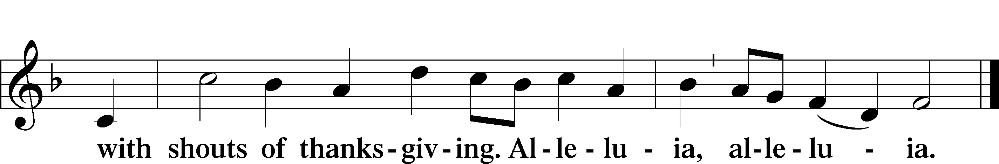

POST-COMMUNION COLLECT

BENEDICTION LSB 166
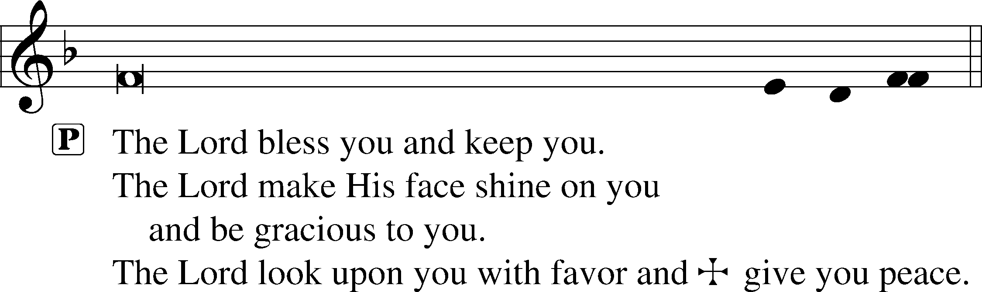


RECESSIONAL HYMN
513 THE CLOUDS OF JUDGMENT GATHER

1 The clouds of judgment gather,
The time is growing late;
Be sober and be watchful,
Our judge is at the gate:
The judge who comes in mercy,
The judge who comes in might
To put an end to evil
And diadem the right.

2 Arise, O true disciples;
Let wrong give way to right,
And penitential shadow
To Jesus’ blessèd light:
The light that has no evening,
That knows no moon or sun,
The light so new and golden,
The light that is but one.

3 The home of fadeless splendor,
Of blooms that bear no thorn,
Where they shall dwell as children
Who here as exiles mourn;
The peace of all the faithful,
The calm of all the blest,
Inviolate, unfading,
Divinest, sweetest, best.

4 Oh, happy, holy portion,
Relief for all distressed,
True vision of true beauty,
Refreshment for the blest!
Strive now to win that glory,
Toil now to gain that light;
Send hope ahead to grasp it
Till hope be lost in sight.

ANNOUNCEMENTS
See the announcements and prayer guide at the end of the bulletin.

SENDING
P Let us pray.
Lord God, You have called Your servants to ventures of which we cannot see the ending, by paths as yet untrodden, through perils unknown. Give us faith to go out with good courage, not knowing where we go but only that Your hand is leading us and Your love supporting us; through Jesus Christ, our Lord.
C Amen

P Go in peace to serve the Lord.
C Thanks be to God.

THIS WEEK AT FAITH

Sunday Sept. 13 Bible Study 8:30am
Fellowship 9:30am
Worship 10:00am
Mon-Fri Sept. 14-18 Chapel 8:30am
Tuesday Sept. 15 Create in Me Crafting 10:00am
Wednesday Sept. 16 Dinner 5:30pm
Adult Bible Studies 6:30 pm
Confirmation & Youth Group
Saturday Sept. 19 Sharing & Caring Festival 7:00am
Sunday Sept. 20 Bible Studies 8:30am
Fellowship 9:30am
Worship 10:00am

CHURCH ANNOUNCEMENTS

BACK PARKING LOT CLOSED – September 14-15
Please note that the back parking lot will be temporarily relocated to the front entrance of the school on September 14 and 15 while the security gate installation is completed. The work is scheduled to be completed by the end of the day on September 15. We expect the back parking lot to open by Wednesday, September 16. We apologize for any inconvenience and greatly appreciate your patience and understanding during this time.

PRIVATE CONFESSION AND ABSOLUTION - available Monday-Thursday 4:30-5:30pm
In the Church, God daily and richly forgives our sins. This forgiveness (absolution) is a gift we receive in worship each week. It is also available to you personally in order to comfort you with Christ's victory in the battle against sin and the devil. Whether you are particularly troubled by sin, or simply desire to receive the absolution personally, you are welcomed. Appointments are preferred so that Pastor can set aside dedicated time for you.

WEDNESDAY NIGHTS ARE BACK - Family dinner at 5:30pm, special programming 6:30-8
Every Wednesday night we start with a family dinner at 5:30 followed by special programming 6:30-8 for the whole family (including confirmation, youth group, adult Bible studies, choir practice and handbells practice). The menu for September 16th: Hamburgers, tater tots, fruit and cake.

SHARING & CARING FESTIVAL - Saturday, September 19
Volunteers for the Sharing & Caring Festival: meet in the parking lot in front of the school at 7:00 a.m. We will carpool to the event and meet with volunteers from other Lutheran churches to distribute gift cards, clothing, and personal-use items. This is a wonderful opportunity to serve and share Christ’s love with members of our community who are less fortunate. If children attend, we recommend they only be older children, if you do bring a younger child, please be sure to supervise them at all times. For more information, call or text Ron Shultheiss at 770-846-4317. Thank you for your generosity, support, and willingness to help us serve our community!

MENS CAMPING RETREAT - September 24-26th
Men of Faith, join us for a weekend dedicated to brotherhood and authentic fellowship. Choose your own adventure Tent, Cabin, Pole Barn (Indoor cabin spaces are first-come, first-serve basis). Location of the Irvin’s property is in Upson County roughly 95 miles from church. If you have questions, please contact Ward Irvin. You can see more at faithmarietta.com/mensretreat

LWML ZONE RALLY - Oct 3, 9-2:00 pm
Registration is $15 (includes lunch, pay at the rally) please make checks payable to LWML FL-GA Atlanta Zone Rally. Gifts from the Heart (handmade or purchased) LWML is collecting small or medium-size teddy bears (sewn eyes) for local Police and Fire Departments, these gifts are given to children who have experienced traumatic events. Please leave teddy bears in the narthex. Contact Louise Cox 478-957-7332 to RSVP, you can find more information at faithmarietta.com/lwml

NEW MEMBER CLASS (Adult Confirmation) - Start Sunday, October 4, 11:15am
Classes begin Sunday, October 4, 2026 at 11:15am in the Sanctuary. This 6-week class will focus on the Doctrine of the Christian Church as taught in Luther's Small Catechism. This is required for those who are not currently members of a congregation of the Lutheran Church – Missouri Synod (LCMS). Contact Pastor Shaun to be added to the class.

FAITH SCHOOL PRAYERS - October 13, 9:00am
The School Prayer group meets the 2nd Tuesday of the month, at 9:00am in the craft room. Dates are Oct 13th, Nov 10th, Dec 8th. Call or text Norma Palmer at (256-653-8349) for more information.

LUTHERAN COALITION FOR HABITAT - BUILD PROJECT
Lutheran Coalition for Habitat is sponsoring a build this fall in Austell, GA, and has volunteer
opportunities available. Work days will be Saturdays from 7:45am – 4pm. Opportunities include;
9/19: Interior framing, 10/10: Exterior paint, 10/17: Interior prep and trim, 10/31: Painting and trim work, 11/7: Paint and punchout day, 11/14: Landscaping
Contact Laura Elston at laura.elston2@gmail.com for more information or to sign up to work
on the house.

REFORMATION FESTIVAL - October 30, 5:00-7:00pm
Reformation Festival will feature a Trunk-or-Treat, be sure to mark your calendars for our next community event. Stay tuned for more details!

FAITH LUTHERAN NEW MEMBER ORIENTATION - Sunday November 15, 11:15am
Orientation is a 1-week introduction to Faith for those transferring AND for those who have just finished Adult Confirmation. Please Contact Pastor Shaun to be added to the class.

NEW MEMBER SUNDAY - November 22, 10:00am
Join us this day as new members will be formally received during Worship. Please welcome them into our Faith Family by visiting afterwards at the Welcoming Luncheon.


ONE FAITH
Family Devotions for the Week of September 13, 2026
THEME: Rooted in Christ - Not Carried Away

by Pastor Shaun

“…take care that you are not carried away with the error of lawless people and lose your own stability. ¹⁸ But grow in the grace and knowledge of our Lord and Savior Jesus Christ. To him be the glory both now and to the day of eternity. Amen. (2 Peter 3:7-8 ESV)

DEVOTION:
Being ROOTED in CHRIST means we grow in God’s grace.
Can you imagine a healthy plant that never grew? Of course not! Growth is part of having roots deeply planted in good soil. So also, with you and me. Growth is part of a life ROOTED in God’s Word. We feed on the Word each day. We learn from it and receive life from it. And our growth reflects the goodness of the one in whom we are rooted.
In 2 Peter, the apostle is concerned that if we are not firm in our faith, we will be carried away by the errors of the world. Like a plant, rooted in poor soil (Mark 4:1-20), if our lives are not properly ROOTED in Christ, we will ready targets for the lies of the devil, the world, and our flesh. And if we hear and believe these lies, we will lose our stability.
Our world is, unsurprisingly, filled with lies. We hear lies masquerading as science, telling us that our ORIGIN is not God’s Work (Genesis 1:1), by rather it is the product of millions of years of chance. We hear lies parading as progressive wisdom, telling us that our IDENTITY is not declared with certainty by God (Genesis 1:26-27), who made us “male and female,” but that instead, we can choose to be whomever we wish, even in matters well-established by objective biology. The lies continue, attacking our PURPOSE. We are told that we are not meant to love God and neighbor (Matthew 22:37-40), but instead we are to be unapologetically selfish, looking out for “number 1.”
On and on the lies go. They are on repeat in our world. And repetition is the mother of memory. As a middle school teacher, I would often tell student that “saying something over and over again doesn’t make it true.” But politicians and pundits everywhere know that repeating things, even false things, can convince a broad swath of society to believe them.
Let it not be so with you, dear children of God! Read His Word every day. Memorize it. Let what is repeated into your soul be “the very truth of God and not the invention of any man.” (Creed, Rich Mullens) And in this way you will be ROOTED in CHRIST, growing in grace, stable in all your ways, and not easily carried away by the errors of this world.
-Pastor Shaun

CATECHISM MEMORY:
The Sixth Commandment: You shall not commit adultery.
What does this mean? We should fear and love God so that we lead a sexually pure and decent life in what we say and do, and husband and wife love and honor each other.
READINGS FOR THIS WEEK:
Mon: Matthew 16:13-20
Tue: Matthew 16:21-28
Wed: 2 Peter 1
Thu: 2 Peter 2
Fri: 2 Peter 3
Sat: Romans 16
Sunday, September 13: (Isaiah 55:6-9| Romans 16 | Matthew 20:1-16)

REFLECTION QUESTIONS & ACTIVITIES FOR THE READINGS
- What does each reading teach you about God's Word and its intended effects on our lives?
- What does each reading teach you about how you should receive and respond to God’s Word?
- What does it mean that Jesus is the Christ? (Mon)
- Why does Peter not Jesus to die on the cross? Why is Peter wrong? (Tues)
- How does Peter encourage us in His 2nd epistle to stand firm against the lies of this world and grow in God’s grace? (Wed.-Fri)
- What questions do you have about the readings this week?
(Write them down and share them with Pastor Shaun!)
Prayers for the Week
Let my prayer rise before You as incense…” - Psalm 141:2 Following the instruction of God's Word, we lift our hearts and hands in prayer. As a priesthood of believers called to bear one another’s burdens, we bring our petitions before our heavenly Father.

Please join us in interceding for: MaryLou (recovery from injuries after car accident); Elizabeth (recovery following surgery); Debby Lenord (peace, protection, guidance) //Sandy Skrbanek’s sister; Judy Hamilton (recover from shoulder surgery) // Carol Seelman’s sister-in-law; Sandy (complications from chemotherapy) // friend of Schleichers; Paula Gronemeyer (recovery from stroke, restoration of vision); Makenna (guidance, faith and Christian fellowship); LaJaun (mercy, faith, and wise decision making for her family members); Heidi Fletcher’s mother (recovery following stroke and fall); Nathan (relief and treatment for bulging disc in back) // Jill Musgrove’s son; Allie and her baby (high-risk pregnancy) // sister of Roby Hamilton; Viva Kirk (health and employment); Thanksgiving for the birth of Finnegan to Brittain and Josh Rebuck; Thanksgiving for Shirley’s move to a rehabilitation center // Greg Schaag’s aunt; Janice Schaag (health and peace following diagnosis of a hereditary condition); Steve and his family as he nears the end of his life // father of Phil Manginelli (Phil is Ward’s & Susan’s son-in-law); Brennan Lambert (a quick recovery from jaw surgery); Audrey and Thomas (provision for their needs of body and soul, following a house fire); family of Henshaws; Alex (protection during deployment, safe return to family in October) and his wife, Amanda, and children William, Aurora, & Olivia; Thanksgiving for medical and spiritual care for Tracy Woolery following his recent surgery; Ruth Brown as she mourns the death of her husband // friend of Sandy Skrybanek; Darrell Weers (hospitalized with pneumonia) // brother of George Weers; Thanksgiving for our flourish Youth Group; Beth (suffering from an illness), and her husband Matthew as he cares for her and their children // Marylou’s son; Andrew Hirschler (hospitalization) // former member, friend of Pietros; Caroline O’Neal (cancer); Ramona (recovery from surgery, peace) and her husband John, and children // sister of Rosina Sawh; Gary Griffin (cancer treatment and gallbladder infection) and his wife, Karen // former members, friends of Lamberts; Thanksgiving for progress in recovery for GanneElyse and for the joy of seeing her in worship!; Kyle Laurendine (diagnosed with brain tumor); Thanksgiving for the birth of Charlotte Ross Webb to Ciji Parrish and Craig Webb

ONGOING
For faith and salvation for those who are not yet believers; and repentance for those who have strayed from the faith (especially Jonathan, Bethany, Ean, Bud, Roger, Connor Brett, Mike, Brad, Joel, Ben, Regan, Adam, Corinne, Ana, Samantha, Victoria, Jason, Mike, Josh, Dan, Lisa, Steve, Jessica, Daniel, Hannah, Destiny, Nate, Carol, a member’s brother and sisters, Ben, Bill, Mary, Jack and Jason; along with those others we hold in our heart.); For those who mourn (the families of Joyce Elston, Steven Erny, Jewley Del Duca, and Tom Olson); For members of the Armed Forces of the United States, who protect and defend us (Alex & Brett) ; For our Staff: Pastor Shaun, Headmaster Bradshaw, and all the staff and leaders of Faith Lutheran Church and School (for Godly vision and stewardship; and that the Gospel would be faithfully proclaimed in church and school.); For our Missionaries: Rev. Chris and Dr. Jenny Yang, missionaries to Taiwan; For the families and youth of Faith Lutheran Church & School (that God would grant them steadfast, vibrant faith); For our confirmation students (Daniel, Lily, Zach, Madeline, Isabelle, and Melanie); For more students at Faith Lutheran School, according to God’s will; For faithful leaders of our state and nation.

