

Thirteenth Sunday After Pentecost
August 23, 2026
OUR MISSION: Connecting People to Jesus

Contact us
Faith Lutheran Church & School 2111 Lower Roswell Rd, Marietta, GA 30068 | 770-973-8877

CHURCH: www.faithmarietta.com SCHOOL: www.faithmarietta.org
Rev. Shaun Daugherty, Pastor Mr. Chris Bradshaw, Headmaster
pastor.shaun@faithmarietta.org chris.bradshaw@faithmarietta.org
470-289-9469 470-641-6239
See the full leadership directory: www.faithmarietta.com/leadership
Serving This Month at Faith
 | 8/2/2026 | 8/9/2026 | 8/16/2026 | 8/23/2026 | 8/30/2026
Musicians | Vaunda Noerenberg | Vaunda Noerenberg | Ben Nye | Vaunda Noerenberg | Vaunda Noerenberg
Elders | Ward Irvin  Greg Sinatra | Vinny Caracci  Ward Irvin | Steve Buchtrup  Woody Wood | Russ Couch  Greg Schaag | Jon Cain  Peter Amelingmeier
Reader | Danette Smith | David Barnett | Karen Cerny | Jill Musgrove | Russell Couch
Ushers | Greg Czerwonka  Matthew Czerwonka  Jacob Czerwonka  Luke Czerwonka  Sam Czerwonka | Steve Buchtrup  Mark Patterson  Gary Schleicher  Reagan Gronsbell  Paris Brown | Kim Kaumeyer  David Barnett  Greg Sinatra | Chris Bradshaw  Herman Dean  Bryan Powell  Christian Campbell | Rosina Sawh  Louise Cox  Jamie Bass  Pam Cole
Acolytes | Adam Cain  Amadeo Brown | Josiah Brown  Alex Bradshaw | Adam Cain  Christian Brown | Silas Daugherty  Ryan Cain | Josiah Brown  Eli Bradshaw



Pay Pal

For your convenience,
we now accept gifts
via Venmo or PayPal.

Our Discipleship
Date | 8/9 | 8/16 | 8/23 |  | 2025-2026 (Summary)
Worship | 142/138 | 151/145 |  |  | Avg. Worship | 144
Sunday School | 44 | 29 |  |  | Avg. SS | 35
Gen. Giving | $10,954 | $11,511 | $ |  | Gen. Giving | $676,918
MTD Giving | $24,084 | $35,595 | $ |  | Budgeted Giving | $711,360
 |  |  |  |  | Over/(Under) | ($34,442)
 |  |  |  |  | Other Gifts | $538,821
Monthly Budget | $42,400 | $42,400 | $42,400 |  | Other Gifts | $538,821
FAITH GROWS is our debt reduction account, geared towards eliminating our mortgage.
Please prayerfully consider donating to this fund - over and beyond your normal tithe.

YTD Debt Reduction | $248,588 | Remaining Mortgage Debt | $2,680,644
ALTAR FLOWERS are given today to the Glory of God

+ Confession and Absolution +
We enter the presence of God by humbly confessing our sins and gladly receiving His forgiveness.

Stand

PROCESSIONAL HYMN

913 O HOLY SPIRIT, ENTER IN

1 O Holy Spirit, enter in,
And in our hearts Your work begin,
Your dwelling place now make us.
Sun of the soul, O Light divine,
Around and in us brightly shine,
To joy and gladness wake us
That we may be
Truly living,
To You giving
Prayer unceasing
And in love be still increasing.

2 Give to Your Word impressive pow’r,
That in our hearts from this good hour
As fire it may be glowing,
That in true Christian unity
We faithful witnesses may be,
Your glory ever showing.
Hear us, cheer us
By Your teaching;
Let our preaching
And our labor
Praise You, Lord, and serve our neighbor.

3 O mighty Rock, O Source of life,
Let Your dear Word, in doubt and strife,
In us be strongly burning
That we be faithful unto death
And live in love and holy faith,
From You true wisdom learning.
Your grace and peace
On us shower;
By Your power
Christ confessing,
Let us see our Savior’s blessing.

The sign of the cross may be made by all in remembrance of their Baptism.

INVOCATION
P In the name of the Father and of the T Son and of the Holy Spirit.
C Amen.

P If we say we have no sin, we deceive ourselves, and the truth is not in us.
C But if we confess our sins, God, who is faithful and just, will forgive our sins and cleanse us from all unrighteousness.

Silence for reflection on God’s Word and for self-examination.

CONFESSION AND ABSOLUTION LSB 151
P Let us then confess our sins to God our Father.
C Most merciful God, we confess that we are by nature sinful and unclean. We have sinned against You in thought, word, and deed, by what we have done and by what we have left undone. We have not loved You with our whole heart; we have not loved our neighbors as ourselves. We justly deserve Your present and eternal punishment. For the sake of Your Son, Jesus Christ, have mercy on us. Forgive us, renew us, and lead us, so that we may delight in Your will and walk in Your ways to the glory of Your holy name. Amen.

P Almighty God in His mercy has given His Son to die for you and for His sake forgives you all your sins. As a called and ordained servant of Christ, and by His authority, I therefore forgive you all your sins in the name of the Father and of the T Son and of the Holy Spirit.
C Amen.
Stand
+ Service of the Word +
Having received God's forgiveness, we come before Him with songs of praise, eager to hear His Word.

INTROIT

But we will | bless the Lord*
from this time forth and forevermore. | Praise the Lord!
As for me, I have | set my King*
on Zion, my | holy hill.
I will tell of | the decree:*
The Lord said to me, “You are my Son; today I have be- | gotten you.”
Praise the Lord, all | nations!*
Extol him, all | peoples!
For great is his steadfast | love toward us,*
and the faithfulness of the Lord endures forever. | Praise the Lord!
Glory be to the Father and | to the Son*
and to the Holy | Spirit;
as it was in the be- | ginning,*
is now, and will be forever. | Amen.
But we will | bless the Lord*
from this time forth and forevermore. | Praise the Lord!

KYRIE LSB 152

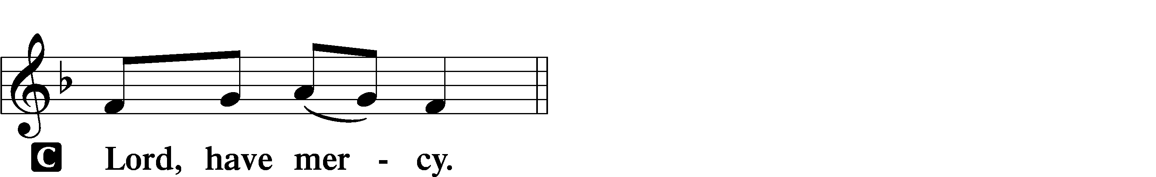
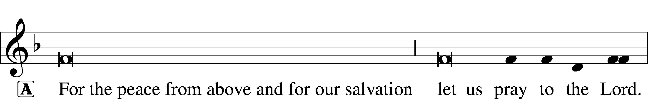
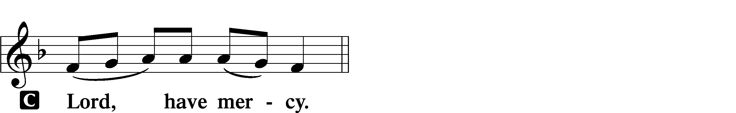
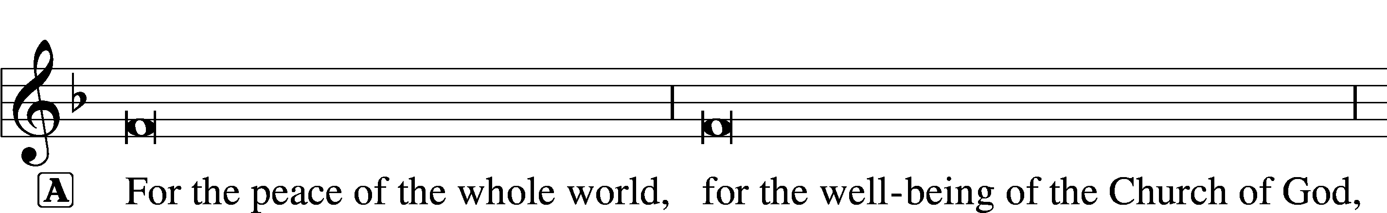

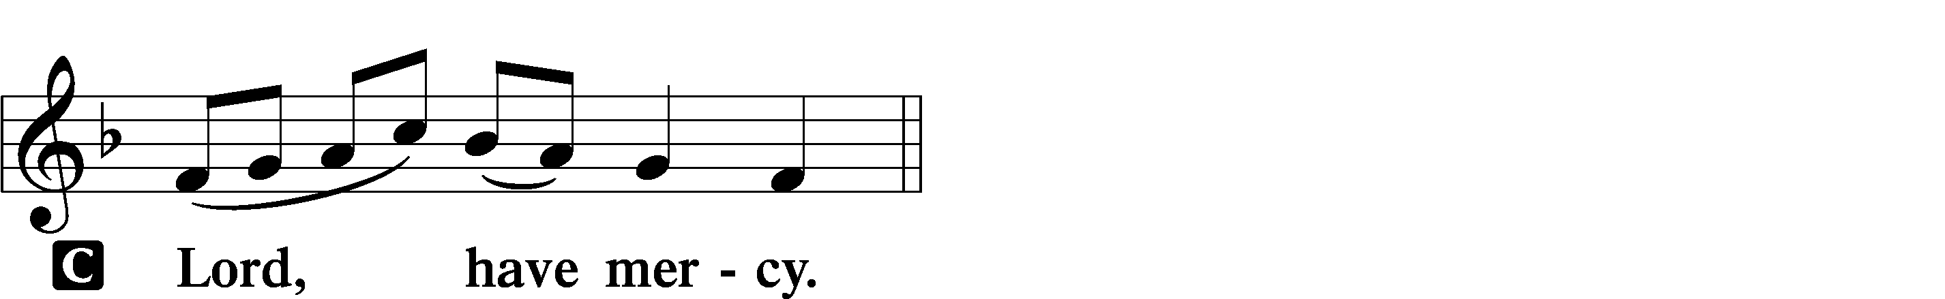
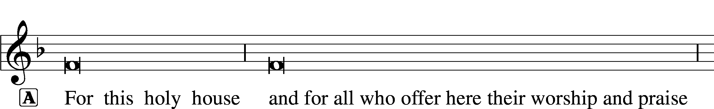

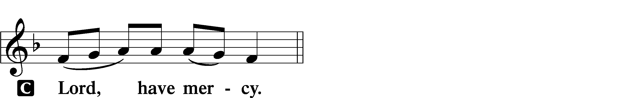



THIS IS THE FEAST LSB 155
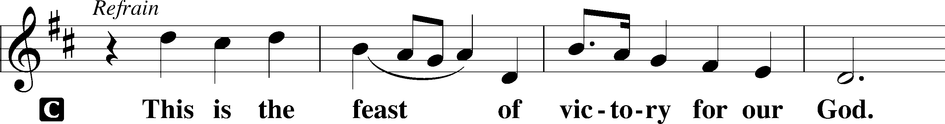
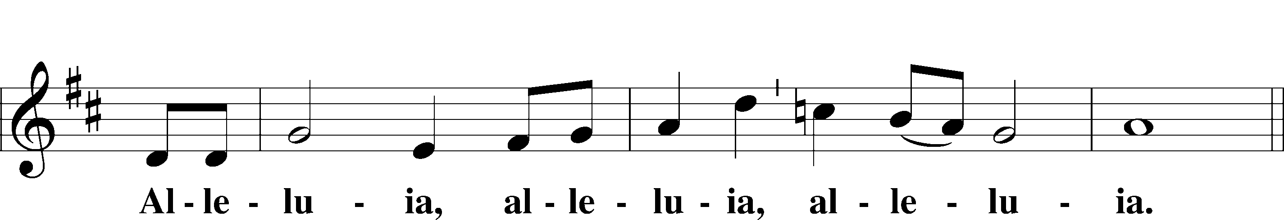
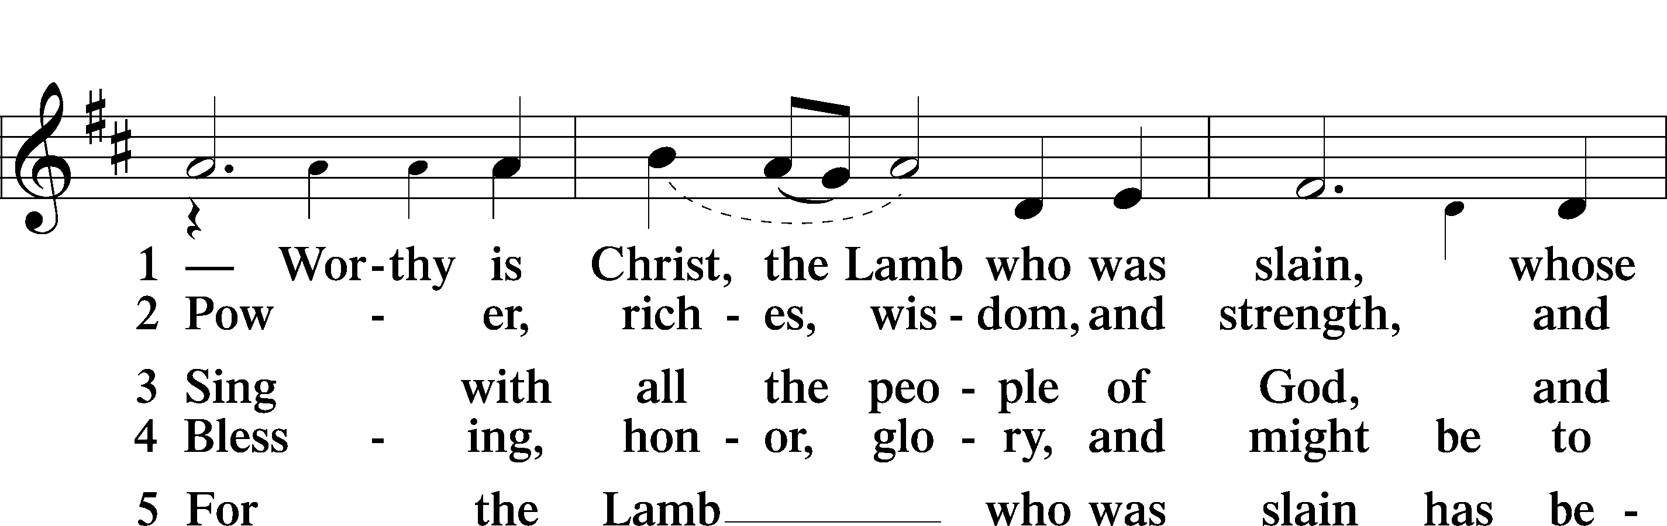
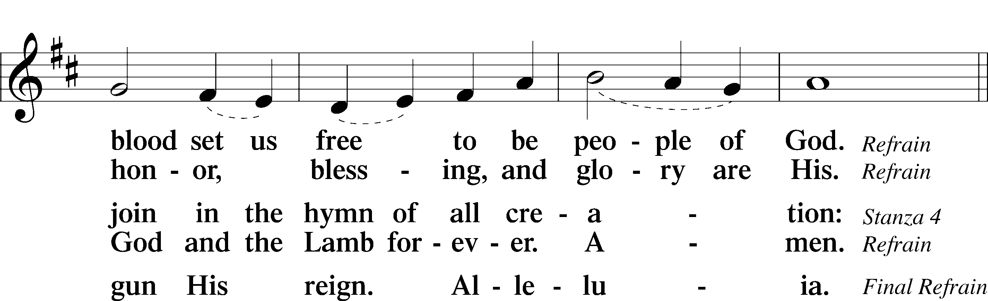
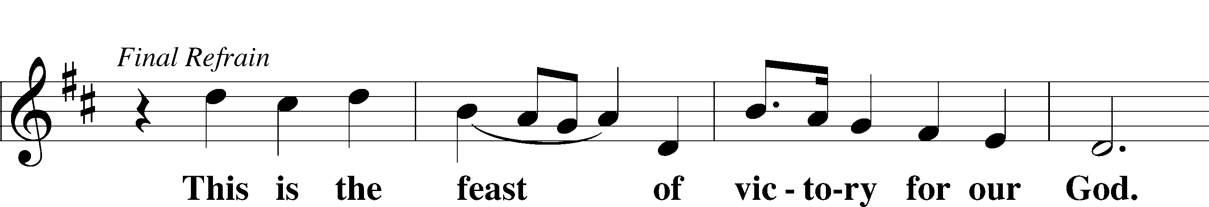
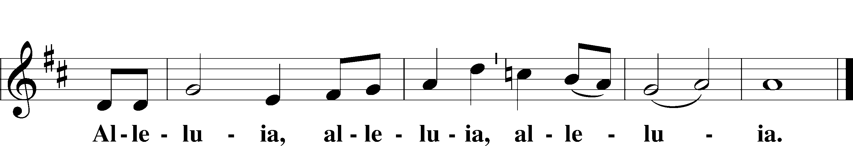

SALUTATION AND COLLECT OF THE DAY
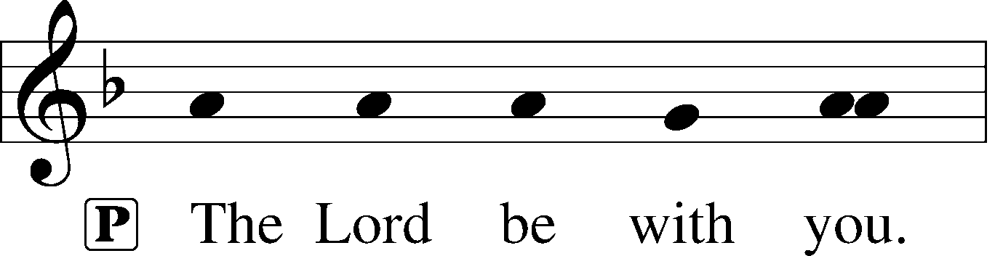
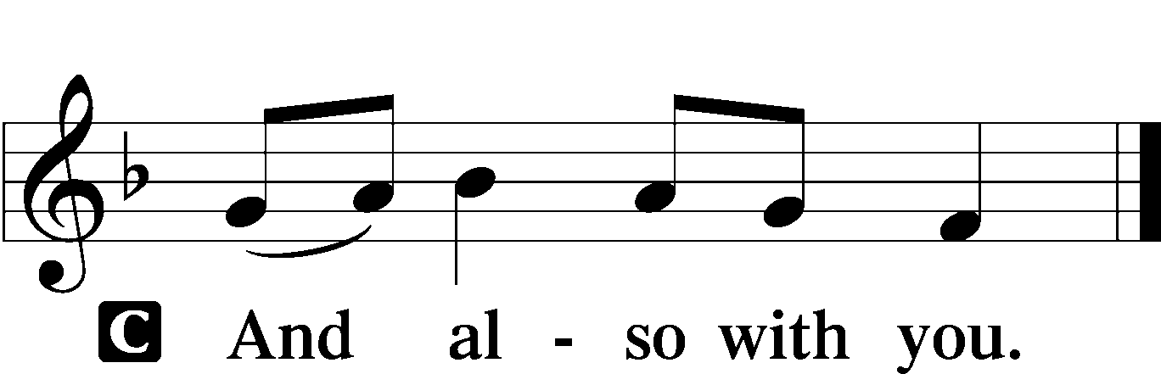

P Let us pray.
Almighty God, whom to know is everlasting life, grant us to know Your Son, Jesus, to be the way, the truth, and the life that we may boldly confess Him to be the Christ and steadfastly walk in the way that leads to life eternal; through the same Jesus Christ, our Lord, who lives and reigns with You and the Holy Spirit, one God, now and forever.

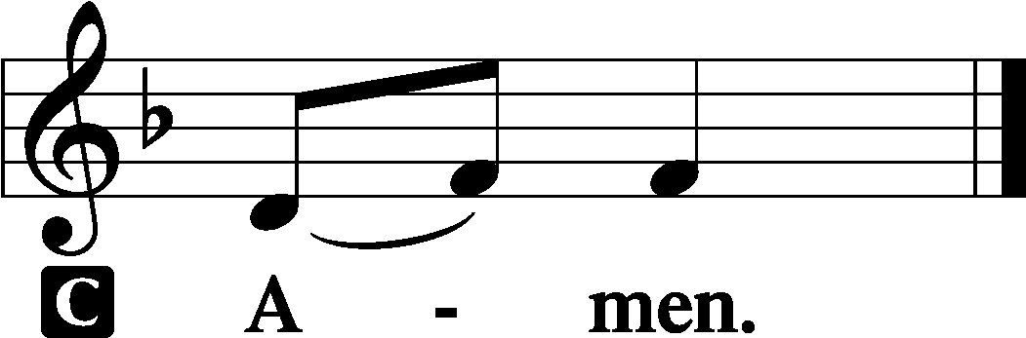

Sit

OLD TESTAMENT READING Isaiah 51:1–6
1“Listen to me, you who pursue righteousness,
you who seek the Lord:
look to the rock from which you were hewn,
and to the quarry from which you were dug.
2Look to Abraham your father
and to Sarah who bore you;
for he was but one when I called him,
that I might bless him and multiply him.
3For the Lord comforts Zion;
he comforts all her waste places
and makes her wilderness like Eden,
her desert like the garden of the Lord;
joy and gladness will be found in her,
thanksgiving and the voice of song.
4“Give attention to me, my people,
and give ear to me, my nation;
for a law will go out from me,
and I will set my justice for a light to the peoples.
5My righteousness draws near,
my salvation has gone out,
and my arms will judge the peoples;
the coastlands hope for me,
and for my arm they wait.
6Lift up your eyes to the heavens,
and look at the earth beneath;
for the heavens vanish like smoke,
the earth will wear out like a garment,
and they who dwell in it will die in like manner;
but my salvation will be forever,
and my righteousness will never be dismayed.”

A This is the Word of the Lord.
C Thanks be to God.

GRADUAL
Fear the Lord, | you his saints,*
for those who fear him lack | nothing!
Many are the afflictions of the | righteous,*
but the Lord delivers him out | of them all.

EPISTLE Romans 12
1I appeal to you therefore, brothers, by the mercies of God, to present your bodies as a living sacrifice, holy and acceptable to God, which is your spiritual worship. 2Do not be conformed to this world, but be transformed by the renewal of your mind, that by testing you may discern what is the will of God, what is good and acceptable and perfect.
3For by the grace given to me I say to everyone among you not to think of himself more highly than he ought to think, but to think with sober judgment, each according to the measure of faith that God has assigned. 4For as in one body we have many members, and the members do not all have the same function, 5so we, though many, are one body in Christ, and individually members one of another. 6Having gifts that differ according to the grace given to us, let us use them: if prophecy, in proportion to our faith; 7if service, in our serving; the one who teaches, in his teaching; 8the one who exhorts, in his exhortation; the one who contributes, in generosity; the one who leads, with zeal; the one who does acts of mercy, with cheerfulness.
9Let love be genuine. Abhor what is evil; hold fast to what is good. 10Love one another with brotherly affection. Outdo one another in showing honor. 11Do not be slothful in zeal, be fervent in spirit, serve the Lord. 12Rejoice in hope, be patient in tribulation, be constant in prayer. 13Contribute to the needs of the saints and seek to show hospitality.
14Bless those who persecute you; bless and do not curse them. 15Rejoice with those who rejoice, weep with those who weep. 16Live in harmony with one another. Do not be haughty, but associate with the lowly. Never be conceited. 17Repay no one evil for evil, but give thought to do what is honorable in the sight of all. 18If possible, so far as it depends on you, live peaceably with all. 19Beloved, never avenge yourselves, but leave it to the wrath of God, for it is written, “Vengeance is mine, I will repay, says the Lord.” 20To the contrary, “if your enemy is hungry, feed him; if he is thirsty, give him something to drink; for by so doing you will heap burning coals on his head.” 21Do not be overcome by evil, but overcome evil with good.

A This is the Word of the Lord.
C Thanks be to God.

Stand

ALLELUIA AND VERSE LSB 156
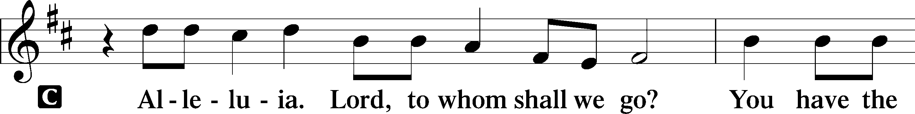
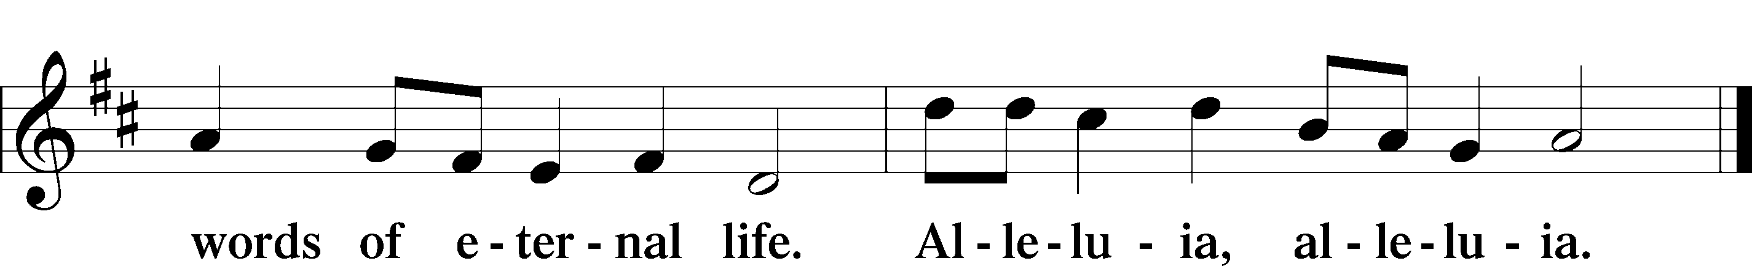

HOLY GOSPEL Matthew 16:13–20
P The Holy Gospel according to St. Matthew, the sixteenth chapter.

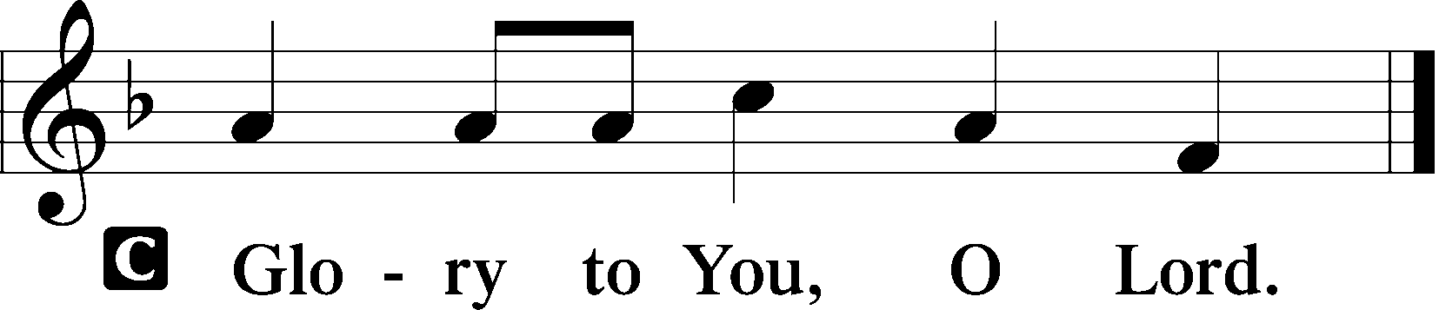

13Now when Jesus came into the district of Caesarea Philippi, he asked his disciples, “Who do people say that the Son of Man is?” 14And they said, “Some say John the Baptist, others say Elijah, and others Jeremiah or one of the prophets.” 15He said to them, “But who do you say that I am?” 16Simon Peter replied, “You are the Christ, the Son of the living God.” 17And Jesus answered him, “Blessed are you, Simon Bar-Jonah! For flesh and blood has not revealed this to you, but my Father who is in heaven. 18And I tell you, you are Peter, and on this rock I will build my church, and the gates of hell shall not prevail against it. 19I will give you the keys of the kingdom of heaven, and whatever you bind on earth shall be bound in heaven, and whatever you loose on earth shall be loosed in heaven.” 20Then he strictly charged the disciples to tell no one that he was the Christ.

P This is the Gospel of the Lord.

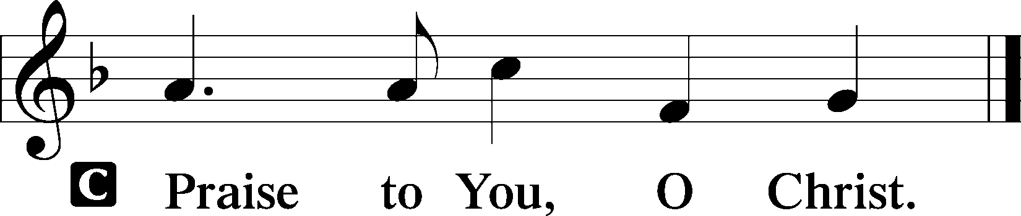

Sit

CHILDREN'S MESSAGE

HYMN OF THE DAY

839 O CHRIST, OUR TRUE AND ONLY LIGHT

1 O Christ, our true and only light,
Enlighten those who sit in night;
Let those afar now hear Your voice
And in Your fold with us rejoice.

2 Fill with the radiance of Your grace
The souls now lost in error’s maze;
Enlighten those whose inmost minds
Some dark delusion haunts and blinds.

3 O gently call those gone astray
That they may find the saving way!
Let ev’ry conscience sore oppressed
In You find peace and heav’nly rest.

4 Shine on the darkened and the cold;
Recall the wand’rers to Your fold.
Unite all those who walk apart;
Confirm the weak and doubting heart,

5 That they with us may evermore
Such grace with wond’ring thanks adore
And endless praise to You be giv’n
By all Your Church in earth and heav’n.

SERMON Rev. Shaun Daugherty

Stand

APOSTLES’ CREED
C I believe in God, the Father Almighty, maker of heaven and earth.

And in Jesus Christ, His only Son, our Lord, who was conceived by the Holy Spirit, born of the virgin Mary, suffered under Pontius Pilate, was crucified, died and was buried. He descended into hell. The third day He rose again from the dead. He ascended into heaven and sits at the right hand of God the Father Almighty. From thence He will come to judge the living and the dead.

I believe in the Holy Spirit, the holy Christian Church, the communion of saints, the forgiveness of sins, the resurrection of the body, and the life T everlasting. Amen.

PRAYER OF THE CHURCH
After each petition:
P Lord, in Your mercy,
C hear our prayer.

Sit

COLLECTION OF TITHES AND OFFERING

Stand

OFFERTORY LSB 159
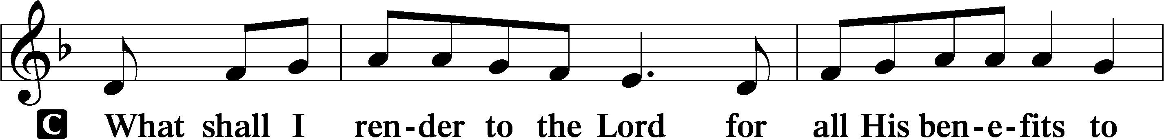
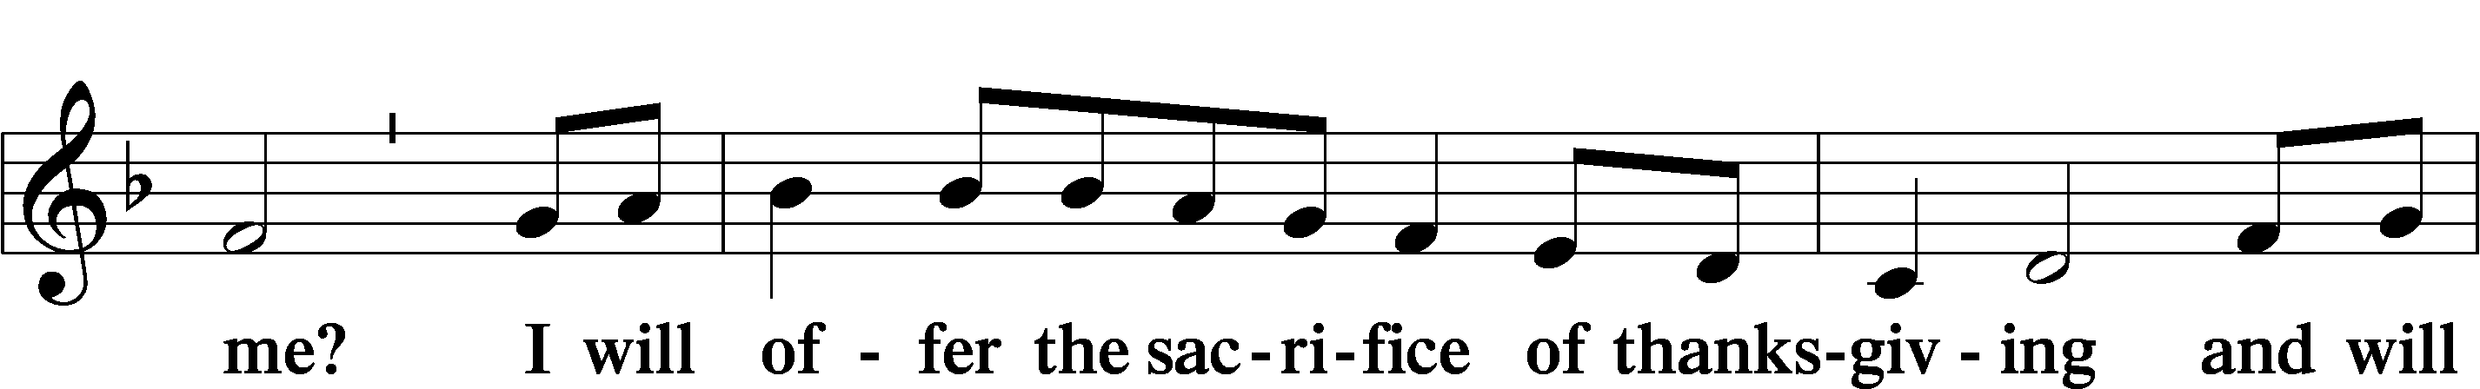
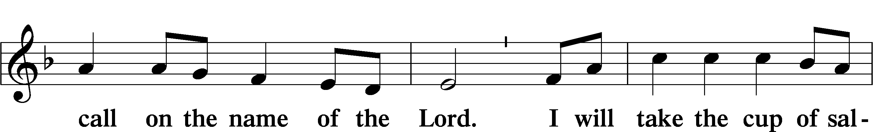
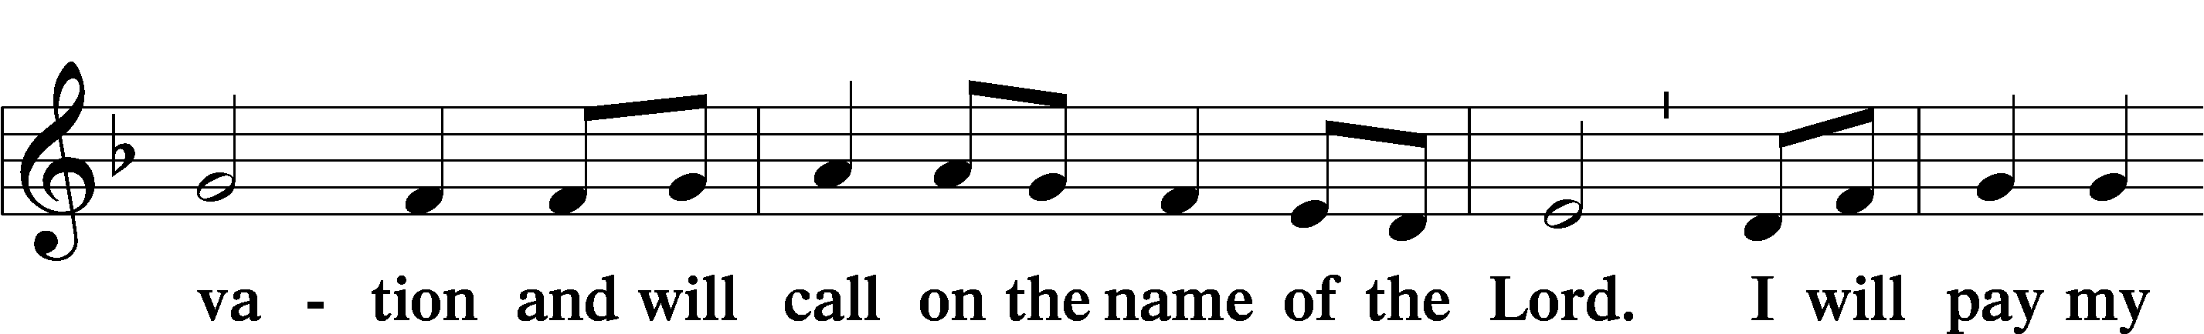
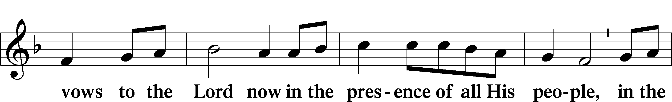
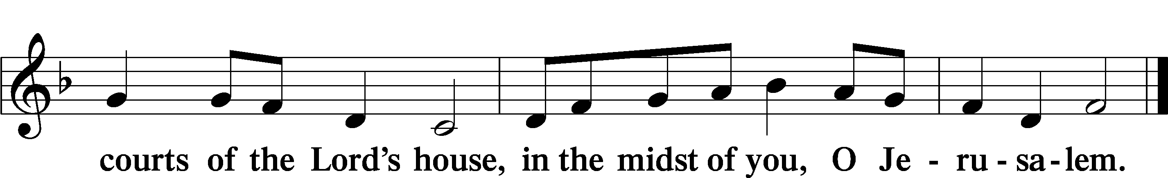

+ Service of the Sacrament +
As God's baptized and forgiven people, we gather at His invitation to receive The Lord's Supper.

The Lord’s Supper is celebrated at this congregation in the confession and glad confidence that, as he says, our Lord gives into our mouths not only bread and wine but His very body and blood to eat and to drink for the forgiveness of sins and to strengthen our union with him and with one another. Our Lord invites to his table those Baptized Christians who trust his words, repent of all sin, and set aside any refusal to forgive and love as he forgives and loves us, that they may show forth his death until he comes.

Because those who eat and drink our Lord’s body and blood unworthily do so to their great harm and because Holy Communion is a confession of the faith which is confessed at this altar, any who are not yet instructed, in doubt, or who hold a confession differing from that of this congregation and The Lutheran Church— Missouri Synod, and yet desire to receive the sacrament, are asked first to speak with the pastor or an elder.

For further study, see Matthew 5:23f.; 10:32f.; 18:15-35; 26:26-29; 1 Cor. 11:17- 34.

PREFACE LSB 160





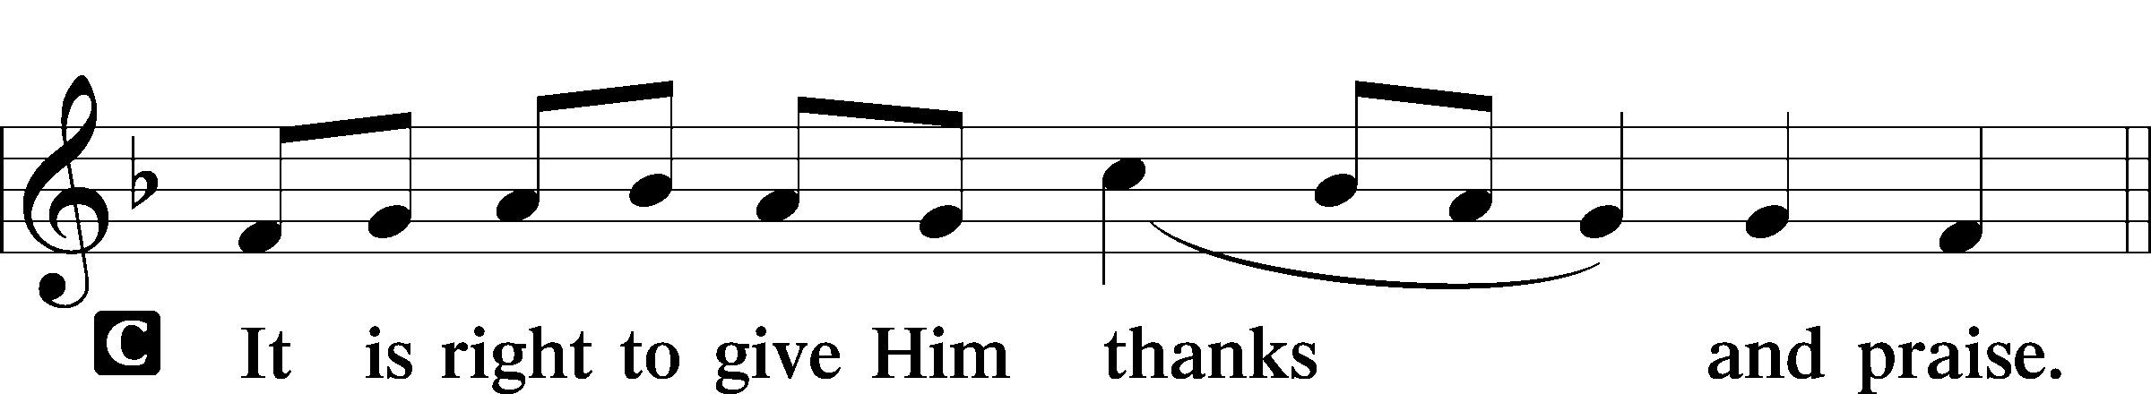

PROPER PREFACE LSB 161
P It is truly good, right, and salutary . . . evermore praising You and saying:

SANCTUS LSB 161
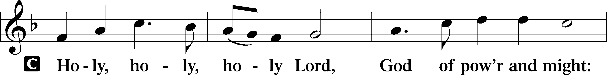
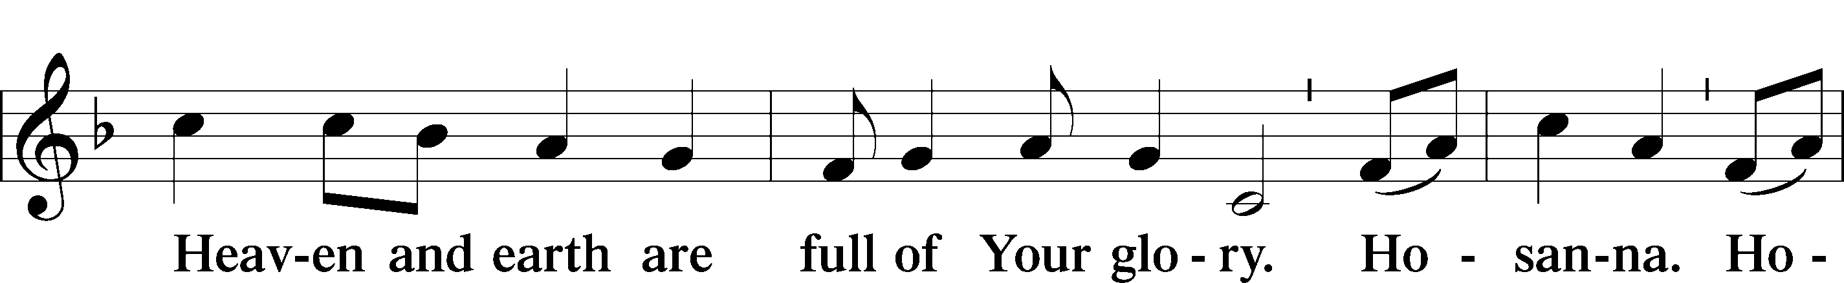
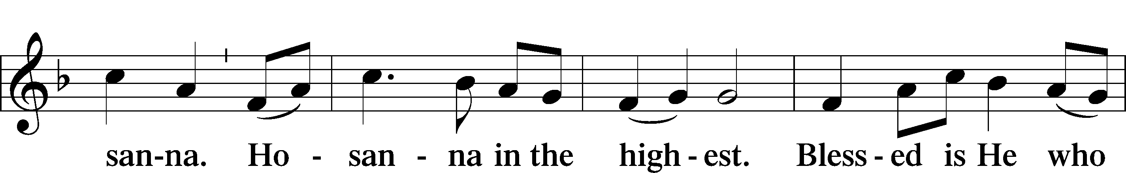
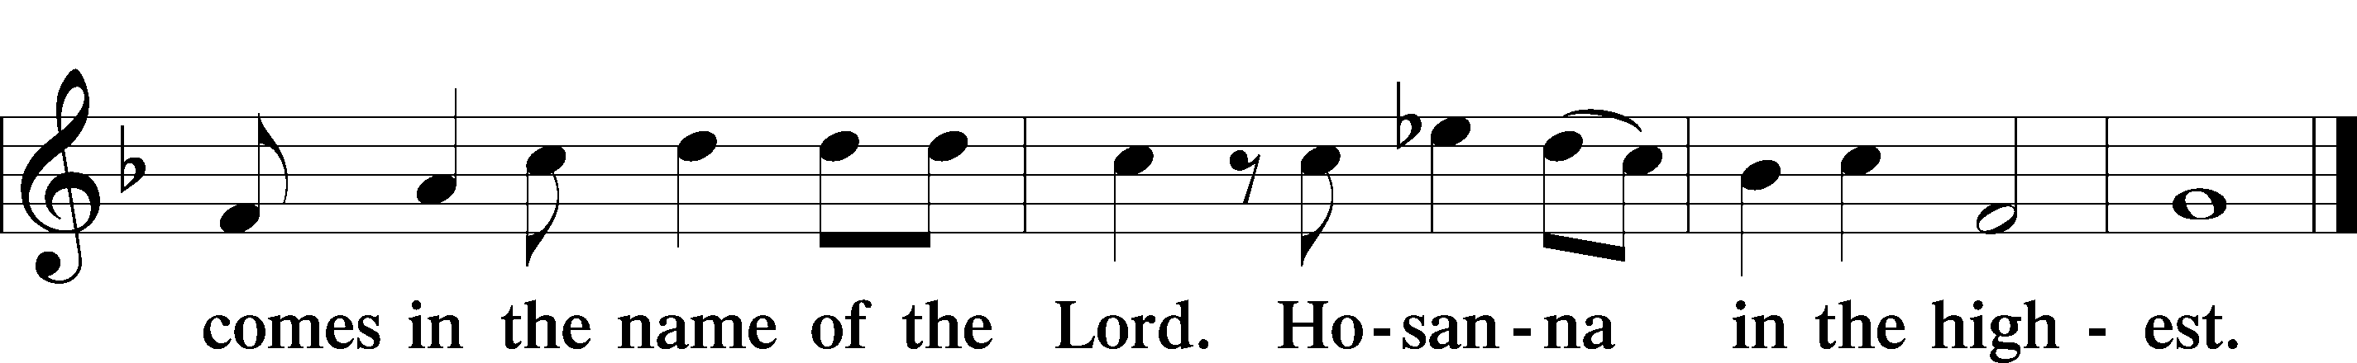

PRAYER OF THANKSGIVING 161
P Blessed are You, Lord of heaven and earth, for You have had mercy on those whom You created and sent Your only-begotten Son into our flesh to bear our sin and be our Savior. With repentant joy we receive the salvation accomplished for us by the all-availing sacrifice of His body and His blood on the cross.

Gathered in the name and the remembrance of Jesus, we beg You, O Lord, to forgive, renew, and strengthen us with Your Word and Spirit. Grant us faithfully to eat His body and drink His blood as He bids us do in His own testament. Gather us together, we pray, from the ends of the earth to celebrate with all the faithful the marriage feast of the Lamb in His kingdom, which has no end. Graciously receive our prayers; deliver and preserve us. To You alone, O Father, be all glory, honor, and worship, with the Son and the Holy Spirit, one God, now and forever.
C Amen.

THE WORDS OF OUR LORD

PROCLAMATION OF CHRIST
P As often as we eat this bread and drink this cup, we proclaim the Lord’s death until He comes.
C Amen. Come, Lord Jesus.

P O Lord Jesus Christ, only Son of the Father, in giving us Your body and blood to eat and to drink, You lead us to remember and confess Your holy cross and passion, Your blessed death, Your rest in the tomb, Your resurrection from the dead, Your ascension into heaven, and Your coming for the final judgment. So remember us in Your kingdom and teach us to pray:

LORD’S PRAYER
C Our Father who art in heaven, hallowed be Thy name, Thy kingdom come, Thy will be done on earth as it is in heaven; give us this day our daily bread; and forgive us our trespasses as we forgive those who trespass against us; and lead us not into temptation, but deliver us from evil. For Thine is the kingdom and the power and the glory forever and ever. Amen.

PAX DOMINI LSB 163
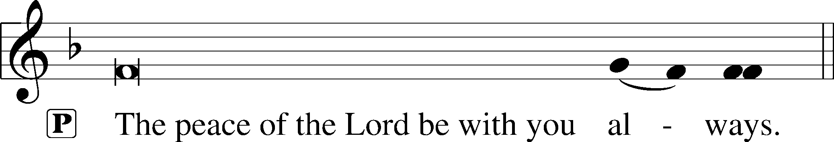


AGNUS DEI LSB 163
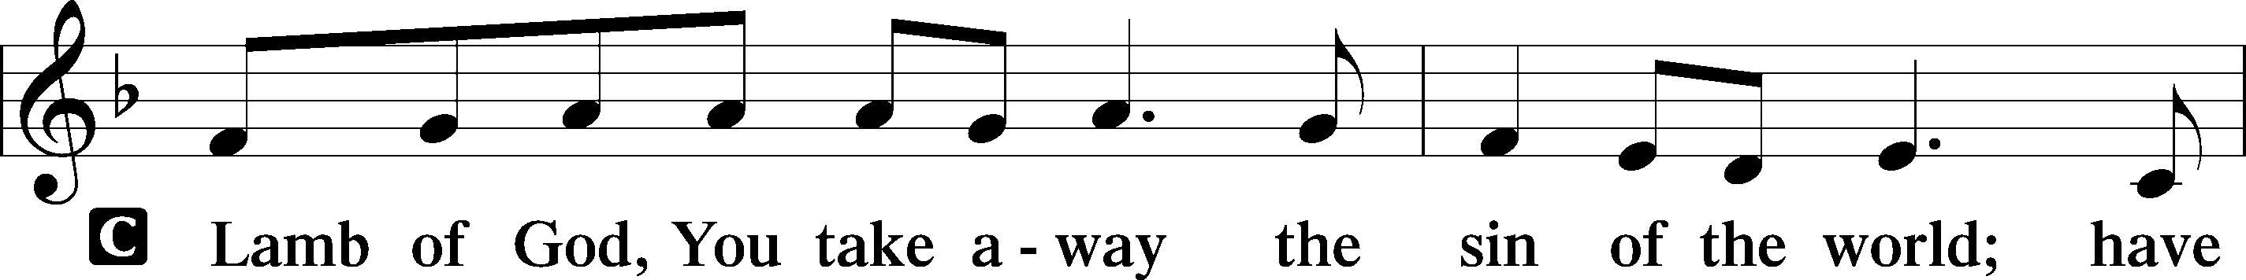
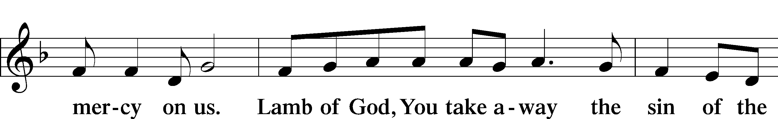
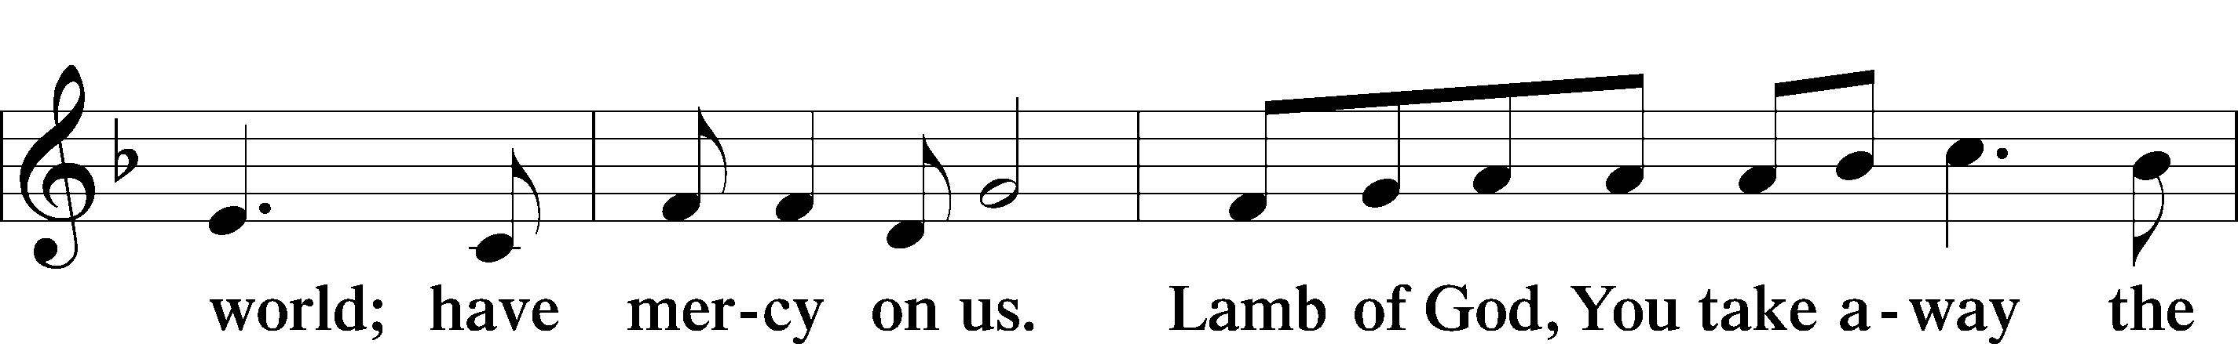
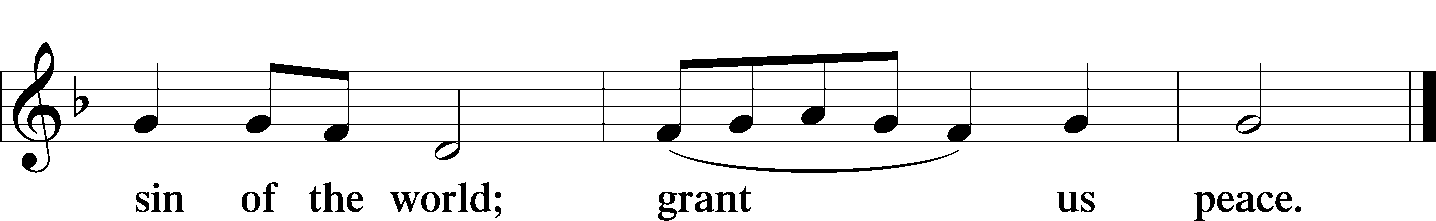
Following the Agnus Dei, please greet one another in the name of the Lord, saying, “Peace be with you,” as a sign of reconciliation and of the unity of the Spirit in the bond of peace (Matt. 5:22–24; Eph. 4:1–3).

Sit

DISTRIBUTION HYMNS

576 MY HOPE IS BUILT ON NOTHING LESS

1 My hope is built on nothing less
Than Jesus’ blood and righteousness;
No merit of my own I claim
But wholly lean on Jesus’ name. Refrain

ref On Christ, the solid rock, I stand;
All other ground is sinking sand,
All other ground is sinking sand.

2 When darkness veils His lovely face,
I rest on His unchanging grace;
In ev’ry high and stormy gale
My anchor holds within the veil. Refrain

3 His oath, His covenant and blood
Support me in the raging flood;
When ev’ry earthly prop gives way,
He then is all my hope and stay. Refrain

4 When He shall come with trumpet sound,
Oh, may I then in Him be found,
Clothed in His righteousness alone,
Redeemed to stand before His throne! Refrain

802 IMMORTAL, INVISIBLE, GOD ONLY WISE

1 Immortal, invisible,
God only wise,
In light inaccessible
hid from our eyes,
Most blessèd, most glorious,
the Ancient of Days,
Almighty, victorious,
Thy great name we praise.

2 Unresting, unhasting,
and silent as light,
Nor wanting, nor wasting,
Thou rulest in might;
Thy justice like mountains
high soaring above
Thy clouds which are fountains
of goodness and love.

3 To all life Thou givest—
to both great and small—
In all life Thou livest,
the true Life of all;
We blossom and flourish
as leaves on the tree
And wither and perish—
but naught changes Thee.

4 Great Father of glory,
pure Father of light,
Thine angels adore Thee,
all veiling their sight;
All laud we would render:
O help us to see
’Tis only the splendor
of light that hides Thee.

644 THE CHURCH’S ONE FOUNDATION sts. 1–5

1 The Church’s one foundation
Is Jesus Christ, her Lord;
She is His new creation
By water and the Word.
From heav’n He came and sought her
To be His holy bride;
With His own blood He bought her,
And for her life He died.

2 Elect from ev’ry nation,
Yet one o’er all the earth;
Her charter of salvation:
One Lord, one faith, one birth.
One holy name she blesses,
Partakes one holy food,
And to one hope she presses
With ev’ry grace endued.

3 Though with a scornful wonder
The world sees her oppressed,
By schisms rent asunder,
By heresies distressed,
Yet saints their watch are keeping;
Their cry goes up, “How long?”
And soon the night of weeping
Shall be the morn of song.

4 Through toil and tribulation
And tumult of her war
She waits the consummation
Of peace forevermore
Till with the vision glorious
Her longing eyes are blest,
And the great Church victorious
Shall be the Church at rest.

5 Yet she on earth has union
With God, the Three in One,
And mystic sweet communion
With those whose rest is won.
O blessèd heav’nly chorus!
Lord, save us by Your grace
That we, like saints before us,
May see You face to face.

Stand

DISMISSAL

THANK THE LORD LSB 164
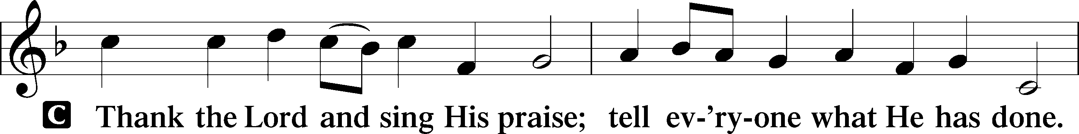
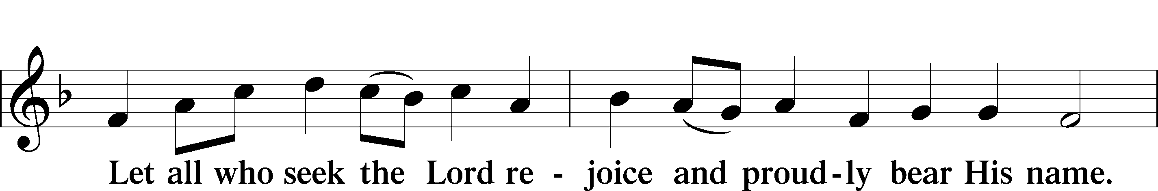
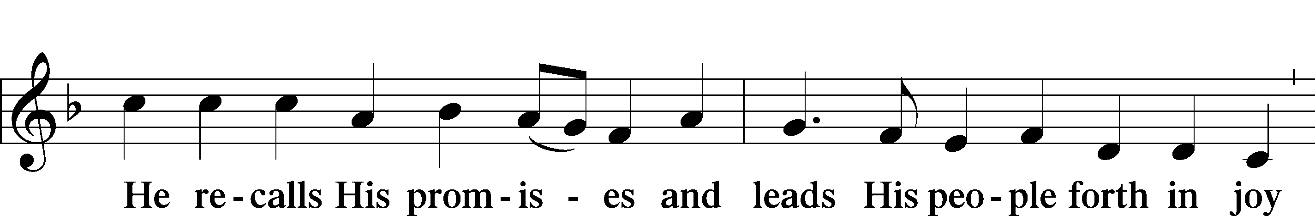
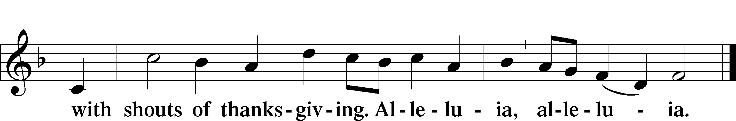

POST-COMMUNION COLLECT

BENEDICTION LSB 166
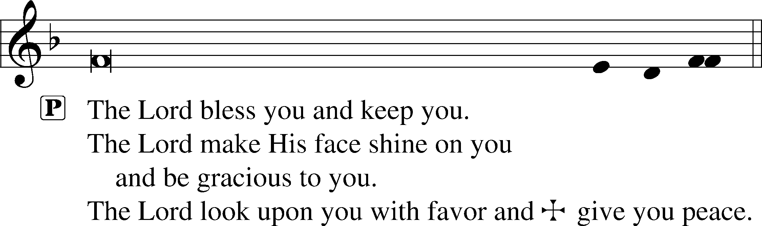


RECESSIONAL HYMN

662 ONWARD, CHRISTIAN SOLDIERS

1 Onward, Christian soldiers,
Marching as to war,
With the cross of Jesus
Going on before.
Christ, the royal master,
Leads against the foe;
Forward into battle
See His banners go! Refrain

ref Onward, Christian soldiers,
Marching as to war,
With the cross of Jesus
Going on before.

2 Like a mighty army
Moves the Church of God;
Brothers, we are treading
Where the saints have trod.
We are not divided,
All one body we,
One in hope and doctrine,
One in charity. Refrain

3 Crowns and thrones may perish,
Kingdoms rise and wane,
But the Church of Jesus
Constant will remain.
Gates of hell can never
’Gainst that Church prevail;
We have Christ’s own promise,
And that cannot fail. Refrain

4 Onward, then, ye faithful,
Join our happy throng,
Blend with ours your voices
In the triumph song:
Glory, laud, and honor
Unto Christ, the king;
This through countless ages
Men and angels sing. Refrain

ANNOUNCEMENTS
See announcements on the back of the bulletin.

SENDING
P Let us pray.
Lord God, You have called Your servants to ventures of which we cannot see the ending, by paths as yet untrodden, through perils unknown. Give us faith to go out with good courage, not knowing where we go but only that Your hand is leading us and Your love supporting us; through Jesus Christ, our Lord.
C Amen

P Go in peace to serve the Lord.
C Thanks be to God.

THIS WEEK AT FAITH

Sun. August 23 Bible Studies 8:15am
Worship 9:30am
Voters Meeting 10:45am
Mon-Fri August 24-28 Chapel 8:30 pm
Tues. August 25 Create in Me Crafting 10:00am
Sun. August 30 Bible Studies 8:15am
Worship 9:30am
Rally Day 10:45am
CHURCH ANNOUNCEMENTS
FAITH LUTHERAN SCHOOL NEEDS MISSIONARIES - If you would like to share the love of Christ with His littlest lambs, please consider working as a preschool teacher on either a permanent basis for the school year or for a few weeks while one of our teachers enjoys maternity leave. Please contact Chris Bradshaw with questions.

VOTERS’ MEETINGS - take place after Sunday worship. Next Tentative Meetings: Today - Nominating Committee; Nov 15 – Elections

RALLY DAY – Sunday, August 30 after worship - Let’s Rally! Kick off the fall season with us at Faith. Join us immediately after church for lunch and bring your favorite potluck dish to share. There will be a display on the patio showcasing upcoming educational classes, connection groups, and Wednesday gathering events. If you would like to get involved or have questions, contact Muriel Pfaff. Rally Day is hosted by the Board of Christian Education

CONFIRMATION CLASSES - For students (grades 7 and 8) who desire to grow in their faith and progress toward the milestone of adult membership at Faith Lutheran Church. Classes will be Wednesday nights at 6:30pm. Regular classes will begin on September 2. A required confirmation orientation for students and their parents will be held on Saturday August 29, 9am-12noon. Please contact Pastor Shaun to sign up for classes. pastor.shaun@faithmarietta.org

WEDNESDAY NIGHT CORN HOLE – September 2nd Dinner 5:30 pm, Tournament 6:30 pm., You are invited to our 3rd Annual Cornhole Tournament! Join us for dinner, drinks, ice cream sundaes and friendly competition! Co-Hosted by Family Life & Board of Christian Education.

FAITH SCHOOL PRAYERS – The School Prayer group meets 2nd Tuesday of the month, at 9:00am in the craft room. Dates are September 8th, Oct 13th, Nov 10th, Dec 8th. Call or text Norma Palmer at (256-653-8349) for more information.

SHARING & CARING FESTIVAL – September 19, 7:30am meet at the church - Social and Evangelism ministries are supporting and attending a feed and clothe the hungry event in downtown Atlanta. Join us as we get out and share the love of Jesus with those in need. This event is put on by Stepping Stone Ministry of Atlanta (an LCMS Recognized Service Organization). Contact Ron or Gary to get involved.

CHURCH EVENTS AND UPDATES- Are you interested in reading the weekly and monthly newsletters for updates but unable to check your emails on Fridays? Weekly newsletters are released Fridays by noon and monthly are released by the first Friday of the month. You can find all our newsletters at faithmarietta.com/newsletter at your leisure.

WORSHIP SCHEDULE - Beginning September 6, our Sunday morning schedule will change:
Bible Study 8:30a - 9:30a; Fellowship 9:30a - 10:00a; Worship 10:00a - 11:30a.
The purpose of this change is to promote fellowship within the Faith Community and to give the choir and congregation time to prepare for worship. In addition, this will also allow for regular fellowship activities after worship.

