



Twelfth Sunday After Pentecost
August 16, 2026
OUR MISSION: Connecting People to Jesus

Contact us
Faith Lutheran Church & School 2111 Lower Roswell Rd, Marietta, GA 30068 | 770-973-8877

CHURCH: www.faithmarietta.com SCHOOL: www.faithmarietta.org
Rev. Shaun Daugherty, Pastor Mr. Chris Bradshaw, Headmaster
pastor.shaun@faithmarietta.org chris.bradshaw@faithmarietta.org
470-289-9469 470-641-6239
See the full leadership directory: www.faithmarietta.com/leadership
Serving This Month at Faith
 | 8/2/2026 | 8/9/2026 | 8/16/2026 | 8/23/2026 | 8/30/2026
Musicians | Vaunda Noerenberg | Vaunda Noerenberg | Ben Nye | Vaunda Noerenberg | Vaunda Noerenberg
Elders | Ward Irvin  Greg Sinatra | Vinny Caracci  Ward Irvin | Steve Buchtrup  Woody Wood | Russ Couch  Greg Schaag | Jon Cain  Peter Amelingmeier
Reader | Danette Smith | David Barnett | Karen Cerny | Jill Musgrove | Russell Couch
Ushers | Greg Czerwonka  Matthew Czerwonka  Jacob Czerwonka  Luke Czerwonka  Sam Czerwonka | Steve Buchtrup  Mark Patterson  Gary Schleicher  Reagan Gronsbell  Paris Brown | Kim Kaumeyer  David Barnett  Greg Sinatra | Chris Bradshaw  Herman Dean  Bryan Powell  Christian Campbell | Rosina Sawh  Louise Cox  Jamie Bass  Pam Cole
Acolytes | Adam Cain  Amadeo Brown | Josiah Brown  Alex Bradshaw | Adam Cain  Christian Brown | Silas Daugherty  Ryan Cain | Josiah Brown  Eli Bradshaw



Pay Pal

For your convenience,
we now accept gifts
via Venmo or PayPal.

Our Discipleship
Date | 8/2 | 8/9 | 8/16 |  | YTD Report (Aug thru June)
Worship | 168/148 | 142/138 |  |  | Avg. Worship | 144
Sunday School | 16 | 44 |  |  | Avg. SS | 35
Gen. Giving | $13,130 | $10,954 | $ |  | YTD Gen. Giving | $638,903
MTD Giving | $13,130 | $24,084 | $ |  | Budgeted Giving | $658,060
 |  |  |  |  | Over/(Under) | ($19,157)
 |  |  |  |  | "Special" Gifts | $383,020
Monthly Budget | $53,300 | $53,300 | $53,300 |  | Designated Gifts | $169,633
FAITH GROWS is our debt reduction account, geared towards eliminating our mortgage.
Please prayerfully consider donating to this fund - over and beyond your normal tithe.

YTD Debt Reduction | $245,146 | Remaining Mortgage Debt | $2,684,085
ALTAR FLOWERS given today, In Celebration of Bob & Louise Cox 57th Wedding Anniversary

+ Confession and Absolution +
We enter the presence of God by humbly confessing our sins and gladly receiving His forgiveness.

Stand

PROCESSIONAL HYMN

979 GOD, WHOSE ALMIGHTY WORD

1 God, whose almighty word
Chaos and darkness heard
And took their flight:
Hear us, we humbly pray,
And where the Gospel day
Sheds not its glorious ray,
Let there be light!

2 Lord, who once came to bring,
On Your redeeming wing,
Healing and sight,
Health to the sick in mind,
Sight to the inly blind:
Oh, now to humankind
Let there be light!

3 Spirit of truth and love,
Life-giving, holy dove,
Speed forth Your flight;
Move on the water’s face,
Bearing the lamp of grace,
And in earth’s darkest place
Let there be light!

D 4 Holy and blessèd Three,
Glorious Trinity,
Wisdom, love, might!
Boundless as ocean’s tide,
Rolling in fullest pride,
Through the earth, far and wide,
Let there be light!

The sign of the cross may be made by all in remembrance of their Baptism.

INVOCATION
P In the name of the Father and of the T Son and of the Holy Spirit.
C Amen.

P If we say we have no sin, we deceive ourselves, and the truth is not in us.
C But if we confess our sins, God, who is faithful and just, will forgive our sins and cleanse us from all unrighteousness.

Silence for reflection on God’s Word and for self-examination.

CONFESSION AND ABSOLUTION LSB 151
P Let us then confess our sins to God our Father.
C Most merciful God, we confess that we are by nature sinful and unclean. We have sinned against You in thought, word, and deed, by what we have done and by what we have left undone. We have not loved You with our whole heart; we have not loved our neighbors as ourselves. We justly deserve Your present and eternal punishment. For the sake of Your Son, Jesus Christ, have mercy on us. Forgive us, renew us, and lead us, so that we may delight in Your will and walk in Your ways to the glory of Your holy name. Amen.

P Almighty God in His mercy has given His Son to die for you and for His sake forgives you all your sins. As a called and ordained servant of Christ, and by His authority, I therefore forgive you all your sins in the name of the Father and of the T Son and of the Holy Spirit.
C Amen.

Stand

+ Service of the Word +
Having received God's forgiveness, we come before Him with songs of praise, eager to hear His Word.

INTROIT

The Lord is the strength of his | people;*
he is the saving refuge of his a- | nointed.
To you, O Lord, I call; my rock, be not | deaf to me,*
lest, if you be silent to me, I become like those who go down | to the pit.
Hear the voice of my pleas for mercy, when I cry to | you for help,*
when I lift up my hands toward your most holy sanctu- | ary.
Blessèd | be the Lord!*
For he has heard the voice of my pleas for | mercy.
The Lord is my strength and my shield; in him my heart trusts, and | I am helped;*
my heart exults, and with my song I give | thanks to him.
Glory be to the Father and | to the Son*
and to the Holy | Spirit;
as it was in the be- | ginning,*
is now, and will be forever. | Amen.
The Lord is the strength of his | people;*
he is the saving refuge of his a- | nointed.
KYRIE LSB 152

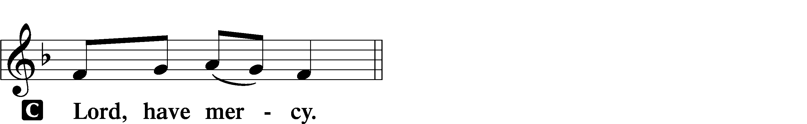
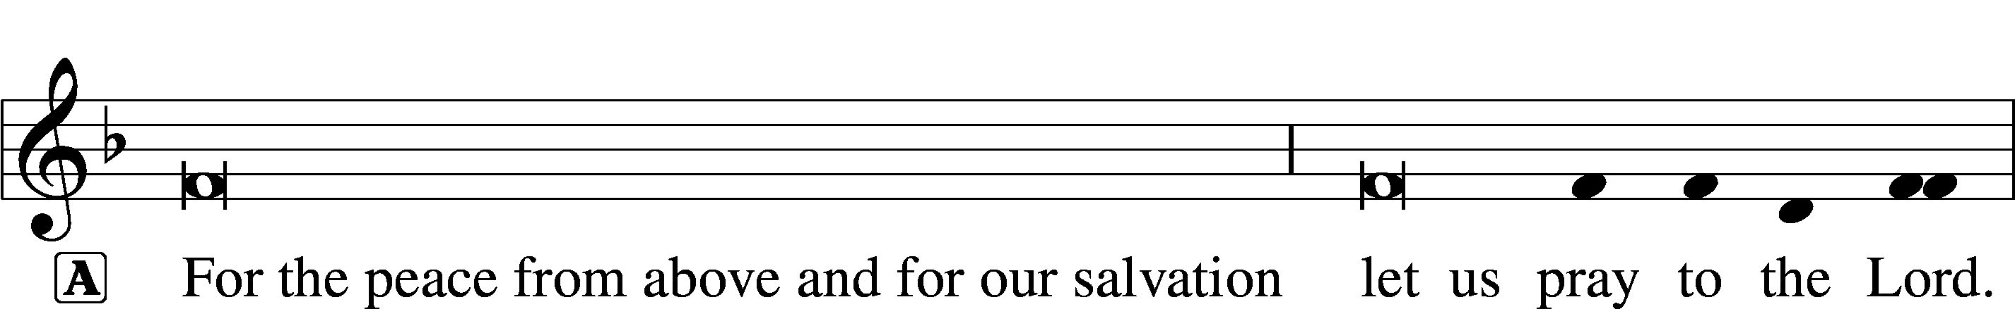
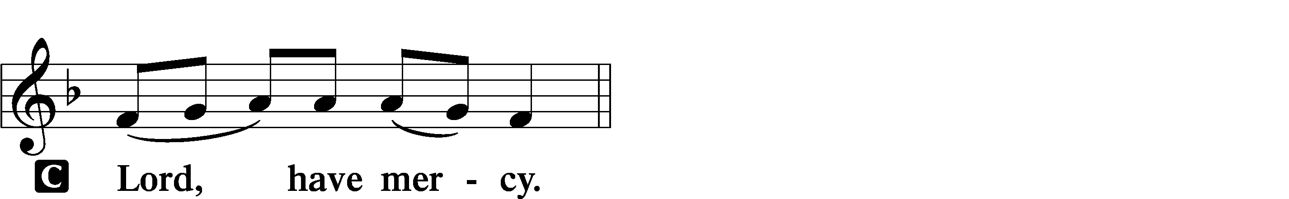
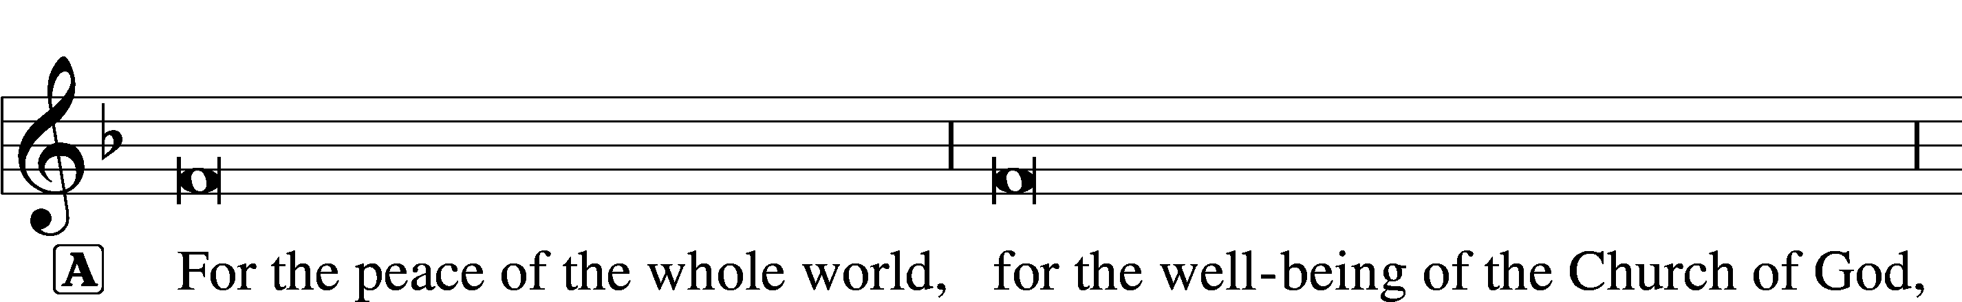

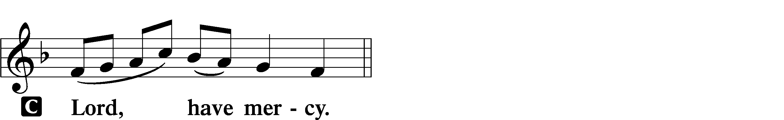
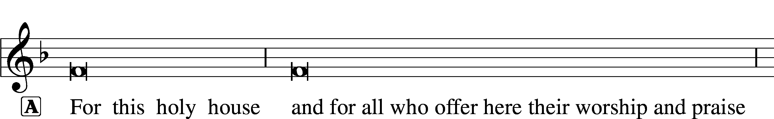

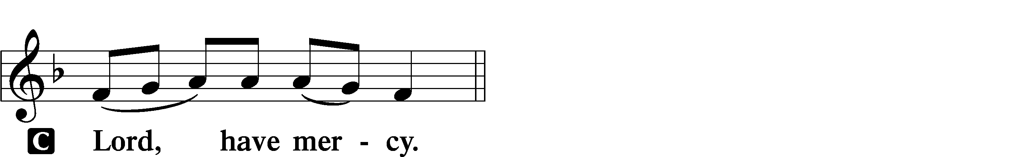



THIS IS THE FEAST LSB 155
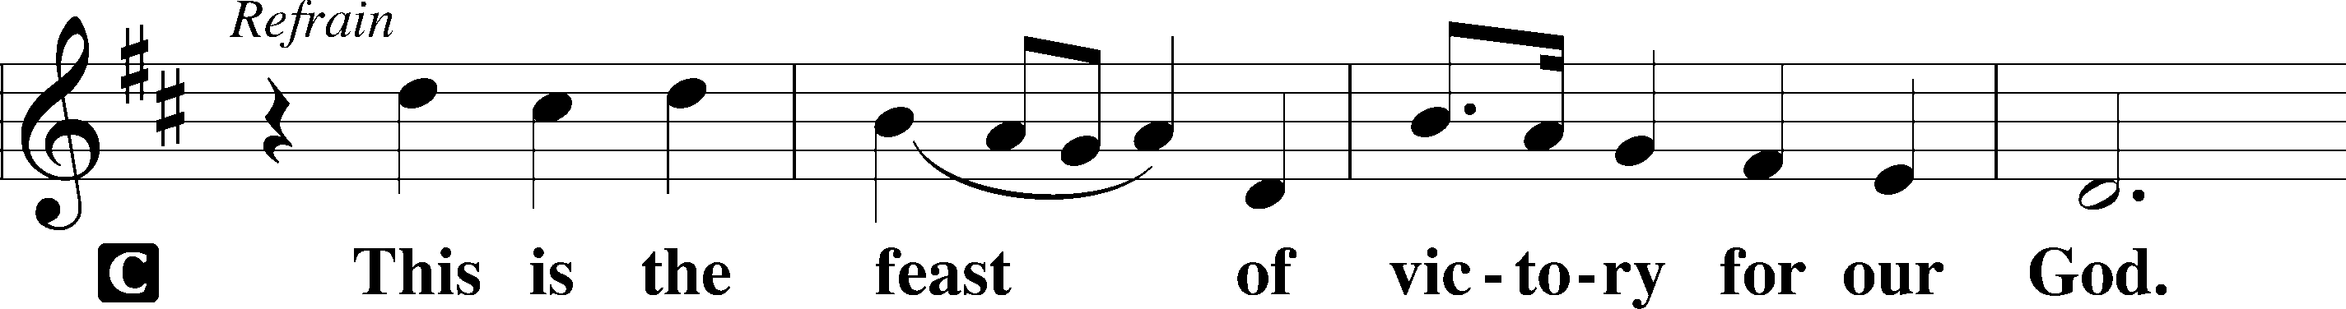
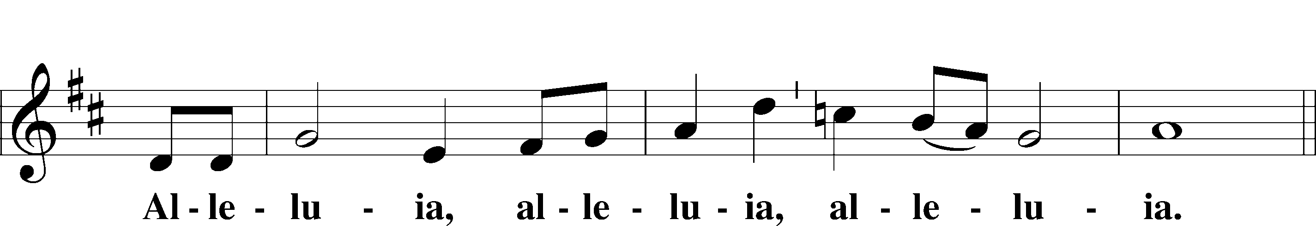
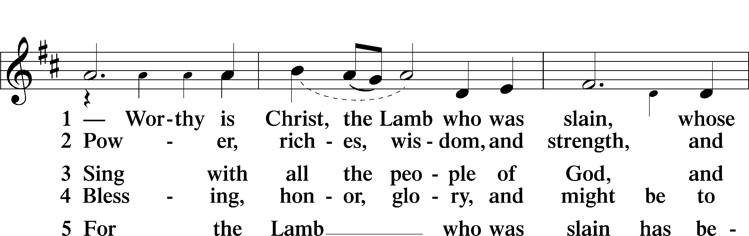
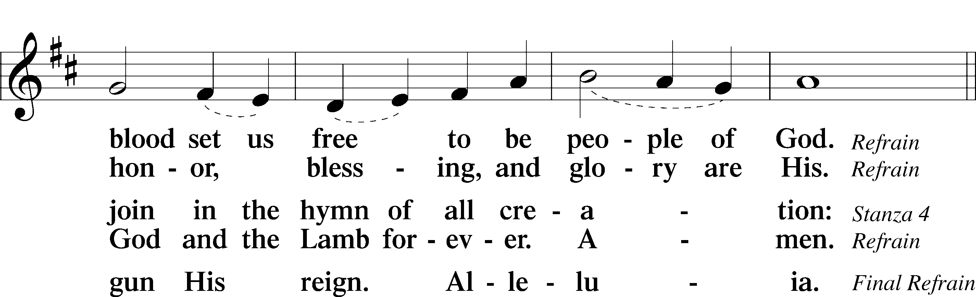
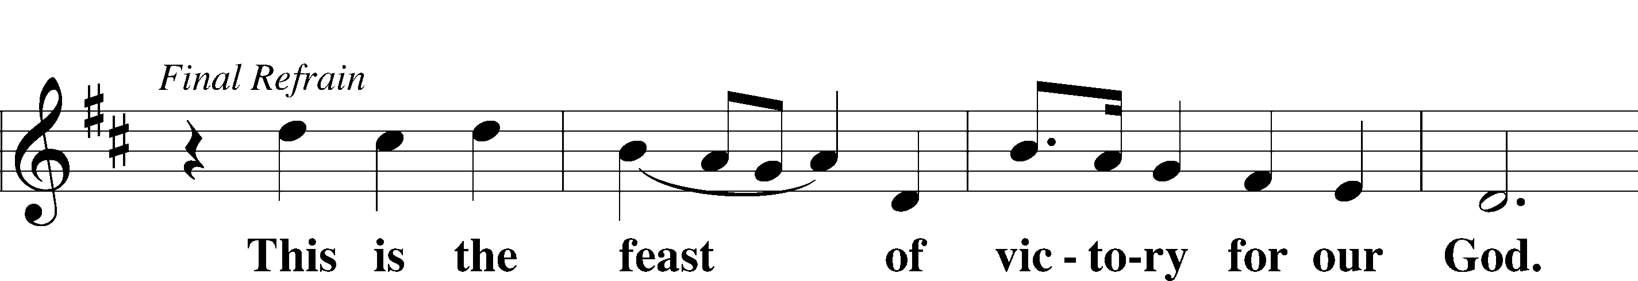
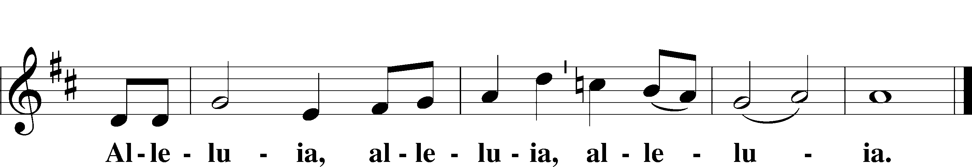

SALUTATION AND COLLECT OF THE DAY
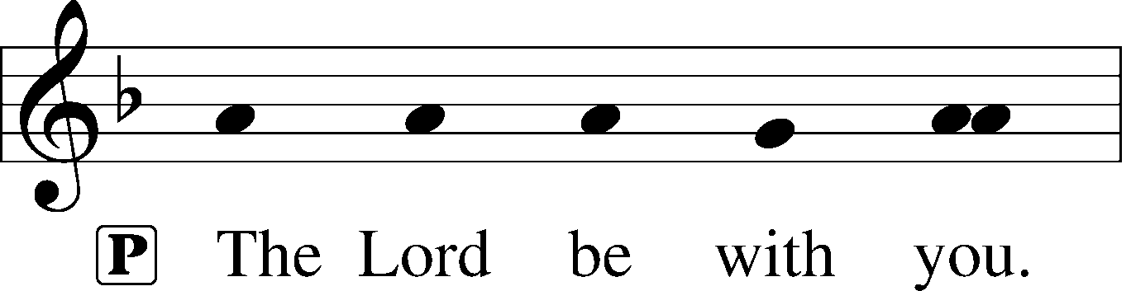
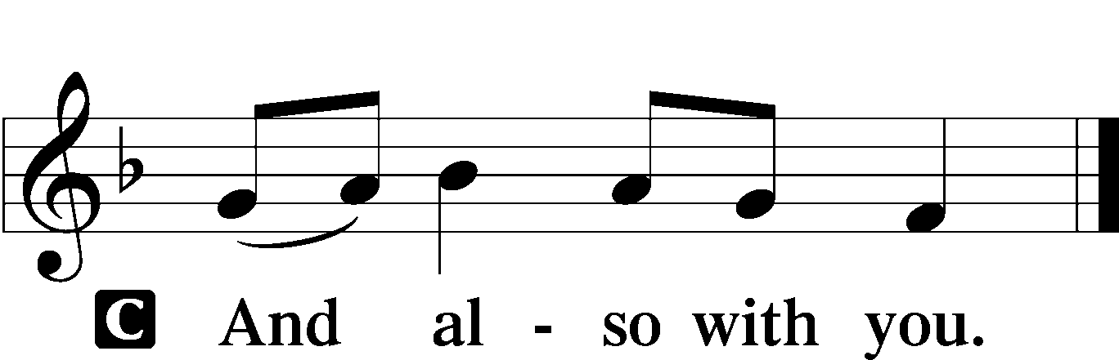

P Let us pray.
Almighty and everlasting Father, You give Your children many blessings even though we are undeserving. In every trial and temptation grant us steadfast confidence in Your loving-kindness and mercy; through Jesus Christ, Your Son, our Lord, who lives and reigns with You and the Holy Spirit, one God, now and forever.
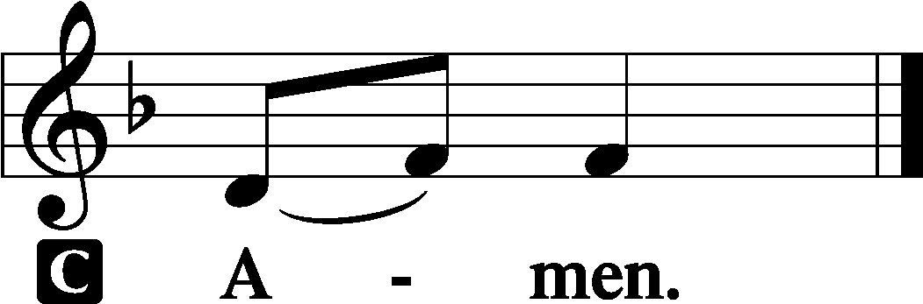

Sit
OLD TESTAMENT READING Isaiah 56:1, 6–8
1Thus says the Lord:
“Keep justice, and do righteousness,
for soon my salvation will come,
and my deliverance be revealed. . . .
6“And the foreigners who join themselves to the Lord,
to minister to him, to love the name of the Lord,
and to be his servants,
everyone who keeps the Sabbath and does not profane it,
and holds fast my covenant—
7these I will bring to my holy mountain,
and make them joyful in my house of prayer;
their burnt offerings and their sacrifices
will be accepted on my altar;
for my house shall be called a house of prayer
for all peoples.”
8The Lord God,
who gathers the outcasts of Israel, declares,
“I will gather yet others to him
besides those already gathered.”

A This is the Word of the Lord.
C Thanks be to God.

GRADUAL
Fear the Lord, | you his saints,*
for those who fear him lack | nothing!
Many are the afflictions of the | righteous,*
but the Lord delivers him out | of them all.
EPISTLE Romans 11
1I ask, then, has God rejected his people? By no means! For I myself am an Israelite, a descendant of Abraham, a member of the tribe of Benjamin. 2God has not rejected his people whom he foreknew. Do you not know what the Scripture says of Elijah, how he appeals to God against Israel? 3“Lord, they have killed your prophets, they have demolished your altars, and I alone am left, and they seek my life.” 4But what is God’s reply to him? “I have kept for myself seven thousand men who have not bowed the knee to Baal.” 5So too at the present time there is a remnant, chosen by grace. 6But if it is by grace, it is no longer on the basis of works; otherwise grace would no longer be grace.
7What then? Israel failed to obtain what it was seeking. The elect obtained it, but the rest were hardened, 8as it is written,
“God gave them a spirit of stupor,
eyes that would not see
and ears that would not hear,
down to this very day.”
9And David says,
“Let their table become a snare and a trap,
a stumbling block and a retribution for them;
10let their eyes be darkened so that they cannot see,
and bend their backs forever.”
11So I ask, did they stumble in order that they might fall? By no means! Rather through their trespass salvation has come to the Gentiles, so as to make Israel jealous. 12Now if their trespass means riches for the world, and if their failure means riches for the Gentiles, how much more will their full inclusion mean!
13Now I am speaking to you Gentiles. Inasmuch then as I am an apostle to the Gentiles, I magnify my ministry 14in order somehow to make my fellow Jews jealous, and thus save some of them. 15For if their rejection means the reconciliation of the world, what will their acceptance mean but life from the dead? 16If the dough offered as firstfruits is holy, so is the whole lump, and if the root is holy, so are the branches.
17But if some of the branches were broken off, and you, although a wild olive shoot, were grafted in among the others and now share in the nourishing root of the olive tree, 18do not be arrogant toward the branches. If you are, remember it is not you who support the root, but the root that supports you. 19Then you will say, “Branches were broken off so that I might be grafted in.” 20That is true. They were broken off because of their unbelief, but you stand fast through faith. So do not become proud, but stand in awe. 21For if God did not spare the natural branches, neither will he spare you. 22Note then the kindness and the severity of God: severity toward those who have fallen, but God’s kindness to you, provided you continue in his kindness. Otherwise you too will be cut off. 23And even they, if they do not continue in their unbelief, will be grafted in, for God has the power to graft them in again. 24For if you were cut from what is by nature a wild olive tree, and grafted, contrary to nature, into a cultivated olive tree, how much more will these, the natural branches, be grafted back into their own olive tree.
25Lest you be wise in your own conceits, I want you to understand this mystery, brothers: a partial hardening has come upon Israel, until the fullness of the Gentiles has come in. 26And in this way all Israel will be saved, as it is written,
“The Deliverer will come from Zion,
he will banish ungodliness from Jacob”;
27“and this will be my covenant with them
when I take away their sins.”
28As regards the gospel, they are enemies of God for your sake. But as regards election, they are beloved for the sake of their forefathers. 29For the gifts and the calling of God are irrevocable. 30Just as you were at one time disobedient to God but now have received mercy because of their disobedience, 31so they too have now been disobedient in order that by the mercy shown to you they also may now receive mercy. 32For God has consigned all to disobedience, that he may have mercy on all.
33Oh, the depth of the riches and wisdom and knowledge of God! How unsearchable are his judgments and how inscrutable his ways!
34“For who has known the mind of the Lord,
or who has been his counselor?”
35“Or who has given a gift to him
that he might be repaid?”
36For from him and through him and to him are all things. To him be glory forever. Amen.

A This is the Word of the Lord.
C Thanks be to God.

Stand

ALLELUIA AND VERSE LSB 156
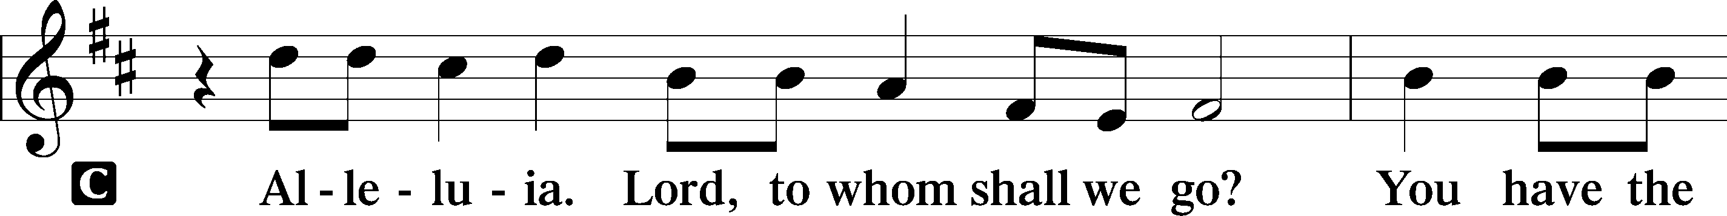
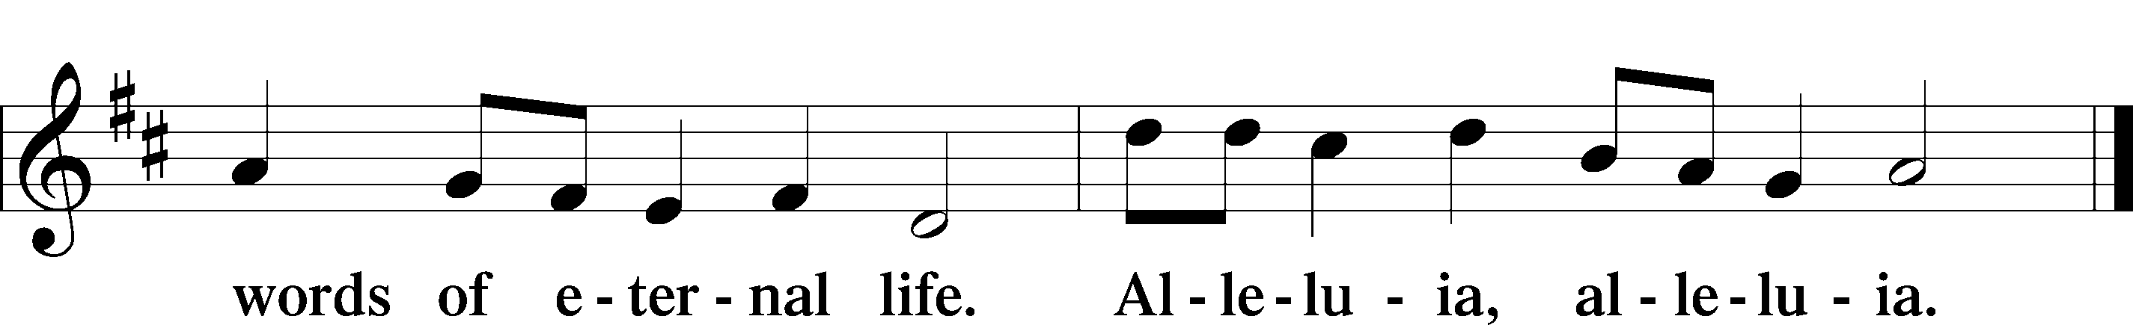

HOLY GOSPEL Matthew 15:21-28
P The Holy Gospel according to St. Matthew, the sixteenth chapter.

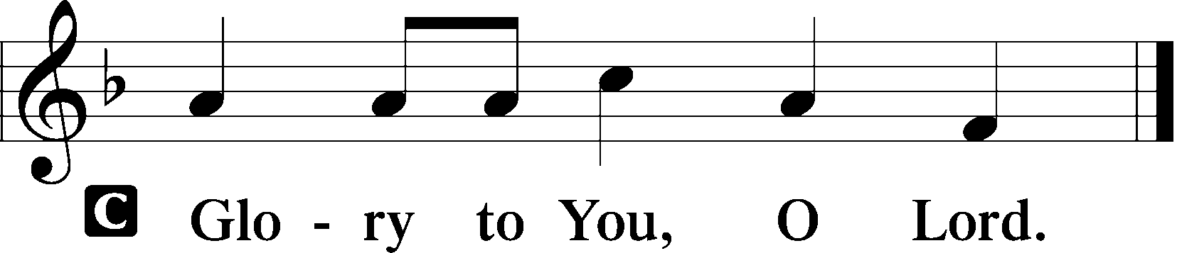

21Jesus went away from there and withdrew to the district of Tyre and Sidon. 22And behold, a Canaanite woman from that region came out and was crying, “Have mercy on me, O Lord, Son of David; my daughter is severely oppressed by a demon.” 23But he did not answer her a word. And his disciples came and begged him, saying, “Send her away, for she is crying out after us.” 24He answered, “I was sent only to the lost sheep of the house of Israel.” 25But she came and knelt before him, saying, “Lord, help me.” 26And he answered, “It is not right to take the children’s bread and throw it to the dogs.” 27She said, “Yes, Lord, yet even the dogs eat the crumbs that fall from their masters’ table.” 28Then Jesus answered her, “O woman, great is your faith! Be it done for you as you desire.” And her daughter was healed instantly.

P This is the Gospel of the Lord.

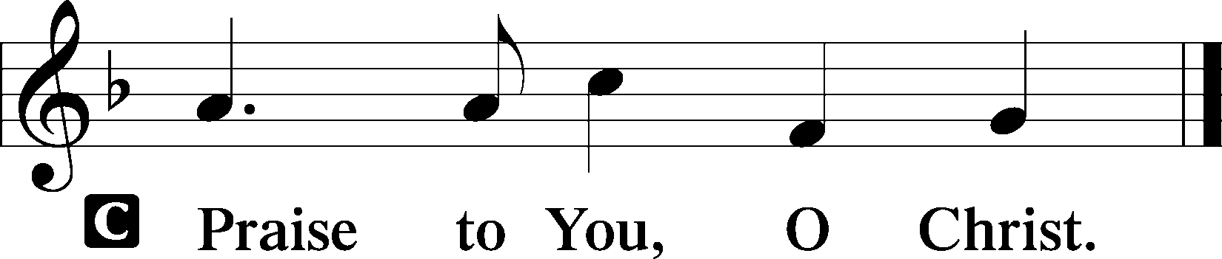

Sit

CHILDREN'S MESSAGE

HYMN OF THE DAY

653 IN CHRIST THERE IS NO EAST OR WEST

1 In Christ there is no east or west,
In Him no south or north,
But one great fellowship of love
Throughout the whole wide earth.

2 With God there is no tribe or race;
In Him we all are one.
He loves us as His children through
Our faith in His dear Son.

3 So, brothers, sisters, praise His name
Who died to set us free
From sin, division, hate, and shame,
From spite and enmity!

4 Join hands, disciples of the faith,
Whate’er your race may be;
Who serves my Father as His child
Is surely kin to me.

5 In Christ now meet both east and west;
In Him meet south and north.
All Christian souls are one in Him
Throughout the whole wide earth.

SERMON Rev. Shaun Daugherty

Stand

APOSTLES’ CREED
C I believe in God, the Father Almighty, maker of heaven and earth.

And in Jesus Christ, His only Son, our Lord, who was conceived by the Holy Spirit, born of the virgin Mary, suffered under Pontius Pilate, was crucified, died and was buried. He descended into hell. The third day He rose again from the dead. He ascended into heaven and sits at the right hand of God the Father Almighty. From thence He will come to judge the living and the dead.

I believe in the Holy Spirit, the holy Christian Church, the communion of saints, the forgiveness of sins, the resurrection of the body, and the life T everlasting. Amen.

PRAYER OF THE CHURCH
After each petition:
P Lord, in Your mercy,
C hear our prayer.

Sit

COLLECTION OF TITHES AND OFFERING

Stand

OFFERTORY LSB 159
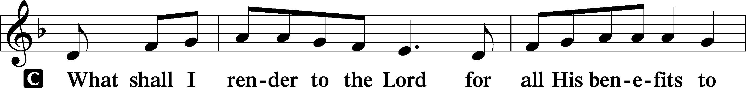
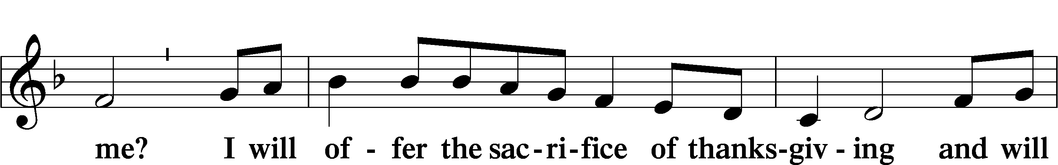
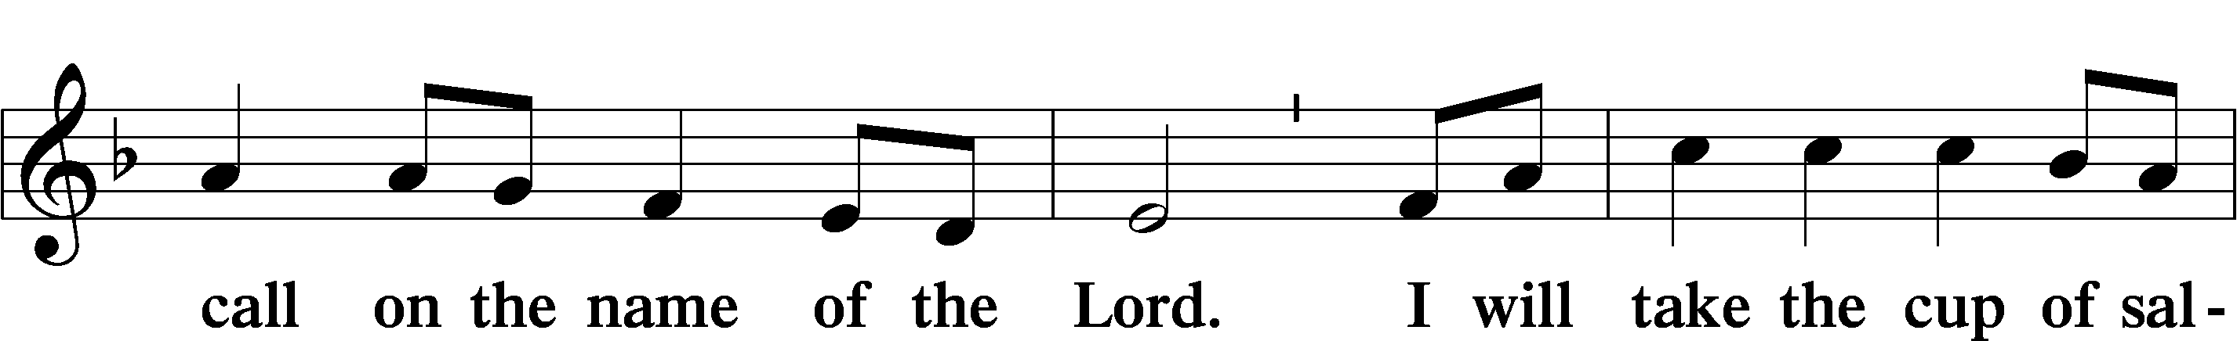
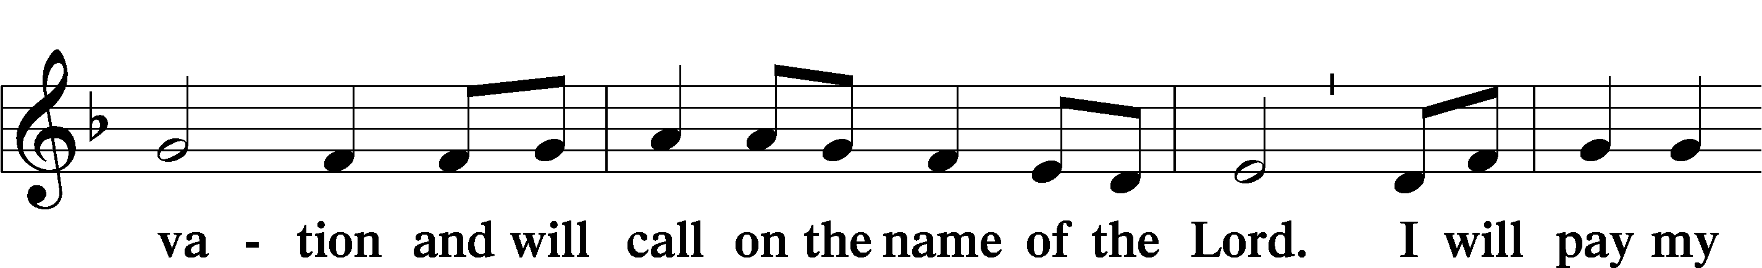
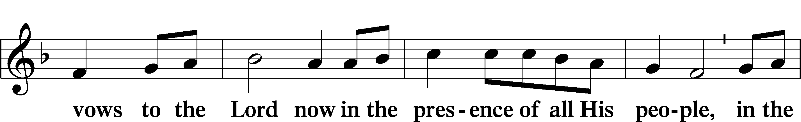
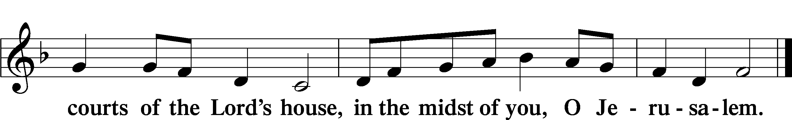
+ Service of the Sacrament +
As God's baptized and forgiven people, we gather at His invitation to receive The Lord's Supper.

The Lord’s Supper is celebrated at this congregation in the confession and glad confidence that, as he says, our Lord gives into our mouths not only bread and wine but His very body and blood to eat and to drink for the forgiveness of sins and to strengthen our union with him and with one another. Our Lord invites to his table those Baptized Christians who trust his words, repent of all sin, and set aside any refusal to forgive and love as he forgives and loves us, that they may show forth his death until he comes.

Because those who eat and drink our Lord’s body and blood unworthily do so to their great harm and because Holy Communion is a confession of the faith which is confessed at this altar, any who are not yet instructed, in doubt, or who hold a confession differing from that of this congregation and The Lutheran Church— Missouri Synod, and yet desire to receive the sacrament, are asked first to speak with the pastor or an elder.

For further study, see Matthew 5:23f.; 10:32f.; 18:15-35; 26:26-29; 1 Cor. 11:17- 34.

PREFACE LSB 160





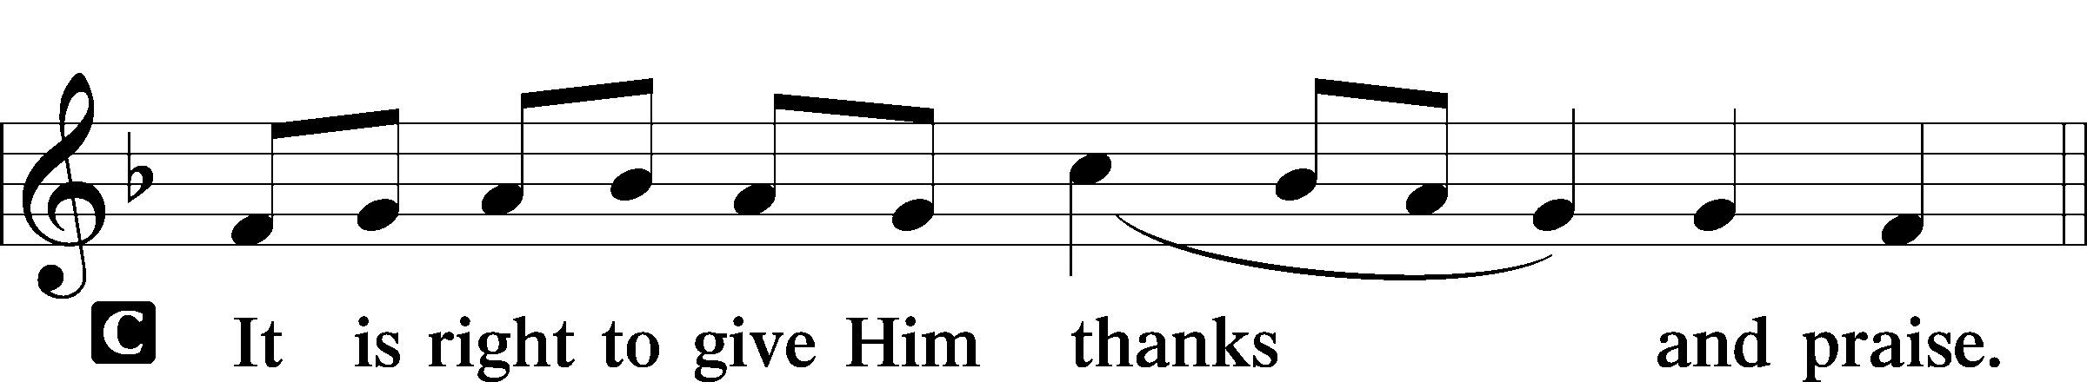

PROPER PREFACE LSB 161
P It is truly good, right, and salutary . . . evermore praising You and saying:

SANCTUS LSB 161
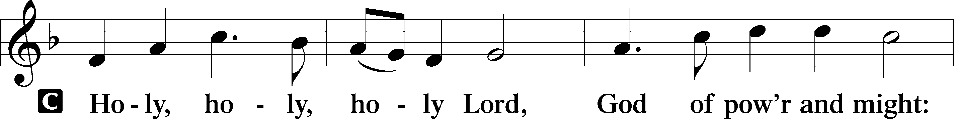
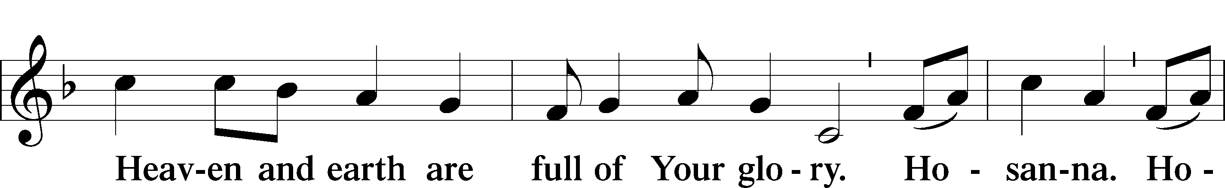
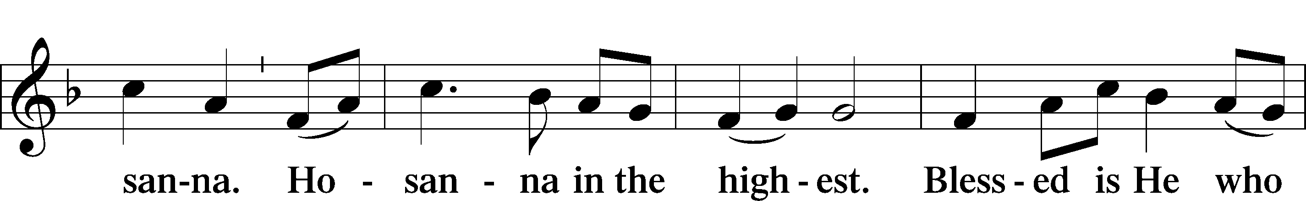
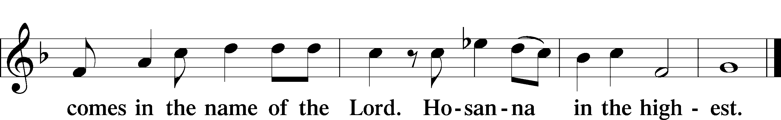

PRAYER OF THANKSGIVING 161
P Blessed are You, Lord of heaven and earth, for You have had mercy on those whom You created and sent Your only-begotten Son into our flesh to bear our sin and be our Savior. With repentant joy we receive the salvation accomplished for us by the all-availing sacrifice of His body and His blood on the cross.

Gathered in the name and the remembrance of Jesus, we beg You, O Lord, to forgive, renew, and strengthen us with Your Word and Spirit. Grant us faithfully to eat His body and drink His blood as He bids us do in His own testament. Gather us together, we pray, from the ends of the earth to celebrate with all the faithful the marriage feast of the Lamb in His kingdom, which has no end. Graciously receive our prayers; deliver and preserve us. To You alone, O Father, be all glory, honor, and worship, with the Son and the Holy Spirit, one God, now and forever.
C Amen.

THE WORDS OF OUR LORD

PROCLAMATION OF CHRIST
P As often as we eat this bread and drink this cup, we proclaim the Lord’s death until He comes.
C Amen. Come, Lord Jesus.

P O Lord Jesus Christ, only Son of the Father, in giving us Your body and blood to eat and to drink, You lead us to remember and confess Your holy cross and passion, Your blessed death, Your rest in the tomb, Your resurrection from the dead, Your ascension into heaven, and Your coming for the final judgment. So remember us in Your kingdom and teach us to pray:

LORD’S PRAYER
C Our Father who art in heaven, hallowed be Thy name, Thy kingdom come, Thy will be done on earth as it is in heaven; give us this day our daily bread; and forgive us our trespasses as we forgive those who trespass against us; and lead us not into temptation, but deliver us from evil. For Thine is the kingdom and the power and the glory forever and ever. Amen.

PAX DOMINI LSB 163
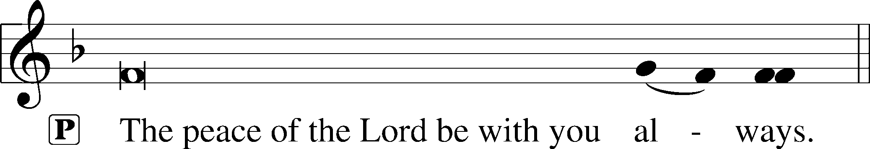


AGNUS DEI LSB 163
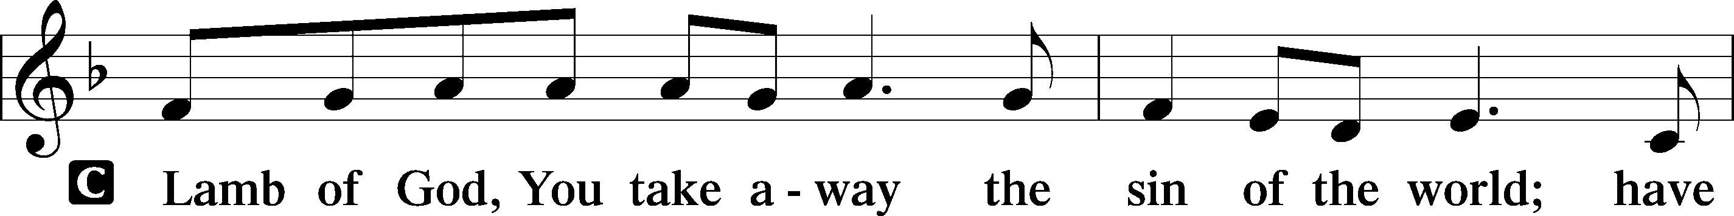
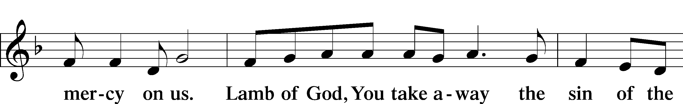
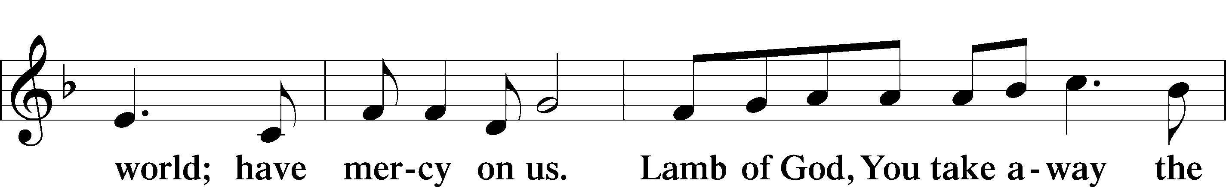
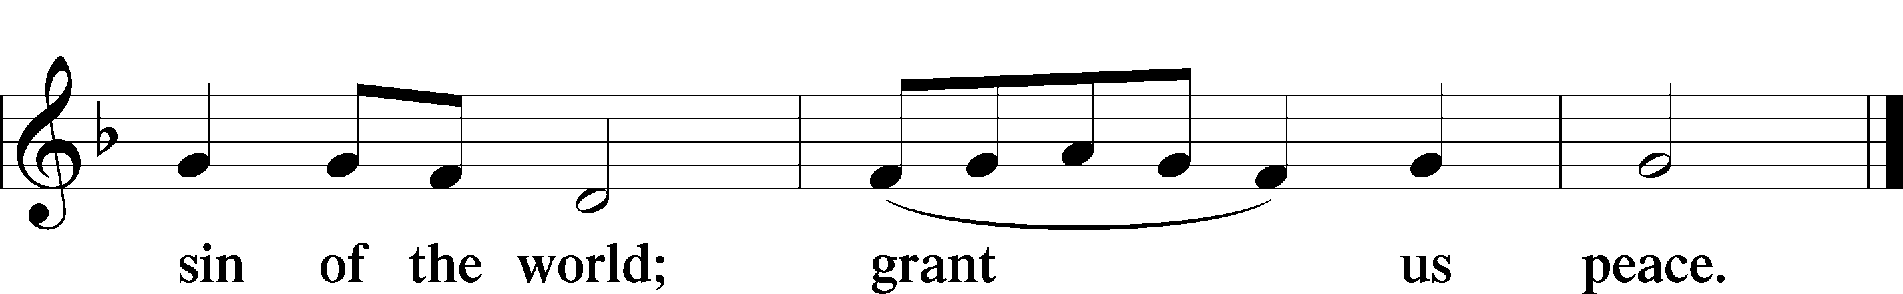

Following the Agnus Dei, please greet one another in the name of the Lord, saying, “Peace be with you,” as a sign of reconciliation and of the unity of the Spirit in the bond of peace (Matt. 5:22–24; Eph. 4:1–3).

Sit

DISTRIBUTION HYMNS

901 OPEN NOW THY GATES OF BEAUTY

1 Open now thy gates of beauty;
Zion, let me enter there,
Where my soul in joyful duty
Waits for Him who answers prayer.
Oh, how blessèd is this place,
Filled with solace, light, and grace!

2 Gracious God, I come before Thee;
Come Thou also unto me.
Where we find Thee and adore Thee,
There a heav’n on earth must be.
To my heart, O enter Thou;
Let it be Thy temple now!

3 Here Thy praise is gladly chanted;
Here Thy seed is duly sown.
Let my soul, where it is planted,
Bring forth precious sheaves alone,
So that all I hear may be
Fruitful unto life in me.

4 Thou my faith increase and quicken;
Let me keep Thy gift divine,
Howsoe’er temptations thicken;
May Thy Word still o’er me shine
As my guiding star through life,
As my comfort in all strife.

5 Speak, O God, and I will hear Thee;
Let Thy will be done indeed.
May I undisturbed draw near Thee
While Thou dost Thy people feed.
Here of life the fountain flows;
Here is balm for all our woes.

779 COME, MY SOUL, WITH EVERY CARE

1 Come, my soul, with ev’ry care,
Jesus loves to answer prayer;
He Himself has bid thee pray,
Therefore will not turn away.

2 Thou art coming to a King,
Large petitions with thee bring;
For His grace and pow’r are such
None can ever ask too much.

3 With my burden I begin:
Lord, remove this load of sin;
Let Thy blood, for sinners spilt,
Set my conscience free from guilt.
4 Lord, Thy rest to me impart,
Take possession of my heart;
There Thy blood-bought right maintain
And without a rival reign.

5 While I am a pilgrim here,
Let Thy love my spirit cheer;
As my guide, my guard, my friend,
Lead me to my journey’s end.

6 Show me what is mine to do;
Ev’ry hour my strength renew.
Let me live a life of faith;
Let me die Thy people’s death.

510 A MULTITUDE COMES FROM THE EAST AND THE WEST

1 A multitude comes from the east and the west
To sit at the feast of salvation
With Abraham, Isaac, and Jacob, the blest,
Obeying the Lord’s invitation.
Have mercy upon us, O Jesus!

2 O God, let us hear when our Shepherd shall call
In accents persuasive and tender,
That while there is time we make haste, one and all,
And find Him, our mighty defender.
Have mercy upon us, O Jesus!

3 All trials shall be like a dream that is past,
Forgotten all trouble and mourning.
All questions and doubts have been answered at last,
When rises the light of that morning.
Have mercy upon us, O Jesus!

4 The heavens shall ring with an anthem more grand
Than ever on earth was recorded.
The blest of the Lord shall receive at His hand
The crown to the victors awarded.
Have mercy upon us, O Jesus!

Stand

DISMISSAL

THANK THE LORD LSB 164
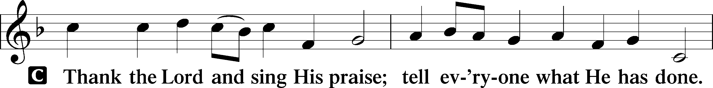
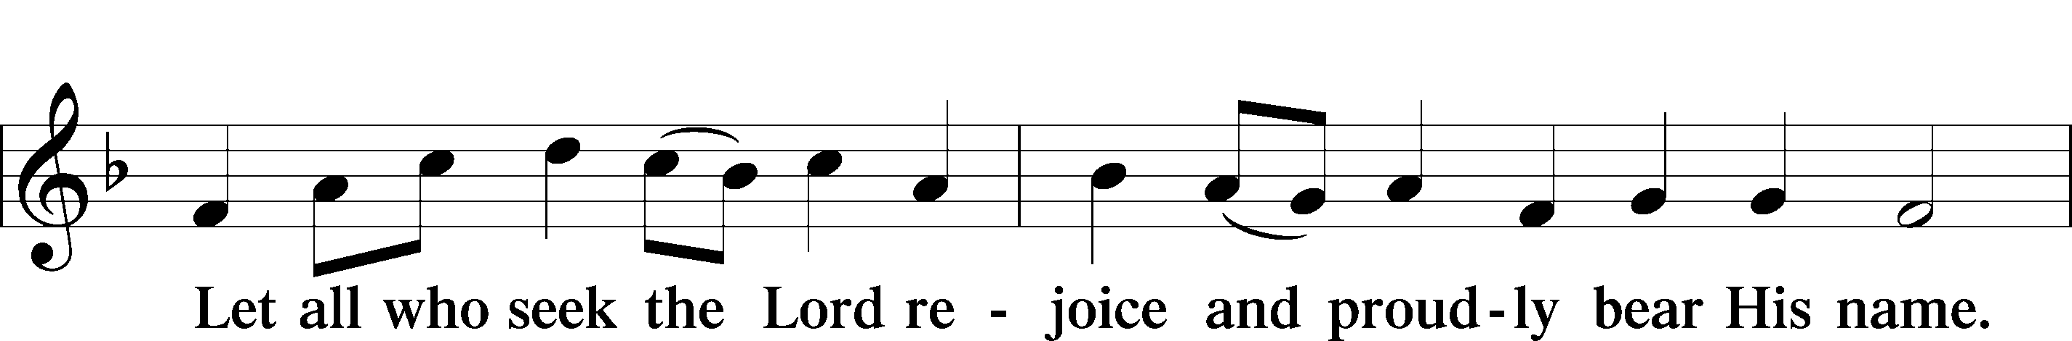
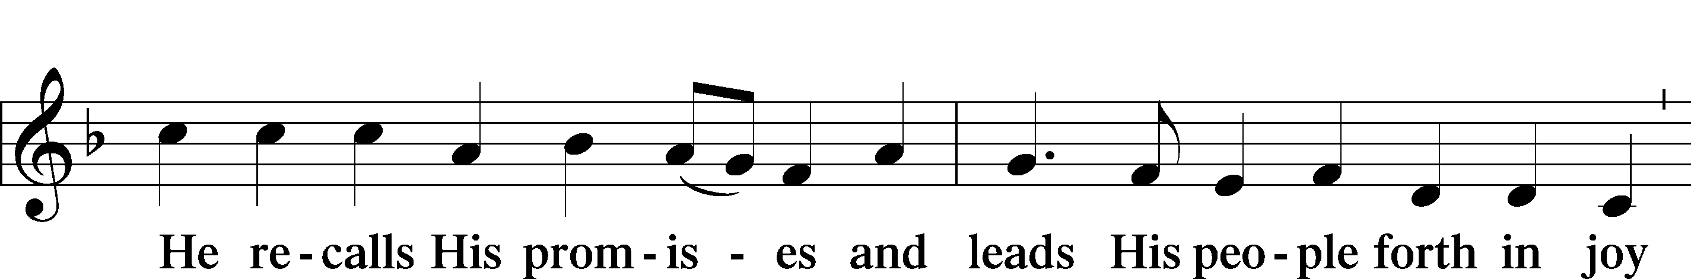
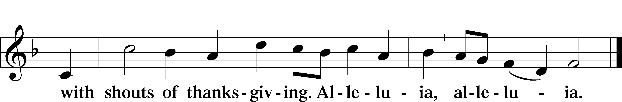

POST-COMMUNION COLLECT

BENEDICTION LSB 166
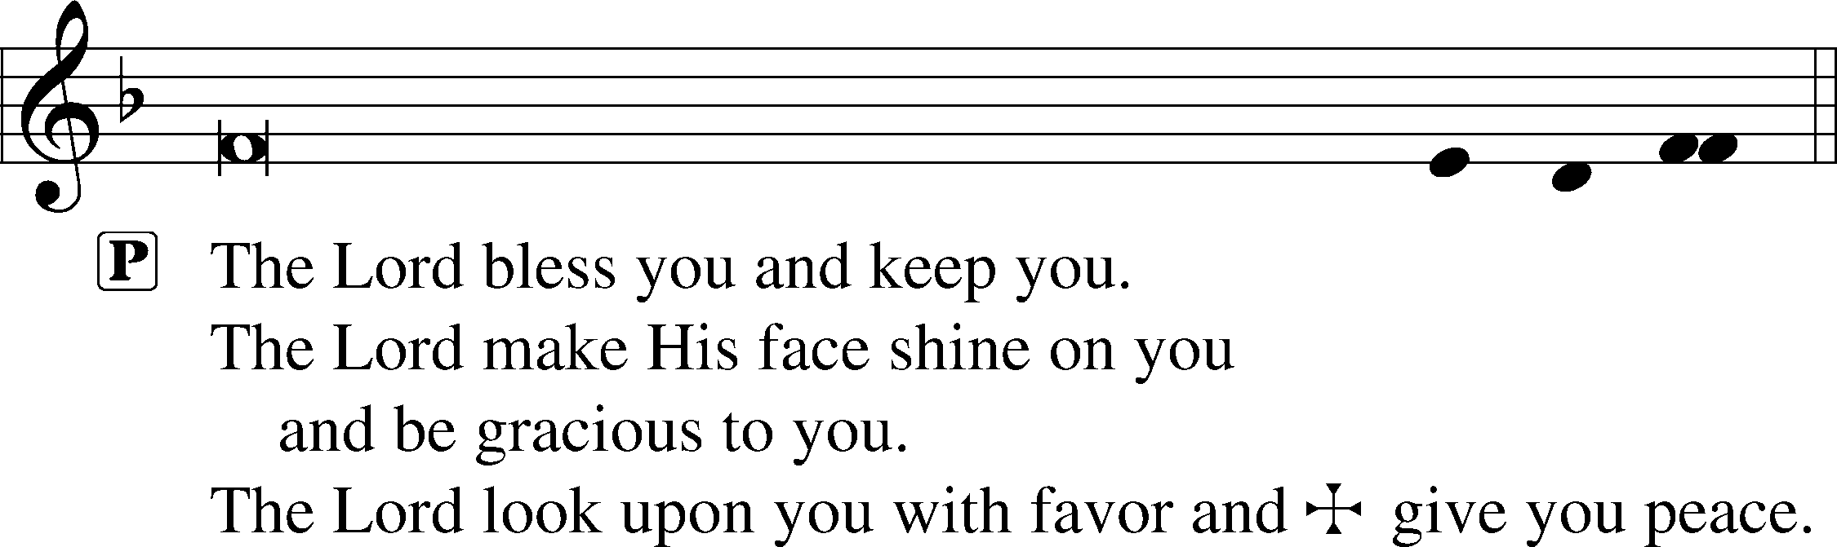


RECESSIONAL HYMN

832 JESUS SHALL REIGN

1 Jesus shall reign where’er the sun
Does its successive journeys run;
His kingdom stretch from shore to shore
Till moons shall wax and wane no more.

2 To Him shall endless prayer be made,
And endless praises crown His head;
His name like sweet perfume shall rise
With ev’ry morning sacrifice.

3 People and realms of ev’ry tongue
Dwell on His love with sweetest song;
And infant voices shall proclaim
Their early blessings on His name.

4 Blessings abound where’er He reigns:
The pris’ners leap, unloose their chains,
The weary find eternal rest,
And all who suffer want are blest.

5 Let ev’ry creature rise and bring
Honors peculiar to our King;
Angels descend with songs again,
And earth repeat the loud amen.

ANNOUNCEMENTS
See announcements on the back of the bulletin.

SENDING
P Let us pray.
Lord God, You have called Your servants to ventures of which we cannot see the ending, by paths as yet untrodden, through perils unknown. Give us faith to go out with good courage, not knowing where we go but only that Your hand is leading us and Your love supporting us; through Jesus Christ, our Lord.
C Amen

P Go in peace to serve the Lord.
C Thanks be to God.

THIS WEEK AT FAITH
Sun. August 16 Bible Studies 8:15am
Worship 9:30am
Youth Event 12-2pm
Mon-Fri August 17-21 Chapel 8:30 pm
Tues. August 18 Create in Me Crafting 10:00am
Sun. August 23 Bible Studies 8:15am
Worship 9:30am

CHURCH ANNOUNCEMENTS
HOMEMADE FROM THE HEART - Making Mondays Sweeter - We have a fun way to support our amazing staff at FLS with homemade or store-bought baked goods. To sign up please see the most recent newsletter or contact Natalie Brown at Natalie.brown@faithmarietta.org.

VOTERS’ MEETINGS - take place after Sunday worship. Next Tentative Meetings: Aug 23 - Nominating Committee; Nov 15 – Elections

RALLY DAY – Sunday, August 30 after worship - Let’s Rally! Kick off the fall season with us at Faith. Join us immediately after church for lunch and bring your favorite potluck dish to share. There will be a display on the patio showcasing upcoming educational classes, connection groups, and Wednesday gathering events. If you would like to get involved or have questions, contact Muriel Pfaff.
Rally Day is hosted by the Board of Christian Education

CONFIRMATION CLASSES
For students (grades 7 and 8) who desire to grow in their faith and progress toward the milestone of adult membership at Faith Lutheran Church. Classes will be Wednesday nights at 6:30pm. Regular classes will begin on September 2. A required confirmation orientation for students and their parents will be held on Saturday August 29, 9am-12noon. Please contact Pastor Shaun to sign up for classes. pastor.shaun@faithmarietta.org

WEDNESDAY NIGHT CORN HOLE – September 2nd Dinner 5:30 pm, Tournament 6:30 pm., You are invited to our 3rd Annual Cornhole Tournament! Join us for dinner, drinks, ice cream sundaes and friendly competition! Co-Hosted by Family Life & Board of Christian Education.

WORSHIP SCHEDULE - Beginning September 6, our Sunday morning schedule will change:
Bible Study 8:30a - 9:30a; Fellowship 9:30a - 10:00a; Worship 10:00a - 11:30a.
The purpose of this change is to promote fellowship within the Faith Community and to give the choir and congregation time to prepare for worship. In addition, this will also allow for regular fellowship activities after worship.

FAITH SCHOOL PRAYERS - The School Prayer group meets 2nd Tuesday of the month, at 9:00am in craft room. Dates are September 8th, Oct 13th, Nov 10th, Dec 8th. Call or text Norma Palmer at (256-653-8349) for more information.

FAITH LUTHERAN SCHOOL NEEDS MISSIONARIES - If you would like to share the love of Christ with His littlest lambs, please consider working as a preschool teacher on either a permanent basis for the school year or for a few weeks while one of our teachers enjoys maternity leave. Please contact Chris Bradshaw with questions.

