

Tenth Sunday After Pentecost
August 2, 2026
OUR MISSION: Connecting People to Jesus

Contact us
Faith Lutheran Church & School 2111 Lower Roswell Rd, Marietta, GA 30068 | 770-973-8877

CHURCH: www.faithmarietta.com SCHOOL: www.faithmarietta.org
Rev. Shaun Daugherty, Pastor Mr. Chris Bradshaw, Headmaster
pastor.shaun@faithmarietta.org chris.bradshaw@faithmarietta.org
470-289-9469 470-641-6239
See the full leadership directory: www.faithmarietta.com/leadership
Serving This Month at Faith
 | 8/2/2026 | 8/9/2026 | 8/16/2026 | 8/23/2026 | 8/30/2026
Musicians | Vaunda Noerenberg | Vaunda Noerenberg | Ben Nye | Vaunda Noerenberg | Vaunda Noerenberg
Elders | Ward Irvin  Greg Sinatra | Vinny Caracci  Ward Irvin | Steve Buchtrup  Woody Wood | Russ Couch  Greg Schaag | Jon Cain  Peter Amelingmeier
Reader | Danette Smith | David Barnett | Karen Cerny | Jill Musgrove | Russell Couch
Ushers | Greg Czerwonka  Matthew Czerwonka  Jacob Czerwonka  Luke Czerwonka  Sam Czerwonka | Steve Buchtrup  Mark Patterson  Gary Schleicher  Reagan Gronsbell  Paris Brown | Kim Kaumeyer  David Barnett  Greg Sinatra | Chris Bradshaw  Herman Dean  Bryan Powell  Christian Campbell | Rosina Sawh  Louise Cox  Jamie Bass  Pam Cole
Acolytes | Adam Cain  Amadeo Brown | Josiah Brown  Alex Bradshaw | Adam Cain  Christian Brown | Silas Daugherty  Ryan Cain | Josiah Brown  Eli Bradshaw



Pay Pal

For your convenience,
we now accept gifts
via Venmo or PayPal.

Our Discipleship
Date | 7/19 | 7/26 | 8/2 |  | YTD Report (Aug thru June)
Worship | 137/130 | 130/122 | -- |  | Avg. Worship | 144
Sunday School | 24 | 14 | -- |  | Avg. SS | 35
Gen. Giving | $11,714 | $6,085 | $ |  | YTD Gen. Giving | $638,903
MTD Giving | $31,410 | $37,495 | $ |  | Budgeted Giving | $658,060
 |  |  |  |  | Over/(Under) | ($19,157)
 |  |  |  |  | "Special" Gifts | $383,020
Monthly Budget | $53,300 | $53,300 | $53,300 |  | Designated Gifts | $169,633
FAITH GROWS is our debt reduction account, geared towards eliminating our mortgage.
Please prayerfully consider donating to this fund - over and beyond your normal tithe.

YTD Debt Reduction | $245,146 | Remaining Mortgage Debt | $2,684,085
ALTAR FLOWERS given today to the Glory of God
+ Confession and Absolution +
We enter the presence of God by humbly confessing our sins and gladly receiving His forgiveness.

Stand

PROCESSIONAL HYMN

697 AWAKE, O SLEEPER, RISE FROM DEATH

1 Awake, O sleeper, rise from death,
And Christ shall give you light;
So learn His love, its length and breadth,
Its fullness, depth, and height.

2 To us on earth He came to bring
From sin and fear release,
To give the Spirit’s unity,
The very bond of peace.

3 Then walk in love as Christ has loved,
Who died that He might save;
With kind and gentle hearts forgive
As God in Christ forgave.

4 For us Christ lived, for us He died,
And conquered in the strife;
Awake, arise, go forth in faith,
And Christ shall give you life.

The sign of the cross may be made by all in remembrance of their Baptism.

INVOCATION
P In the name of the Father and of the T Son and of the Holy Spirit.
C Amen.

P If we say we have no sin, we deceive ourselves, and the truth is not in us.
C But if we confess our sins, God, who is faithful and just, will forgive our sins and cleanse us from all unrighteousness.

Silence for reflection on God’s Word and for self-examination.

CONFESSION AND ABSOLUTION LSB 151
P Let us then confess our sins to God our Father.
C Most merciful God, we confess that we are by nature sinful and unclean. We have sinned against You in thought, word, and deed, by what we have done and by what we have left undone. We have not loved You with our whole heart; we have not loved our neighbors as ourselves. We justly deserve Your present and eternal punishment. For the sake of Your Son, Jesus Christ, have mercy on us. Forgive us, renew us, and lead us, so that we may delight in Your will and walk in Your ways to the glory of Your holy name. Amen.

P Almighty God in His mercy has given His Son to die for you and for His sake forgives you all your sins. As a called and ordained servant of Christ, and by His authority, I therefore forgive you all your sins in the name of the Father and of the T Son and of the Holy Spirit.
C Amen.

Stand
+ Service of the Word +
Having received God's forgiveness, we come before Him with songs of praise, eager to hear His Word.

INTROIT

Oh give thanks to the Lord; call up- | on his name;*
make known his deeds among the | peoples!
He spread a cloud for a | covering,*
and fire to give | light by night.
They asked, and he | brought quail,*
and gave them bread from heaven in a- | bundance.
He opened the rock, and water | gushed out;*
it flowed through the desert like a | river.
For he remembered his holy | promise,*
and Abraham, his | servant.
So he brought his people | out with joy,*
his chosen ones with | singing.
Glory be to the Father and | to the Son*
and to the Holy | Spirit;
as it was in the be- | ginning,*
is now, and will be forever. | Amen.
Oh give thanks to the Lord; call up- | on his name;*
make known his deeds among the | peoples!
KYRIE LSB 152

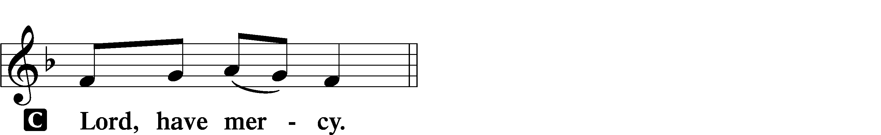

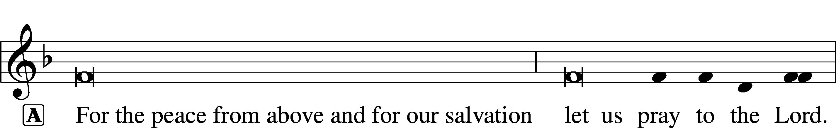
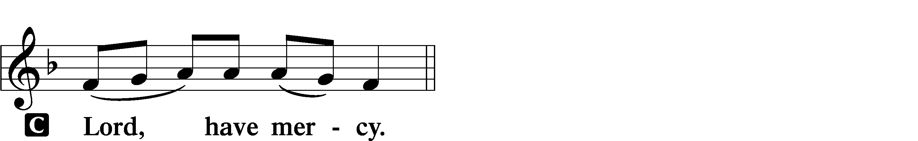

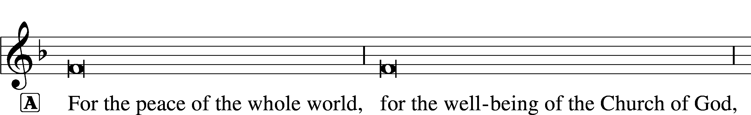

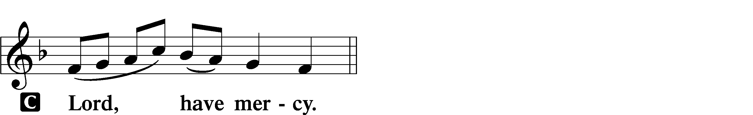

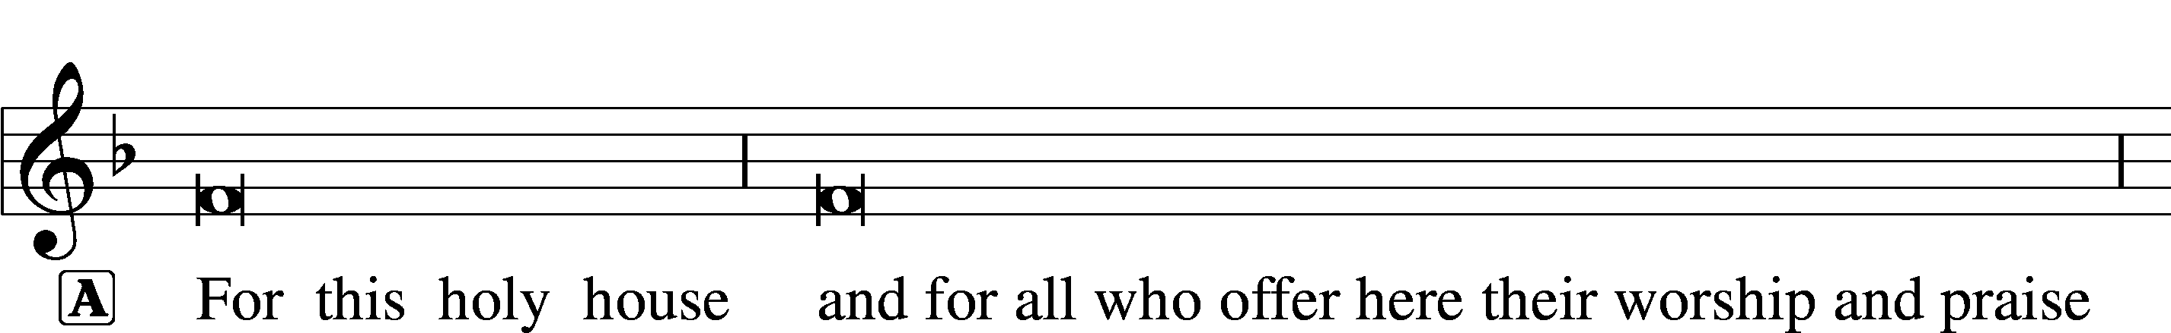

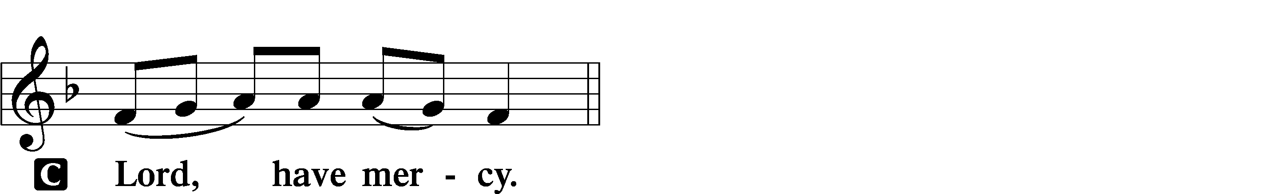




THIS IS THE FEAST LSB 155
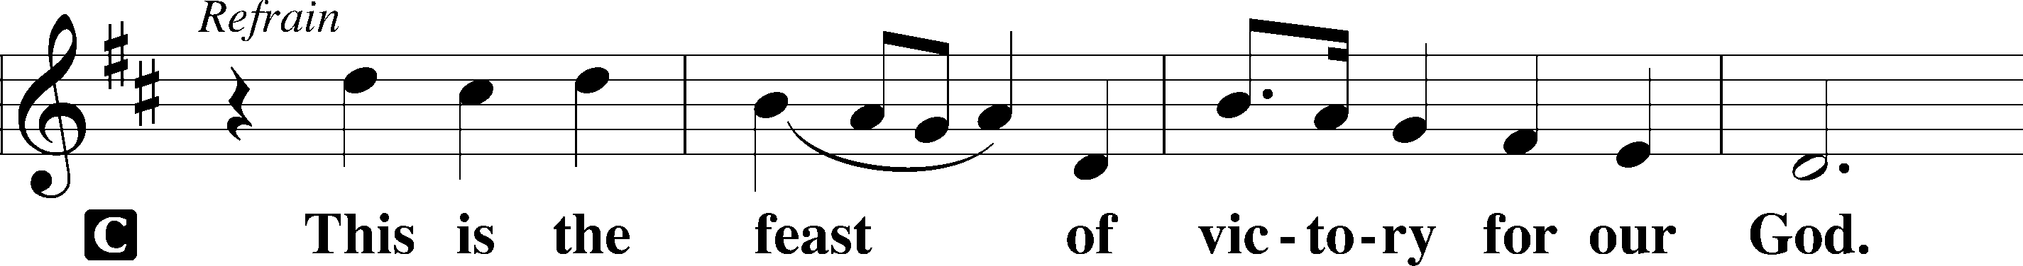
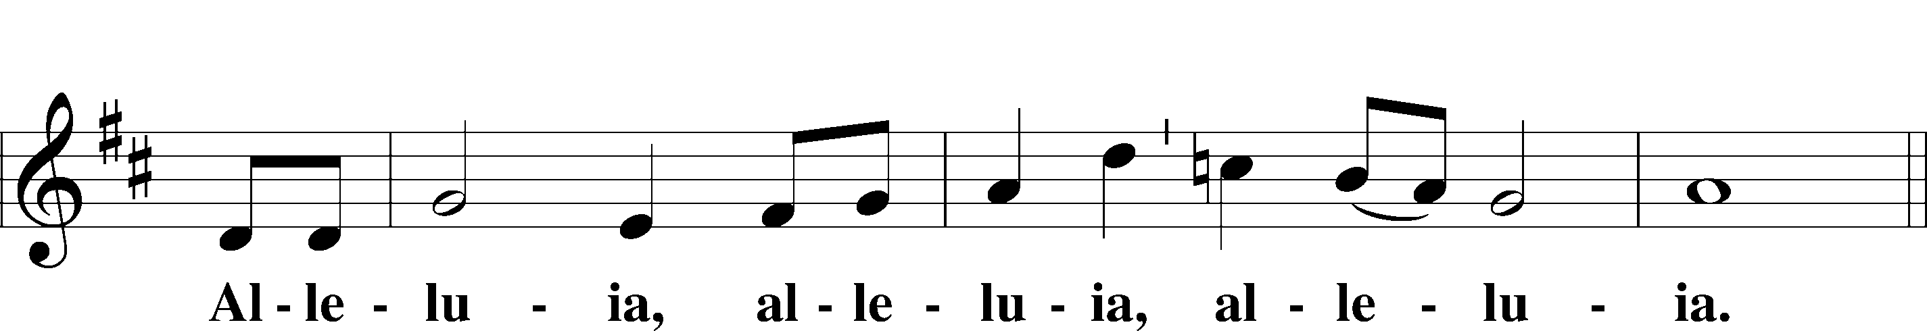
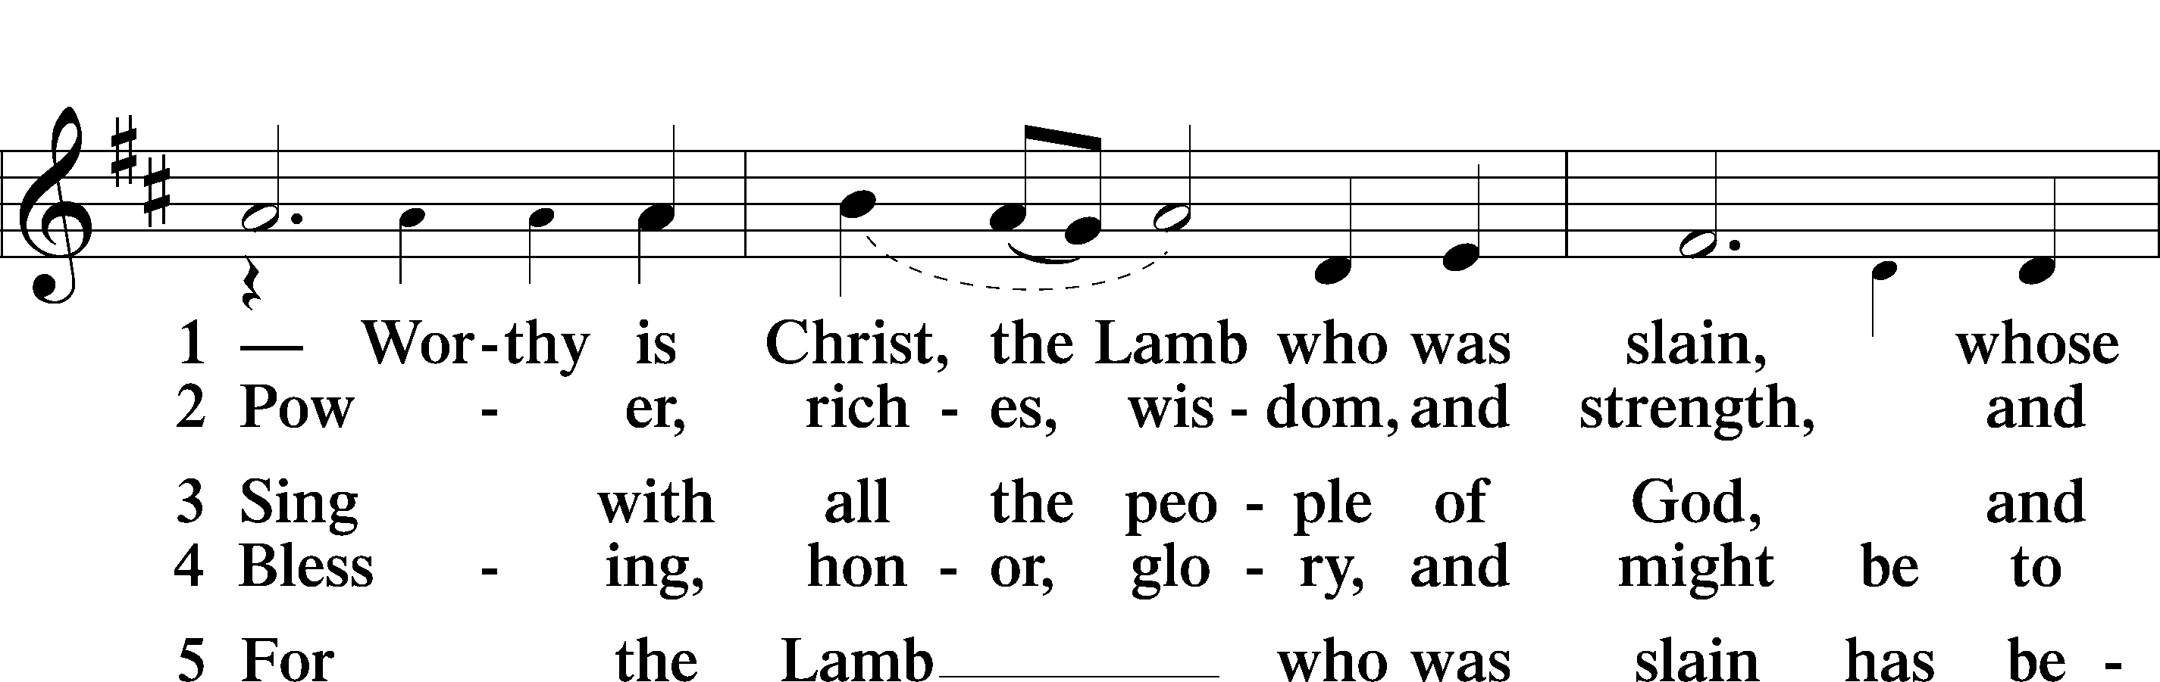
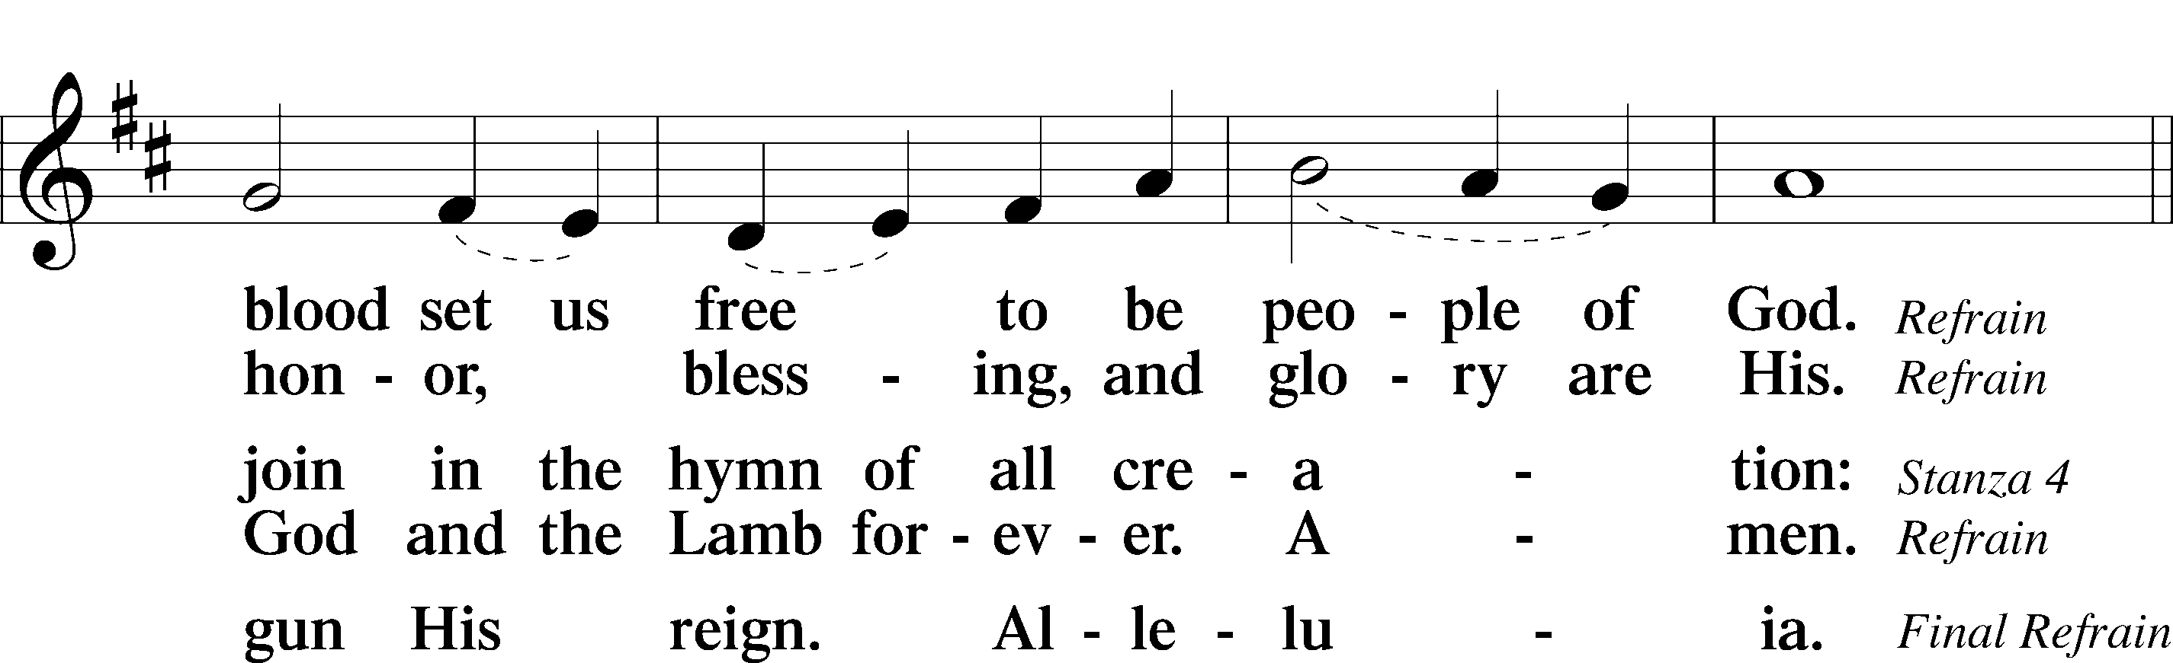
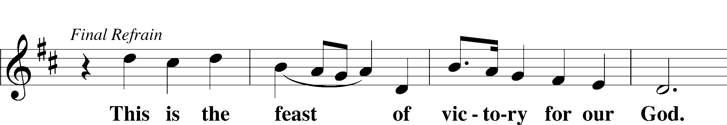
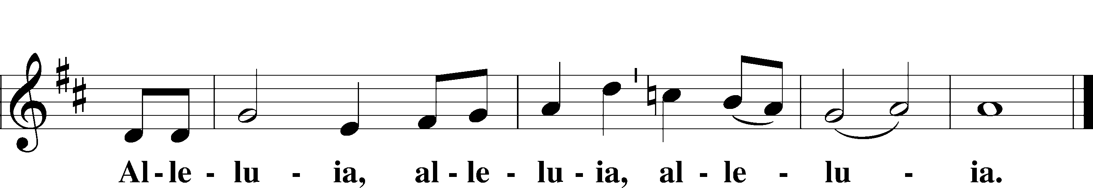

SALUTATION AND COLLECT OF THE DAY
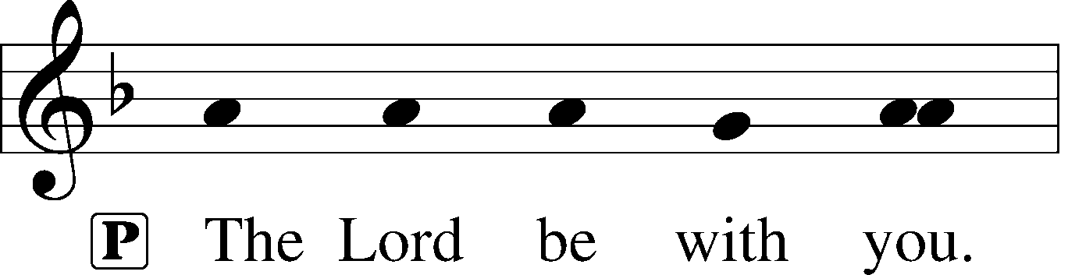
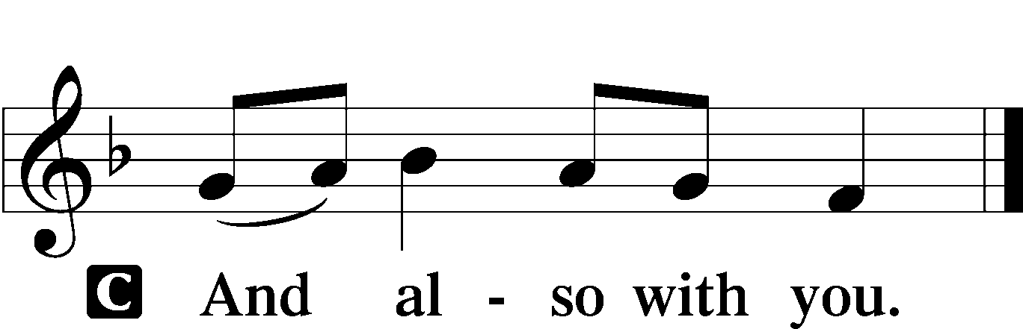

P Let us pray.
Heavenly Father, though we do not deserve Your goodness, still You provide for all our needs of body and soul. Grant us Your Holy Spirit that we may acknowledge Your gifts, give thanks for all Your benefits, and serve You in willing obedience; through Jesus Christ, Your Son, our Lord, who lives and reigns with You and the Holy Spirit, one God, now and forever.

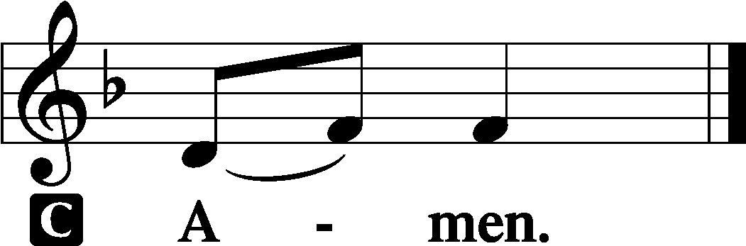

Sit

OLD TESTAMENT READING Isaiah 55:1–5
1“Come, everyone who thirsts,
come to the waters;
and he who has no money,
come, buy and eat!
Come, buy wine and milk
without money and without price.
2Why do you spend your money for that which is not bread,
and your labor for that which does not satisfy?
Listen diligently to me, and eat what is good,
and delight yourselves in rich food.
3Incline your ear, and come to me;
hear, that your soul may live;
and I will make with you an everlasting covenant,
my steadfast, sure love for David.
4Behold, I made him a witness to the peoples,
a leader and commander for the peoples.
5Behold, you shall call a nation that you do not know,
and a nation that did not know you shall run to you,
because of the Lord your God, and of the Holy One of Israel,
for he has glorified you.”

A This is the Word of the Lord.
C Thanks be to God.

GRADUAL
Oh, the depth of the riches and wisdom and knowl- | edge of God!*
How unsearchable are his judgments and how inscrutable | his ways!
For from him and through him and to him are | all things.*
To him be glory forever. | Amen.

EPISTLE Romans 9
1I am speaking the truth in Christ—I am not lying; my conscience bears me witness in the Holy Spirit— 2that I have great sorrow and unceasing anguish in my heart. 3For I could wish that I myself were accursed and cut off from Christ for the sake of my brothers, my kinsmen according to the flesh. 4They are Israelites, and to them belong the adoption, the glory, the covenants, the giving of the law, the worship, and the promises. 5To them belong the patriarchs, and from their race, according to the flesh, is the Christ who is God over all, blessed forever. Amen.
6But it is not as though the word of God has failed. For not all who are descended from Israel belong to Israel, 7and not all are children of Abraham because they are his offspring, but “Through Isaac shall your offspring be named.” 8This means that it is not the children of the flesh who are the children of God, but the children of the promise are counted as offspring. 9For this is what the promise said: “About this time next year I will return and Sarah shall have a son.” 10And not only so, but also when Rebecca had conceived children by one man, our forefather Isaac, 11though they were not yet born and had done nothing either good or bad—in order that God’s purpose of election might continue, not because of works but because of his call— 12she was told, “The older will serve the younger.” 13As it is written, “Jacob I loved, but Esau I hated.”
14What shall we say then? Is there injustice on God’s part? By no means! 15For he says to Moses, “I will have mercy on whom I have mercy, and I will have compassion on whom I have compassion.” 16So then it depends not on human will or exertion, but on God, who has mercy. 17For the Scripture says to Pharaoh, “For this very purpose I have raised you up, that I might show my power in you, and that my name might be proclaimed in all the earth.” 18So then he has mercy on whomever he wills, and he hardens whomever he wills.
19You will say to me then, “Why does he still find fault? For who can resist his will?” 20But who are you, O man, to answer back to God? Will what is molded say to its molder, “Why have you made me like this?” 21Has the potter no right over the clay, to make out of the same lump one vessel for honored use and another for dishonorable use? 22What if God, desiring to show his wrath and to make known his power, has endured with much patience vessels of wrath prepared for destruction, 23in order to make known the riches of his glory for vessels of mercy, which he has prepared beforehand for glory— 24even us whom he has called, not from the Jews only but also from the Gentiles? 25As indeed he says in Hosea,
“Those who were not my people I will call ‘my people,’
and her who was not beloved I will call ‘beloved.’”
26“And in the very place where it was said to them, ‘You are not my people,’
there they will be called ‘sons of the living God.’”
27And Isaiah cries out concerning Israel: “Though the number of the sons of Israel be as the sand of the sea, only a remnant of them will be saved, 28for the Lord will carry out his sentence upon the earth fully and without delay.” 29And as Isaiah predicted,
“If the Lord of hosts had not left us offspring,
we would have been like Sodom
and become like Gomorrah.”
30What shall we say, then? That Gentiles who did not pursue righteousness have attained it, that is, a righteousness that is by faith; 31but that Israel who pursued a law that would lead to righteousness did not succeed in reaching that law. 32Why? Because they did not pursue it by faith, but as if it were based on works. They have stumbled over the stumbling stone, 33as it is written,
“Behold, I am laying in Zion a stone of stumbling, and a rock of offense;
and whoever believes in him will not be put to shame.”

A This is the Word of the Lord.
C Thanks be to God.

Stand

ALLELUIA AND VERSE LSB 156
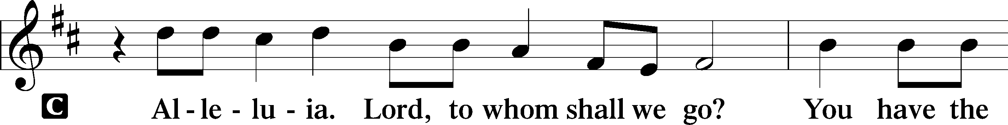
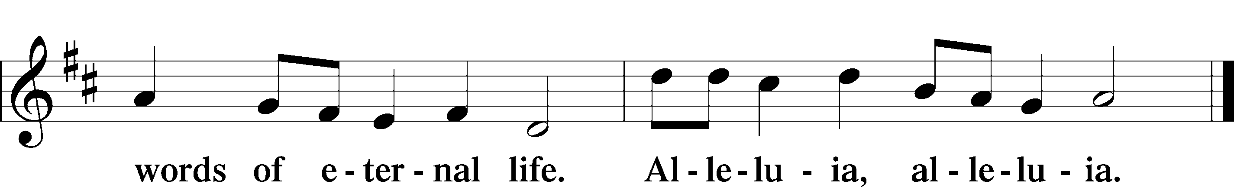

HOLY GOSPEL Matthew 14:13–21
P The Holy Gospel according to St. Matthew, the fourteenth chapter.

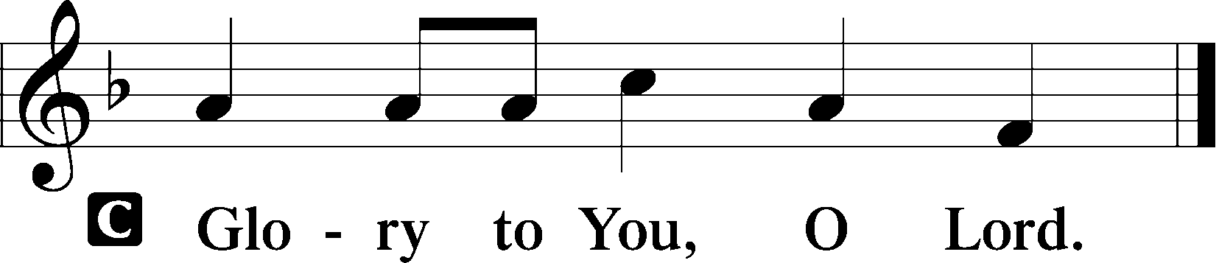

13Now when Jesus heard [about the death of John], he withdrew from there in a boat to a desolate place by himself. But when the crowds heard it, they followed him on foot from the towns. 14When he went ashore he saw a great crowd, and he had compassion on them and healed their sick. 15Now when it was evening, the disciples came to him and said, “This is a desolate place, and the day is now over; send the crowds away to go into the villages and buy food for themselves.” 16But Jesus said, “They need not go away; you give them something to eat.” 17They said to him, “We have only five loaves here and two fish.” 18And he said, “Bring them here to me.” 19Then he ordered the crowds to sit down on the grass, and taking the five loaves and the two fish, he looked up to heaven and said a blessing. Then he broke the loaves and gave them to the disciples, and the disciples gave them to the crowds. 20And they all ate and were satisfied. And they took up twelve baskets full of the broken pieces left over. 21And those who ate were about five thousand men, besides women and children.

P This is the Gospel of the Lord.

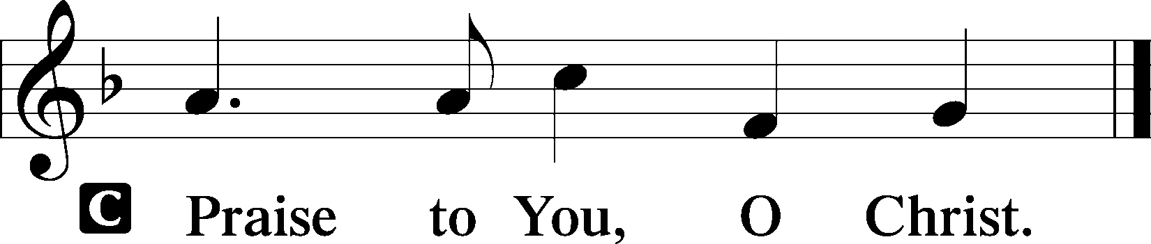

Sit

CHILDREN'S MESSAGE

HYMN OF THE DAY

864 SHEPHERD OF TENDER YOUTH

1 Shepherd of tender youth,
Guiding in love and truth
Through devious ways;
Christ, our triumphant king,
We come Your name to sing
And here our children bring
To join Your praise.

2 You are the holy Lord,
O all-subduing Word,
Healer of strife.
Yourself You did abase
That from sin’s deep disgrace
You so might save our race
And give us life.

3 You are the great High Priest;
You have prepared the feast
Of holy love;
And in our mortal pain
None calls on You in vain;
Our plea do not disdain;
Help from above.

4 O ever be our guide,
Our shepherd, and our pride,
Our staff and song.
Jesus, O Christ of God,
By Your enduring Word
Lead us where You have trod;
Make our faith strong.

5 So now, and till we die,
Sound we Your praises high
And joyful sing:
Infants and all the throng,
Who to the Church belong,
Unite to swell the song
To Christ, our king!

SERMON Rev. Shaun Daugherty

Stand

APOSTLES’ CREED
C I believe in God, the Father Almighty, maker of heaven and earth.

And in Jesus Christ, His only Son, our Lord, who was conceived by the Holy Spirit, born of the virgin Mary, suffered under Pontius Pilate, was crucified, died and was buried. He descended into hell. The third day He rose again from the dead. He ascended into heaven and sits at the right hand of God the Father Almighty. From thence He will come to judge the living and the dead.

I believe in the Holy Spirit, the holy Christian Church, the communion of saints, the forgiveness of sins, the resurrection of the body, and the life T everlasting. Amen.

INSTALLATION OF SCHOOL FACULTY & STAFF

PRAYER OF THE CHURCH
After each petition:
P Lord, in Your mercy,
C hear our prayer.

Sit

COLLECTION OF TITHES AND OFFERING

Stand

OFFERTORY LSB 159
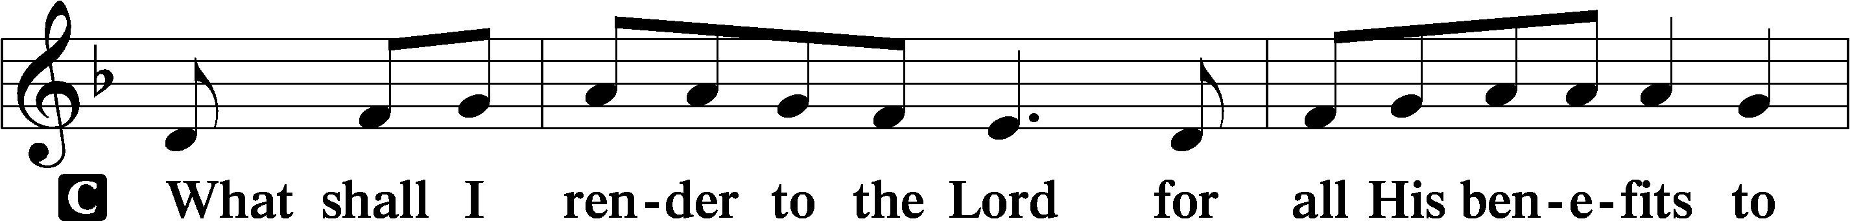
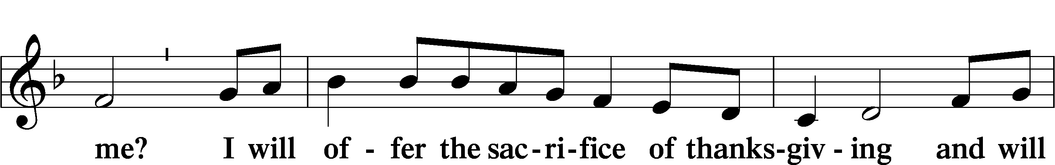
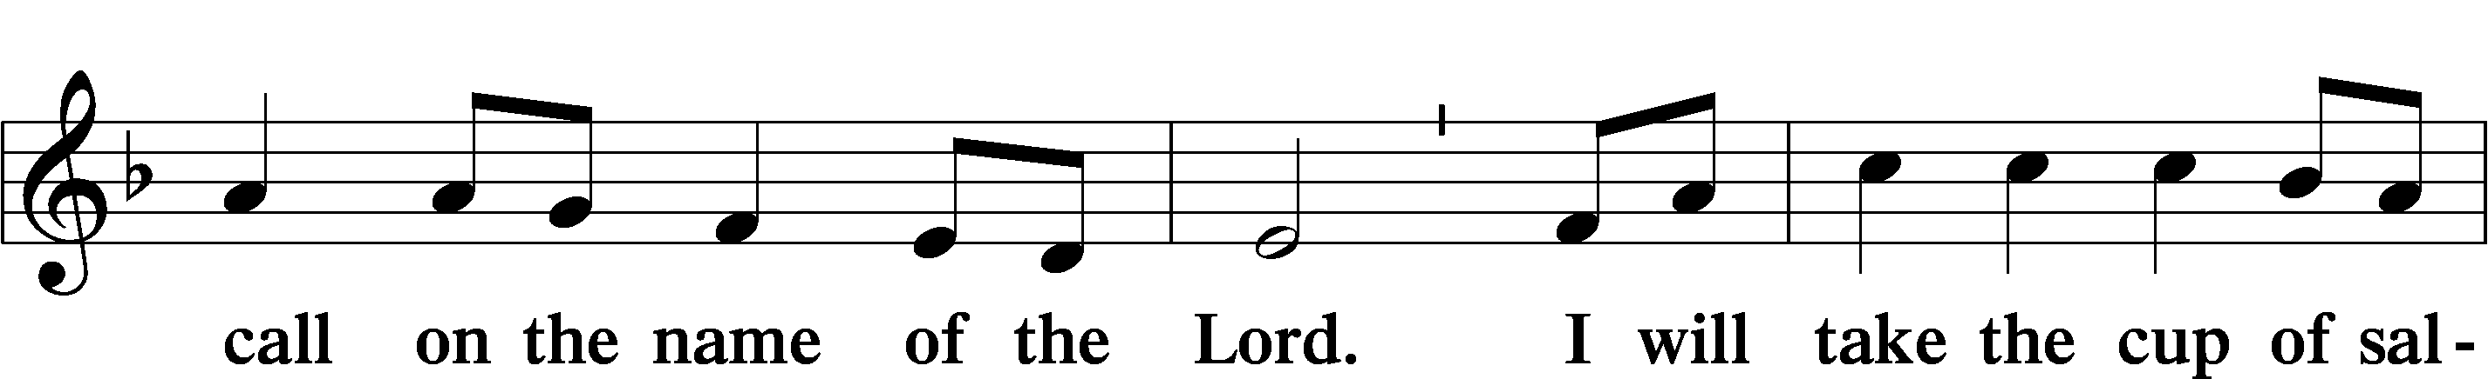
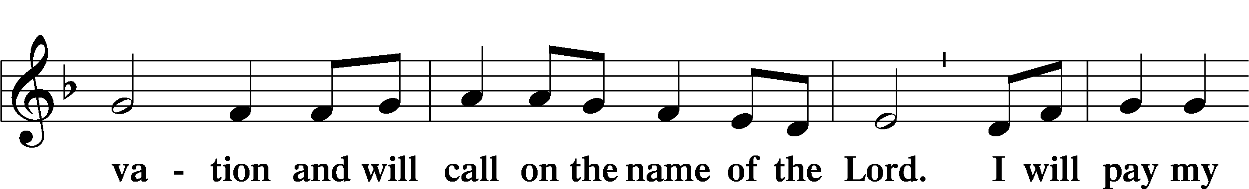
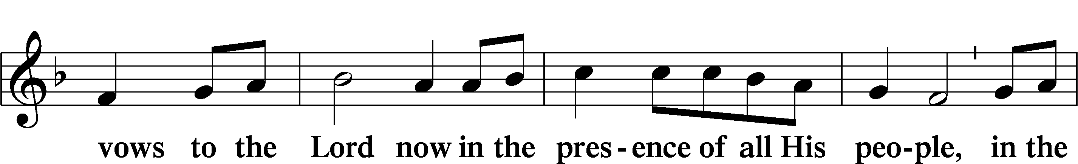
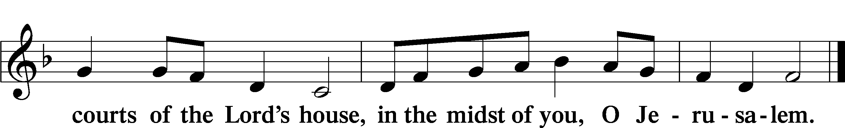

+ Service of the Sacrament +
As God's baptized and forgiven people, we gather at His invitation to receive The Lord's Supper.

The Lord’s Supper is celebrated at this congregation in the confession and glad confidence that, as he says, our Lord gives into our mouths not only bread and wine but His very body and blood to eat and to drink for the forgiveness of sins and to strengthen our union with him and with one another. Our Lord invites to his table those Baptized Christians who trust his words, repent of all sin, and set aside any refusal to forgive and love as he forgives and loves us, that they may show forth his death until he comes.

Because those who eat and drink our Lord’s body and blood unworthily do so to their great harm and because Holy Communion is a confession of the faith which is confessed at this altar, any who are not yet instructed, in doubt, or who hold a confession differing from that of this congregation and The Lutheran Church— Missouri Synod, and yet desire to receive the sacrament, are asked first to speak with the pastor or an elder.
For further study, see Matthew 5:23f.; 10:32f.; 18:15-35; 26:26-29; 1 Cor. 11:17- 34.

PREFACE LSB 160


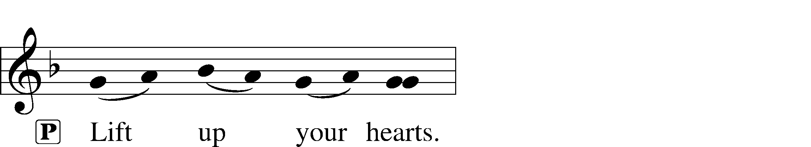


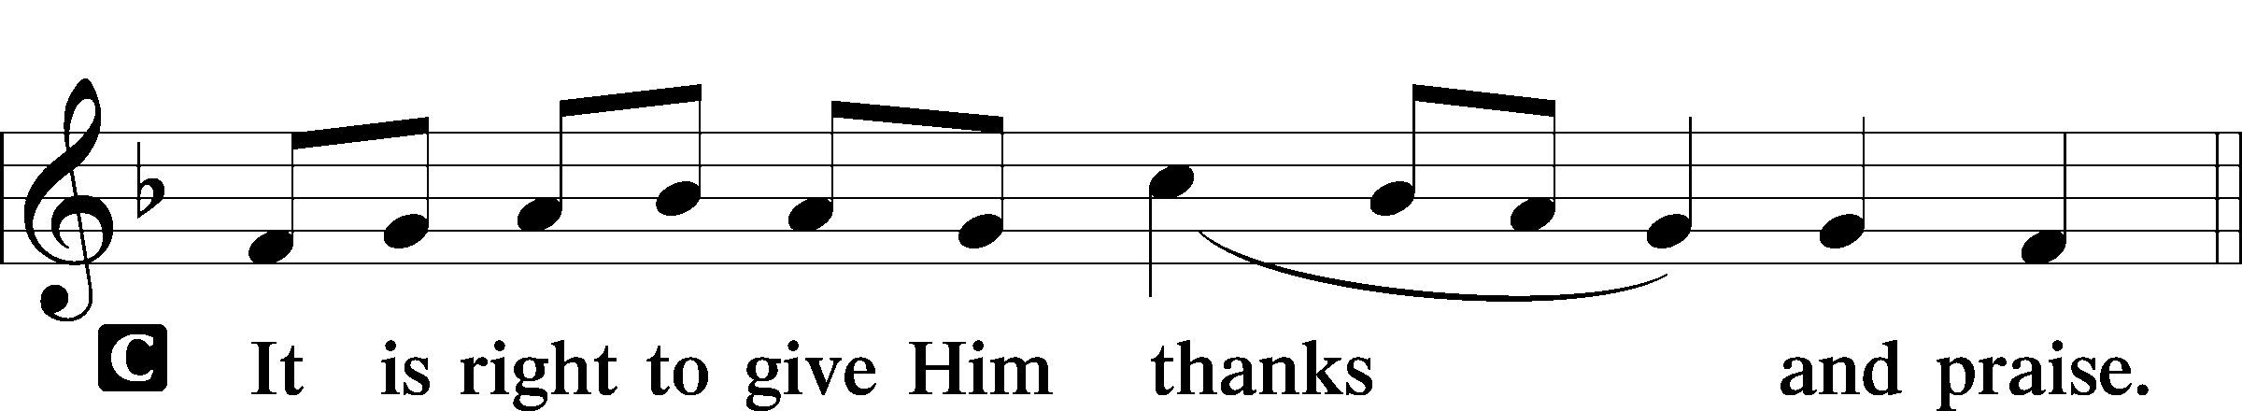

PROPER PREFACE LSB 161
P It is truly good, right, and salutary . . . evermore praising You and saying:

SANCTUS LSB 161
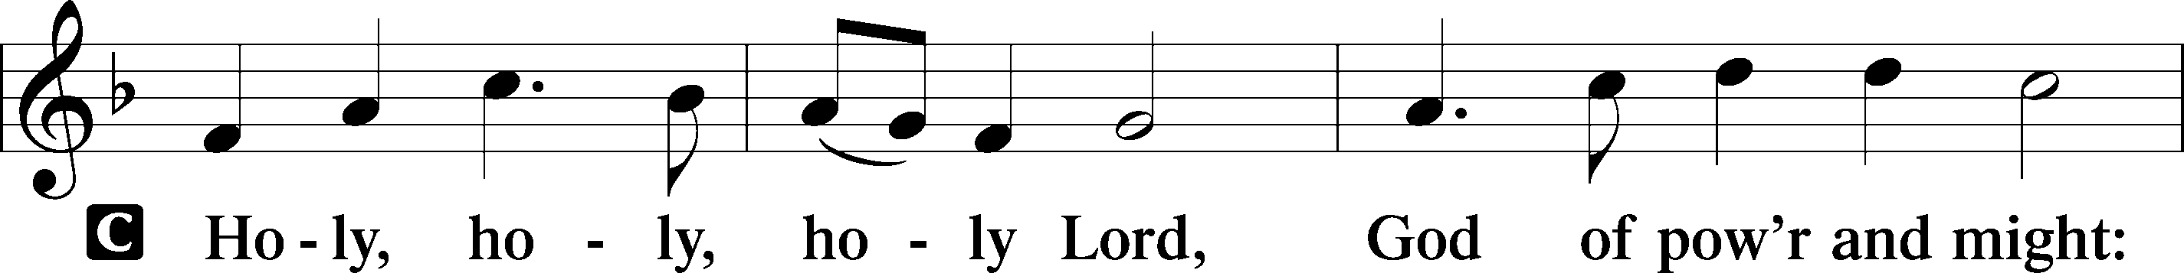
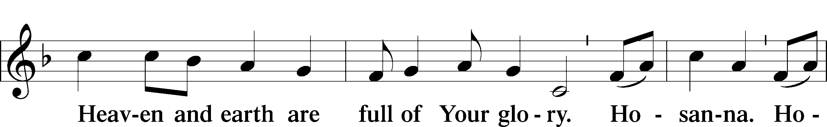
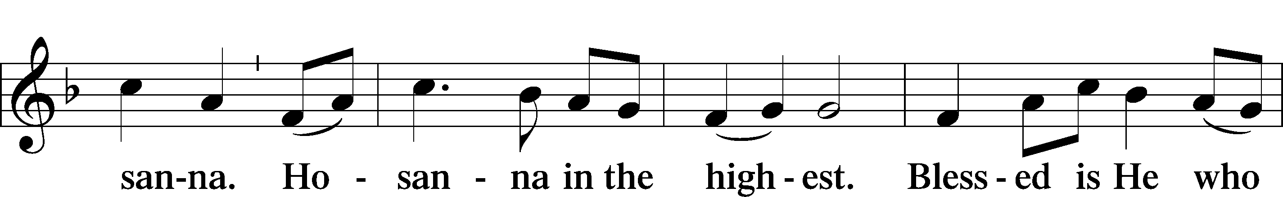
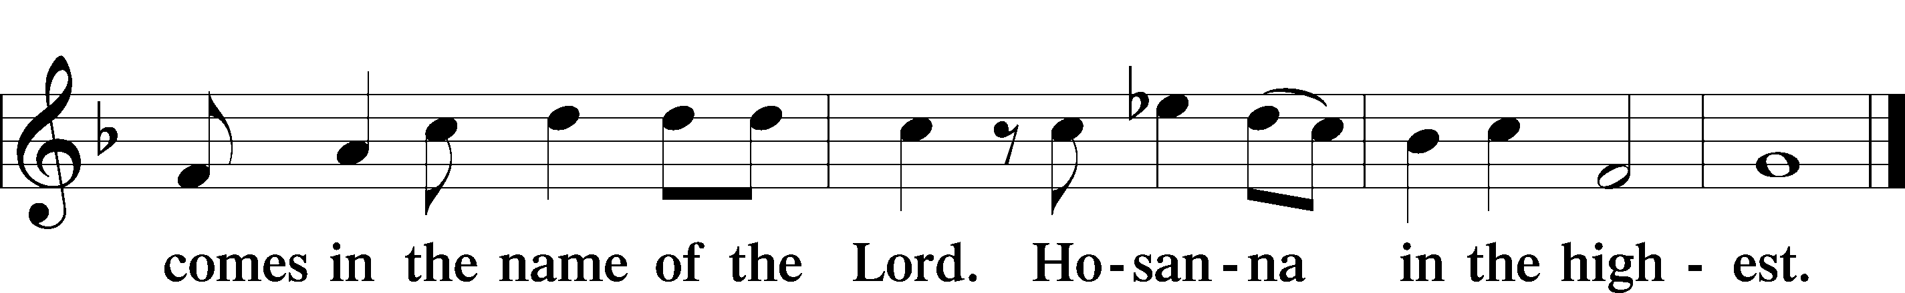

PRAYER OF THANKSGIVING 161
P Blessed are You, Lord of heaven and earth, for You have had mercy on those whom You created and sent Your only-begotten Son into our flesh to bear our sin and be our Savior. With repentant joy we receive the salvation accomplished for us by the all-availing sacrifice of His body and His blood on the cross.

Gathered in the name and the remembrance of Jesus, we beg You, O Lord, to forgive, renew, and strengthen us with Your Word and Spirit. Grant us faithfully to eat His body and drink His blood as He bids us do in His own testament. Gather us together, we pray, from the ends of the earth to celebrate with all the faithful the marriage feast of the Lamb in His kingdom, which has no end. Graciously receive our prayers; deliver and preserve us. To You alone, O Father, be all glory, honor, and worship, with the Son and the Holy Spirit, one God, now and forever.
C Amen.
THE WORDS OF OUR LORD

PROCLAMATION OF CHRIST
P As often as we eat this bread and drink this cup, we proclaim the Lord’s death until He comes.
C Amen. Come, Lord Jesus.

P O Lord Jesus Christ, only Son of the Father, in giving us Your body and blood to eat and to drink, You lead us to remember and confess Your holy cross and passion, Your blessed death, Your rest in the tomb, Your resurrection from the dead, Your ascension into heaven, and Your coming for the final judgment. So remember us in Your kingdom and teach us to pray:

LORD’S PRAYER
C Our Father who art in heaven, hallowed be Thy name, Thy kingdom come, Thy will be done on earth as it is in heaven; give us this day our daily bread; and forgive us our trespasses as we forgive those who trespass against us; and lead us not into temptation, but deliver us from evil. For Thine is the kingdom and the power and the glory forever and ever. Amen.

PAX DOMINI LSB 163
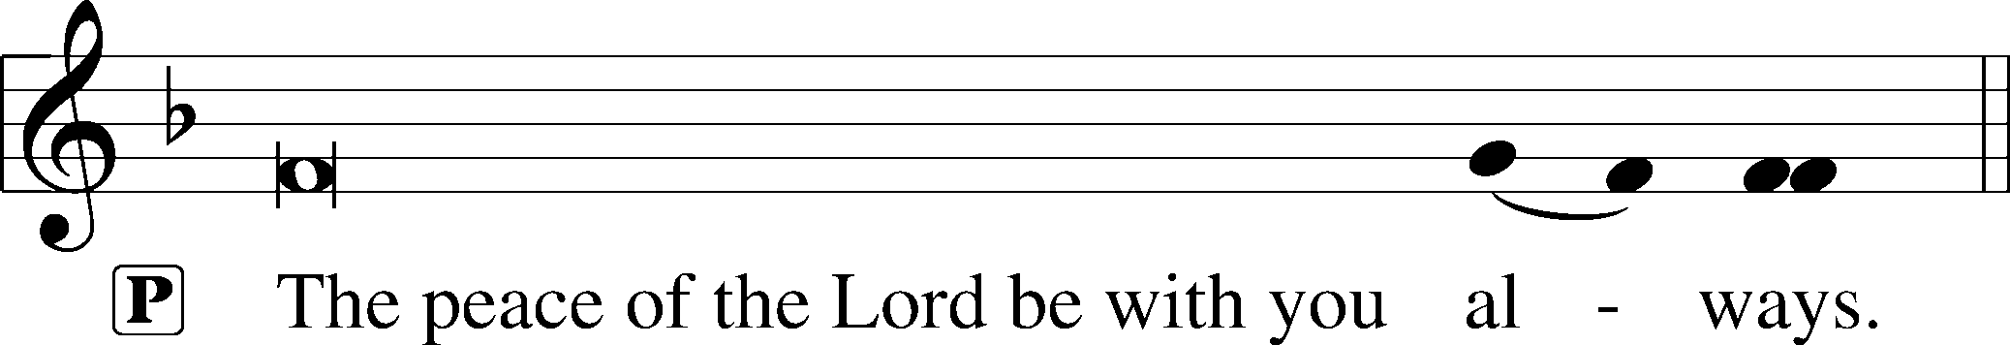


AGNUS DEI LSB 163
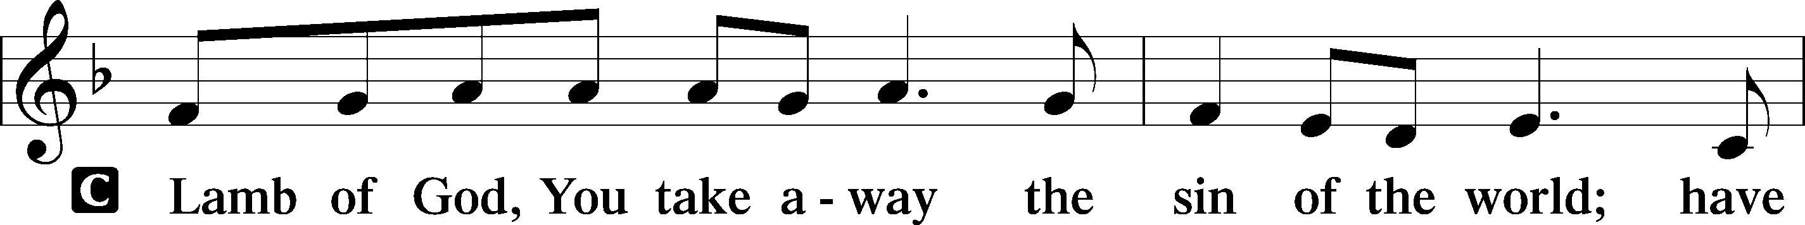
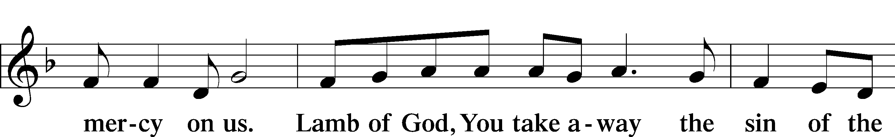
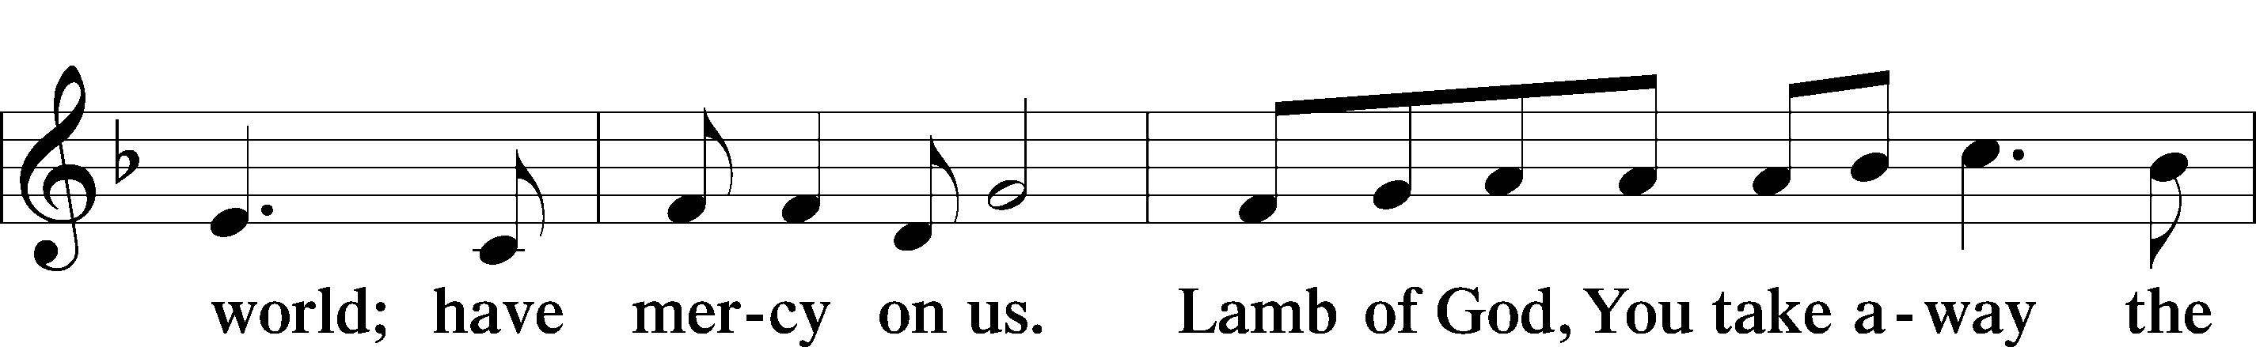
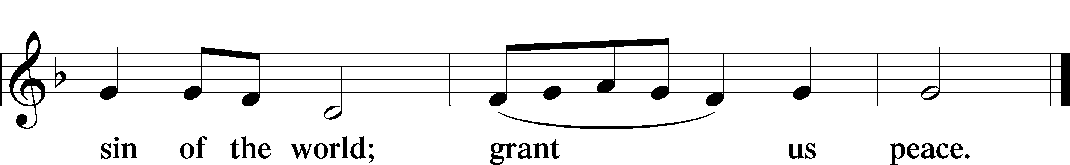

Following the Agnus Dei, please greet one another in the name of the Lord, saying, “Peace be with you,” as a sign of reconciliation and of the unity of the Spirit in the bond of peace (Matt. 5:22–24; Eph. 4:1–3).

Sit

DISTRIBUTION HYMNS

699 I HEARD THE VOICE OF JESUS SAY

1 I heard the voice of Jesus say,
“Come unto Me and rest;
Lay down, thou weary one, lay down
Thy head upon My breast.”
I came to Jesus as I was,
So weary, worn, and sad;
I found in Him a resting place,
And He has made me glad.

2 I heard the voice of Jesus say,
“Behold, I freely give
The living water; thirsty one,
Stoop down and drink and live.”
I came to Jesus, and I drank
Of that life-giving stream;
My thirst was quenched, my soul revived,
And now I live in Him.

3 I heard the voice of Jesus say,
“I am this dark world’s light.
Look unto Me; thy morn shall rise
And all thy day be bright.”
I looked to Jesus, and I found
In Him my star, my sun;
And in that light of life I’ll walk
Till trav’ling days are done.

618 I COME, O SAVIOR, TO THY TABLE

1 I come, O Savior, to Thy table,
For weak and weary is my soul;
Thou, Bread of Life, alone art able
To satisfy and make me whole: Refrain

ref Lord, may Thy body and Thy blood
Be for my soul the highest good!

2 Thy heart is filled with fervent yearning
That sinners may salvation see
Who, Lord, to Thee in faith are turning;
So I, a sinner, come to Thee. Refrain

3 Unworthy though I am, O Savior,
Because I have a sinful heart,
Yet Thou Thy lamb wilt banish never,
For Thou my faithful shepherd art: Refrain

4 Weary am I and heavy laden;
With sin my soul is sore oppressed;
Receive me graciously and gladden
My heart, for I am now Thy guest. Refrain

5 What higher gift can we inherit?
It is faith’s bond and solid base;
It is the strength of heart and spirit,
The covenant of hope and grace. Refrain

633 AT THE LAMB’S HIGH FEAST WE SING

1 At the Lamb’s high feast we sing
Praise to our victorious King,
Who has washed us in the tide
Flowing from His piercèd side.
Alleluia!

2 Praise we Him, whose love divine
Gives His sacred blood for wine,
Gives His body for the feast—
Christ the victim, Christ the priest.
Alleluia!

3 Where the paschal blood is poured,
Death’s dread angel sheathes the sword;
Israel’s hosts triumphant go
Through the wave that drowns the foe.
Alleluia!

4 Praise we Christ, whose blood was shed,
Paschal victim, paschal bread;
With sincerity and love
Eat we manna from above.
Alleluia!

5 Mighty Victim from the sky,
Hell’s fierce pow’rs beneath You lie;
You have conquered in the fight,
You have brought us life and light.
Alleluia!

6 Now no more can death appall,
Now no more the grave enthrall;
You have opened paradise,
And Your saints in You shall rise.
Alleluia!

7 Easter triumph, Easter joy!
This alone can sin destroy;
From sin’s pow’r, Lord, set us free,
Newborn souls in You to be.
Alleluia!

D 8 Father, who the crown shall give,
Savior, by whose death we live,
Spirit, guide through all our days:
Three in One, Your name we praise.
Alleluia!

Stand

DISMISSAL
THANK THE LORD LSB 164
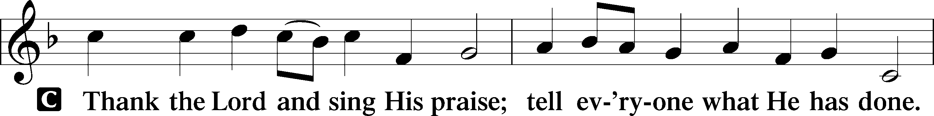
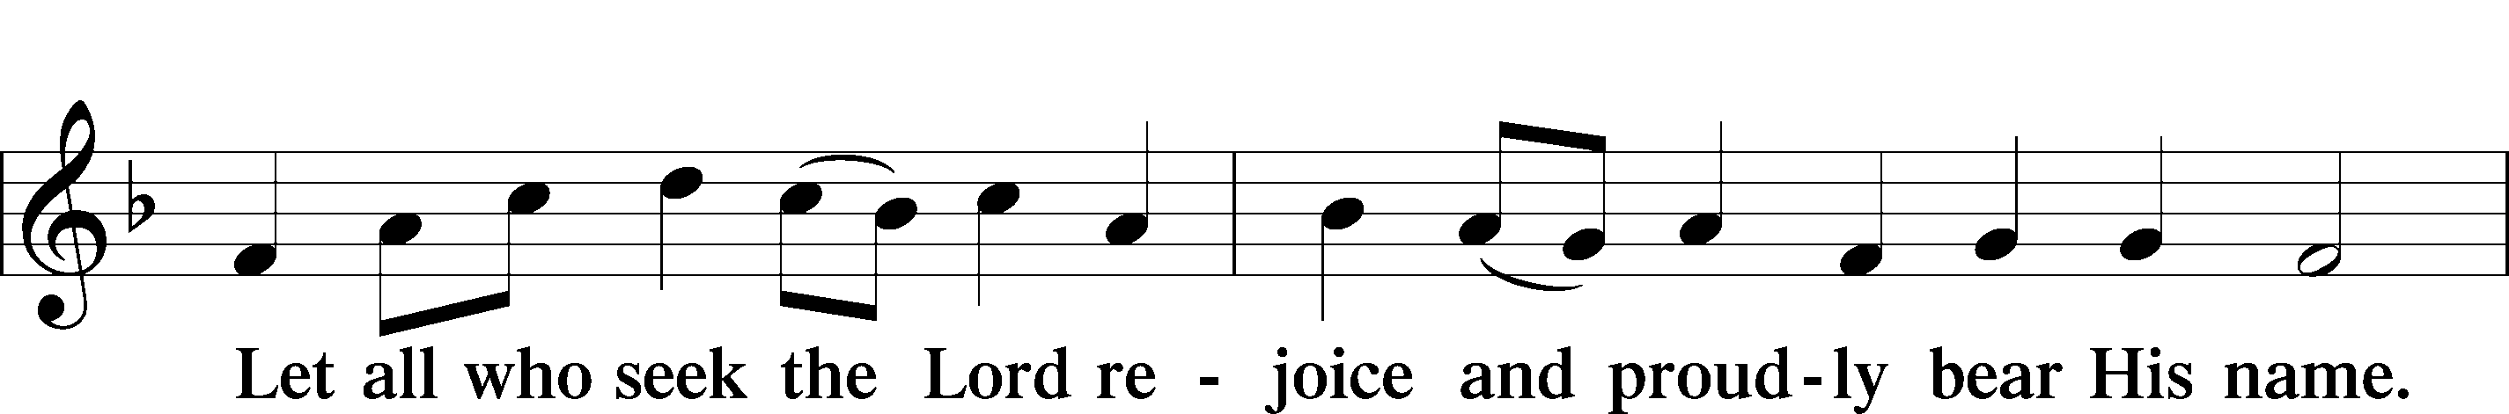
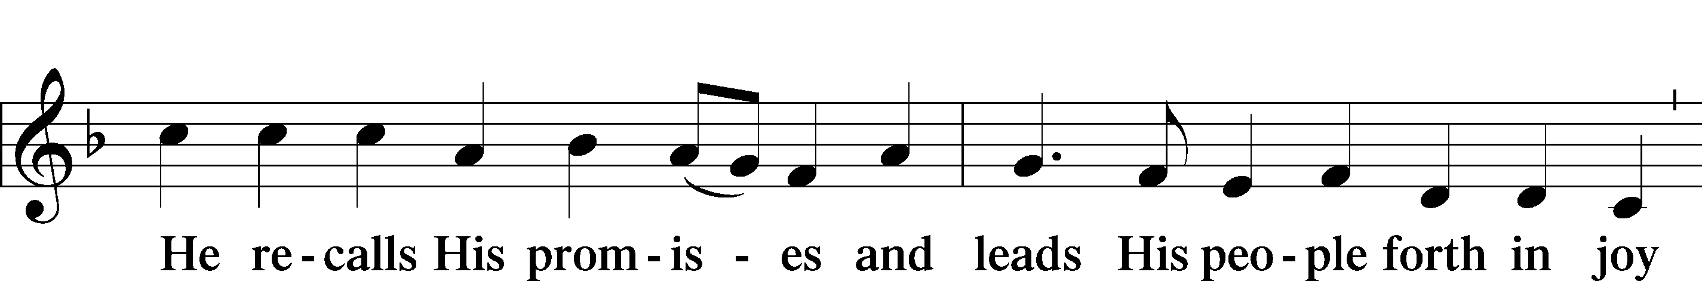
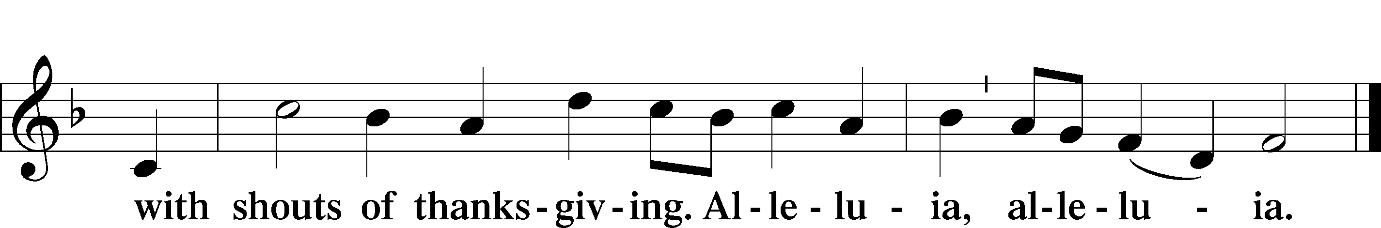

POST-COMMUNION COLLECT

BENEDICTION LSB 166
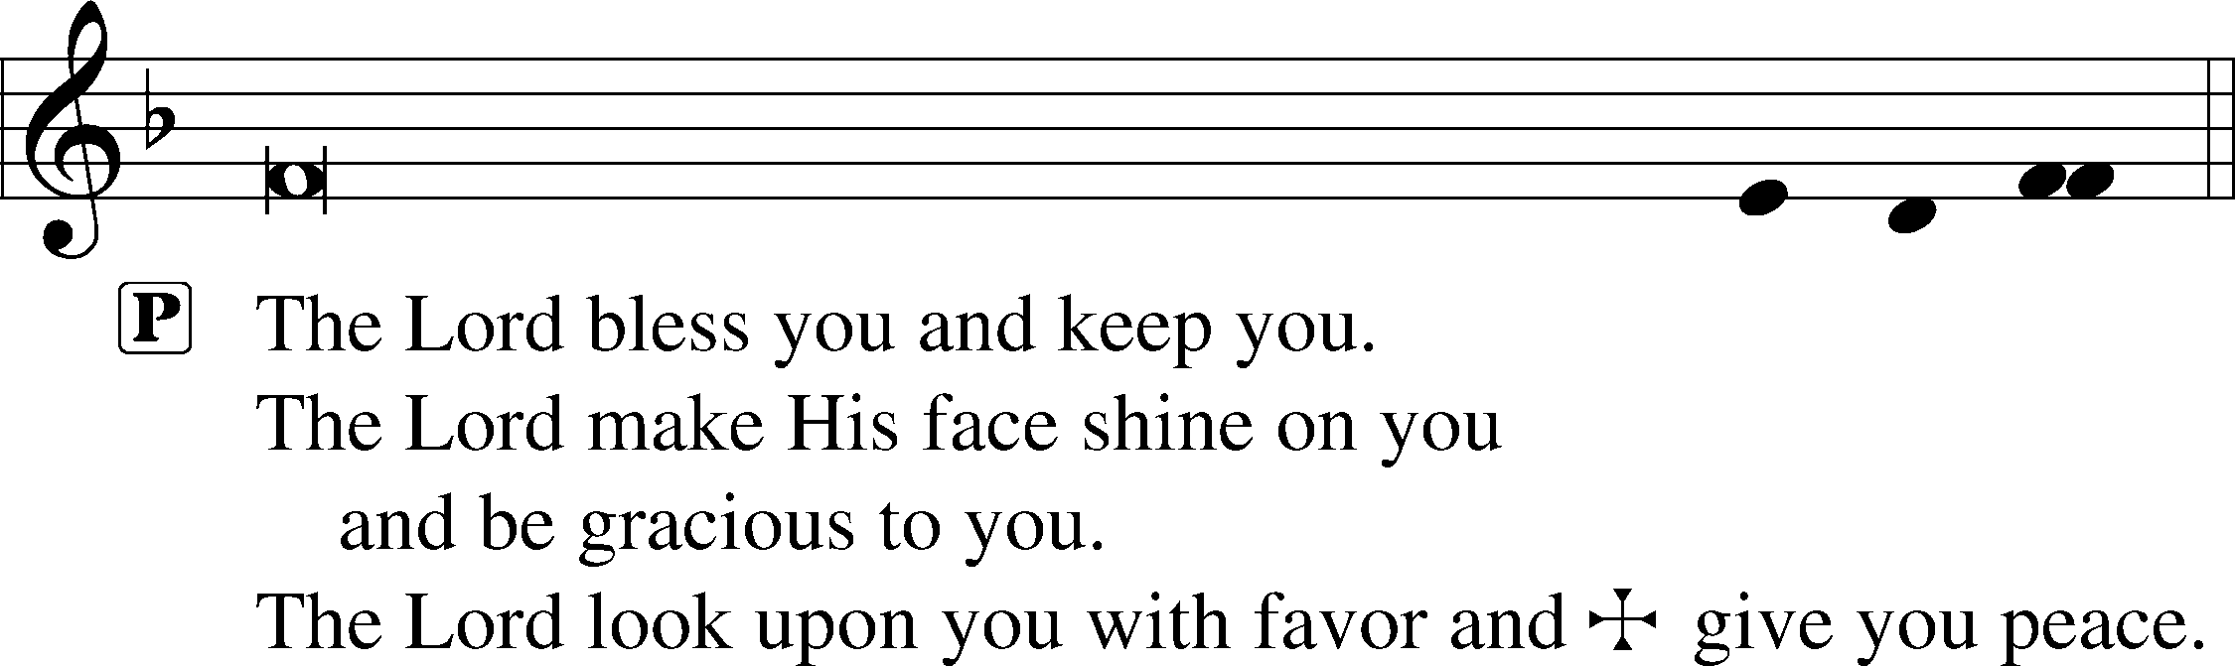

RECESSIONAL HYMN

818 IN THEE IS GLADNESS

1 In Thee is gladness
Amid all sadness,
Jesus, sunshine of my heart.
By Thee are given
The gifts of heaven,
Thou the true Redeemer art.
Our souls Thou wakest,
Our bonds Thou breakest;
Who trusts Thee surely
Has built securely;
He stands forever: Alleluia!
Our hearts are pining
To see Thy shining,
Dying or living
To Thee are cleaving;
Naught can us sever: Alleluia!

2 Since He is ours,
We fear no powers,
Not of earth nor sin nor death.
He sees and blesses
In worst distresses;
He can change them with a breath.
Wherefore the story
Tell of His glory
With hearts and voices;
All heav’n rejoices
In Him forever: Alleluia!
We shout for gladness,
Triumph o’er sadness,
Love Him and praise Him
And still shall raise Him
Glad hymns forever: Alleluia!

ANNOUNCEMENTS
See announcements on the back of the bulletin.

SENDING
P Let us pray.
Lord God, You have called Your servants to ventures of which we cannot see the ending, by paths as yet untrodden, through perils unknown. Give us faith to go out with good courage, not knowing where we go but only that Your hand is leading us and Your love supporting us; through Jesus Christ, our Lord.
C Amen

P Go in peace to serve the Lord.
C Thanks be to God.
THIS WEEK AT FAITH

Sun. August 2 Bible Studies 8:15am
Worship 9:30am
Installation of Faculty & Staff 9:30am
Reception after Worship 10:45am
Mon August 3 Orientation K-5th 6:30 pm
Tues. August 4 Create in Me Crafting 10:00am
Meet & Greet Drop off supplies
Wed August 5 First Day of School 8:15 am
Opening Chapel 8:30 am
Thursday August 6 Matins 8:30 am
Circuit Meeting (Board Room) 9:30 am
Friday August 7 Chapel 8:30 am
Sun. August 9 Bible Studies 8:15am
Worship 9:30am

CHURCH ANNOUNCEMENTS
youth EVENT – August 16th, 12-2pm Faith Gym/Youth Room, Lunch and Ice cream provided. 6th-12th graders and their families are invited to join us for fun and fellowship.

HOMEMADE FROM THE HEART - Making Mondays Sweeter - We have a fun way to support our amazing staff at FLS with homemade or store-bought baked goods. To sign up please see the most recent newsletter or contact Natalie Brown.

VOTERS’ MEETINGS - take place after Sunday worship. Next Tentative Meetings: Aug 23 - Nominating Committee; Nov 15 – Elections

RALLY DAY – Sunday, August 30 after worship, Let’s Rally! Kick off the fall season with us at Faith. Join us immediately after church for lunch and bring your favorite potluck dish to share. There will be a display on the patio showcasing upcoming educational classes, connection groups, and Wednesday gathering events. If you would like to get involved or have questions, contact Muriel Pfaff.
Rally Day is hosted by the Board of Christian Education

CONFIRMATION CLASSES
For students (grades 7 and 8) who desire to grow in their faith and progress toward the milestone of adult membership at Faith Lutheran Church. Classes will be Wednesday nights at 6:30pm. Regular classes will begin on September 2. A required confirmation orientation for students and their parents will be held on Saturday August 29, 9am-12noon. Please contact Pastor Shaun to sign up for classes. pastor.shaun@faithmarietta.org

WORSHIP SCHEDULE - Beginning September 6, our Sunday morning schedule will change:
Bible Study 8:30a - 9:30a; Fellowship 9:30a - 10:00a; Worship 10:00a - 11:30a.
The purpose of this change is to promote fellowship within the Faith Community and to give the choir and congregation time to prepare for worship. In addition, this will also allow for regular fellowship activities after worship.

