



Eighth Sunday After Pentecost
July 19, 2026
OUR MISSION: Connecting People to Jesus

Contact us
Faith Lutheran Church & School 2111 Lower Roswell Rd, Marietta, GA 30068 | 770-973-8877

CHURCH: www.faithmarietta.com SCHOOL: www.faithmarietta.org
Rev. Shaun Daugherty, Pastor Mr. Chris Bradshaw, Headmaster
pastor.shaun@faithmarietta.org chris.bradshaw@faithmarietta.org
470-289-9469 470-641-6239
See the full leadership directory: www.faithmarietta.com/leadership
Serving This Month at Faith
 | 7/5/2026 | 7/12/2026 | 7/19/2026 | 7/26/2026
Musicians | Vaunda Noerenberg | Vaunda Noerenberg | Ben Nye | Vaunda Noerenberg
Elders | Ward Irvin  Vinny Caracci | Jon Cain  Peter Amelingmeier | Steve Buchtrup  Woody Wood | Russ Couch  Glenn Jones
Reader | David Barnett | Stacy Sinatra | Jon Wareham | Greg Sinatra
Ushers | Greg Czerwonka  Matthew Czerwonka  Jacob Czerwonka  Luke Czerwonka  Sam Czerwonka | Steve Buchtrup  Mark Patterson  Gary Schleicher  Reagan Gronsbell  Paris Brown | Kim Kaumeyer  Brennan Lambert  David Barnett  Greg Sinatra | Chris Bradshaw  Herman Dean  Bryan Powell  Christian Campbell
Acolytes | Adam Cain  Amadeo Brown | Josiah Brown  Alex Bradshaw | Andrew Linsey  Christian Brown | Amadeo Brown  Adam Cain



Pay Pal

For your convenience,
we now accept gifts
via Venmo or PayPal.

Our Discipleship
Date | 7/5 | 7/12 | 7/19 |  | YTD Report (Aug thru May)
Worship | 116/109 | 137/115 | -- |  | Avg. Worship | 144
Sunday School |  |  | -- |  | Avg. SS | 35
Gen. Giving | $7,776 | $8,635 | $ |  | YTD Gen. Giving | $576,891
MTD Giving | $7,776 | $16,411 | $ |  | Budgeted Giving | $601,060
 |  |  |  |  | Over/(Under) | ($24,169)
 |  |  |  |  | "Special" Gifts | $383,020
Monthly Budget | $57,000 | $53,300 | $53,300 |  | Designated Gifts | $165,784

FAITH GROWS is our debt reduction account, geared towards eliminating our mortgage.
Please prayerfully consider donating to this fund - over and beyond your normal tithe.

YTD Debt Reduction | $242,174 | Remaining Mortgage Debt | $2,687,058
ALTAR FLOWERS given today In memory of my brothers Daudi Kepha Cuthbert by Joyce Mbeyella
PRE-SERVICE MUSIC
WELCOME
+ Confession and Absolution +
We enter the presence of God by humbly confessing our sins and gladly receiving His forgiveness.

Stand

PROCESSIONAL HYMN

892 COME, YE THANKFUL PEOPLE, COME

1 Come, ye thankful people, come;
Raise the song of harvest home.
All be safely gathered in
Ere the winter storms begin;
God, our maker, doth provide
For our wants to be supplied.
Come to God’s own temple, come;
Raise the song of harvest home.

2 All the world is God’s own field,
Fruit unto His praise to yield;
Wheat and tares together sown,
Unto joy or sorrow grown.
First the blade and then the ear,
Then the full corn shall appear.
Lord of harvest, grant that we
Wholesome grain and pure may be.
3 For the Lord, our God, shall come
And shall take His harvest home,
From His field shall in that day
All offenses purge away,
Give His angels charge at last
In the fire the tares to cast,
But the fruitful ears to store
In His garner evermore.

4 Even so, Lord, quickly come
To Thy final harvest home;
Gather Thou Thy people in,
Free from sorrow, free from sin,
There, forever purified,
In Thy garner to abide:
Come with all Thine angels, come,
Raise the glorious harvest home.

The sign of the cross may be made by all in remembrance of their Baptism.

INVOCATION
P In the name of the Father and of the T Son and of the Holy Spirit.
C Amen.

P If we say we have no sin, we deceive ourselves, and the truth is not in us.
C But if we confess our sins, God, who is faithful and just, will forgive our sins and cleanse us from all unrighteousness.

Silence for reflection on God’s Word and for self-examination.

CONFESSION AND ABSOLUTION LSB 151
P Let us then confess our sins to God our Father.
C Most merciful God, we confess that we are by nature sinful and unclean. We have sinned against You in thought, word, and deed, by what we have done and by what we have left undone. We have not loved You with our whole heart; we have not loved our neighbors as ourselves. We justly deserve Your present and eternal punishment. For the sake of Your Son, Jesus Christ, have mercy on us. Forgive us, renew us, and lead us, so that we may delight in Your will and walk in Your ways to the glory of Your holy name. Amen.

P Almighty God in His mercy has given His Son to die for you and for His sake forgives you all your sins. As a called and ordained servant of Christ, and by His authority, I therefore forgive you all your sins in the name of the Father and of the T Son and of the Holy Spirit.
C Amen.
Stand
+ Service of the Word +
Having received God's forgiveness, we come before Him with songs of praise, eager to hear His Word.

INTROIT

Give ear, O Lord, | to my prayer;*
listen to my | plea for grace.
Teach me your way, O Lord, that I may walk | in your truth;*
unite my heart to | fear your name.
I give thanks to you, O Lord my God, with | my whole heart,*
and I will glorify your name for- | ever.
For great is your steadfast | love toward me;*
you have delivered my soul from the depths | of Sheol.
O God, insolent men have risen up against me; a band of ruthless men | seek my life,*
and they do not set you be- | fore them.
But you, O Lord, are a God merciful and | gracious,*
slow to anger and abounding in steadfast love and | faithfulness.
Glory be to the Father and | to the Son*
and to the Holy | Spirit;
as it was in the be- | ginning,*
is now, and will be forever. | Amen.
Give ear, O Lord, | to my prayer;*
listen to my | plea for grace.

KYRIE LSB 152

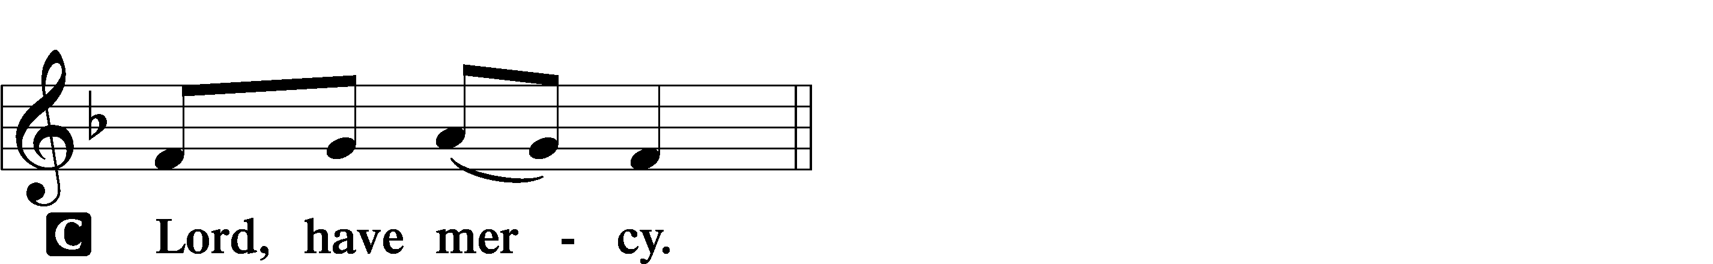
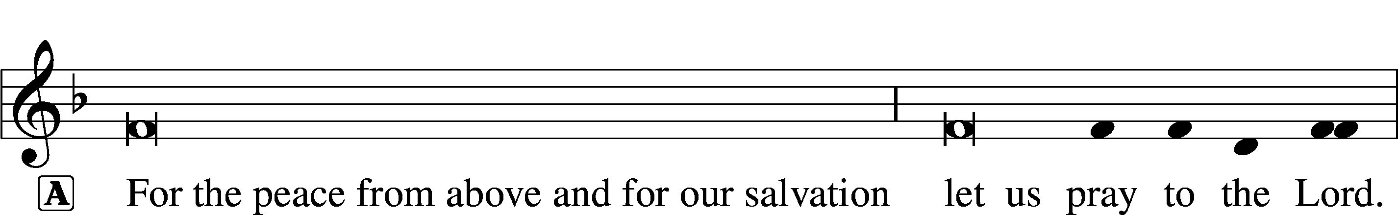
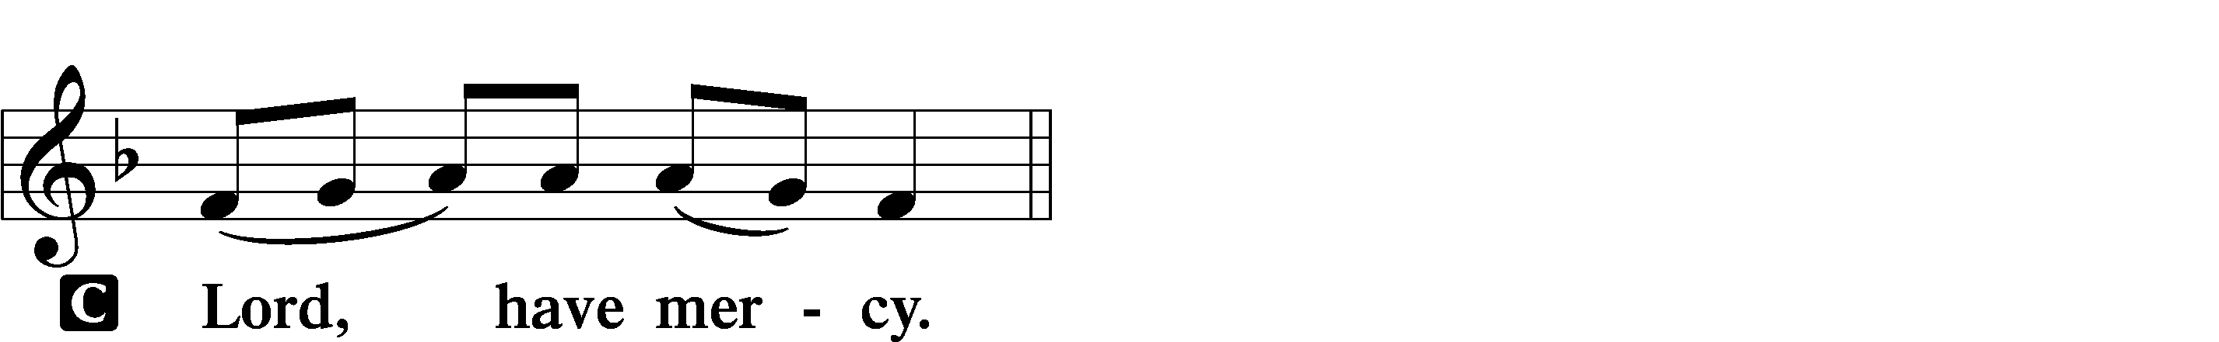

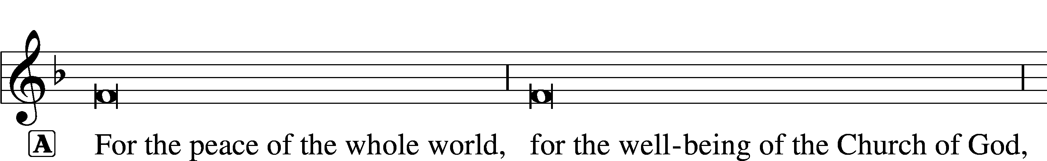
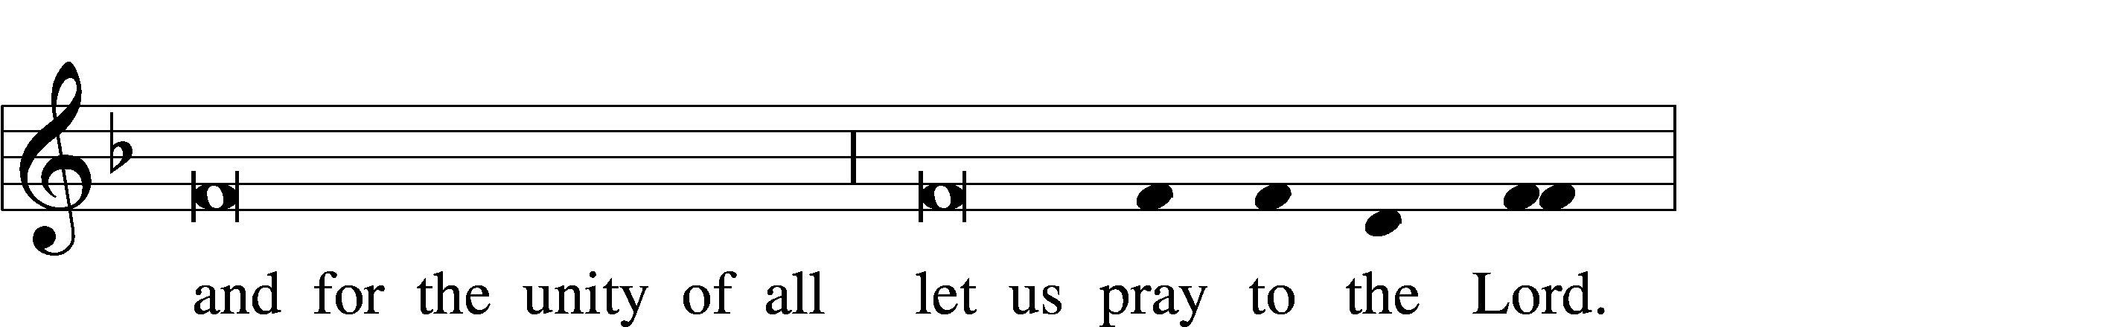
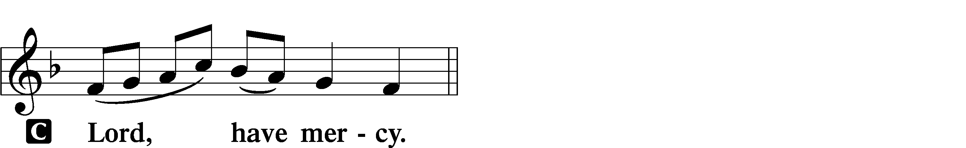

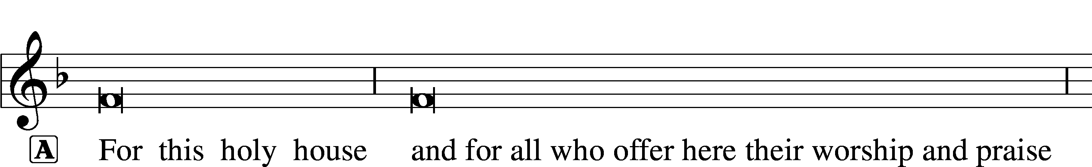

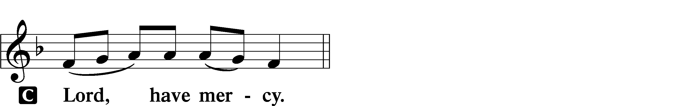

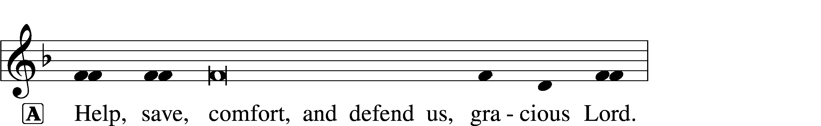


THIS IS THE FEAST LSB 155
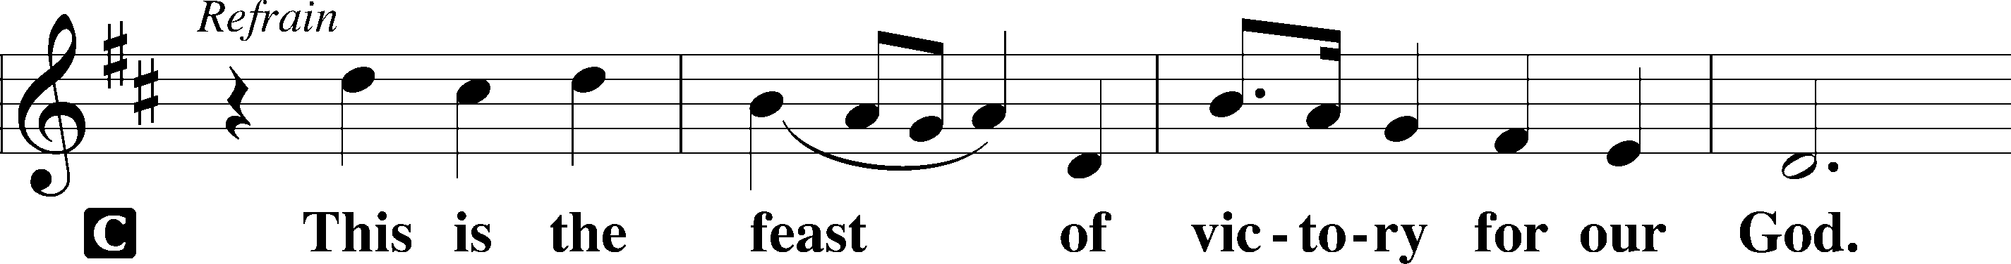
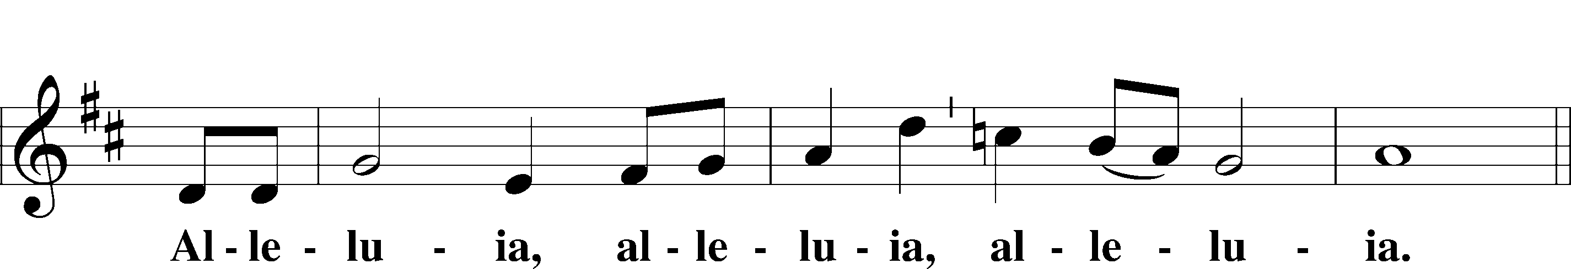
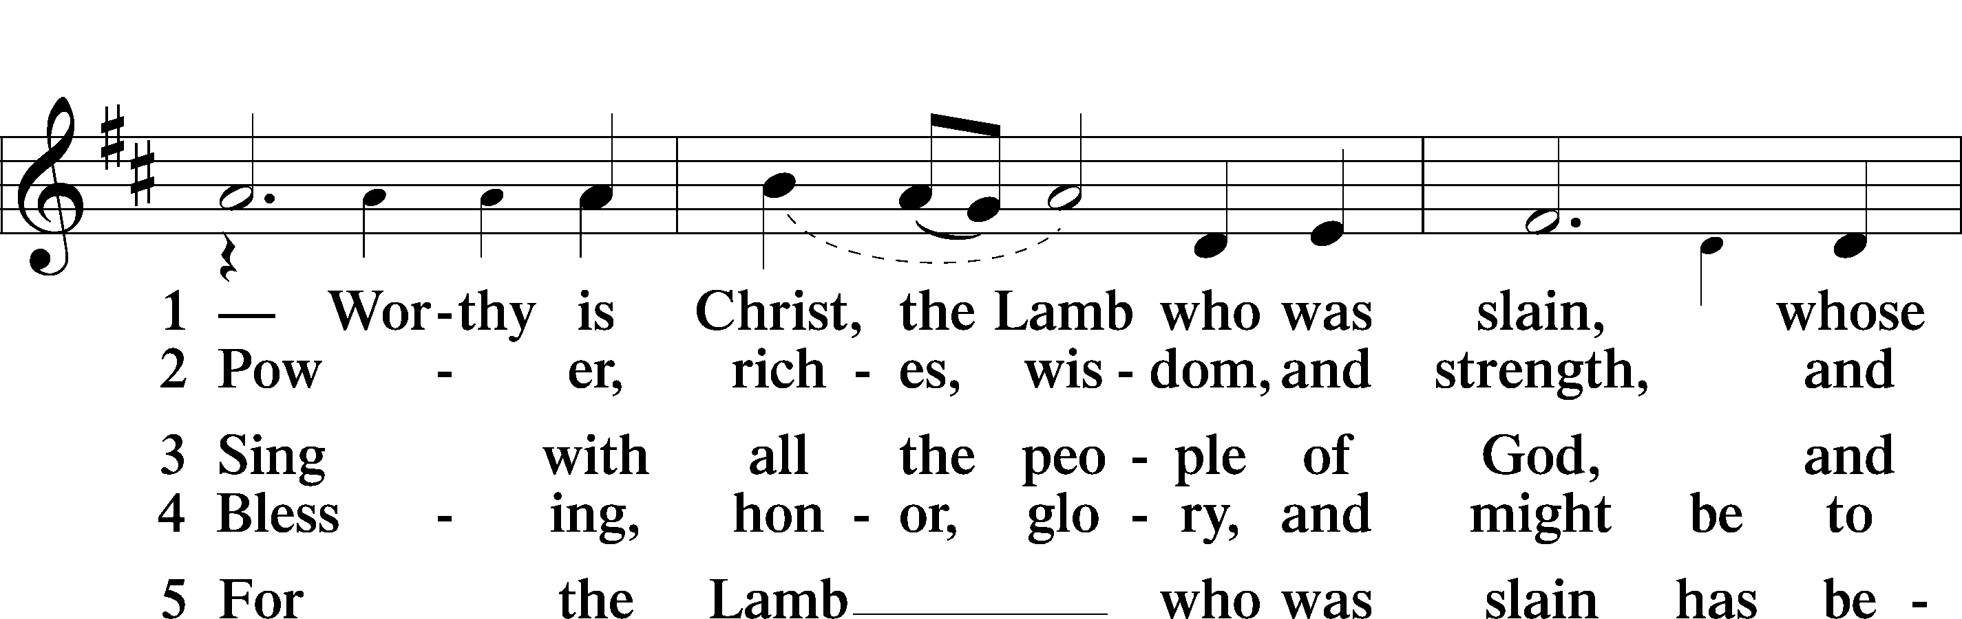
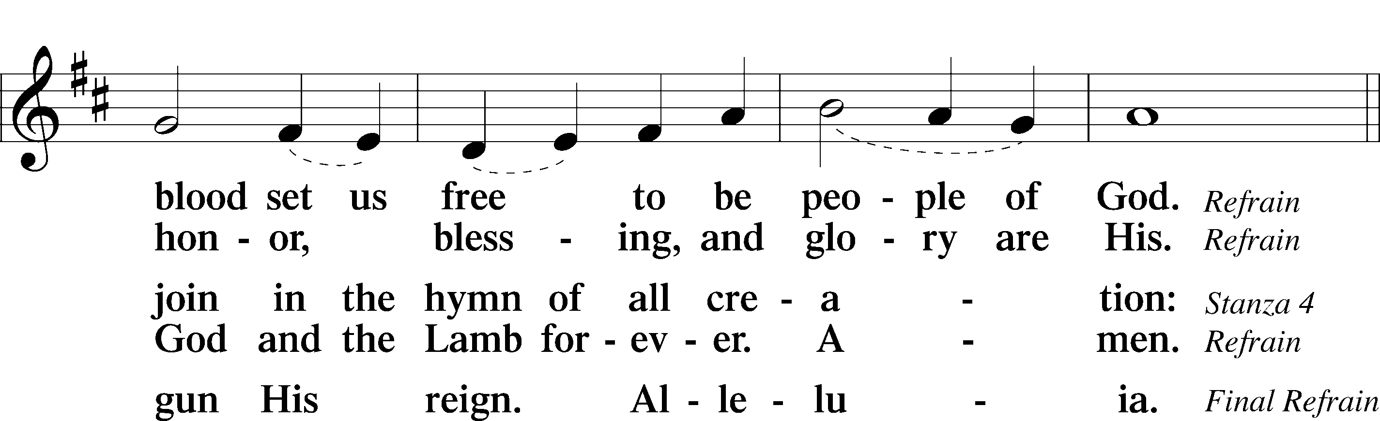
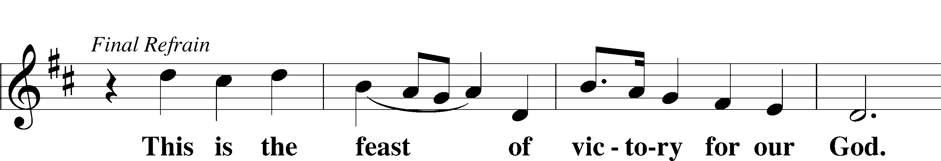
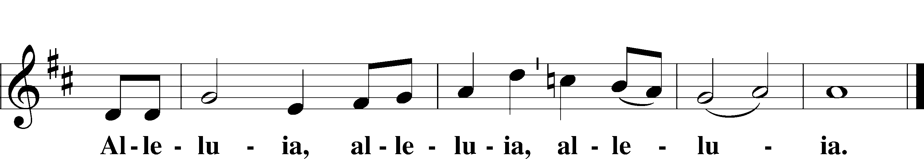

SALUTATION AND COLLECT OF THE DAY
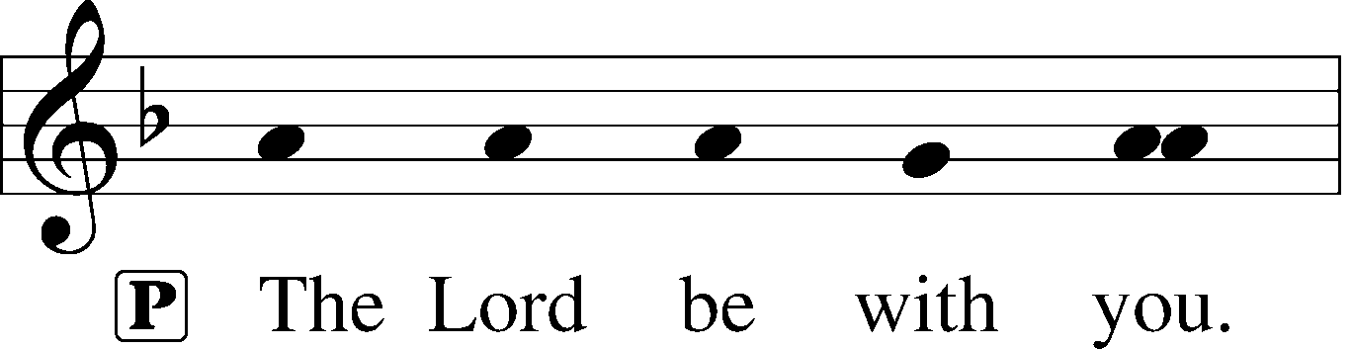
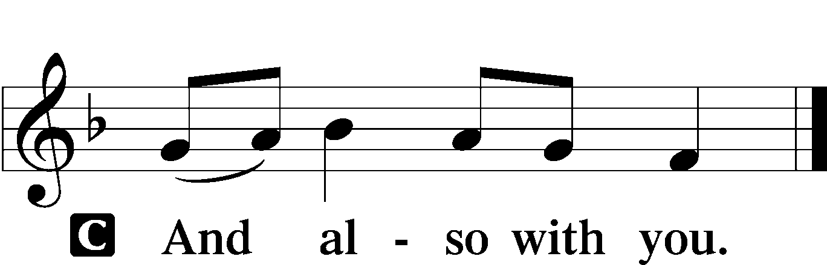

P Let us pray.
O God, so rule and govern our hearts and minds by Your Holy Spirit that, ever mindful of Your final judgment, we may be stirred up to holiness of living here and dwell with You in perfect joy hereafter; through Jesus Christ, Your Son, our Lord, who lives and reigns with You and the Holy Spirit, one God, now and forever.

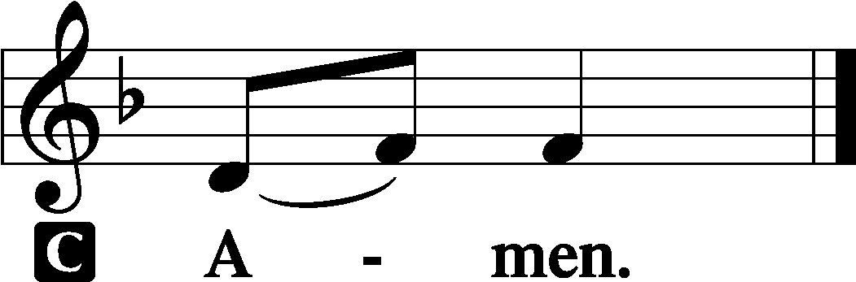

Sit

OLD TESTAMENT READING Isaiah 44:6–8
6Thus says the Lord, the King of Israel
and his Redeemer, the Lord of hosts:
“I am the first and I am the last;
besides me there is no god.
7Who is like me? Let him proclaim it.
Let him declare and set it before me,
since I appointed an ancient people.
Let them declare what is to come, and what will happen.
8Fear not, nor be afraid;
have I not told you from of old and declared it?
And you are my witnesses!
Is there a God besides me?
There is no Rock; I know not any.”

A This is the Word of the Lord.
C Thanks be to God.

GRADUAL
Oh, the depth of the riches and wisdom and knowl- | edge of God!*
How unsearchable are his judgments and how inscrutable | his ways!
For from him and through him and to him are | all things.*
To him be glory forever. | Amen.

EPISTLE Romans 7
1Or do you not know, brothers—for I am speaking to those who know the law—that the law is binding on a person only as long as he lives? 2Thus a married woman is bound by law to her husband while he lives, but if her husband dies she is released from the law of marriage. 3Accordingly, she will be called an adulteress if she lives with another man while her husband is alive. But if her husband dies, she is free from that law, and if she marries another man she is not an adulteress.
4Likewise, my brothers, you also have died to the law through the body of Christ, so that you may belong to another, to him who has been raised from the dead, in order that we may bear fruit for God. 5For while we were living in the flesh, our sinful passions, aroused by the law, were at work in our members to bear fruit for death. 6But now we are released from the law, having died to that which held us captive, so that we serve not under the old written code but in the new life of the Spirit.
7What then shall we say? That the law is sin? By no means! Yet if it had not been for the law, I would not have known sin. I would not have known what it is to covet if the law had not said, “You shall not covet.” 8But sin, seizing an opportunity through the commandment, produced in me all kinds of covetousness. Apart from the law, sin lies dead. 9I was once alive apart from the law, but when the commandment came, sin came alive and I died. 10The very commandment that promised life proved to be death to me. 11For sin, seizing an opportunity through the commandment, deceived me and through it killed me. 12So the law is holy, and the commandment is holy and righteous and good.
13Did that which is good, then, bring death to me? By no means! It was sin, producing death in me through what is good, in order that sin might be shown to be sin, and through the commandment might become sinful beyond measure. 14For we know that the law is spiritual, but I am of the flesh, sold under sin. 15I do not understand my own actions. For I do not do what I want, but I do the very thing I hate. 16Now if I do what I do not want, I agree with the law, that it is good. 17So now it is no longer I who do it, but sin that dwells within me. 18For I know that nothing good dwells in me, that is, in my flesh. For I have the desire to do what is right, but not the ability to carry it out. 19For I do not do the good I want, but the evil I do not want is what I keep on doing. 20Now if I do what I do not want, it is no longer I who do it, but sin that dwells within me.
21So I find it to be a law that when I want to do right, evil lies close at hand. 22For I delight in the law of God, in my inner being, 23but I see in my members another law waging war against the law of my mind and making me captive to the law of sin that dwells in my members. 24Wretched man that I am! Who will deliver me from this body of death? 25Thanks be to God through Jesus Christ our Lord! So then, I myself serve the law of God with my mind, but with my flesh I serve the law of sin.

A This is the Word of the Lord.
C Thanks be to God.

Stand

ALLELUIA AND VERSE LSB 156
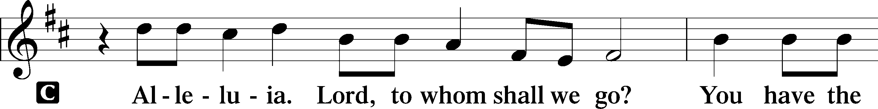
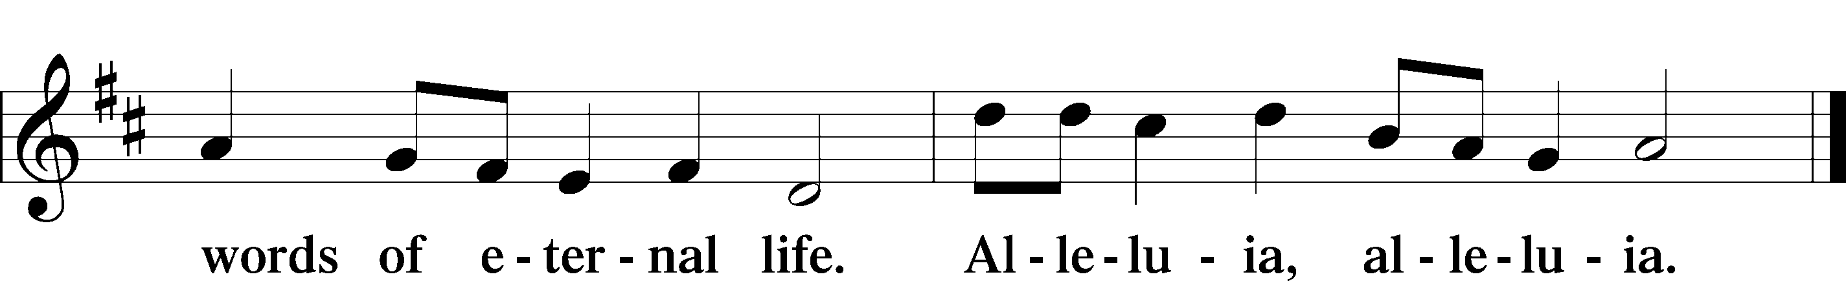

HOLY GOSPEL Matthew 13:24–30, 36–43
P The Holy Gospel according to St. Matthew, the thirteenth chapter.

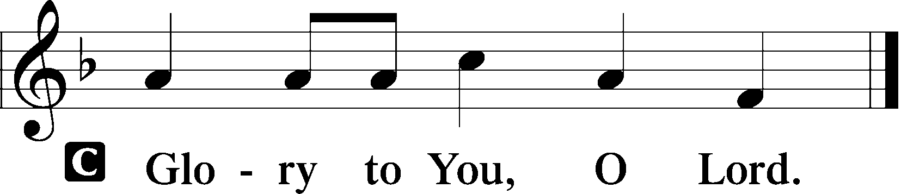

24[Jesus] put another parable before them, saying, “The kingdom of heaven may be compared to a man who sowed good seed in his field, 25but while his men were sleeping, his enemy came and sowed weeds among the wheat and went away. 26So when the plants came up and bore grain, then the weeds appeared also. 27And the servants of the master of the house came and said to him, ‘Master, did you not sow good seed in your field? How then does it have weeds?’ 28He said to them, ‘An enemy has done this.’ So the servants said to him, ‘Then do you want us to go and gather them?’ 29But he said, ‘No, lest in gathering the weeds you root up the wheat along with them. 30Let both grow together until the harvest, and at harvest time I will tell the reapers, Gather the weeds first and bind them in bundles to be burned, but gather the wheat into my barn.’” . . .
36Then he left the crowds and went into the house. And his disciples came to him, saying, “Explain to us the parable of the weeds of the field.” 37He answered, “The one who sows the good seed is the Son of Man. 38The field is the world, and the good seed is the children of the kingdom. The weeds are the sons of the evil one, 39and the enemy who sowed them is the devil. The harvest is the close of the age, and the reapers are angels. 40Just as the weeds are gathered and burned with fire, so will it be at the close of the age. 41The Son of Man will send his angels, and they will gather out of his kingdom all causes of sin and all law-breakers, 42and throw them into the fiery furnace. In that place there will be weeping and gnashing of teeth. 43Then the righteous will shine like the sun in the kingdom of their Father. He who has ears, let him hear.”

P This is the Gospel of the Lord.

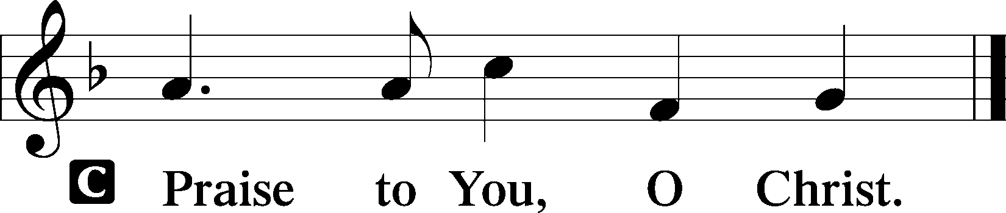

Sit

CHILDREN'S MESSAGE

HYMN OF THE DAY

703 HOW CAN I THANK YOU, LORD

1 How can I thank You, Lord,
For all Your loving-kindness,
That You have patiently
Borne with me in my blindness!
When dead in many sins
And trespasses I lay,
I kindled, holy God,
Your anger ev’ry day.

2 It is Your work alone
That I am now converted;
O’er Satan’s work in me
You have Your pow’r asserted.
Your mercy and Your grace
That rise afresh each morn
Have turned my stony heart
Into a heart newborn.

3 Lord, You have raised me up
To joy and exultation
And clearly shown the way
That leads me to salvation.
My sins are washed away;
For this I thank You, Lord.
Now with my heart and soul
All evil I abhor.

4 Grant that Your Spirit’s help
To me be always given
Lest I should fall again
And lose the way to heaven.
Grant that He give me strength
In my infirmity;
May He renew my heart
To serve You willingly.

SERMON Rev. Shaun Daugherty

Stand

APOSTLES’ CREED
C I believe in God, the Father Almighty, maker of heaven and earth.

And in Jesus Christ, His only Son, our Lord, who was conceived by the Holy Spirit, born of the virgin Mary, suffered under Pontius Pilate, was crucified, died and was buried. He descended into hell. The third day He rose again from the dead. He ascended into heaven and sits at the right hand of God the Father Almighty. From thence He will come to judge the living and the dead.

I believe in the Holy Spirit, the holy Christian Church, the communion of saints, the forgiveness of sins, the resurrection of the body, and the life T everlasting. Amen.

PRAYER OF THE CHURCH
After each petition:
P Lord, in Your mercy,
C hear our prayer.

Sit

COLLECTION OF TITHES AND OFFERING

Stand

OFFERTORY LSB 159
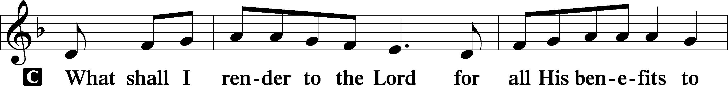
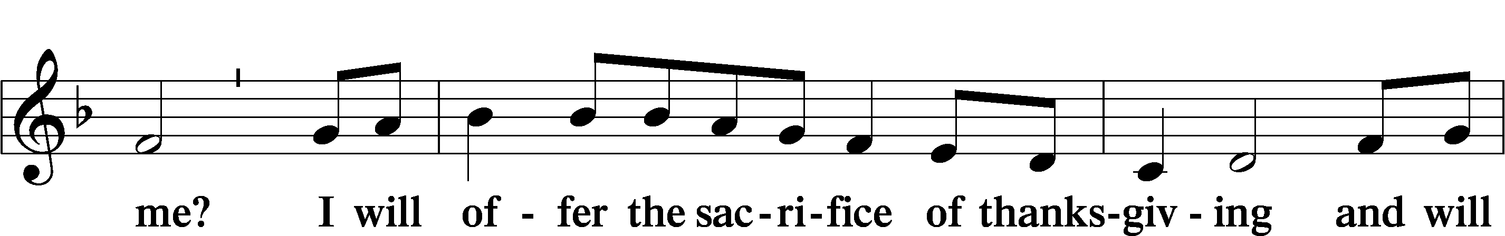
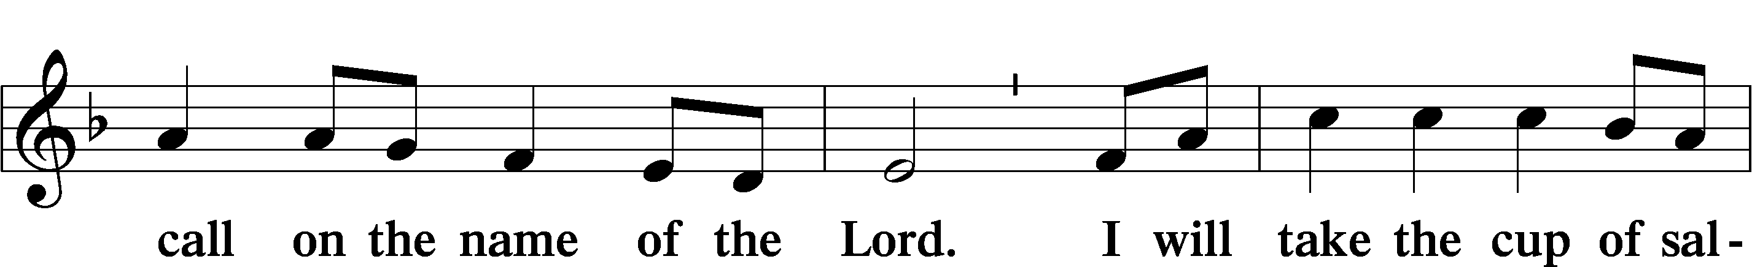
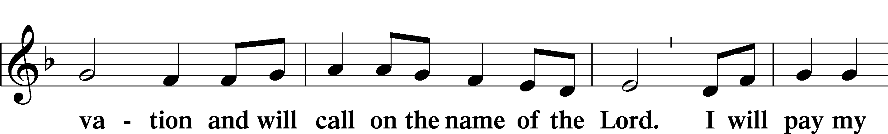
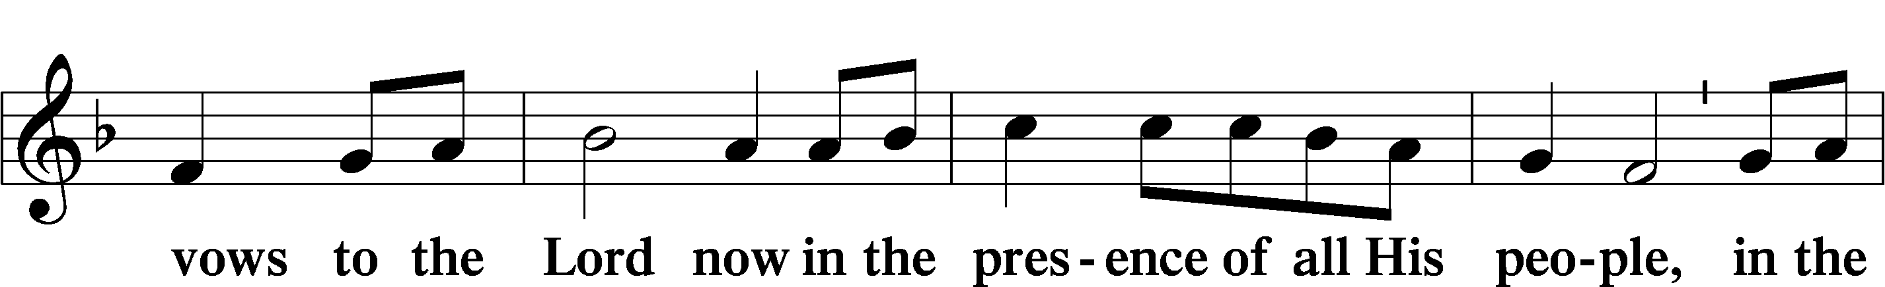
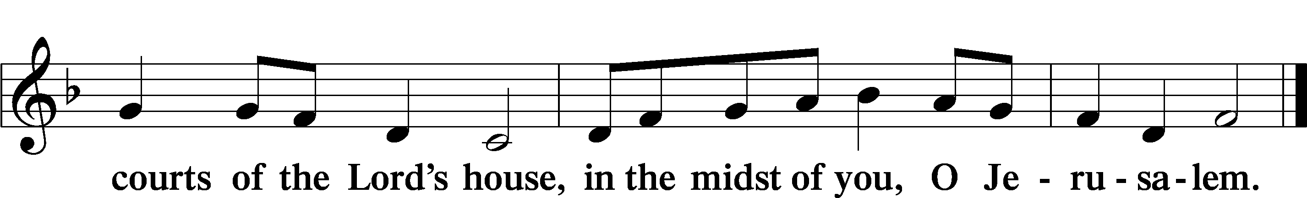

+ Service of the Sacrament +
As God's baptized and forgiven people, we gather at His invitation to receive The Lord's Supper.

The Lord’s Supper is celebrated at this congregation in the confession and glad confidence that, as he says, our Lord gives into our mouths not only bread and wine but His very body and blood to eat and to drink for the forgiveness of sins and to strengthen our union with him and with one another. Our Lord invites to his table those Baptized Christians who trust his words, repent of all sin, and set aside any refusal to forgive and love as he forgives and loves us, that they may show forth his death until he comes.

Because those who eat and drink our Lord’s body and blood unworthily do so to their great harm and because Holy Communion is a confession of the faith which is confessed at this altar, any who are not yet instructed, in doubt, or who hold a confession differing from that of this congregation and The Lutheran Church— Missouri Synod, and yet desire to receive the sacrament, are asked first to speak with the pastor or an elder.

For further study, see Matthew 5:23f.; 10:32f.; 18:15-35; 26:26-29; 1 Cor. 11:17- 34.

PREFACE LSB 160

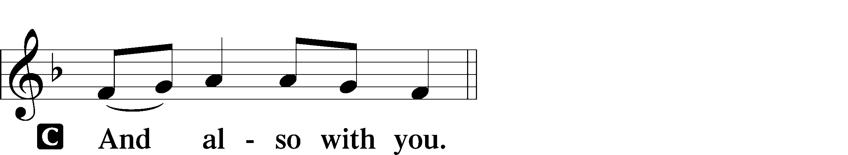
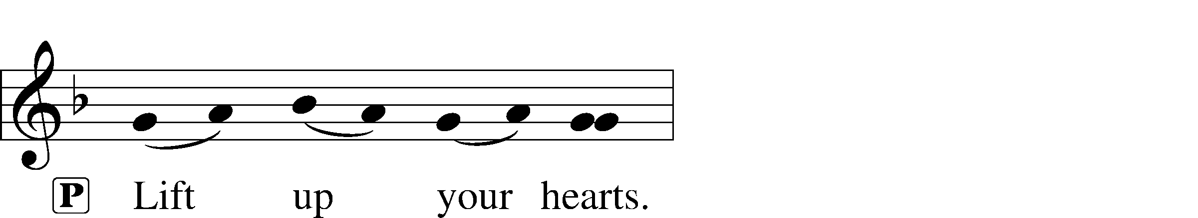

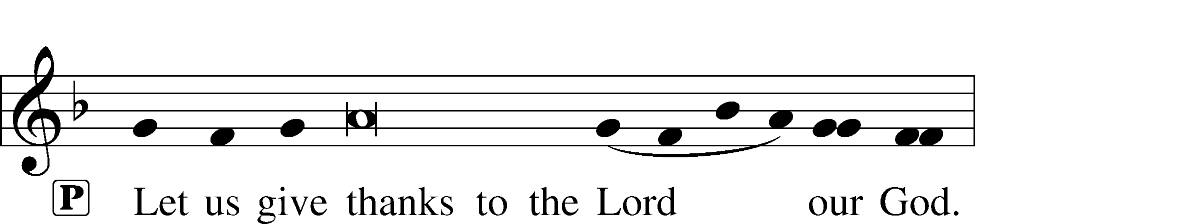
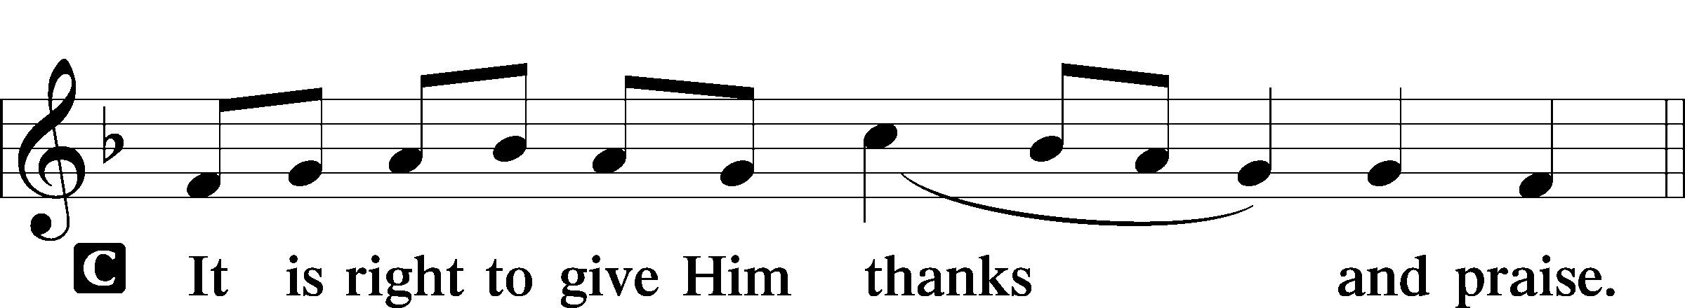

PROPER PREFACE LSB 161
P It is truly good, right, and salutary . . . evermore praising You and saying:

SANCTUS LSB 161
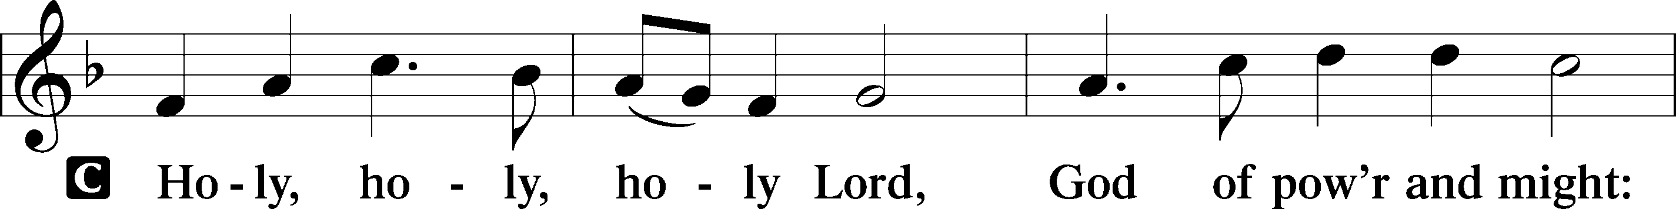
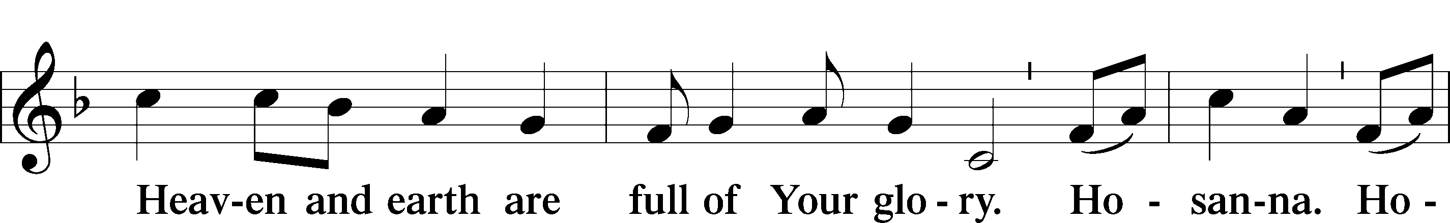
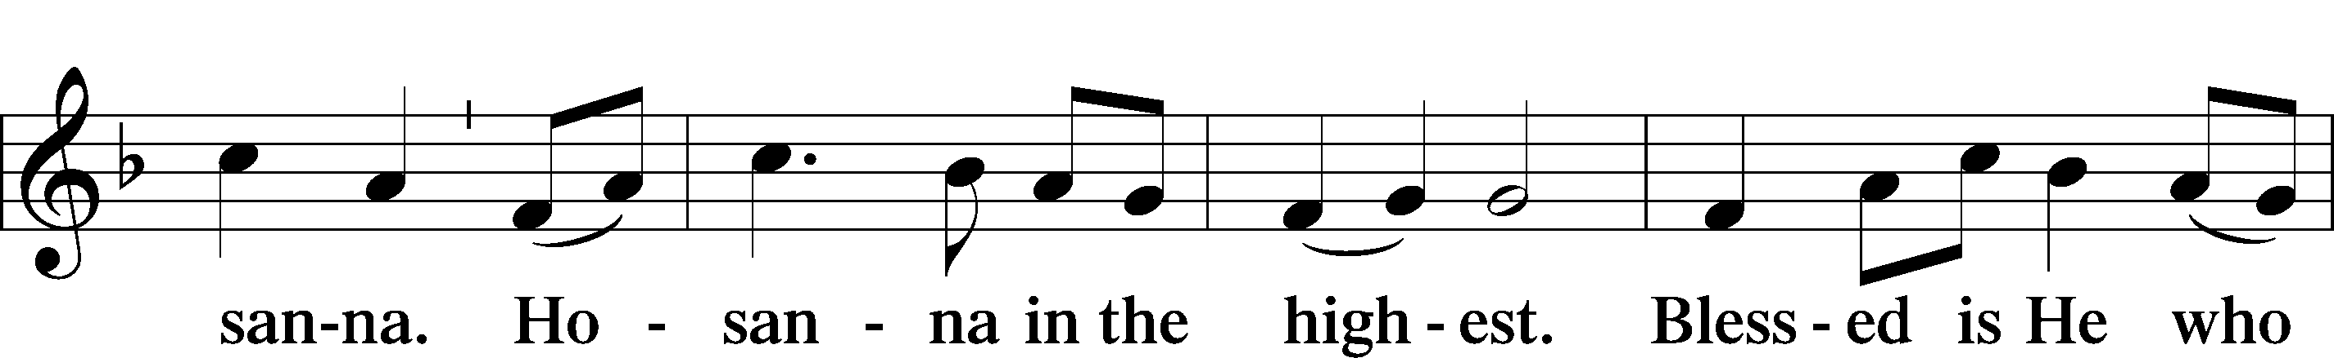
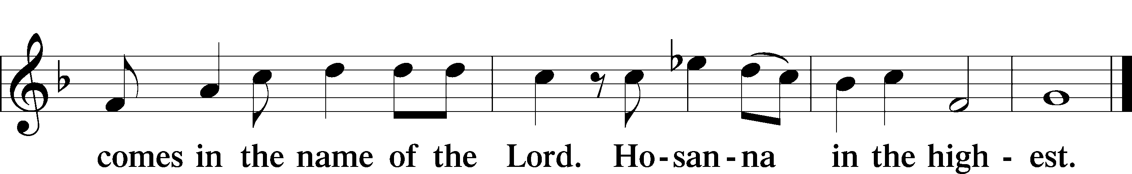

PRAYER OF THANKSGIVING 161
P Blessed are You, Lord of heaven and earth, for You have had mercy on those whom You created and sent Your only-begotten Son into our flesh to bear our sin and be our Savior. With repentant joy we receive the salvation accomplished for us by the all-availing sacrifice of His body and His blood on the cross.

Gathered in the name and the remembrance of Jesus, we beg You, O Lord, to forgive, renew, and strengthen us with Your Word and Spirit. Grant us faithfully to eat His body and drink His blood as He bids us do in His own testament. Gather us together, we pray, from the ends of the earth to celebrate with all the faithful the marriage feast of the Lamb in His kingdom, which has no end. Graciously receive our prayers; deliver and preserve us. To You alone, O Father, be all glory, honor, and worship, with the Son and the Holy Spirit, one God, now and forever.
C Amen.

THE WORDS OF OUR LORD

PROCLAMATION OF CHRIST
P As often as we eat this bread and drink this cup, we proclaim the Lord’s death until He comes.
C Amen. Come, Lord Jesus.

P O Lord Jesus Christ, only Son of the Father, in giving us Your body and blood to eat and to drink, You lead us to remember and confess Your holy cross and passion, Your blessed death, Your rest in the tomb, Your resurrection from the dead, Your ascension into heaven, and Your coming for the final judgment. So remember us in Your kingdom and teach us to pray:

LORD’S PRAYER
C Our Father who art in heaven, hallowed be Thy name, Thy kingdom come, Thy will be done on earth as it is in heaven; give us this day our daily bread; and forgive us our trespasses as we forgive those who trespass against us; and lead us not into temptation, but deliver us from evil. For Thine is the kingdom and the power and the glory forever and ever. Amen.

PAX DOMINI LSB 163
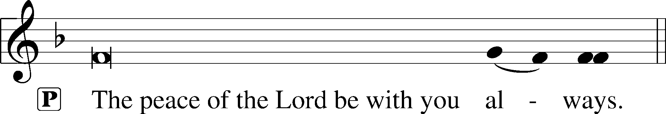


AGNUS DEI LSB 163
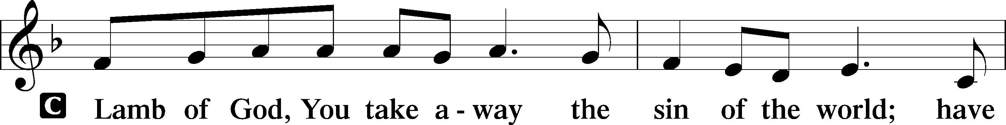
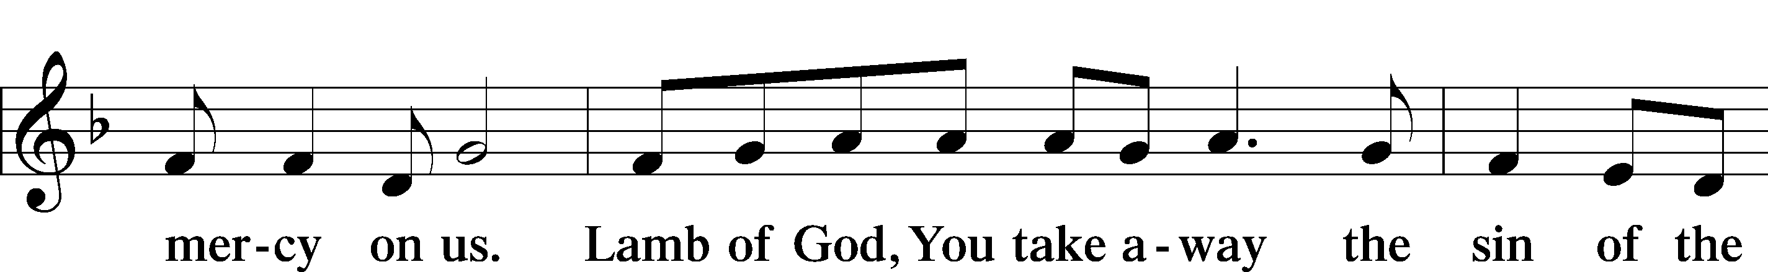
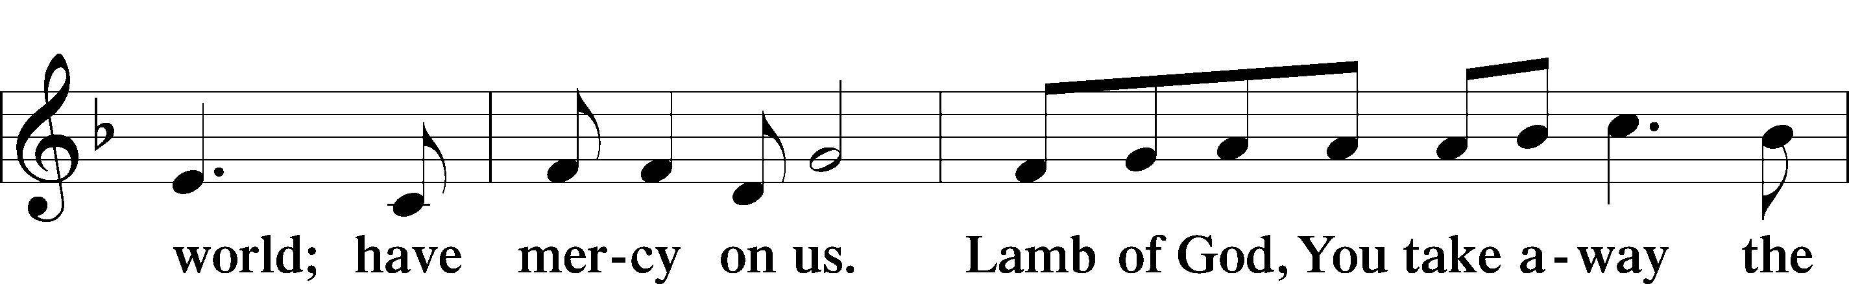
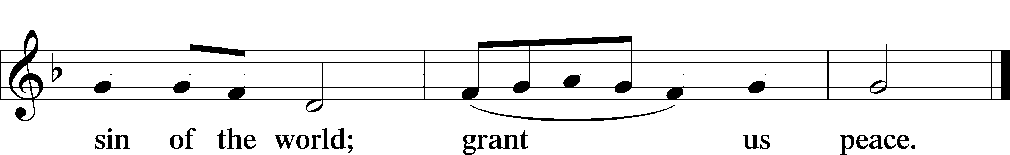

Following the Agnus Dei, please greet one another in the name of the Lord, saying, “Peace be with you,” as a sign of reconciliation and of the unity of the Spirit in the bond of peace (Matt. 5:22–24; Eph. 4:1–3).

Sit

DISTRIBUTION HYMNS
576 MY HOPE IS BUILT ON NOTHING LESS

1 My hope is built on nothing less
Than Jesus’ blood and righteousness;
No merit of my own I claim
But wholly lean on Jesus’ name. Refrain

ref On Christ, the solid rock, I stand;
All other ground is sinking sand,
All other ground is sinking sand.

2 When darkness veils His lovely face,
I rest on His unchanging grace;
In ev’ry high and stormy gale
My anchor holds within the veil. Refrain

3 His oath, His covenant and blood
Support me in the raging flood;
When ev’ry earthly prop gives way,
He then is all my hope and stay. Refrain

4 When He shall come with trumpet sound,
Oh, may I then in Him be found,
Clothed in His righteousness alone,
Redeemed to stand before His throne!
Refrain
617 O LORD, WE PRAISE THEE

1 O Lord, we praise Thee, bless Thee, and adore Thee,
In thanksgiving bow before Thee.
Thou with Thy body and Thy blood didst nourish
Our weak souls that they may flourish:
O Lord, have mercy!
May Thy body, Lord, born of Mary,
That our sins and sorrows did carry,
And Thy blood for us plead
In all trial, fear, and need:
O Lord, have mercy!

2 Thy holy body into death was given,
Life to win for us in heaven.
No greater love than this to Thee could bind us;
May this feast thereof remind us!
O Lord, have mercy!
Lord, Thy kindness did so constrain Thee
That Thy blood should bless and sustain me.
All our debt Thou hast paid;
Peace with God once more is made:
O Lord, have mercy!

3 May God bestow on us His grace and favor
That we follow Christ our Savior
And live together here in love and union
Nor despise this blest Communion!
O Lord, have mercy!
Let not Thy good Spirit forsake us;
Grant that heav’nly-minded He make us;
Give Thy Church, Lord, to see
Days of peace and unity:
O Lord, have mercy!

794 THE LORD, MY GOD, BE PRAISED

1 The Lord, my God, be praised,
My light, my life from heaven;
My maker, who to me
Has soul and body given;
My Father, who will shield
And keep me day by day
And make each moment yield
New blessings on my way.

2 The Lord, my God, be praised,
My trust, my life from heaven,
The Father’s own dear Son,
Whose life for me was given,
Who for my sin atoned
With His most precious blood
And gives to me by faith
The highest heav’nly good.
3 The Lord, my God, be praised,
My hope, my life from heaven,
The Spirit, whom the Son
In love to me has given.
His grace revives my heart
And gives my spirit pow’r,
Help, comfort, and support
In sorrow’s gloomy hour.

D 4 The Lord, my God, be praised,
My God, the ever-living,
To whom the heav’nly host
Their laud and praise are giving.
The Lord, my God, be praised,
In whose great name I boast,
God Father, God the Son,
And God the Holy Ghost.

Stand

DISMISSAL

THANK THE LORD LSB 164
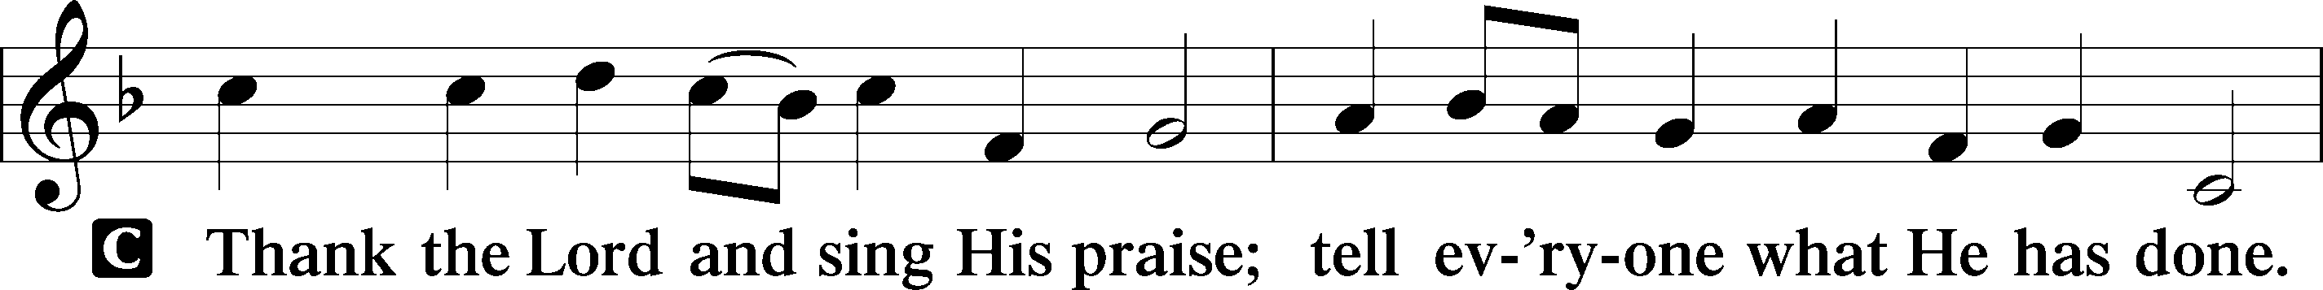
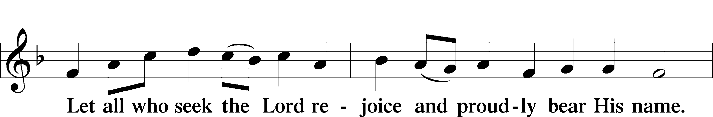
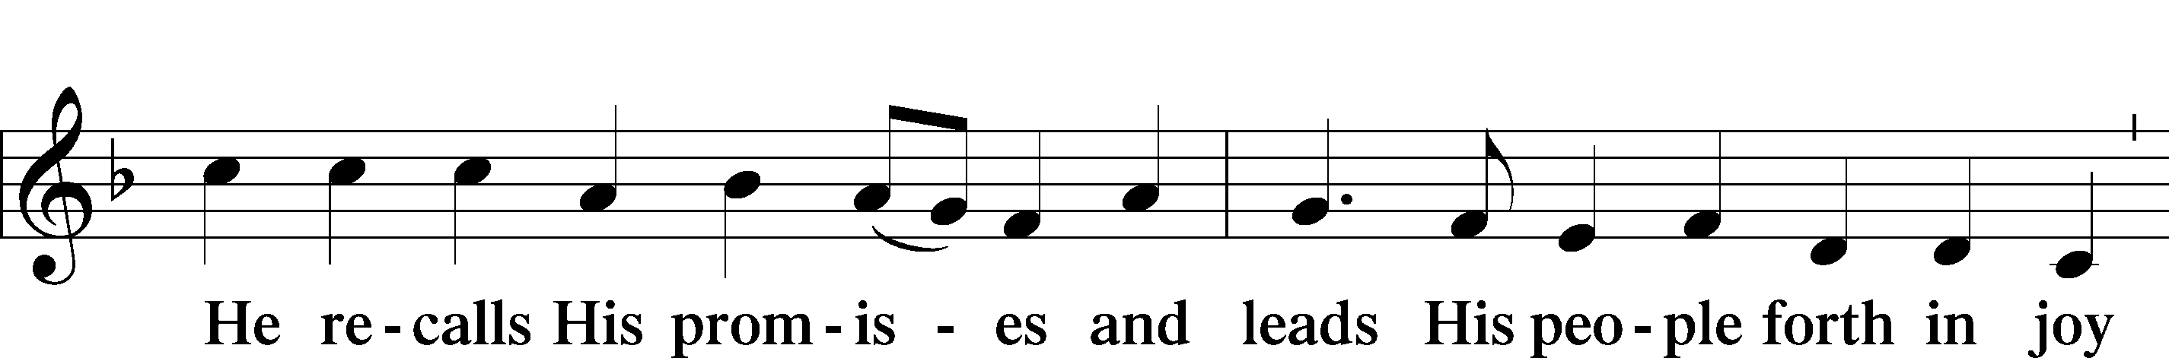
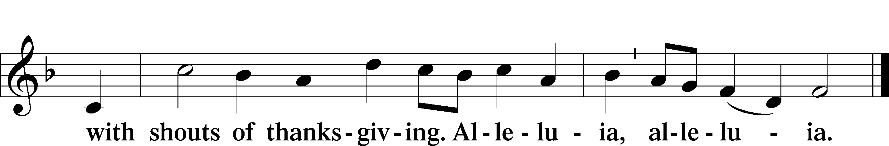

POST-COMMUNION COLLECT
BENEDICTION LSB 166
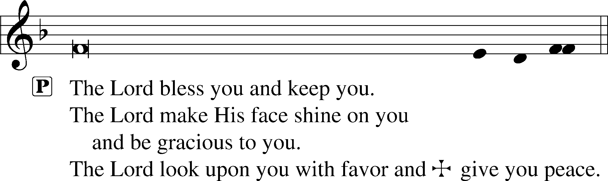


RECESSIONAL HYMN
913 O HOLY SPIRIT, ENTER IN

1 O Holy Spirit, enter in,
And in our hearts Your work begin,
Your dwelling place now make us.
Sun of the soul, O Light divine,
Around and in us brightly shine,
To joy and gladness wake us
That we may be
Truly living,
To You giving
Prayer unceasing
And in love be still increasing.

2 Give to Your Word impressive pow’r,
That in our hearts from this good hour
As fire it may be glowing,
That in true Christian unity
We faithful witnesses may be,
Your glory ever showing.
Hear us, cheer us
By Your teaching;
Let our preaching
And our labor
Praise You, Lord, and serve our neighbor.

3 O mighty Rock, O Source of life,
Let Your dear Word, in doubt and strife,
In us be strongly burning
That we be faithful unto death
And live in love and holy faith,
From You true wisdom learning.
Your grace and peace
On us shower;
By Your power
Christ confessing,
Let us see our Savior’s blessing.

ANNOUNCEMENTS
See announcements on the back of the bulletin.

SENDING
P Let us pray.
Lord God, You have called Your servants to ventures of which we cannot see the ending, by paths as yet untrodden, through perils unknown. Give us faith to go out with good courage, not knowing where we go but only that Your hand is leading us and Your love supporting us; through Jesus Christ, our Lord.
C Amen
P Go in peace to serve the Lord.
C Thanks be to God.
THIS WEEK AT FAITH

Sun. July 19 Bible Studies 8:15am
Worship 9:30am
Mon-Thurs July 20-July 24 Summer Camp VBS 9am-4pm
Tues. July 21 Create in Me Crafting 10:00am
Sun. July 26 Bible Studies 8:15am
Worship 9:30am

CHURCH ANNOUNCEMENTS


show your spirit - This year’s theme at Faith Lutheran School is "Rooted in Christ" and FLS is offering spirit wear t-shirts for $10 each! You can scan the QR code to the right or order from faithmarietta.com/Rooted.

YOUTH EVENTS *SUMMER EDITION* - July 26, 12-2pm
4th-12th graders Meet us in the Youth Room after church for our final "Summer Edition" Youth hangout Esports competition. This is a free drop-off event, but parents are welcome to stay and play! Lunch and drinks are provided. RSVP to Liz Cain (678) 472-5226 *Games are E and E10+ rated

School Blessing - Saturday, August 1st at 10:00am
We warmly invite you, your family and friends to join us for Faith Lutheran School’s Blessing as we begin a new chapter as a classical school, refreshments and fellowship to follow. Kindly RSVP to Susie.Glass@faithmarietta.org so we can plan accordingly. *If you have questions, please contact Chris Bradshaw or Pastor Daugherty.

WORSHIP SCHEDULE - Beginning September 6, our Sunday morning schedule will change:
Bible Study 8:30a - 9:30a ; Fellowship 9:30a - 10:00a ; Worship 10:00a - 11:30a
The purpose of this change is to promote fellowship within the Faith Community and to give the choir and congregation time to prepare for worship. In addition, this will also allow for regular fellowship activities after worship.

VOTERS’ MEETINGS - take place after Sunday worship. Next Tentative Meetings: Aug 23 - Nominating Committee; Nov 15 – Elections

