

Sixth Sunday After Pentecost
July 5, 2026
OUR MISSION: Connecting People to Jesus

Contact us
Faith Lutheran Church & School 2111 Lower Roswell Rd, Marietta, GA 30068 | 770-973-8877

CHURCH: www.faithmarietta.com SCHOOL: www.faithmarietta.org
Rev. Shaun Daugherty, Pastor Mr. Chris Bradshaw, Headmaster
pastor.shaun@faithmarietta.org chris.bradshaw@faithmarietta.org
470-289-9469 470-641-6239
See the full leadership directory: www.faithmarietta.com/leadership
Serving This Month at Faith
 | 7/5/2026 | 7/12/2026 | 7/19/2026 | 7/26/2026
Musicians | Vaunda Noerenberg | Vaunda Noerenberg | Ben Nye | Vaunda Noerenberg
Elders | Ward Irvin  Vinny Caracci | Jon Cain  Peter Amelingmeier | Steve Buchtrup  Woody Wood | Russ Couch  Glenn Jones
Reader | David Barnett | Stacy Sinatra | Jon Wareham | Greg Sinatra
Ushers | Greg Czerwonka, Matthew Czerwonka  Jacob Czerwonka  Luke Czerwonka  Sam Czerwonka | Steve Buchtrup  Mark Patterson  Gary Schleicher  Reagan Gronsbell  Paris Brown | Kim Kaumeyer  Brennan Lambert  David Barnett  Greg Sinatra | Chris Bradshaw  Herman Dean  Bryan Powell  Christian Campbell
Acolytes | Adam Cain  Amadeo Brown | Josiah Brown  Alex Bradshaw | Andrew Linsey  Christian Brown | Amadeo Brown  Adam Cain



Pay Pal

For your convenience,
we now accept gifts
via Venmo or PayPal.

Our Discipleship
Date | 6/21 | 6/28 | 7/5 |  | YTD Report (Aug thru May)
Worship | 134/123 | 130/128 | -- |  | Avg. Worship | 144
Sunday School | 13 | 15 | -- |  | Avg. SS | 35
Gen. Giving | $7,274 | $8,260 | $ |  | YTD Gen. Giving | $576,891
MTD Giving | $41,904 | $50,164 | $ |  | YTD Budget | $601,060
 |  |  |  |  | "Special" Gifts | $383,020
Monthly Budget | $57,000 | $57,000 | $53,300 |  | Designated Gifts | $165,784
ALTAR FLOWERS given today by Musgrove’s in celebration of the 250th anniversary of Our Great Nation “God Bless America.”

PRE-SERVICE MUSIC
WELCOME
+ Confession and Absolution +
We enter the presence of God by humbly confessing our sins and gladly receiving His forgiveness.
Stand

PROCESSIONAL HYMN

966 BEFORE YOU, LORD, WE BOW

1 Before You, Lord, we bow,
Our God who reigns above
And rules the world below,
Boundless in pow’r and love.
Our thanks we bring
In joy and praise,
Our hearts we raise
To You, our King!

2 The nation You have blest
May well Your love declare,
From foes and fears at rest,
Protected by Your care.
For this bright day,
For this fair land—
Gifts of Your hand—
Our thanks we pay.

3 May ev’ry mountain height,
Each vale and forest green,
Shine in Your Word’s pure light,
And its rich fruits be seen!
May ev’ry tongue
Be tuned to praise
And join to raise
A grateful song.

4 Earth, hear your Maker’s voice;
Your great Redeemer own;
Believe, obey, rejoice,
And worship Him alone.
Cast down your pride,
Your sin deplore,
And bow before
The Crucified.

5 And when in pow’r He comes,
Oh, may our native land
From all its rending tombs
Send forth a glorious band,
A countless throng,
With joy to sing
To heav’n’s high King
Salvation’s song!

The sign of the cross may be made by all in remembrance of their Baptism.

INVOCATION
P In the name of the Father and of the T Son and of the Holy Spirit.
C Amen.

P If we say we have no sin, we deceive ourselves, and the truth is not in us.
C But if we confess our sins, God, who is faithful and just, will forgive our sins and cleanse us from all unrighteousness.

Silence for reflection on God’s Word and for self-examination.

CONFESSION AND ABSOLUTION 151
P Let us then confess our sins to God our Father.
C Most merciful God, we confess that we are by nature sinful and unclean. We have sinned against You in thought, word, and deed, by what we have done and by what we have left undone. We have not loved You with our whole heart; we have not loved our neighbors as ourselves. We justly deserve Your present and eternal punishment. For the sake of Your Son, Jesus Christ, have mercy on us. Forgive us, renew us, and lead us, so that we may delight in Your will and walk in Your ways to the glory of Your holy name. Amen.

P Almighty God in His mercy has given His Son to die for you and for His sake forgives you all your sins. As a called and ordained servant of Christ, and by His authority, I therefore forgive you all your sins in the name of the Father and of the T Son and of the Holy Spirit.
C Amen.
Stand
+ Service of the Word +
Having received God's forgiveness, we come before Him with songs of praise, eager to hear His Word.

INTROIT

He who dwells in the shelter of the | Most High*
will abide in the shadow of the Al- | mighty.
I will say to the Lord, “My refuge and my | fortress,*
my God, in | whom I trust.”
Because you have made the Lord your | dwelling place—*
the Most High, who is my | refuge—
no evil shall be allowed to be- | fall you,*
no plague come | near your tent.
Glory be to the Father and | to the Son*
and to the Holy | Spirit;
as it was in the be- | ginning,*
is now, and will be forever. | Amen.
He who dwells in the shelter of the | Most High*
will abide in the shadow of the Al- | mighty.

KYRIE LSB 152

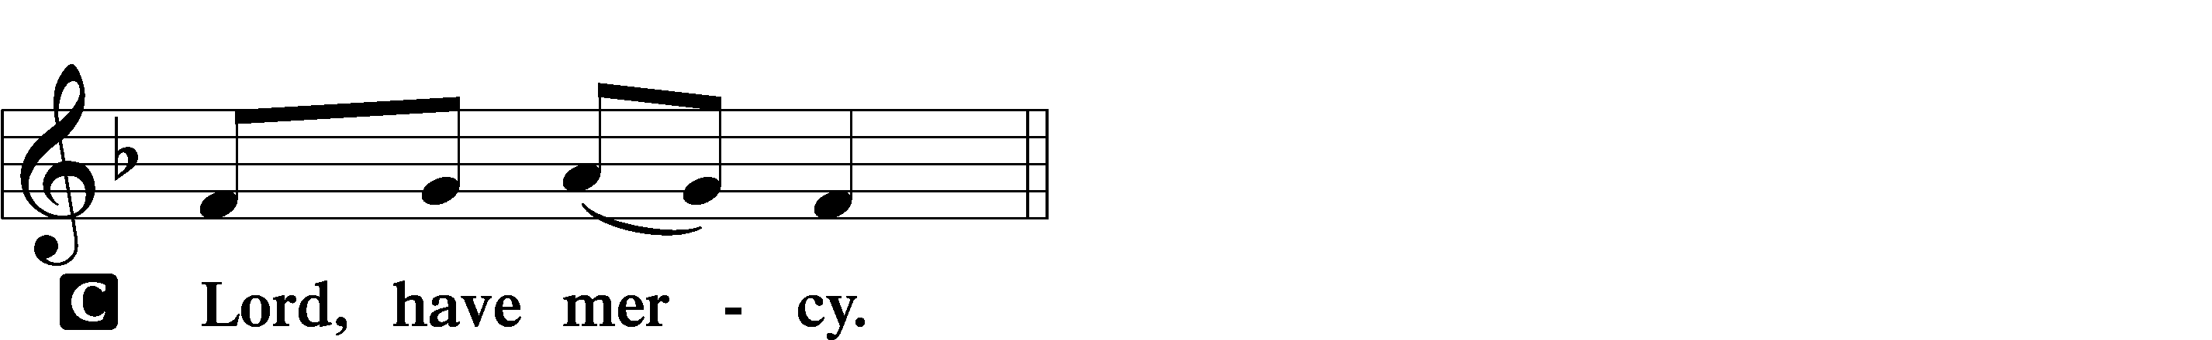

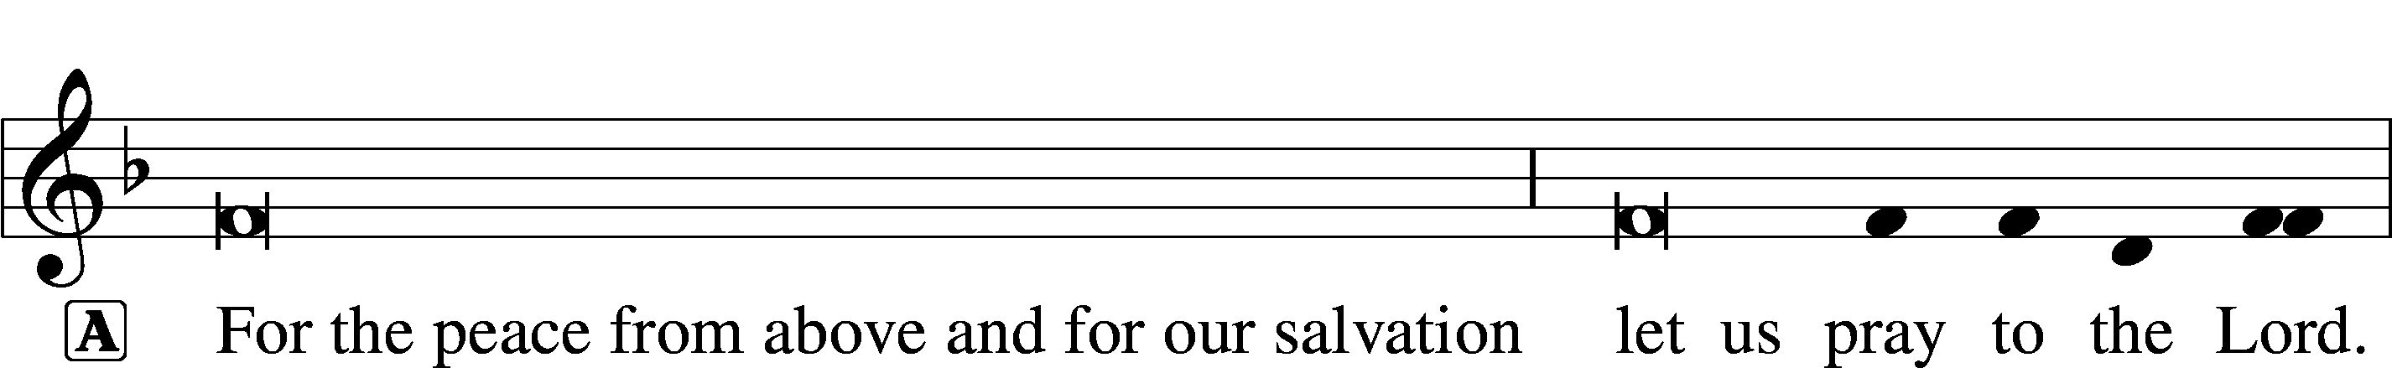
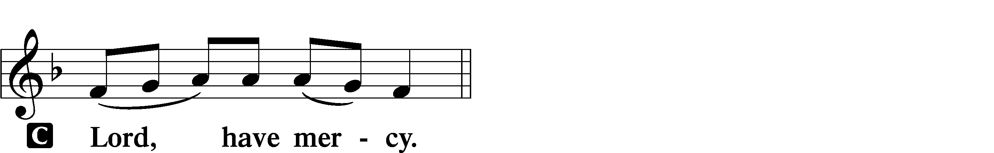

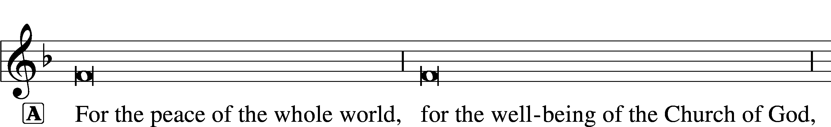

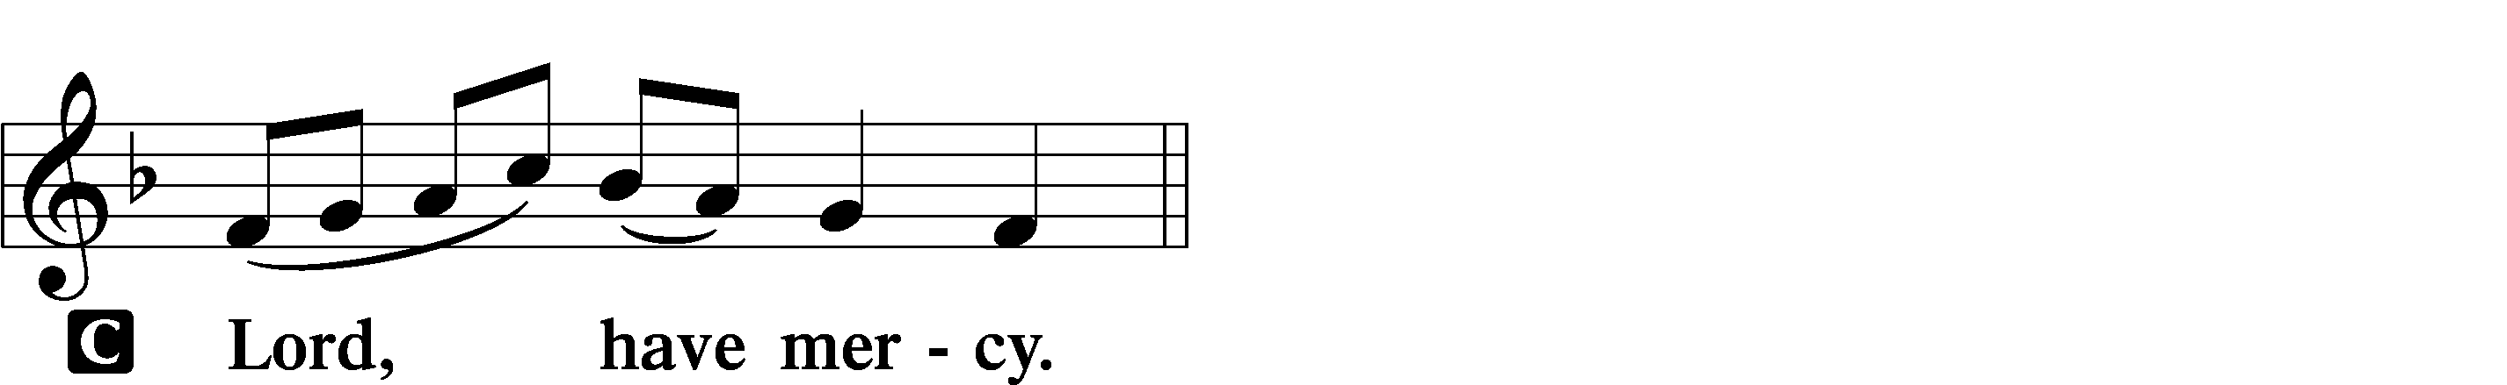

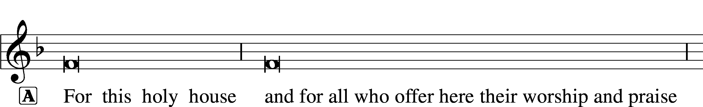

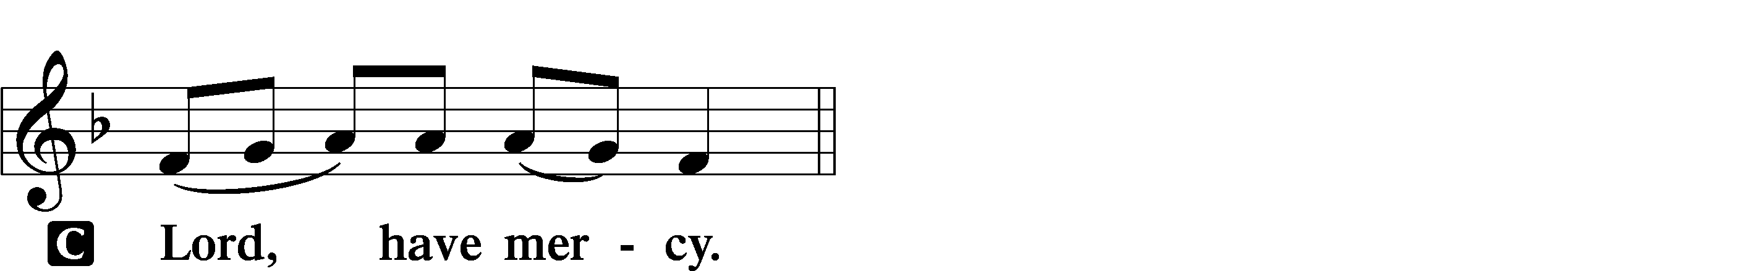




THIS IS THE FEAST LSB 155
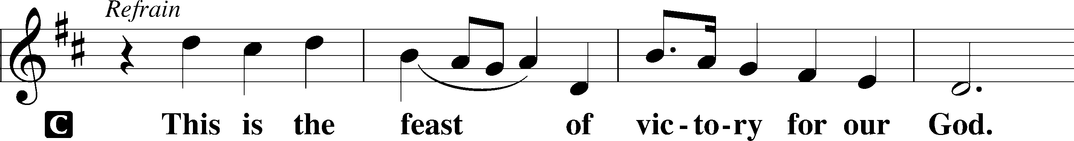
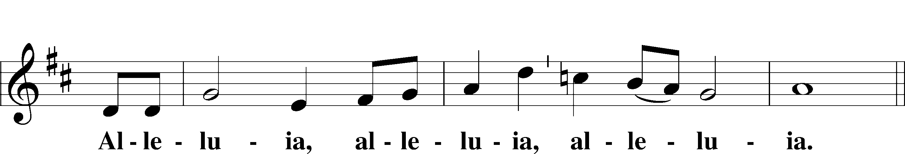
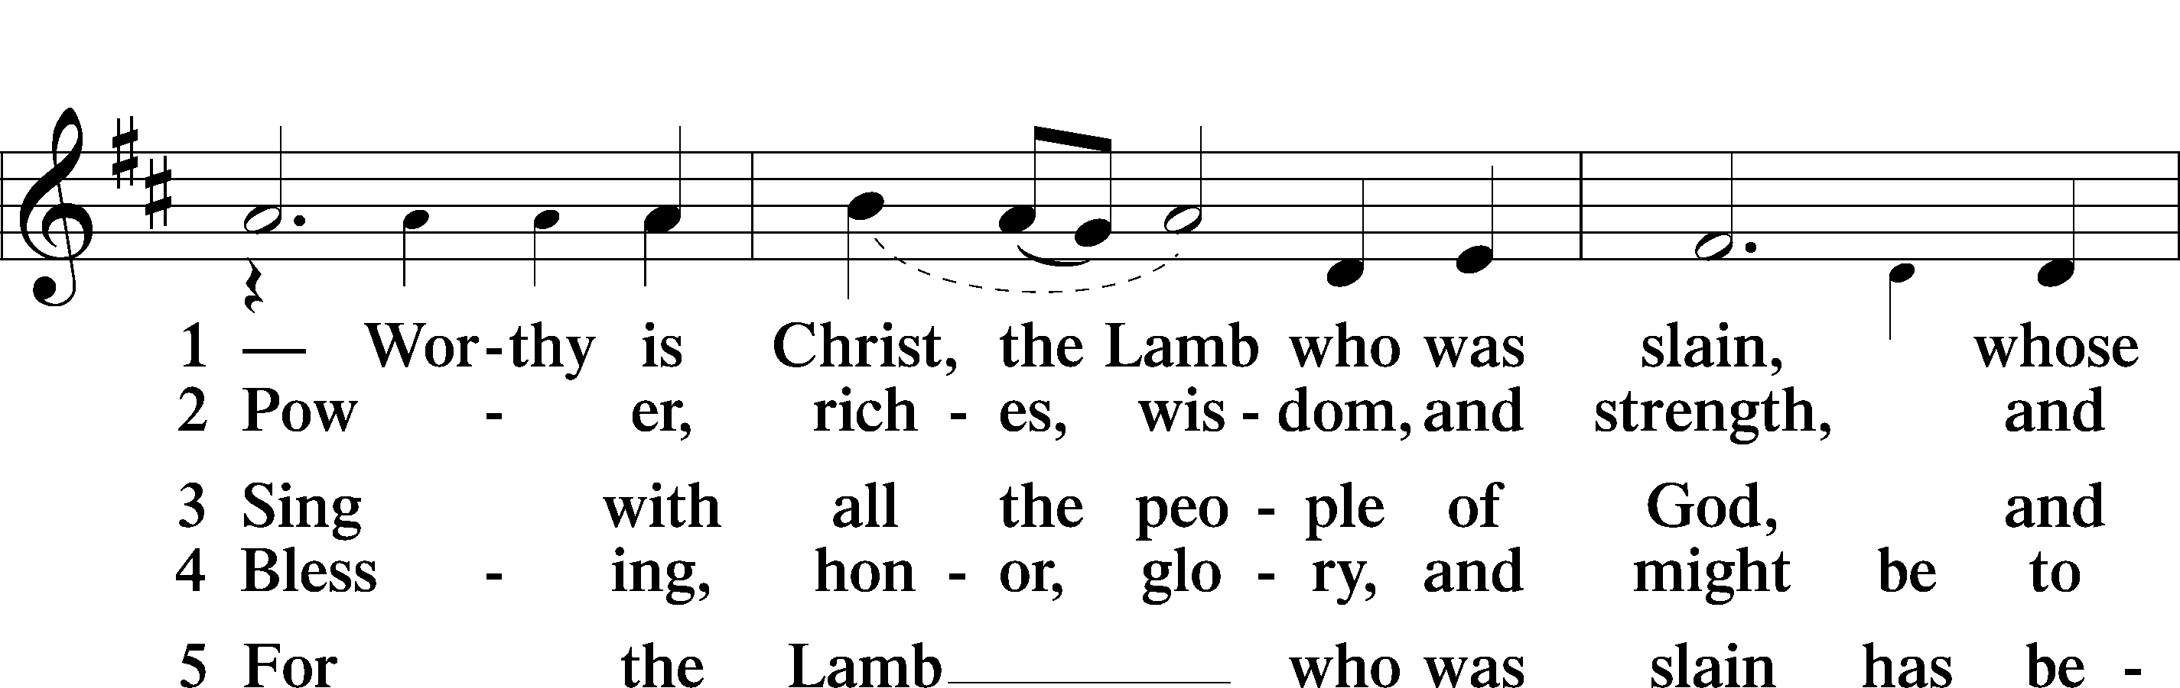
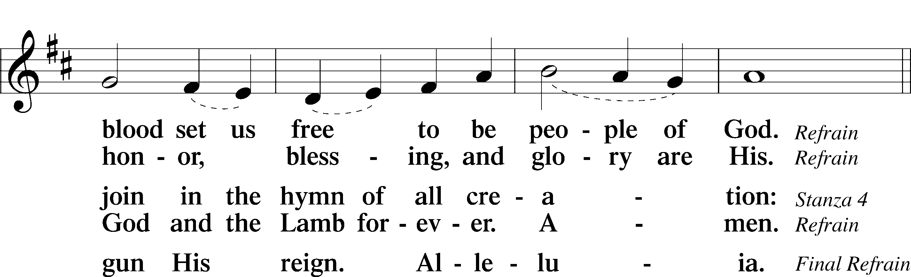
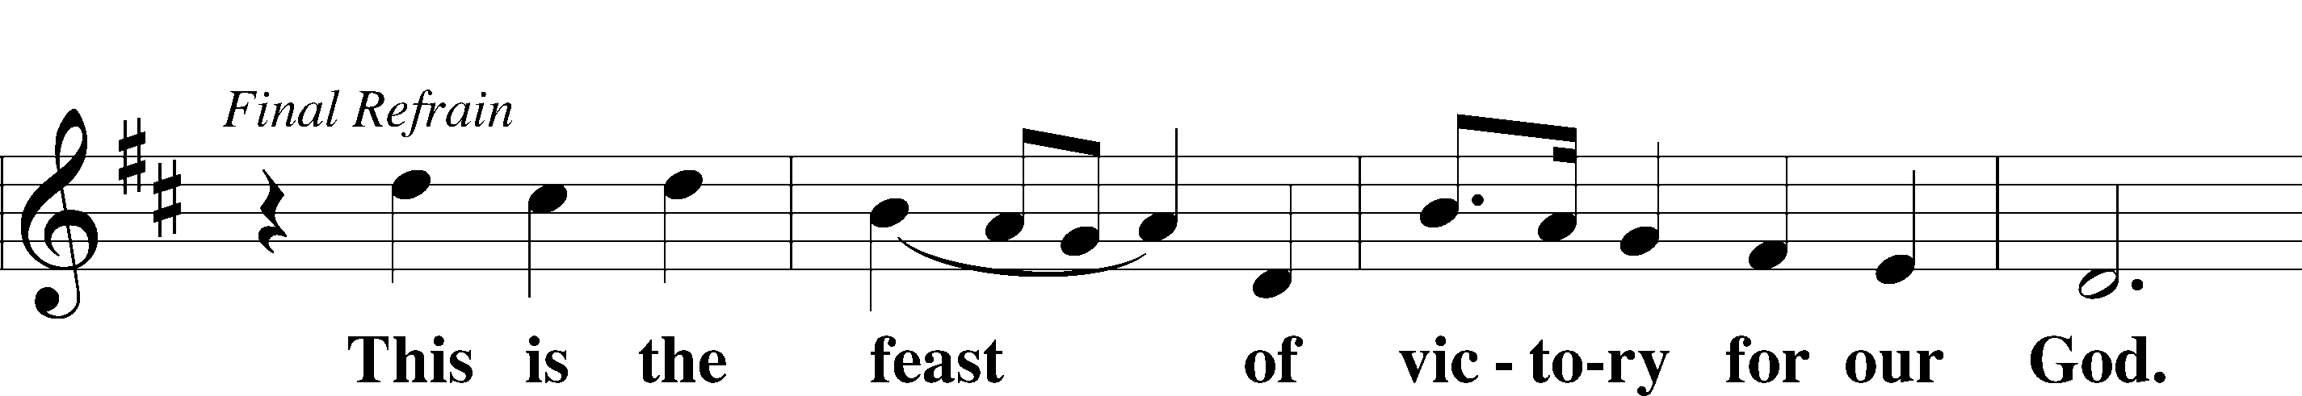
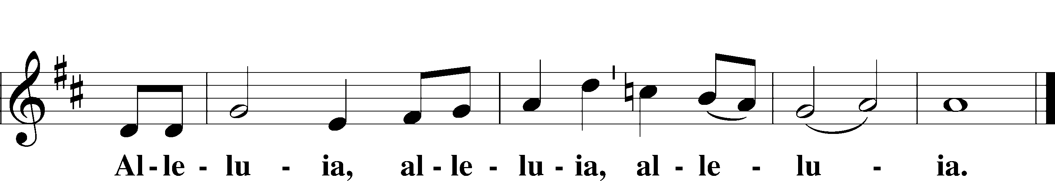

SALUTATION AND COLLECT OF THE DAY
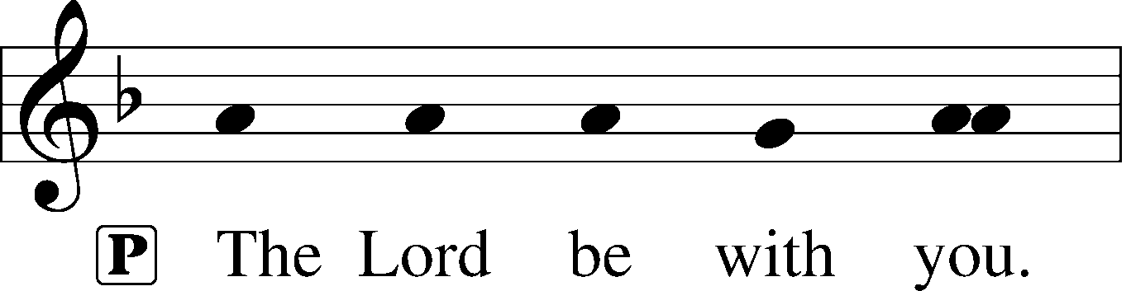
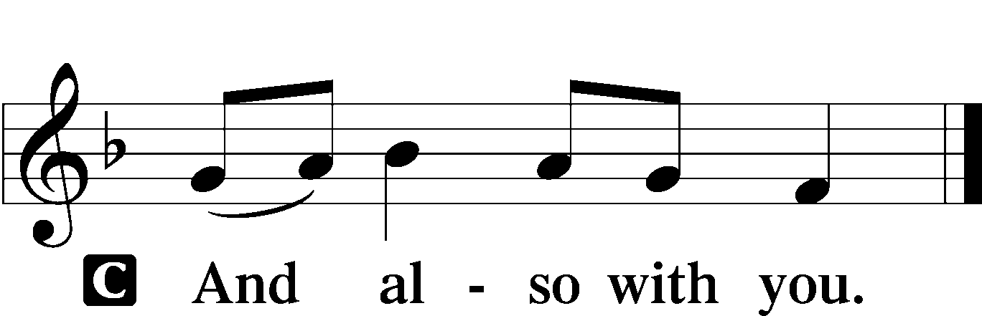

P Let us pray.
Gracious God, our heavenly Father, Your mercy attends us all our days. Be our strength and support amid the wearisome changes of this world, and at life’s end grant us Your promised rest and the full joys of Your salvation; through Jesus Christ, Your Son, our Lord, who lives and reigns with You and the Holy Spirit, one God, now and forever.

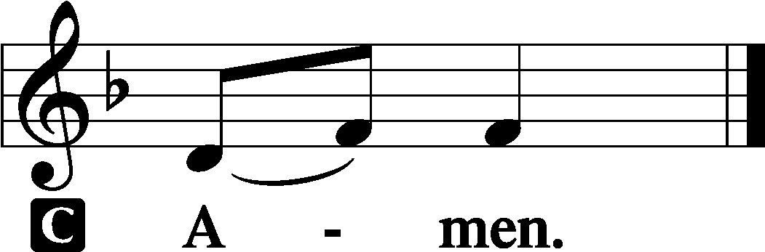

Sit

OLD TESTAMENT READING Zechariah 9:9–12
9Rejoice greatly, O daughter of Zion!
Shout aloud, O daughter of Jerusalem!
behold, your king is coming to you;
righteous and having salvation is he,
humble and mounted on a donkey,
on a colt, the foal of a donkey.
10I will cut off the chariot from Ephraim
and the war horse from Jerusalem;
and the battle bow shall be cut off,
and he shall speak peace to the nations;
his rule shall be from sea to sea,
and from the River to the ends of the earth.
11As for you also, because of the blood of my covenant with you,
I will set your prisoners free from the waterless pit.
12Return to your stronghold, O prisoners of hope;
today I declare that I will restore to you double.

A This is the Word of the Lord.
C Thanks be to God.

GRADUAL
Oh, the depth of the riches and wisdom and knowl- | edge of God!*
How unsearchable are his judgments and how inscrutable | his ways!
For from him and through him and to him are | all things.*
To him be glory forever. | Amen.

EPISTLE Romans 5
1Therefore, since we have been justified by faith, we have peace with God through our Lord Jesus Christ. 2Through him we have also obtained access by faith into this grace in which we stand, and we rejoice in hope of the glory of God. 3More than that, we rejoice in our sufferings, knowing that suffering produces endurance, 4and endurance produces character, and character produces hope, 5and hope does not put us to shame, because God’s love has been poured into our hearts through the Holy Spirit who has been given to us.
6For while we were still weak, at the right time Christ died for the ungodly. 7For one will scarcely die for a righteous person—though perhaps for a good person one would dare even to die— 8but God shows his love for us in that while we were still sinners, Christ died for us. 9Since, therefore, we have now been justified by his blood, much more shall we be saved by him from the wrath of God. 10For if while we were enemies we were reconciled to God by the death of his Son, much more, now that we are reconciled, shall we be saved by his life. 11More than that, we also rejoice in God through our Lord Jesus Christ, through whom we have now received reconciliation.
12Therefore, just as sin came into the world through one man, and death through sin, and so death spread to all men because all sinned— 13for sin indeed was in the world before the law was given, but sin is not counted where there is no law. 14Yet death reigned from Adam to Moses, even over those whose sinning was not like the transgression of Adam, who was a type of the one who was to come.
15But the free gift is not like the trespass. For if many died through one man’s trespass, much more have the grace of God and the free gift by the grace of that one man Jesus Christ abounded for many. 16And the free gift is not like the result of that one man’s sin. For the judgment following one trespass brought condemnation, but the free gift following many trespasses brought justification. 17If, because of one man’s trespass, death reigned through that one man, much more will those who receive the abundance of grace and the free gift of righteousness reign in life through the one man Jesus Christ.
18Therefore, as one trespass led to condemnation for all men, so one act of righteousness leads to justification and life for all men. 19For as by the one man’s disobedience the many were made sinners, so by the one man’s obedience the many will be made righteous. 20Now the law came in to increase the trespass, but where sin increased, grace abounded all the more, 21so that, as sin reigned in death, grace also might reign through righteousness leading to eternal life through Jesus Christ our Lord.

A This is the Word of the Lord.
C Thanks be to God.

Stand

ALLELUIA AND VERSE LSB 156
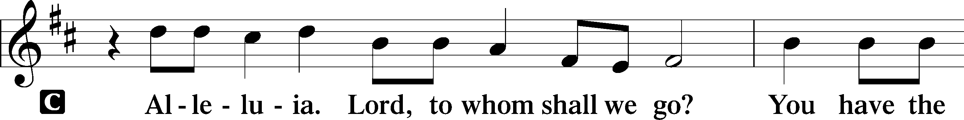
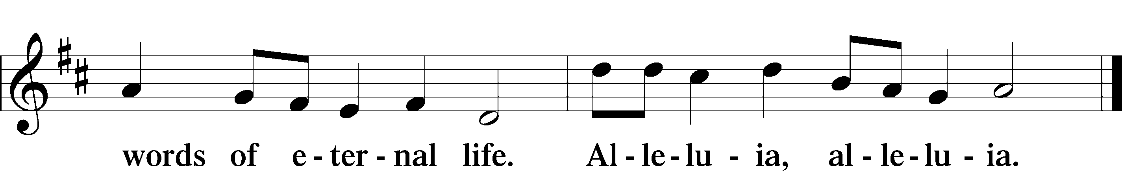

HOLY GOSPEL Matthew 11:25–30
P The Holy Gospel according to St. Matthew, the eleventh chapter.

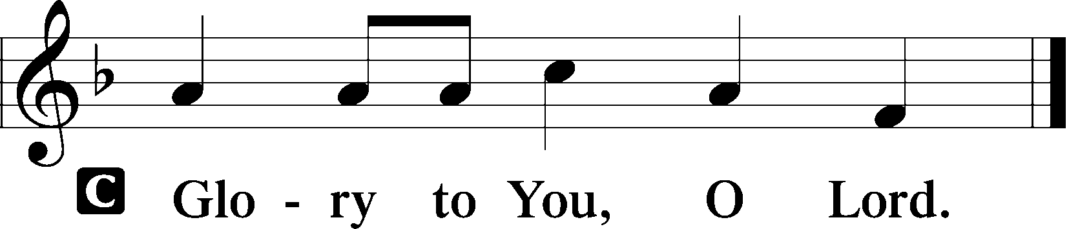

25At that time Jesus declared, “I thank you, Father, Lord of heaven and earth, that you have hidden these things from the wise and understanding and revealed them to little children; 26yes, Father, for such was your gracious will. 27All things have been handed over to me by my Father, and no one knows the Son except the Father, and no one knows the Father except the Son and anyone to whom the Son chooses to reveal him. 28Come to me, all who labor and are heavy laden, and I will give you rest. 29Take my yoke upon you, and learn from me, for I am gentle and lowly in heart, and you will find rest for your souls. 30For my yoke is easy, and my burden is light.”

P This is the Gospel of the Lord.

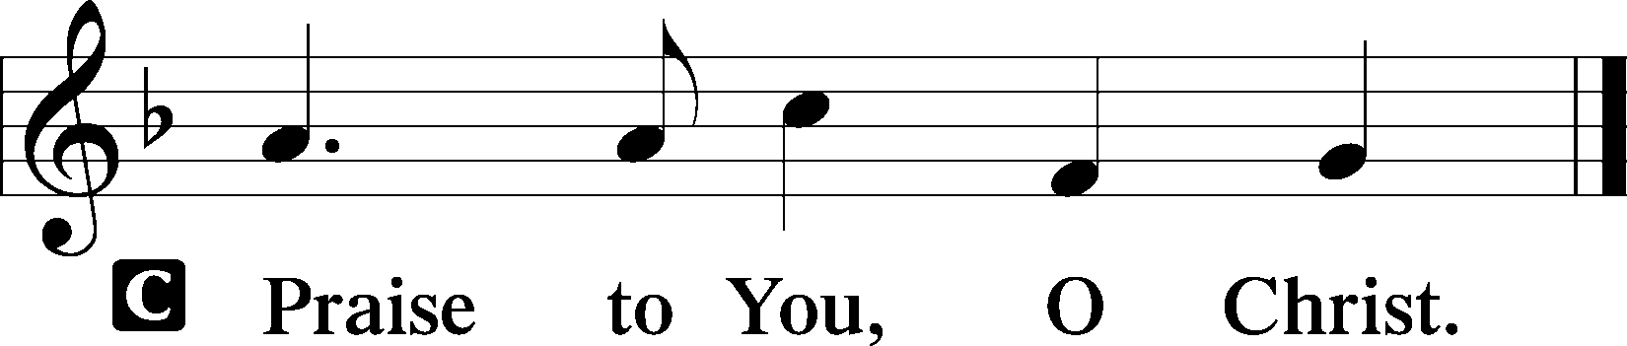

Sit

CHILDREN'S MESSAGE

HYMN OF THE DAY

699 I HEARD THE VOICE OF JESUS SAY

1 I heard the voice of Jesus say,
“Come unto Me and rest;
Lay down, thou weary one, lay down
Thy head upon My breast.”
I came to Jesus as I was,
So weary, worn, and sad;
I found in Him a resting place,
And He has made me glad.

2 I heard the voice of Jesus say,
“Behold, I freely give
The living water; thirsty one,
Stoop down and drink and live.”
I came to Jesus, and I drank
Of that life-giving stream;
My thirst was quenched, my soul revived,
And now I live in Him.

3 I heard the voice of Jesus say,
“I am this dark world’s light.
Look unto Me; thy morn shall rise
And all thy day be bright.”
I looked to Jesus, and I found
In Him my star, my sun;
And in that light of life I’ll walk
Till trav’ling days are done.

SERMON Rev. Shaun Daugherty

Stand

APOSTLES’ CREED
C I believe in God, the Father Almighty, maker of heaven and earth.

And in Jesus Christ, His only Son, our Lord, who was conceived by the Holy Spirit, born of the virgin Mary, suffered under Pontius Pilate, was crucified, died and was buried. He descended into hell. The third day He rose again from the dead. He ascended into heaven and sits at the right hand of God the Father Almighty. From thence He will come to judge the living and the dead.

I believe in the Holy Spirit, the holy Christian Church, the communion of saints, the forgiveness of sins, the resurrection of the body, and the life T everlasting. Amen.

PRAYER OF THE CHURCH
After each petition:
P Lord, in Your mercy,
C hear our prayer.

Sit

COLLECTION OF TITHES AND OFFERING

Stand

OFFERTORY LSB 159
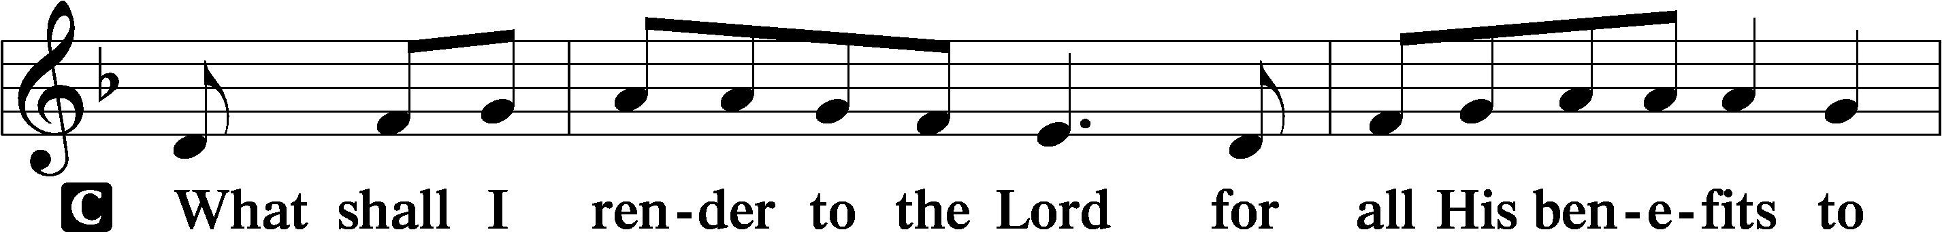
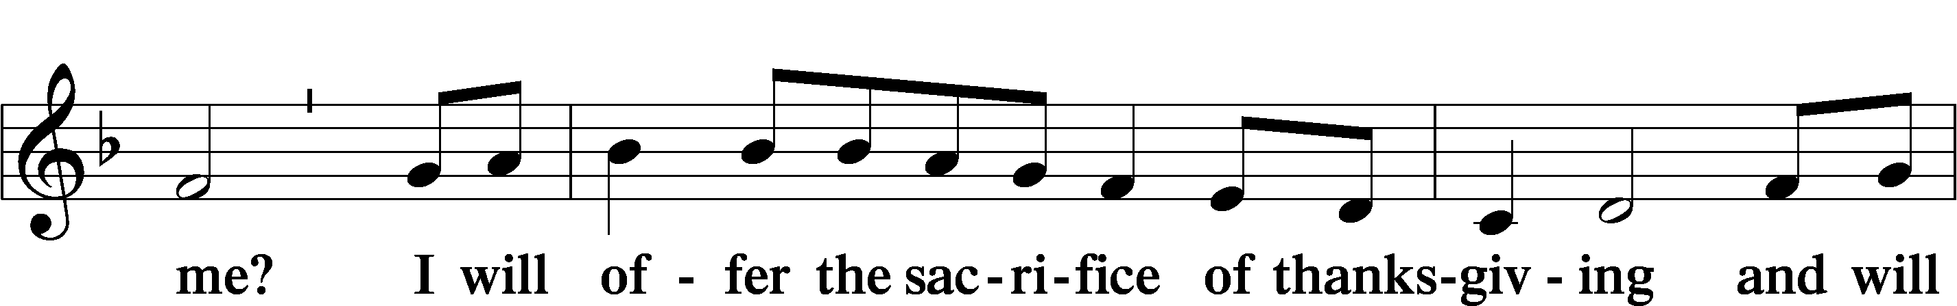
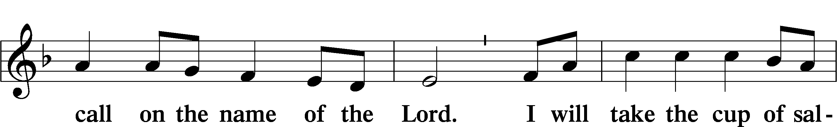
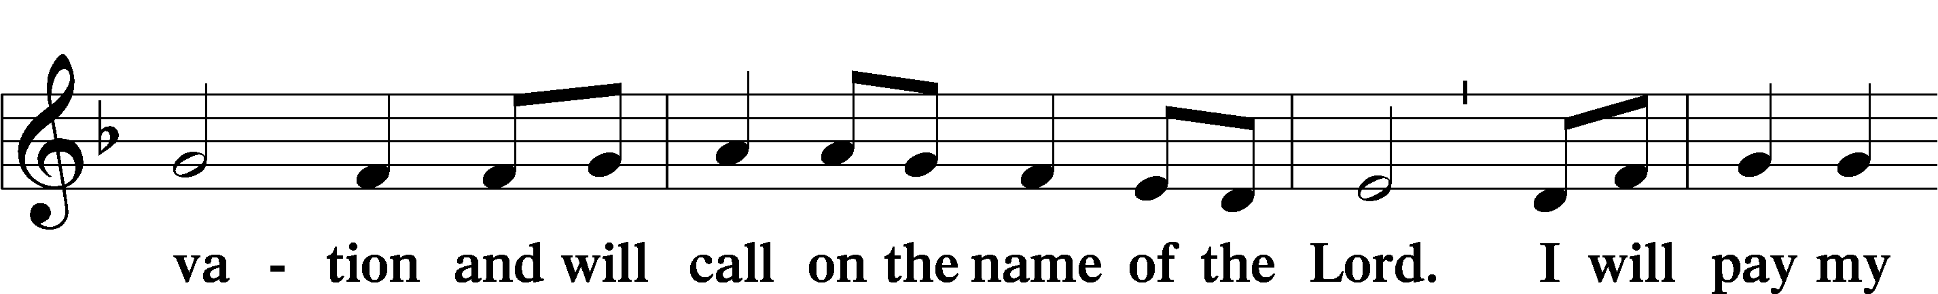
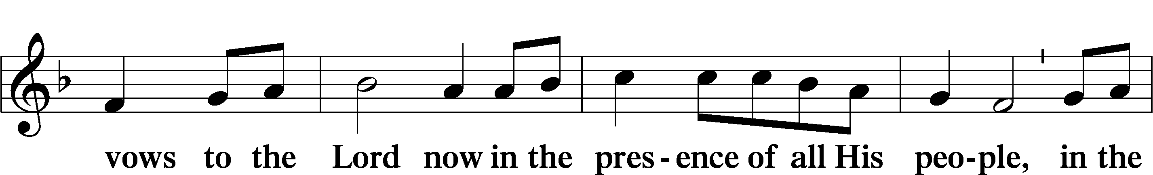
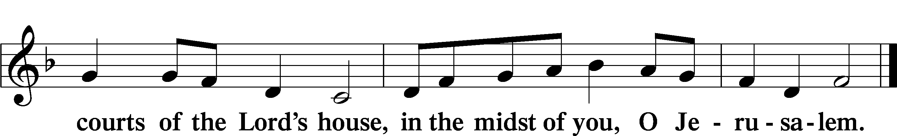

+ Service of the Sacrament +

As God's baptized and forgiven people, we gather at His invitation to receive The Lord's Supper.

The Lord’s Supper is celebrated at this congregation in the confession and glad confidence that, as he says, our Lord gives into our mouths not only bread and wine but His very body and blood to eat and to drink for the forgiveness of sins and to strengthen our union with him and with one another. Our Lord invites to his table those Baptized Christians who trust his words, repent of all sin, and set aside any refusal to forgive and love as he forgives and loves us, that they may show forth his death until he comes.

Because those who eat and drink our Lord’s body and blood unworthily do so to their great harm and because Holy Communion is a confession of the faith which is confessed at this altar, any who are not yet instructed, in doubt, or who hold a confession differing from that of this congregation and The Lutheran Church— Missouri Synod, and yet desire to receive the sacrament, are asked first to speak with the pastor or an elder.

For further study, see Matthew 5:23f.; 10:32f.; 18:15-35; 26:26-29; 1 Cor. 11:17- 34.

PREFACE LSB 160





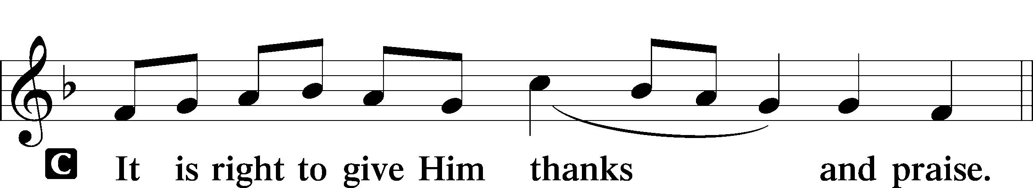

PROPER PREFACE LSB 161
P It is truly good, right, and salutary . . . evermore praising You and saying:

SANCTUS LSB 161
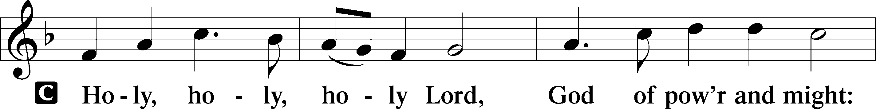
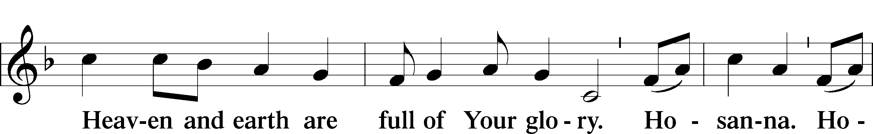
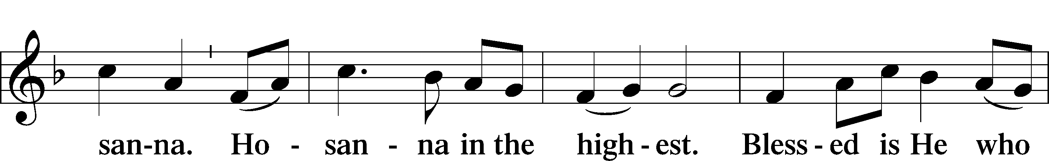
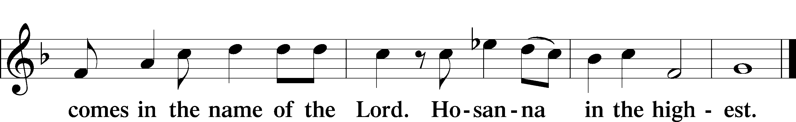

PRAYER OF THANKSGIVING 161
P Blessed are You, Lord of heaven and earth, for You have had mercy on those whom You created and sent Your only-begotten Son into our flesh to bear our sin and be our Savior. With repentant joy we receive the salvation accomplished for us by the all-availing sacrifice of His body and His blood on the cross.

Gathered in the name and the remembrance of Jesus, we beg You, O Lord, to forgive, renew, and strengthen us with Your Word and Spirit. Grant us faithfully to eat His body and drink His blood as He bids us do in His own testament. Gather us together, we pray, from the ends of the earth to celebrate with all the faithful the marriage feast of the Lamb in His kingdom, which has no end. Graciously receive our prayers; deliver and preserve us. To You alone, O Father, be all glory, honor, and worship, with the Son and the Holy Spirit, one God, now and forever.
C Amen.

THE WORDS OF OUR LORD

PROCLAMATION OF CHRIST
P As often as we eat this bread and drink this cup, we proclaim the Lord’s death until He comes.
C Amen. Come, Lord Jesus.

P O Lord Jesus Christ, only Son of the Father, in giving us Your body and blood to eat and to drink, You lead us to remember and confess Your holy cross and passion, Your blessed death, Your rest in the tomb, Your resurrection from the dead, Your ascension into heaven, and Your coming for the final judgment. So remember us in Your kingdom and teach us to pray:

LORD’S PRAYER
C Our Father who art in heaven, hallowed be Thy name, Thy kingdom come, Thy will be done on earth as it is in heaven; give us this day our daily bread; and forgive us our trespasses as we forgive those who trespass against us; and lead us not into temptation, but deliver us from evil. For Thine is the kingdom and the power and the glory forever and ever. Amen.

PAX DOMINI LSB 163
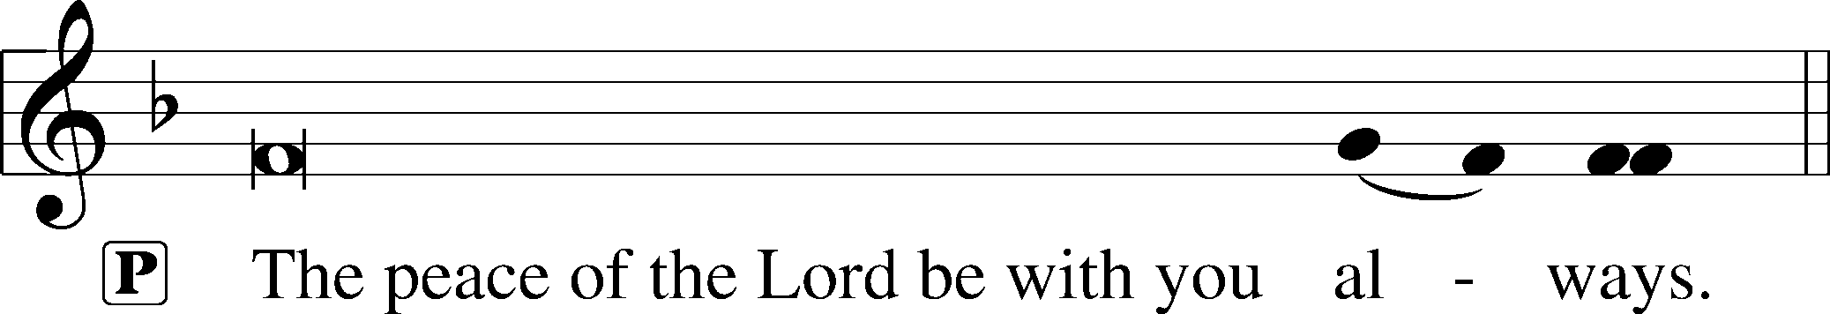


AGNUS DEI LSB 163
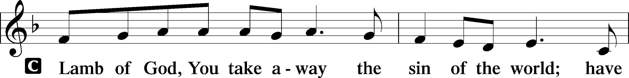
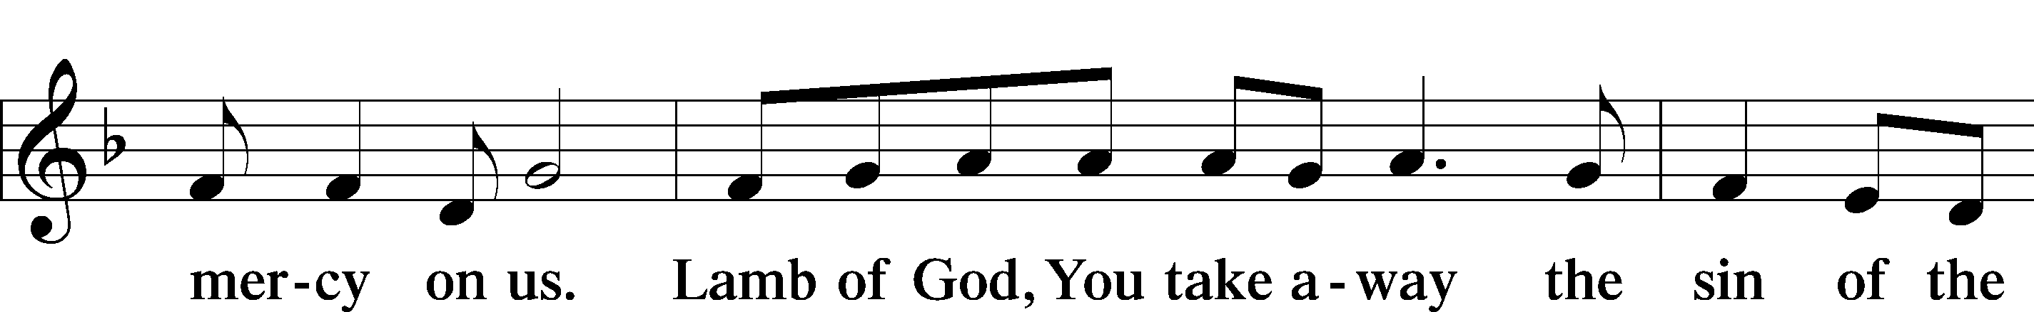
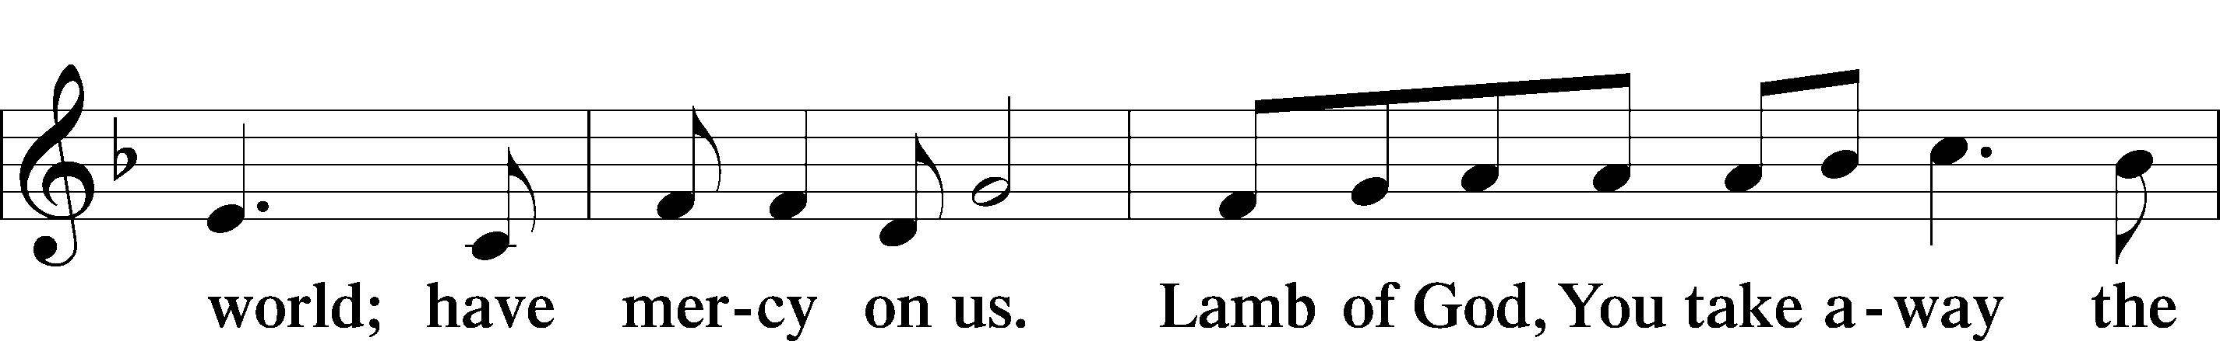
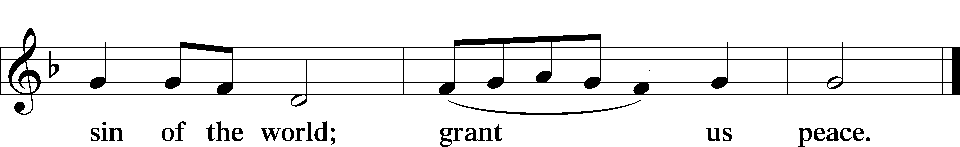

Following the Agnus Dei, please greet one another in the name of the Lord, saying, “Peace be with you,” as a sign of reconciliation and of the unity of the Spirit in the bond of peace (Matt. 5:22–24; Eph. 4:1–3).

Sit

DISTRIBUTION HYMNS

707 OH, THAT THE LORD WOULD GUIDE MY WAYS

1 Oh, that the Lord would guide my ways
To keep His statutes still!
Oh, that my God would grant me grace
To know and do His will!

2 Order my footsteps by Thy Word
And make my heart sincere;
Let sin have no dominion, Lord,
But keep my conscience clear.

3 Assist my soul, too apt to stray,
A stricter watch to keep;
And should I e’er forget Thy way,
Restore Thy wand’ring sheep.

4 Make me to walk in Thy commands—
’Tis a delightful road—
Nor let my head or heart or hands
Offend against my God.

347 COMFORT, COMFORT YE MY PEOPLE

1 “Comfort, comfort ye My people,
Speak ye peace,” thus saith our God;
“Comfort those who sit in darkness,
Mourning ’neath their sorrows’ load.
Speak ye to Jerusalem
Of the peace that waits for them;
Tell her that her sins I cover
And her warfare now is over.”

2 Yea, her sins our God will pardon,
Blotting out each dark misdeed;
All that well deserved His anger
He no more will see or heed.
She hath suffered many_a day,
Now her griefs have passed away;
God will change her pining sadness
Into ever-springing gladness.

3 Hark, the herald’s voice is crying
In the desert far and near,
Calling sinners to repentance,
Since the Kingdom now is here.
O that warning cry obey!
Now prepare for God a way;
Let the valleys rise to meet Him
And the hills bow down to greet Him.

4 Make ye straight what long was crooked;
Make the rougher places plain.
Let your hearts be true and humble,
As befits His holy reign.
For the glory of the Lord
Now o’er earth is shed abroad,
And all flesh shall see the token
That His Word is never broken.

579 THE LAW OF GOD IS GOOD AND WISE

1 The Law of God is good and wise
And sets His will before our eyes,
Shows us the way of righteousness,
And dooms to death when we transgress.

2 Its light of holiness imparts
The knowledge of our sinful hearts
That we may see our lost estate
And turn from sin before too late.
3 To those who help in Christ have found
And would in works of love abound
It shows what deeds are His delight
And should be done as good and right.

4 But those who scornfully disdain
God’s Law shall then in sin remain;
Its terror in their ear resounds
And keeps their wickedness in bounds.

5 The Law is good; but since the fall
Its holiness condemns us all;
It dooms us for our sin to die
And has no pow’r to justify.

6 To Jesus we for refuge flee,
Who from the curse has set us free,
And humbly worship at His throne,
Saved by His grace through faith alone.

Stand

DISMISSAL

THANK THE LORD LSB 164
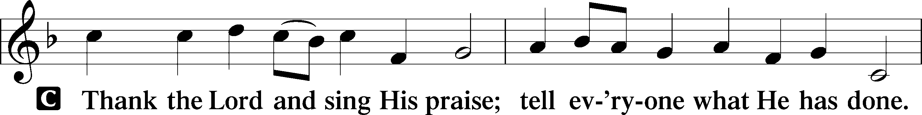
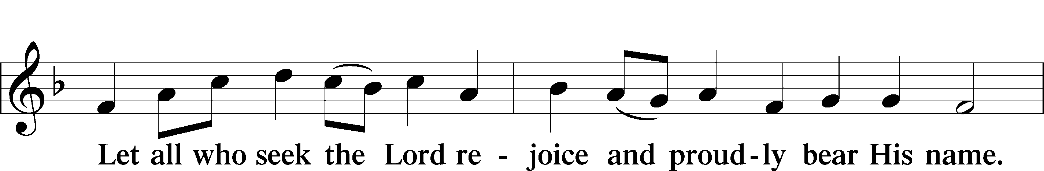
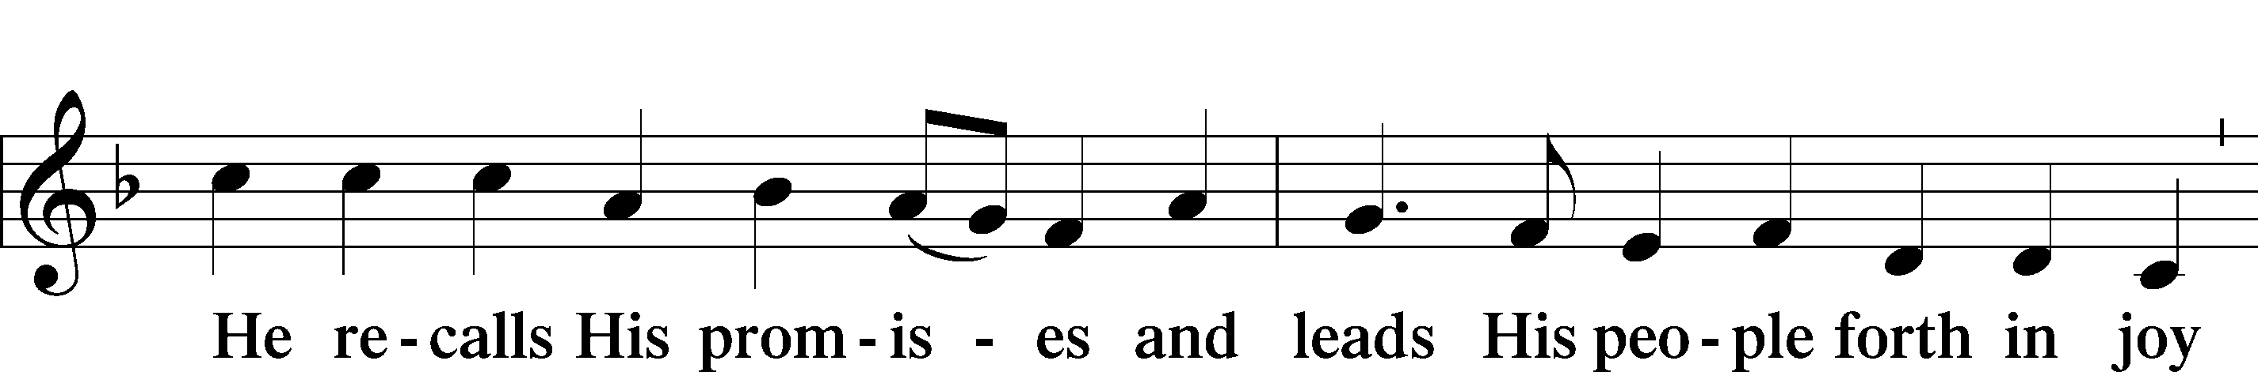
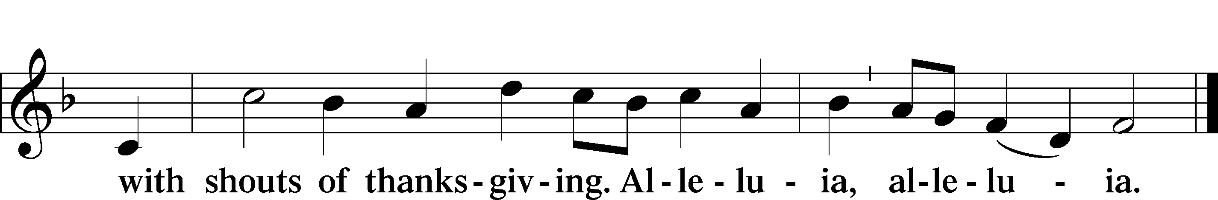

POST-COMMUNION COLLECT

BENEDICTION LSB 166
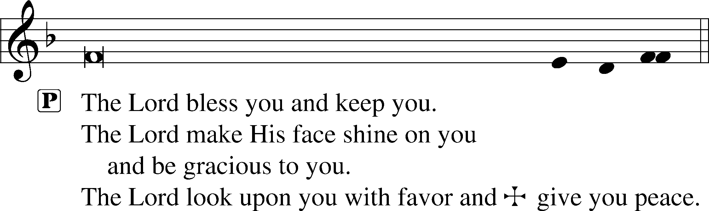


RECESSIONAL HYMN

965 GOD BLESS OUR NATIVE LAND

1 God bless our native land;
Firm may she ever stand
Through storm and night.
When the wild tempests rave,
Ruler of wind and wave,
Do Thou our country save
By Thy great might.

2 So shall our prayers arise
To God above the skies;
On Him we wait.
Thou who art ever nigh,
Guarding with watchful eye,
To Thee aloud we cry:
God save the state!

ANNOUNCEMENTS
See announcements on the back of the bulletin.

SENDING
P Let us pray.
Lord God, You have called Your servants to ventures of which we cannot see the ending, by paths as yet untrodden, through perils unknown. Give us faith to go out with good courage, not knowing where we go but only that Your hand is leading us and Your love supporting us; through Jesus Christ, our Lord.
C Amen

P Go in peace to serve the Lord.
C Thanks be to God.

THIS WEEK AT FAITH

Sun. July 5 Bible Studies 8:15am
Worship 9:30am
Mon-Thurs July 6-July 10 Summer Camp VBS 9am-4pm
Tues. July 7 Create in Me Crafting 10:00am
Sun. July 12 Bible Studies 8:15am
Worship 9:30am
CHURCH ANNOUNCEMENTS

Classical Info Night - Tuesday, July 14th at 5:00pm in the sanctuary.
Come out to learn more about the school’s direction and bring a neighbor or friend with you! Taking part in school events is one of the best ways to support our mission of connecting families to Jesus. It’s a completely screen-free, one-hour event with activities provided
for the kids. Please RSVP to Susie.Glass@faithmarietta.org

MEN’S BREAKFAST - July 18, 8:00 am Faith Cafeteria
The Men of Faith meet every Third Saturday for breakfast to encourage one another, build community, and discuss a topic of interest.

YOUTH EVENTS *SUMMER EDITION* - July 26, 12-2pm
4th-12th graders Meet us in the Youth Room after church for our final "Summer Edition" Youth hangout Esports competition. This is a free drop-off event, but parents are welcome to stay and play! Lunch and drinks are provided. RSVP to Liz Cain (678) 472-5226 *Games are E and E10+ rated

School Blessing - Saturday, August 1st at 10:00am
We warmly invite you, your family and friends to join us for Faith Lutheran School’s Blessing as we begin a new chapter as a classical school. We invite you to come and enjoy the day! Refreshments and fellowship to follow. Kindly RSVP to Susie.Glass@faithmarietta.org so we can plan accordingly. *If you have questions, please contact Chris Bradshaw or Pastor Daugherty.

VOTER’S MEETINGS - take place after Sunday worship. Next Tentative Meetings: Aug 23 - Nominating Committee; Nov 15 – Elections

CONFIRMATION CLASSES
For students (grades 7 and 8) who desire to grow in their faith and progress toward the milestone of adult membership at Faith Lutheran Church. Classes will be Wednesday nights at 6:30pm. Regular classes will begin on September 2. A required confirmation orientation for students and their parents will be held on Saturday August 29, 9am-12noon. Please contact Pastor Shaun to sign up for classes. pastor.shaun@faithmarietta.org

WORSHIP SCHEDULE - Beginning on September 6, our Sunday morning schedule will change:
Bible Study - 8:30a - 9:30a
Fellowship - 9:30a - 10:00a
Worship - 10:00a - 11:30a
The purpose of this change is to promote fellowship within the Faith Community and to give the choir and congregation time to prepare for worship. In addition, this will also allow for regular fellowship activities after worship.

